### **Lecture 1**

* 老师的zoom规则...
  + 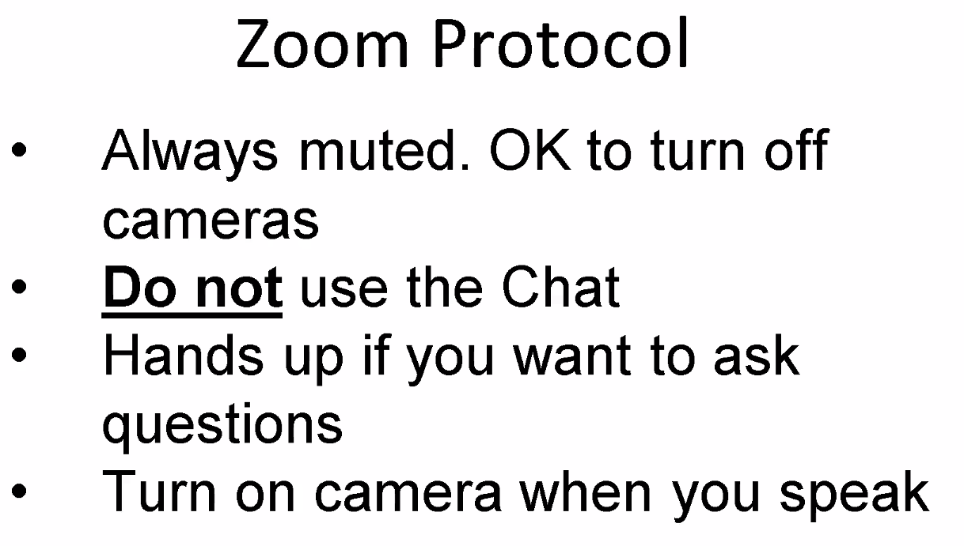
* 前情提要
  + 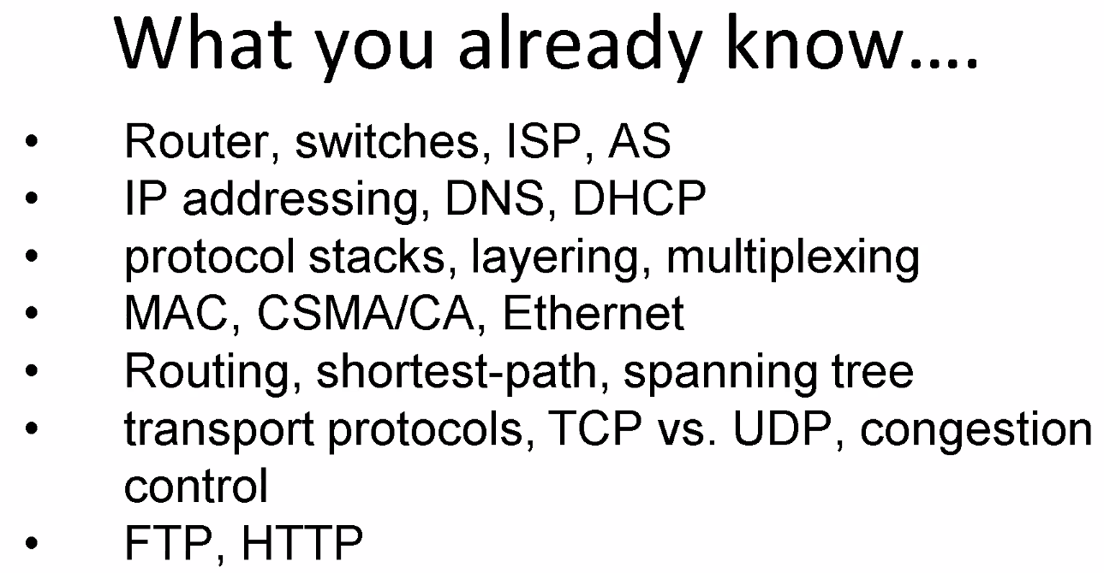
* Topics (might change)
  + 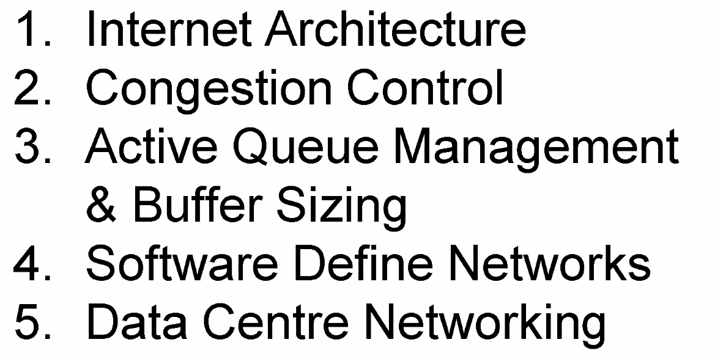
  + 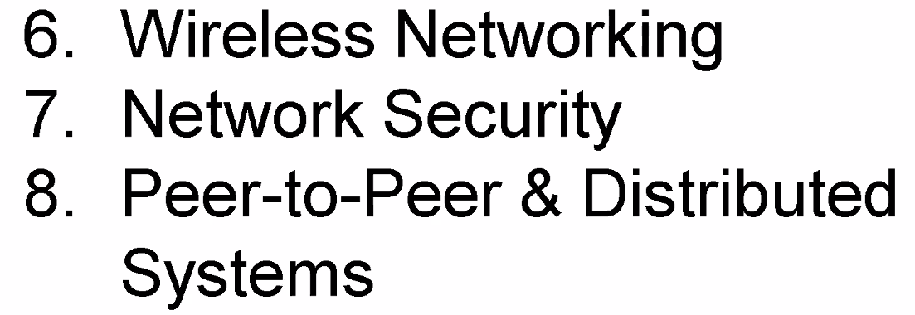
* Grading
  + 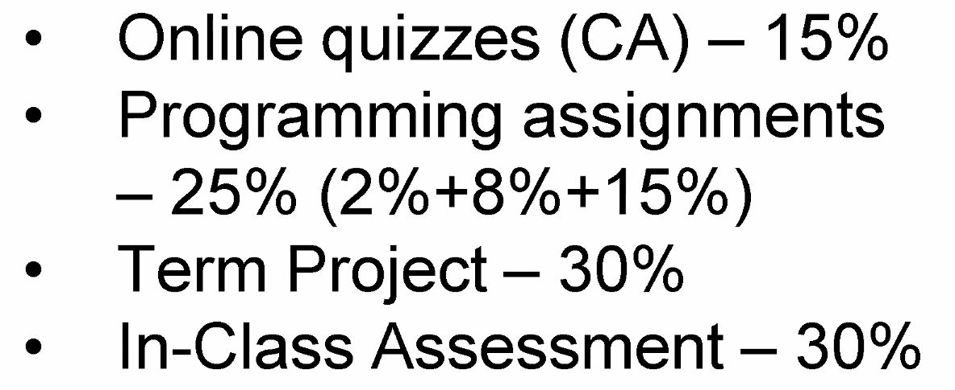
  + 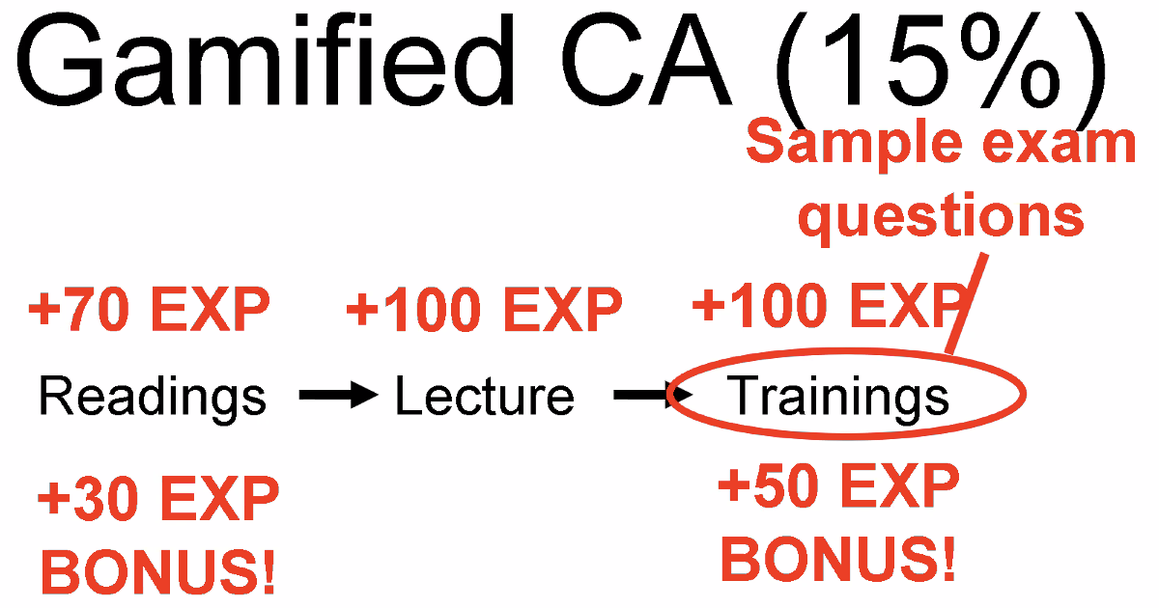
* mininet/ floodlight
* 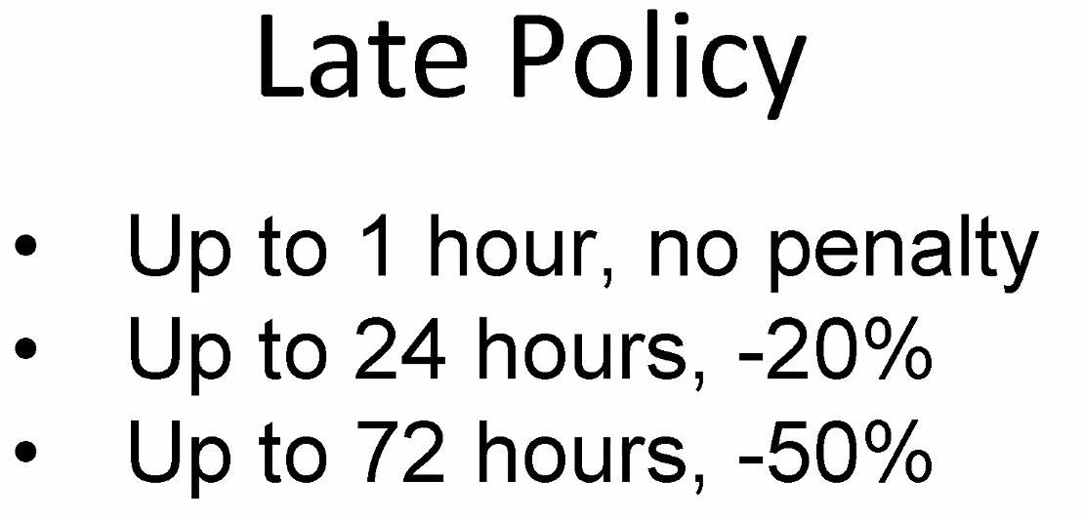
* Final exam
  + 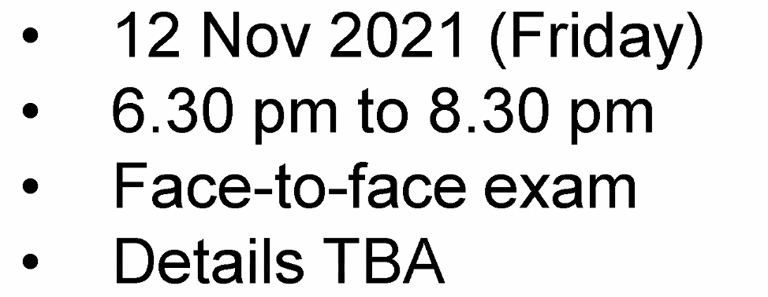
* 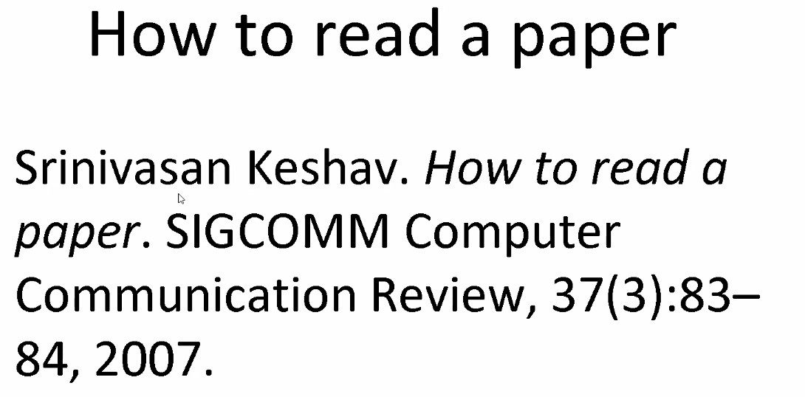
  + 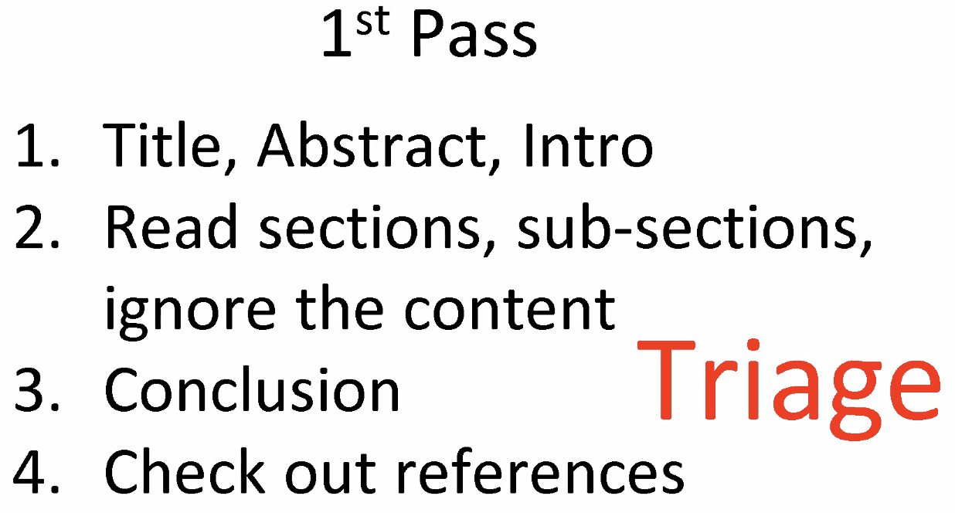
  + 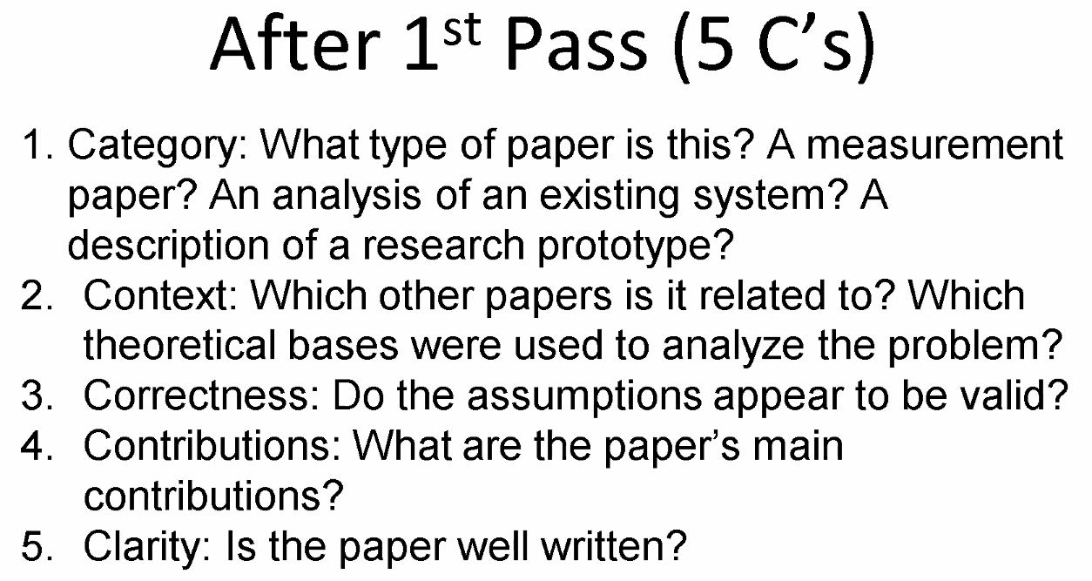
  + 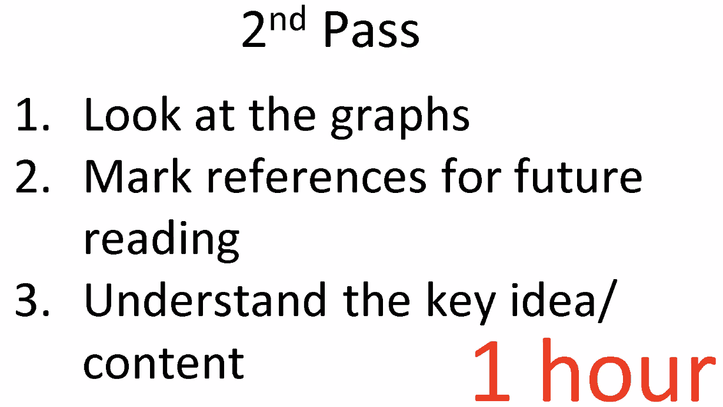
  + 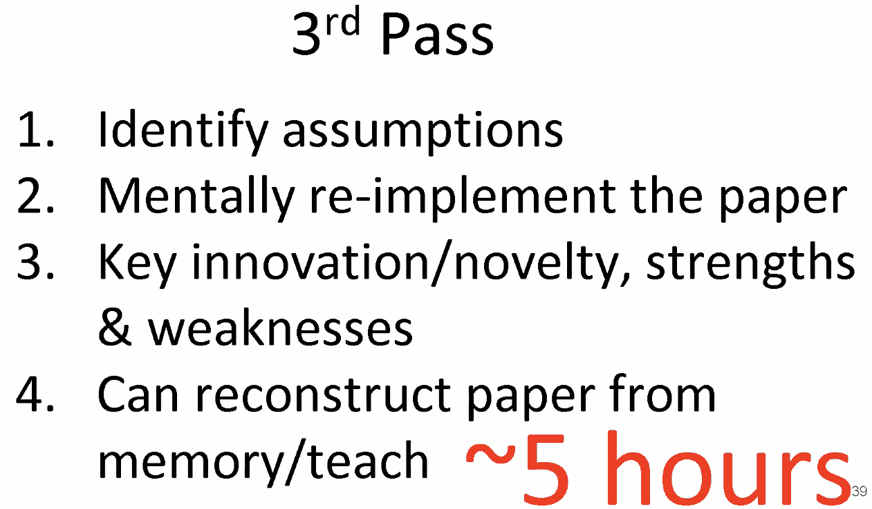
* End-to-end
  + Idea
    - Low-level functions may be redundant, just enhance performance
    - Functions -- bit error recovery/ encryption/ message suppression/ system crash recovery/ delivery acknowledgement
  + Reading 1-1
  + low-level functions
    - Goal -- Reduce the probability of each of the individual threats to an acceptably small value
    - Pros
      * Do have a significant effect on application performance (improve reliability)
    - Cons
      * Uneconomical
      * Unnecessary
      * Lower level subsystems common to many applications, part not need check
      * Have less information than higher levels → less efficient
  + End-to-end check and retry
    - B recalculate checksum and send back to A to compare or retry
  + Trade-off based on effort and correctness
    - End-to-end → frequent retry if too unreliable
    - Low-level → bandwidth lost to redundant data + delay by checks before delivering
  + *“The end-to-end check of the file transfer application must still be implemented no matter how reliable the communication system becomes.”*
  + 所以正常的思路是默认end-to-end，在非常unreliable的点采用low-level functions检查
    - 不是实时传输，不用在意时间的话，tradeoff偏向low-level，packet ordering + duplicate suppression都可以加起来来保证传输质量
    - 哪些functions需要end-to-end，哪些在lower level，正是tradeoff，衡量的
  + 应用
    - Acknowledge/ encryption/ FIFO msg delivery/ transaction management (看了一遍迷迷糊糊，应该也不重要)
    - Duplicate msg suppression
      * 消息重复可能是应用层面本身就信息重复，也可能是传输的时候retry或者超时导致的包重复
      * 使用end-to-end就在应用层面检测重复
* TCP/IP
  + IP -- Internet Protocol, TCP -- Transmission Control Protocol
  + Goal
    - provide useful interconnection among heterogeneous machines
    - Second level goals
      * 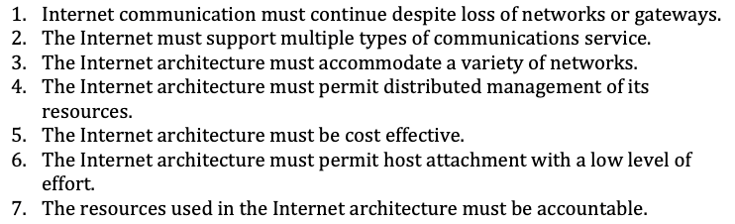
      * 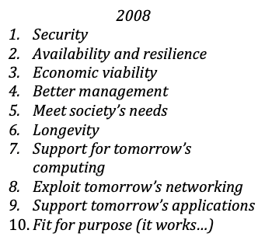
    - Ultimate goal -- Mask completely any transient failure
      * Only take up where it lefts off in reality
  + Use packet switching for multiplexing
    - Fundamental component of Internet
  + Gateways -- packet communication processor
    - A layer of internet packet switches to interconnect networks
    - Implement a store and forward packet forwarding algo
  + To protect state information from loss
    - State
      * Number of packets transmitted/ acknowledged
      * Number of flow control permissions
    - Ways
      * Replication -- replicate states
      * “Fate-sharing” -- take this information and gather it at the endpoint of the net (the entity utilizing the service)
        + Pros -- easy to implement + protect against any intermediate failures
* Internet Architecture
  + History -- Reading 1 2006 Intro部分自取
    - NCP → TCP → TCP/IP → DNS → EGP → TCP Congestion Control → BGP → Classless Inter-Domain Routing (CIDR) → IP Multicast
  + Congestion
    - Network-level problem -- both UDP and TCP can cause
    - → TCP’s congestion control
  + Enhancements
    - IP Multicast
    - Mobile IP
    - Quality of service
    - ECN
  + Evolution -- only just worked
  + Security -- inhibit transparency
    - Firewalls
    - Network Address Translators (NATs) -- reasons 👇
      * Shortage of IPv4
      * Pricing of IP addresses
      * Security
  + A new protocol to widespread
    - Work end-to-end → application developers → OS vendors → NAT and firewall vendors → work end-to-end
    - Vicious circle 死亡闭环
    - > 10 years
  + Short-term problems
    - Spam -- white list
    - Security -- taint-tracking/ detector (monitor & terminate)
    - Denial-of-service attacks
      * DDoS
      * DNS reflection attack -- 通过大量请求DNS的大回包，使线路拥挤，增加延迟
    - Application deployment -- easy to get through the firewall
      * Reverse engineering of Skype -- “complex, ugly and error-prone”
  + Medium-term problems
    - Congestion control
      * Problem description
      * 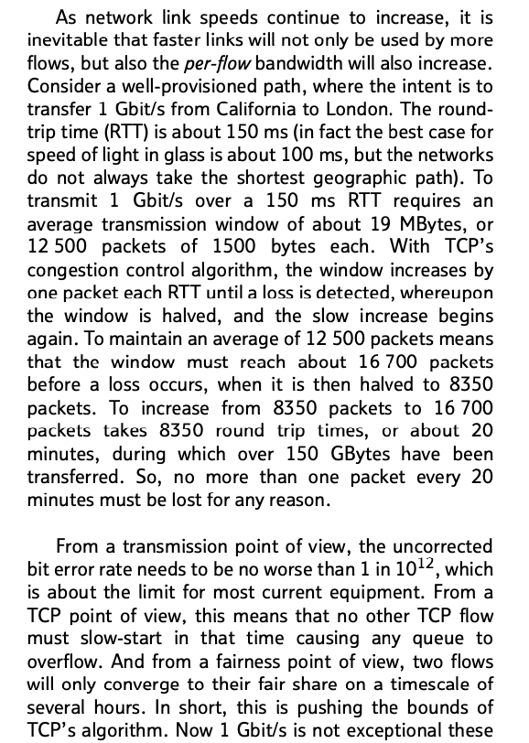
    - Inter-domain routing
      * Problems of BGP
        + Slow to converge in exploring paths

在失败后重新收敛时会探索很多其他路径

* + - * + Easy to misconfigure

Network operators在台后没有公开

* + - * + Difficult to debug
        + Insecure

Easy to infer customer/provider relationships from BGP path info

Most common policies cannot secret

* + - Mobility
    - Multi-homing -- 网络备份（多域名多服务），增加了routing的压力
    - Architectural ossification -- not evolved significantly since the early 1990s
  + Longer-term problems
    - Address space depletion
  + Conclusion
    - The Internet only just works
    - unless faced with a specific and pressing problem
    - an ill co-ordinated last-minute rush
* Internet architecture
  + 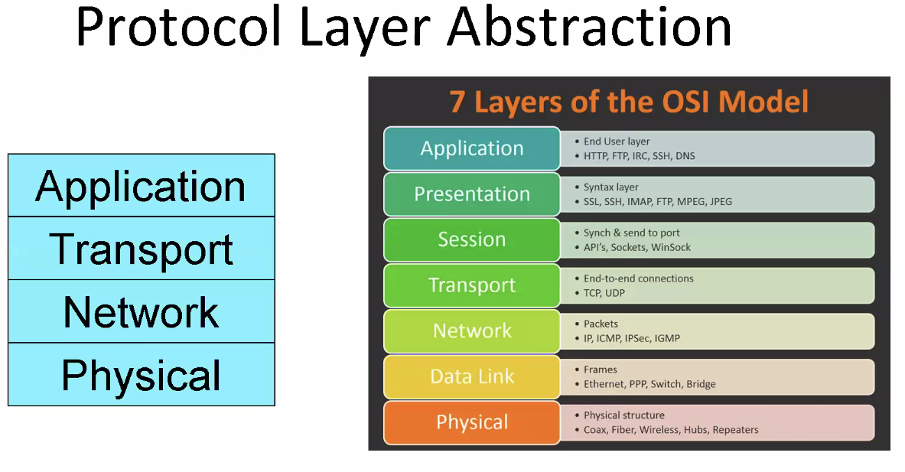
  + First Goals
    - Communication and connection between heterogeneous
    - Expense
  + Second level goals
    - Recover from pack loss/ continue despite loss
    - In-network < end-hosts, why? → paper
      * More robust against intermediate failures/ easy in engineering replication
      * In-network -- check each link
        + Also need end2end → detect problems in host receiving data
      * End-to-end -- check two ends
        + Wait for another end to response → pay for latency
        + Give guarantees
    - Support multiple types of protocols
      * TCP is not suitable for everything
        + Too late for voice/gaming
        + Not need reliability in some applications
        + 40bytes header too much
    - Cost-effective
    - Host ?? → Socket abstraction
  + 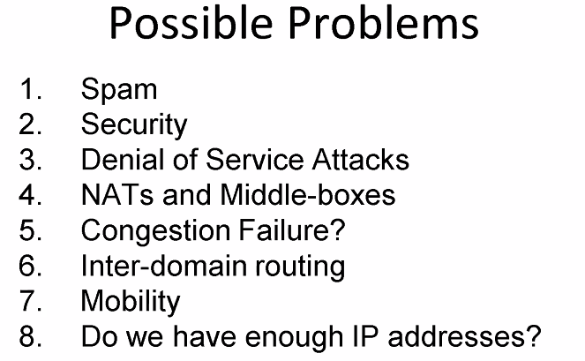
* Tussle
  + 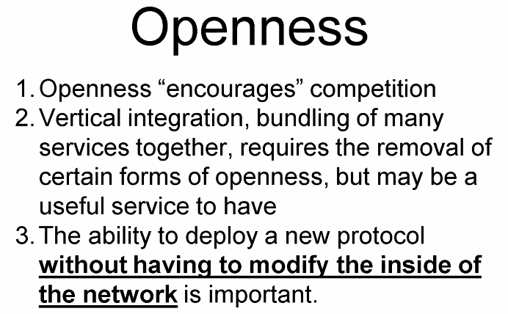
  + Lost of trust
    - Less transparency → firewalls/ NAT
    - ISP control
    - Performance improvement → caches, mirrors, hacks to DNS
    - QUIC -- everything is encrypted
      * Push end-to-end to limit
  + Net neutrality
    - ISPs Treat all internet communications equally
    - Not discriminate or charge differently
* 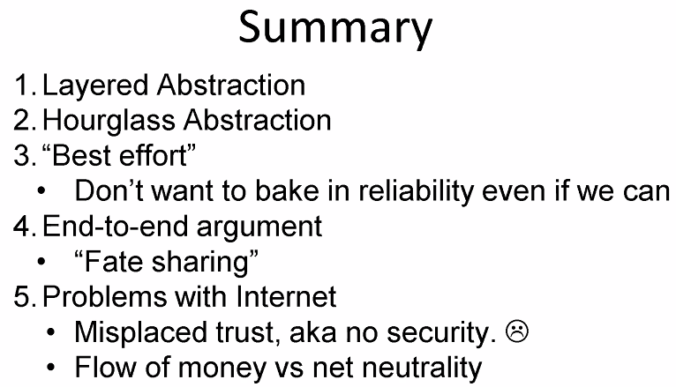
* Reading 1
  + 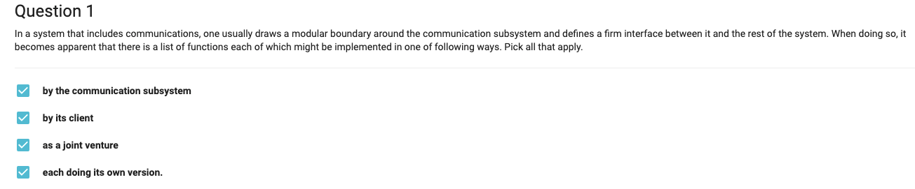
  + 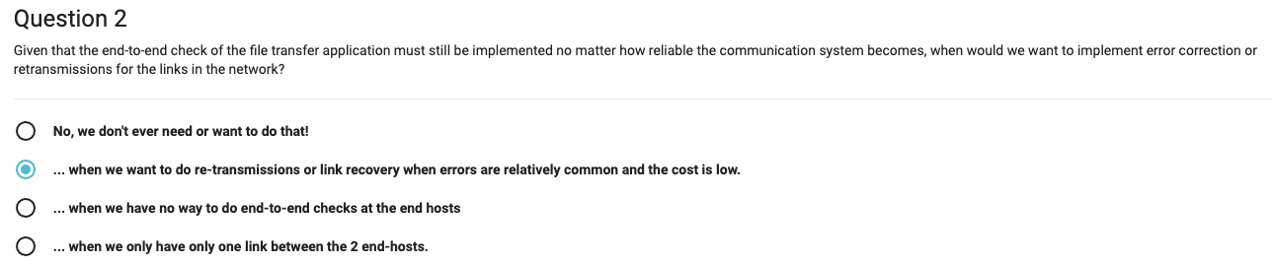
  + 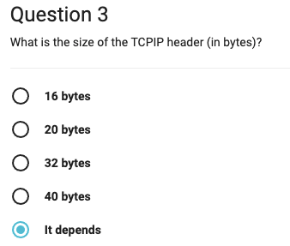
  + 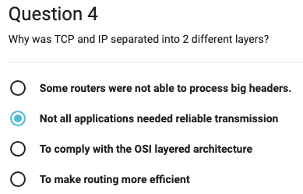
  + 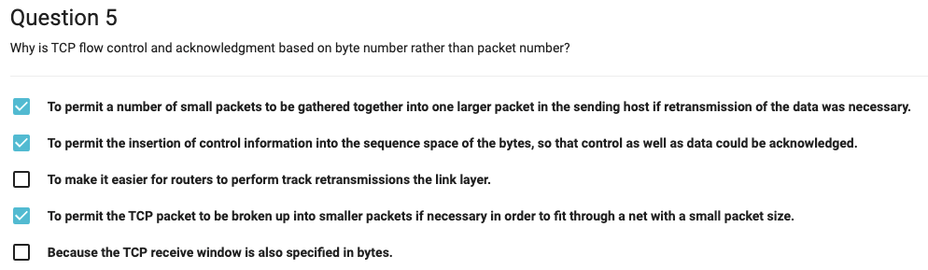

### **Lecture 2**

* Congestion control
  + Correct stage -- conservation of packets
    - Run stably with a full window of data in transit
    - A new packet is injected after an old packet leaves
  + Main idea of control
    - Find places that violate conservation + fix
  + Congestion
    - Three conditions
      * Connection not get to equilibrium
      * 新包在旧包离开之前被放入（顺序不对了？）
      * Resource limit
  + Slow-start
    - Self-clocking
      * the sender uses acks as a 'clock' to strobe new packets into the network
      * 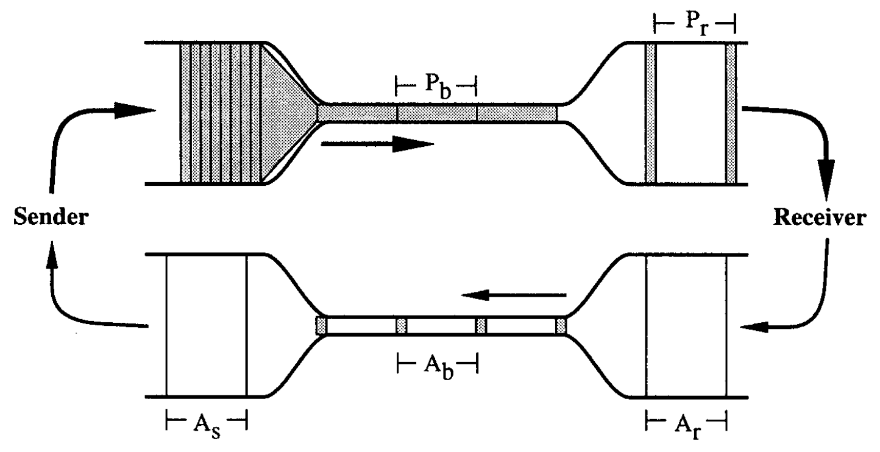
      * Pb = Pr = Ar = Ab = As
      * Pros
        + Automatically adjust to bandwidth and delay variations
        + Wide dynamic range
      * Cons
        + Hard to start

Data flow --(need)→ acks --(trigger)→ data flow

* + - Slow-start algo
      * Idea -- Gradually increase the amount of data
      * 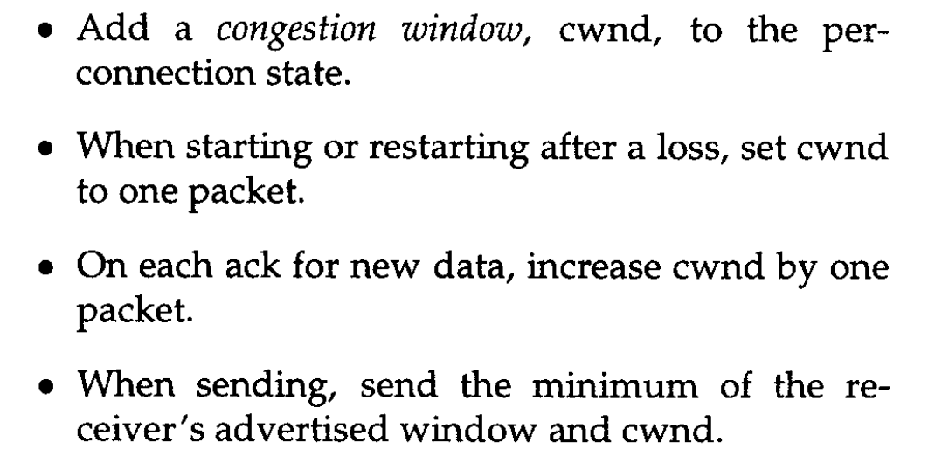
      * 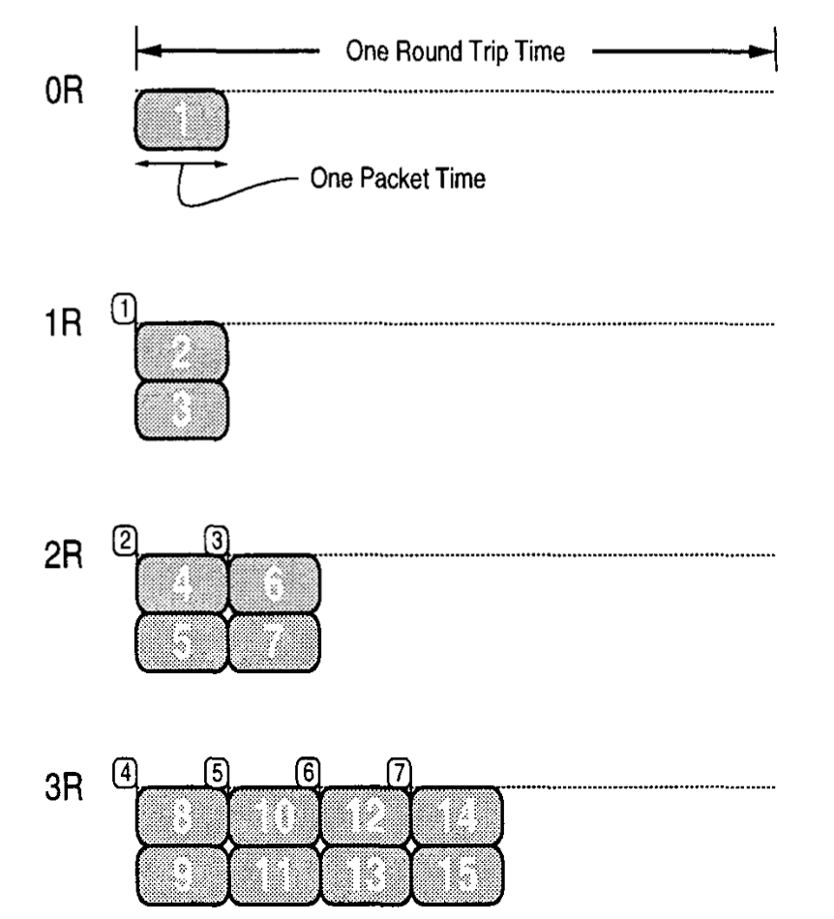
      * 👆上图展示了cwnd增加的过程，纵向显示第几个RTT，每收到一个ack，发送一个新包的同时对cwnd+1，就又发一个包，所以随着ack的增加和cwnd，会成指数变化，直到达到bottleneck的极限
      * 想要cwnd的size是W，bottleneck的buffer size要求W/2，这样可以同时接收处理W/2的ack，最后✖️2就是W
      * cwnd的size增加到W所需要的时间
        + 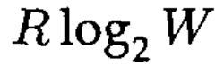
        + R -- RTT, W -- size of cwnd
      * Window opens quickly enough to have a negligible effect on performance
      * Source data at a rate at most twice the maximum possible
  + Round-trip timing
    - round trip time estimator -- core of retransmit timer
      * Mistake
        + Not estimating variation of RTT
        + Backoff after a retransmit
      * 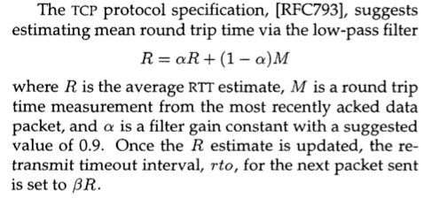
      * 
      * 感觉是B的值固定为2使得可控的loads上限为⅓，再大就会被动retransmit？
    - 采取了estimate B而不是固定B的值来适应不同的load
    - How should the retransmit spaced?
      * Exponential backoff -- help stabilize linear system
  + Congestion avoidance
    - Two components
      * Network be able to signal endpoints where congestion is
      * Endpoints have policy control utilization
    - Congestion → packet loss → timeout
    - Load
      * 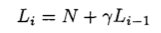
      * N -- new traffic +delay
      * rL -- fraction of left-over load
    - 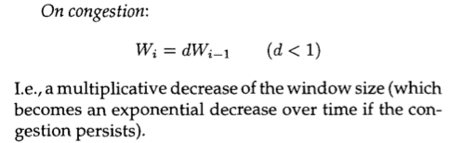
    - Mistake
      * Use symmetric multiplicative increase → oscillate wildly → deliver poor throughput
      * 
      * Easy into saturation but hard to recover
    - Additive increase
      * 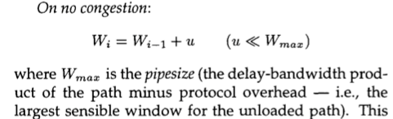
      * 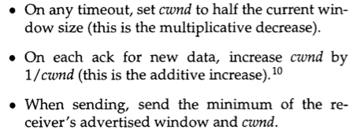
  + Gateway side of congestion control -- congestion detection algo
    - insure fair sharing of that capacity
    - Control sharing and fair allocation
    - Use packet drops as a congestion signal
* Distributed congestion control hard
  + Utilization
  + Fairness
  + Low visibility of the network -- hard to synchronize
    - Hard to know where is the bottleneck
  + Churn
  + Intrinsic delay
* Send A to B
  + File → packets
  + Bottleneck → buffer overflow
* 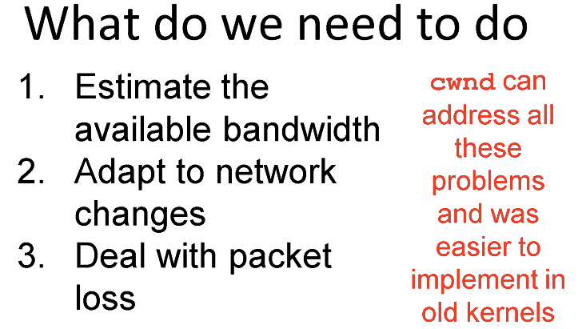
* 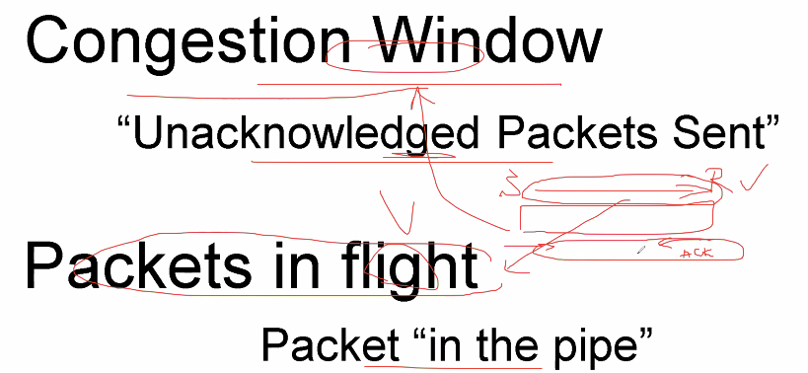 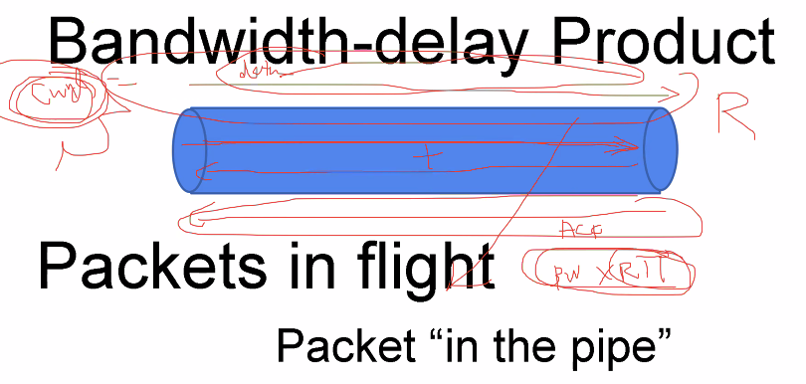
* Control
  + 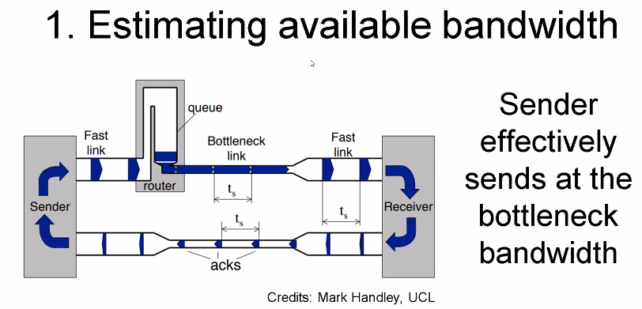
  + 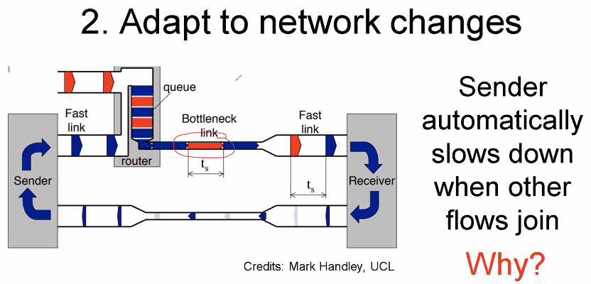
  + 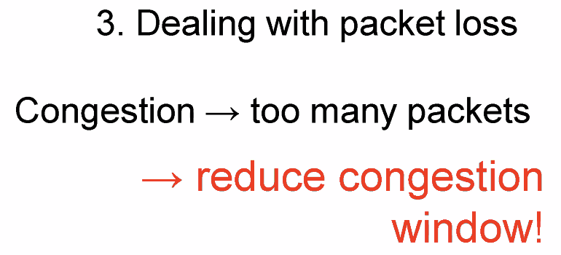
* 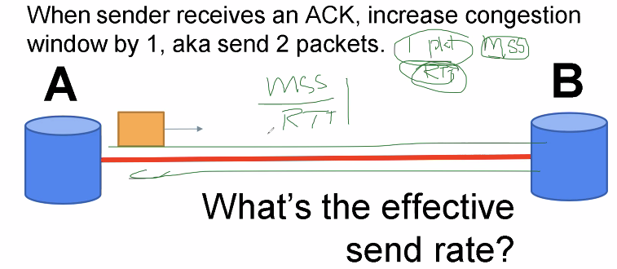
* 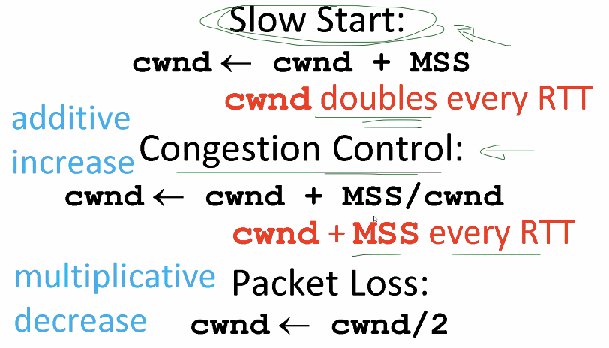
* 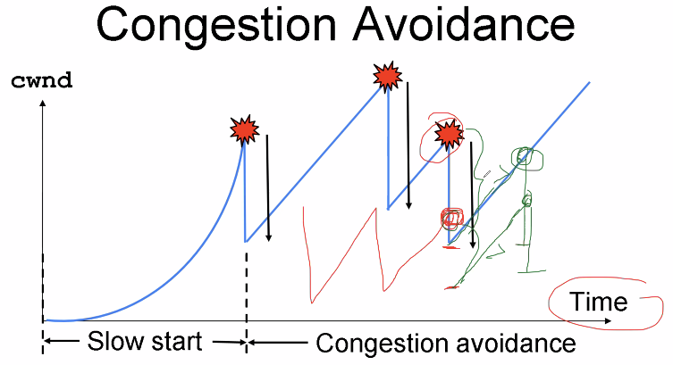
  + 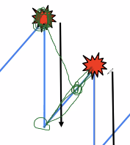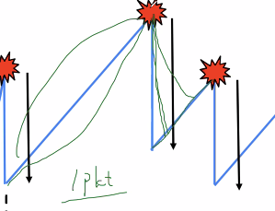
* 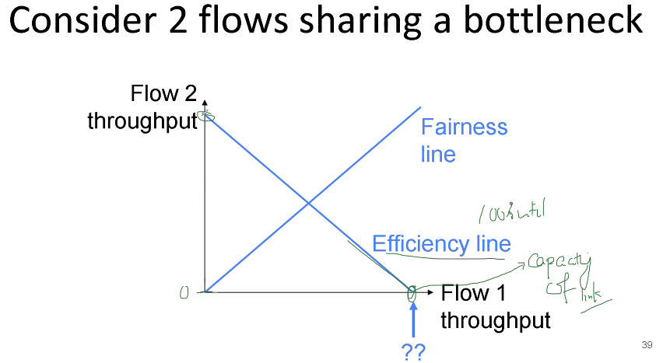 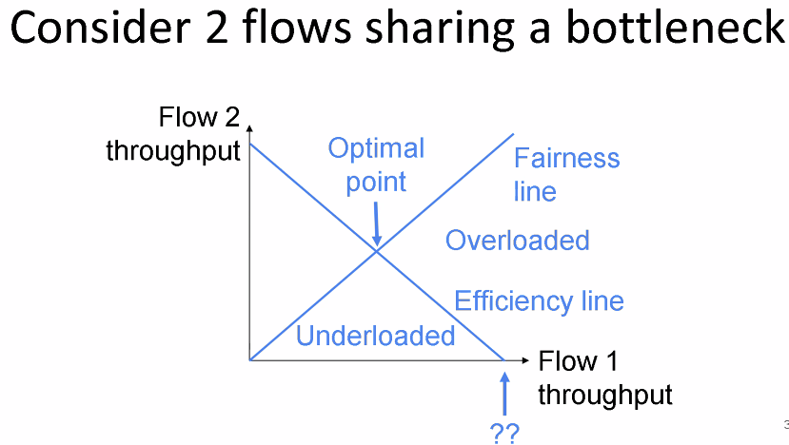
* 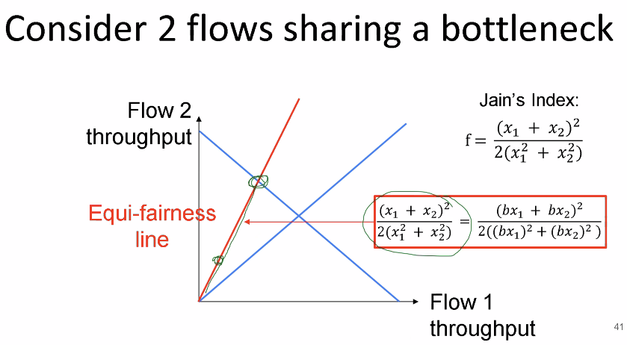
* 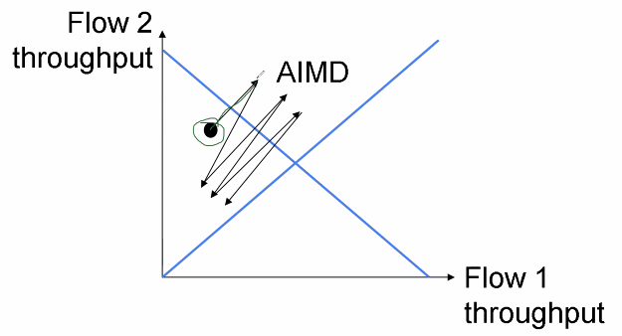 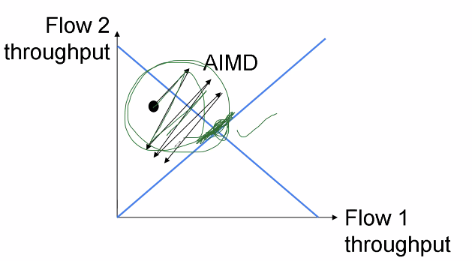
  + 所以这张图是在说两个flow会收敛到 最大化利用网络并且fairness的位置
  + AIMD策略，每次 /2的时候 占用更多资源的flow被砍掉的也越多，线性增的时候两者增加相同的资源，同时达到congestion状态，继续减半，重复多次以后会逐渐趋近
  + 所以MIMD的fairness直线应该是由最开始两个flow占用的资源决定的？所以就过最开始的那个点吧，因为它不会重新分配资源
  + MIMD的逻辑不一样吧，MIMD是先有flow的值，然后才有那条线，所以不存在收敛一说
* 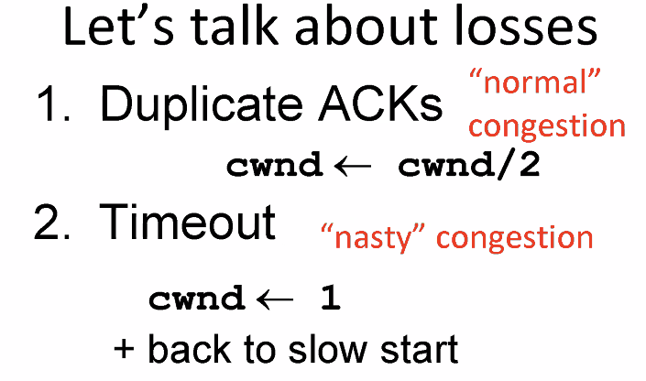
* 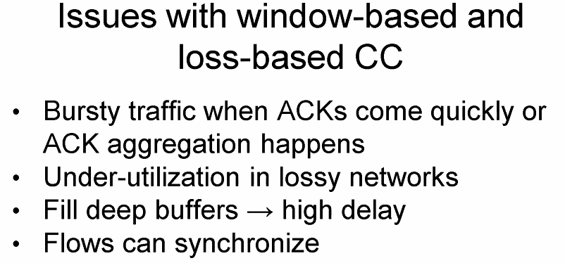
* 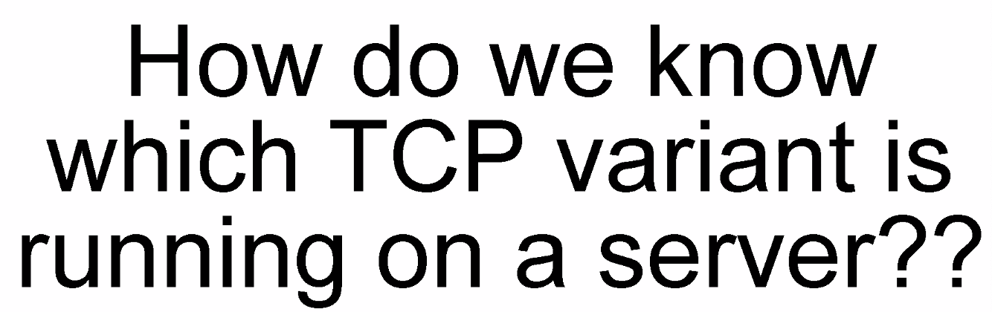
  + 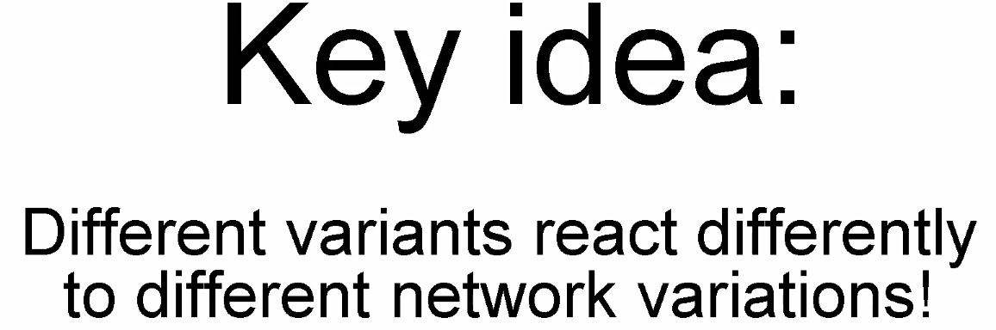
  + Fingerprints the server -- ping it
  + 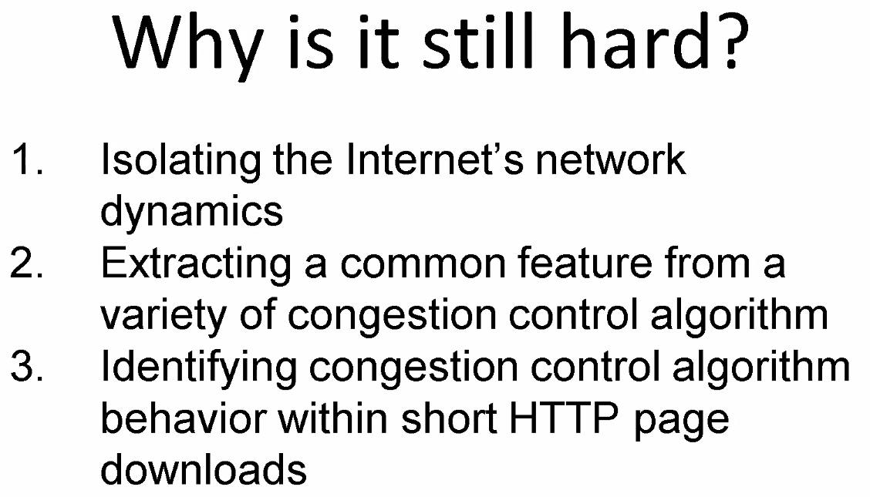
  + 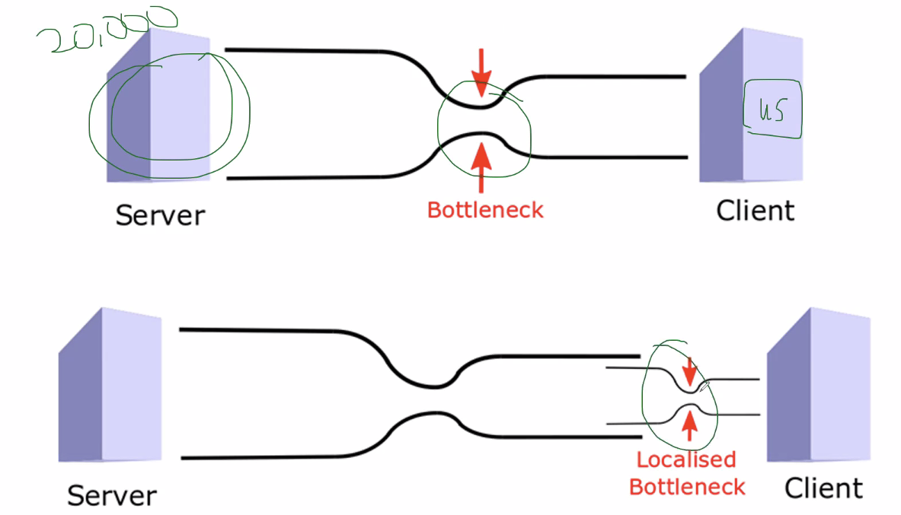
  + 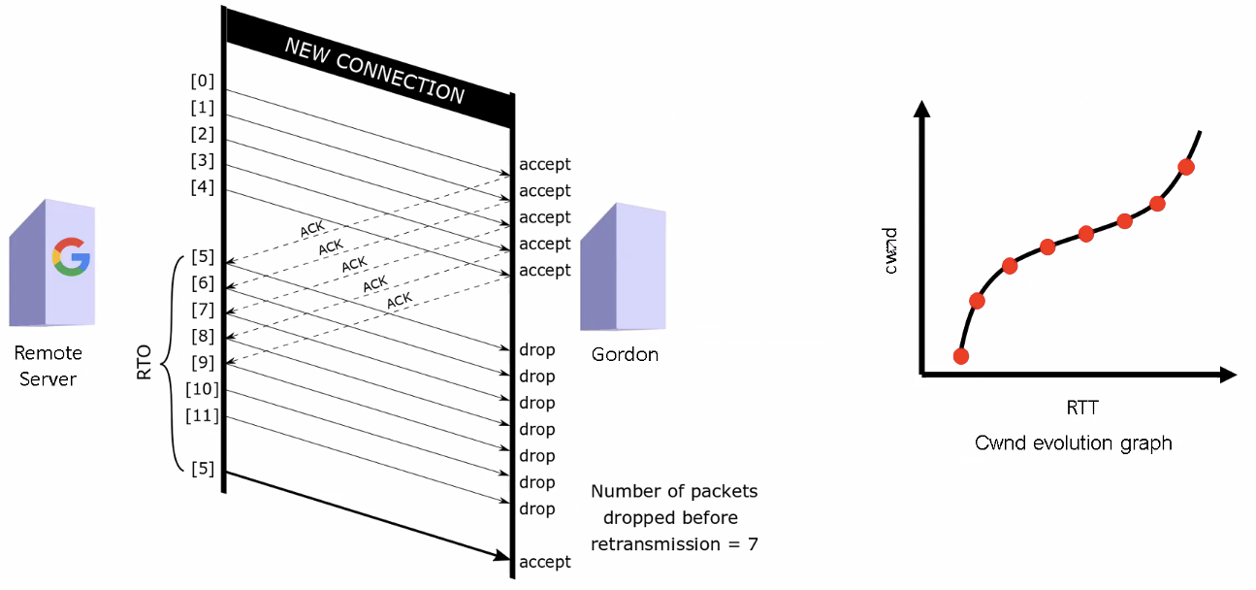
    - 我感觉是这样的，sender会一次性发cwnd那么多的packets，然后receiver故意drop掉一整批的packets，根据这个packets的数量倒推cwnd的大小

### **Lecture 3**

* RED (Random Early Detection)
  + Congestion signal -- packet drop
  + RED的核心思想
    - if the queue length exceeds a certain drop level, then the gateway drops each packet arriving at the gateway with a fixed drop probability.
    - 另一句话说，To provide congestion avoidance by controlling the average queue size
    - Drop level 和 probability 动态变化
    - 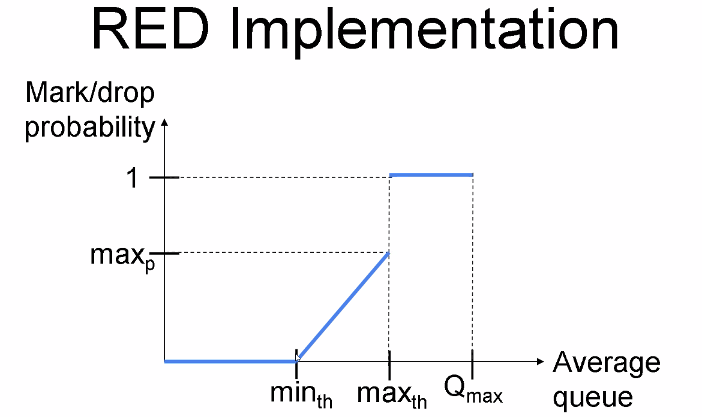
  + Drop Tail的缺点，所有connection一起变化形成Synchronization，并最终会使cwnd趋同
    - 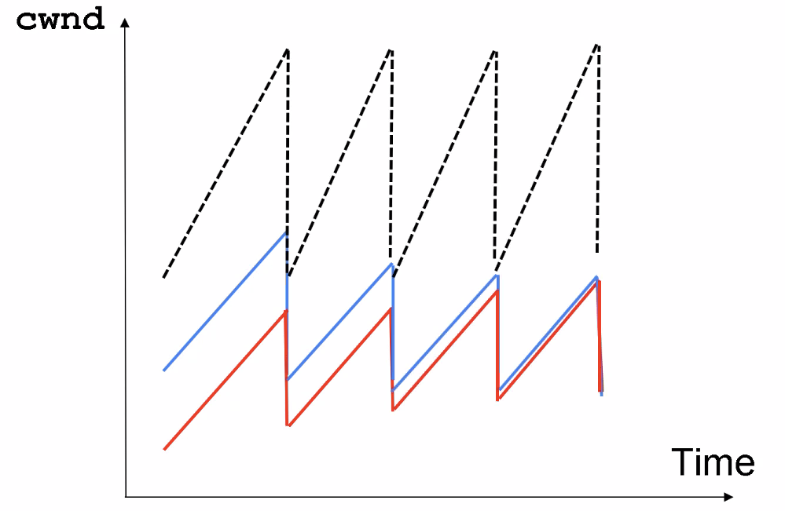
  + RED的三大特性
    - the source should reduce its window even if there is only one marked packet
    - RED avoid the global synchronization that results from many TCP connections reducing their window at the same time
    - the network responds to the instantaneous queue lengths, not to the average queue lengths
  + 同类算法DECbit
    - gateway为Pkt加上congestion的标志bit，source带bits的pkt多于一半，就减小cwnd，反之增加
  + Congestion control的核心目标
    - Low delay
    - High throughput/ Utilization
    - 其实就是一个tradeoff的过程
    - 其他目标包括: accomodate bursty traffic and transient congestion
  + Gateway 的两大基本功能
    - detect incipient congestion that has persisted for a “long time” (several round-trip times).
    - decide which connections to notify of congestion at the gateway
      * 该功能的两个目标
        + to avoid a bias against bursty traffic，RED相比drop tail变相减轻了burst的影响
        + to avoid the global synchronization
  + Implementation
    - 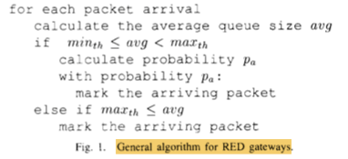
      * The RED gateway calculates the average queue size using a low- pass filter with an exponential weighted moving average.
* AIMD -- congestion cwnd的窗口会变½，但是如果变⅓，¼ 对delay有什么影响
* 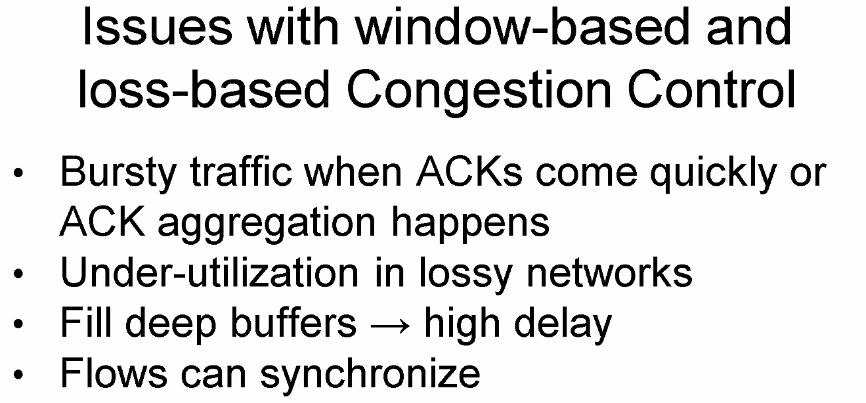
* 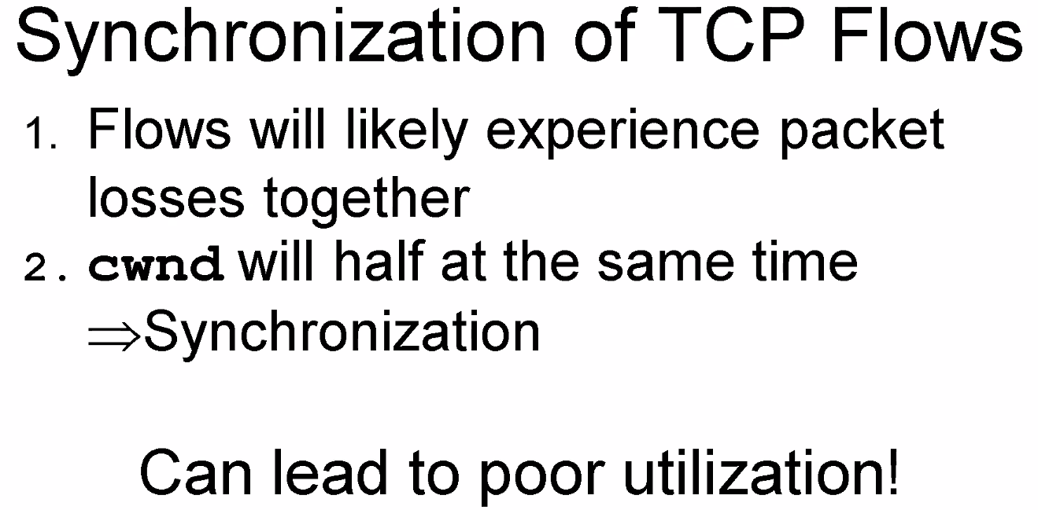
  + 
  + 👆 why AIMD can reach balance state， 两个cwnd会逐渐趋同
* 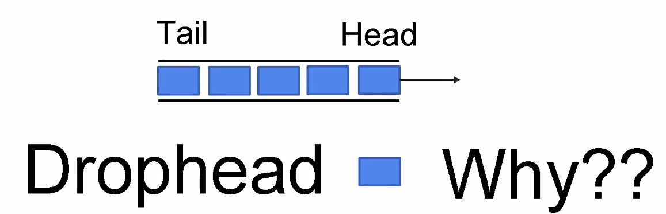
  + Inform the sender that there is congestion as early as possible
* 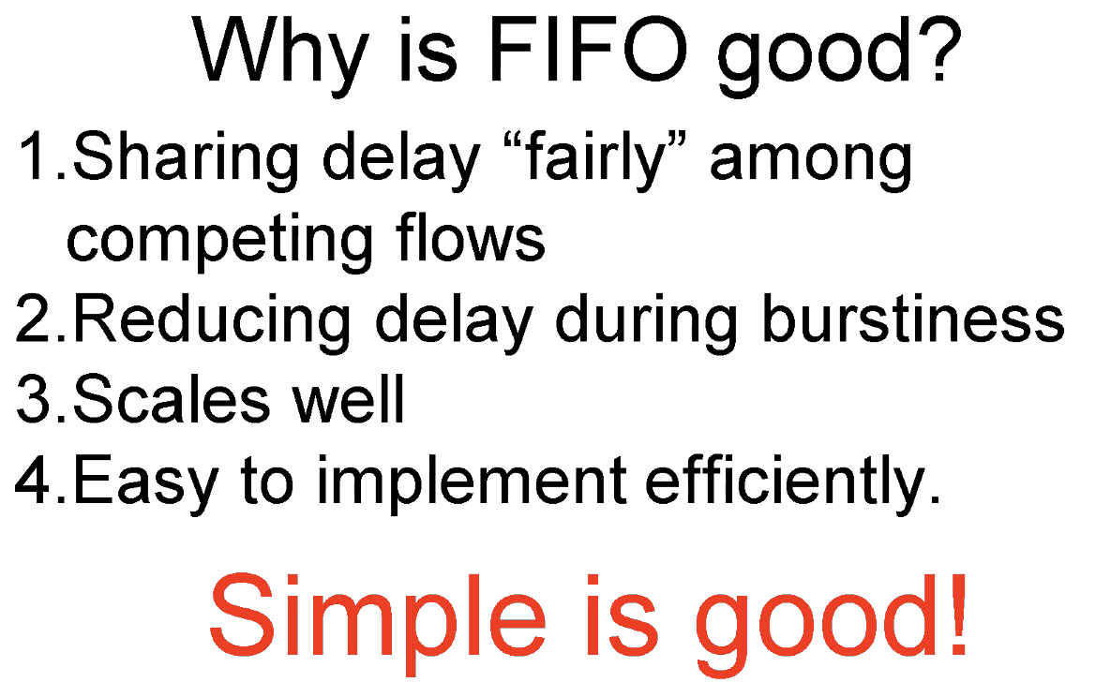
* 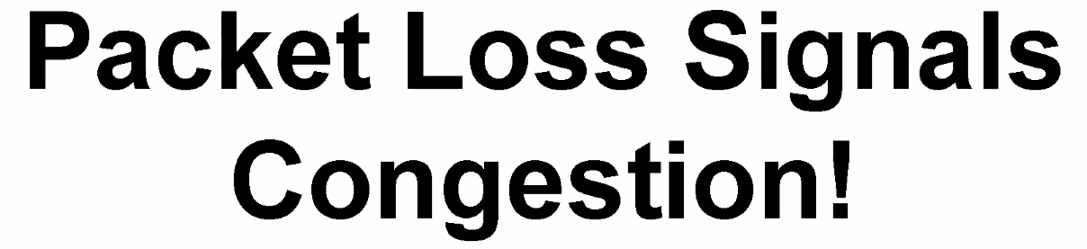
* 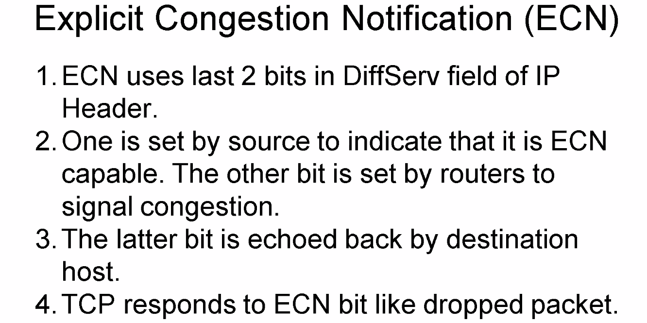
* RED
  + 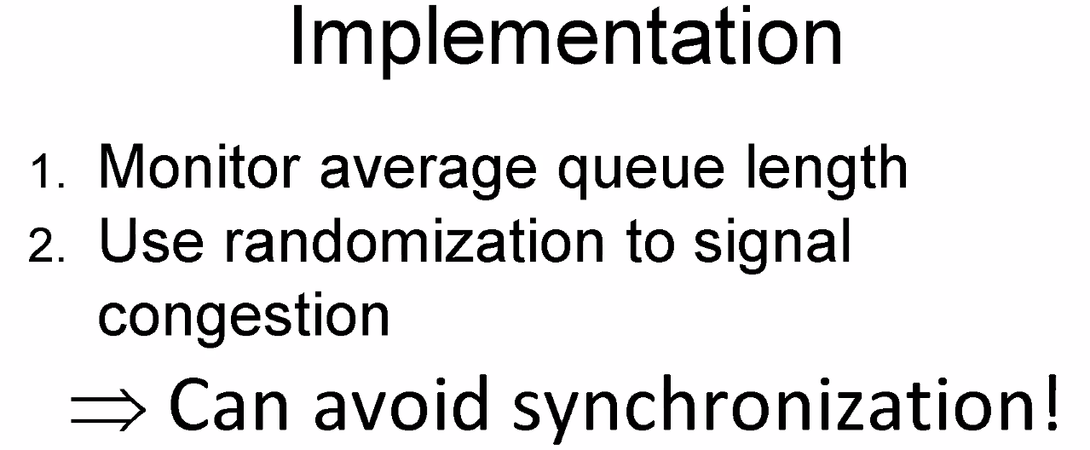
  + 
  + 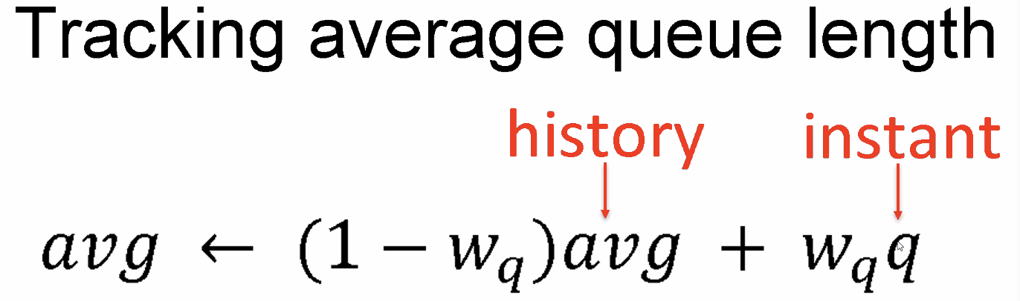 → EWMA 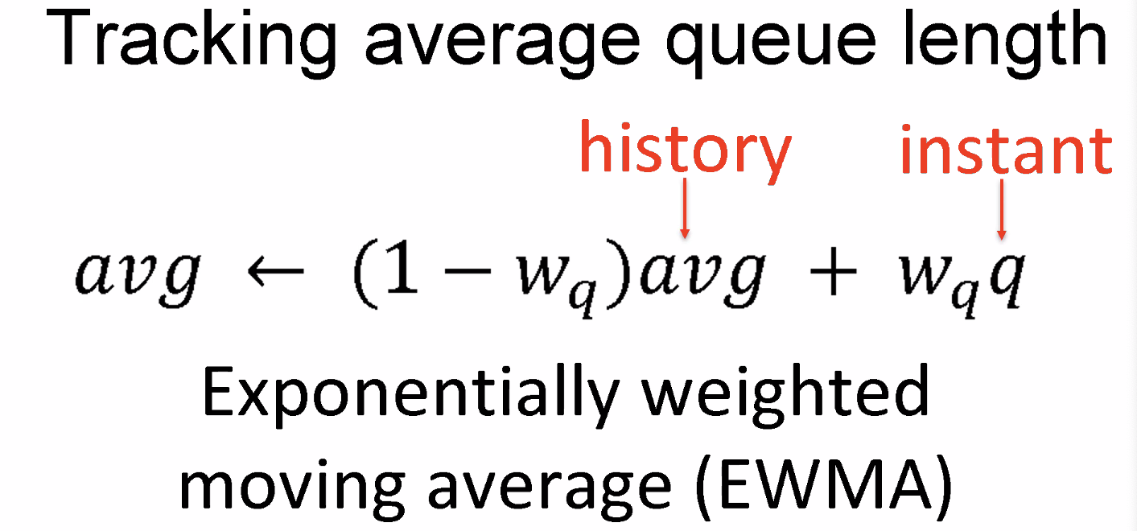
* 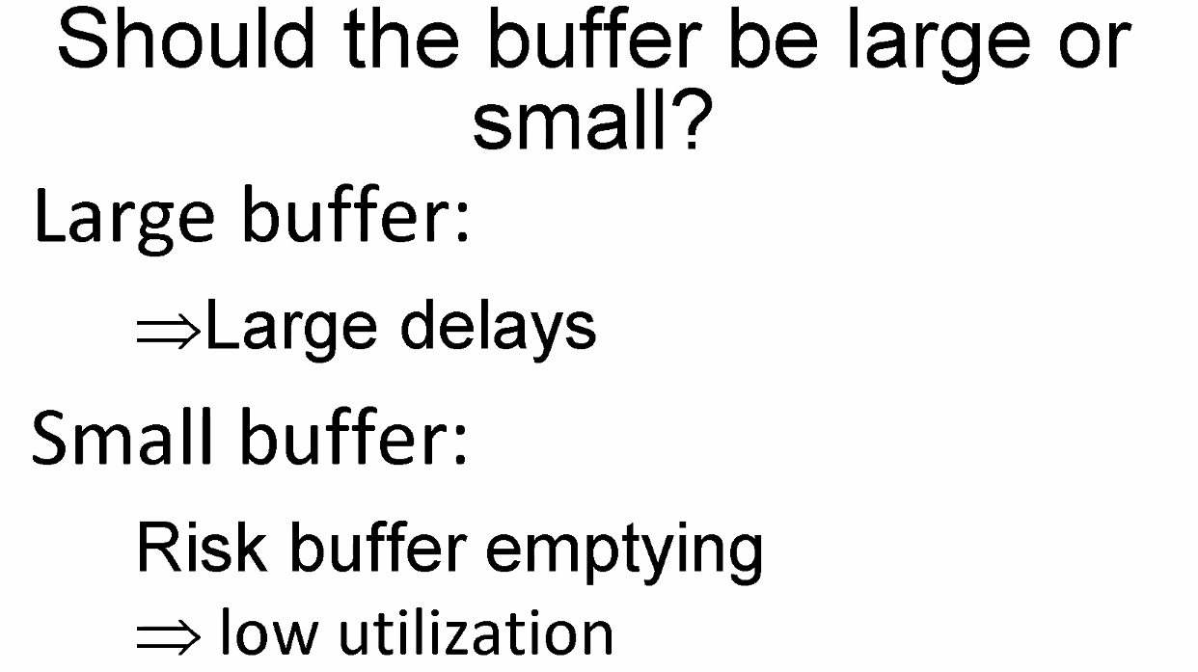
  + 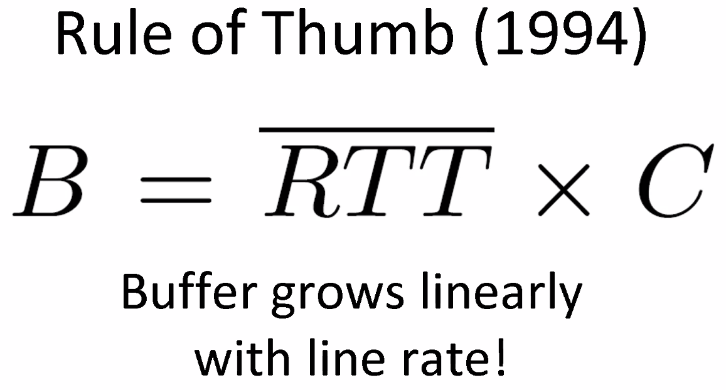
  + 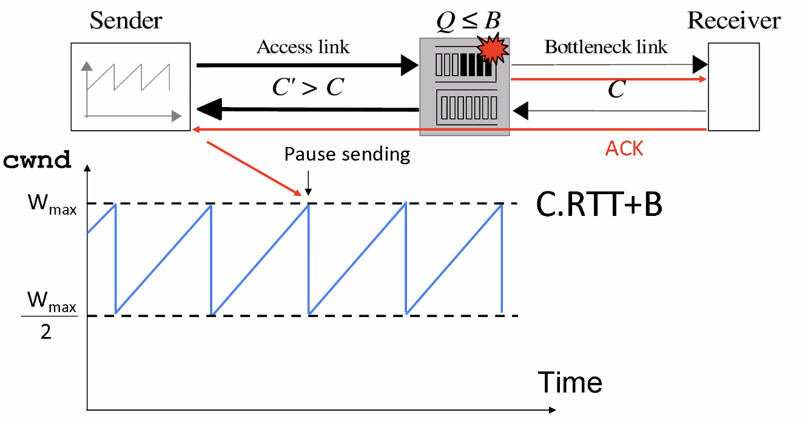
  + 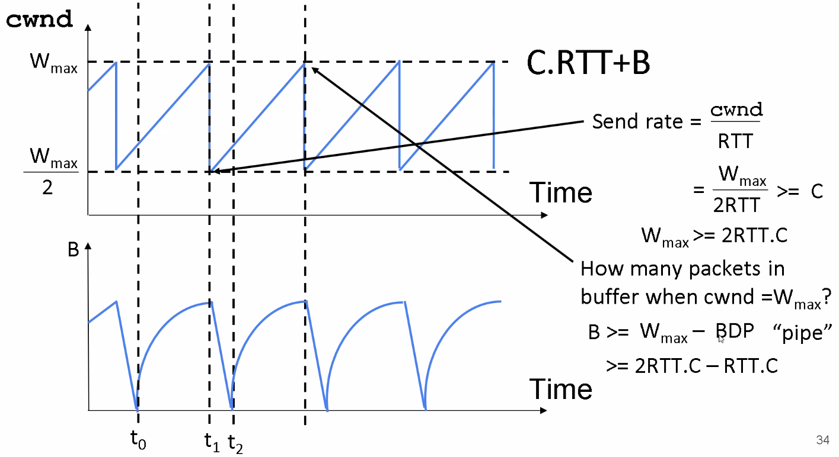
    - 下面那张图的斜率为啥逐渐变小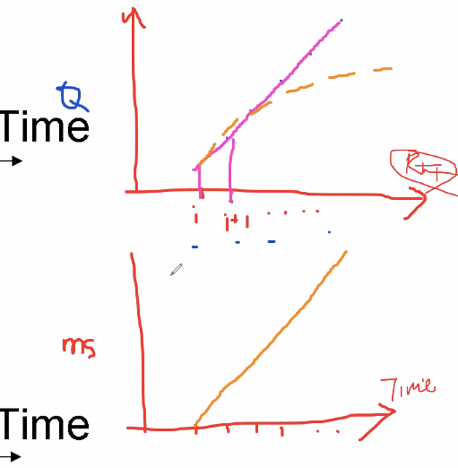
    - 每个RTT queue增加linearly
    - 但是queue变长之后queueing delay会变长，RTT也会变长
  + 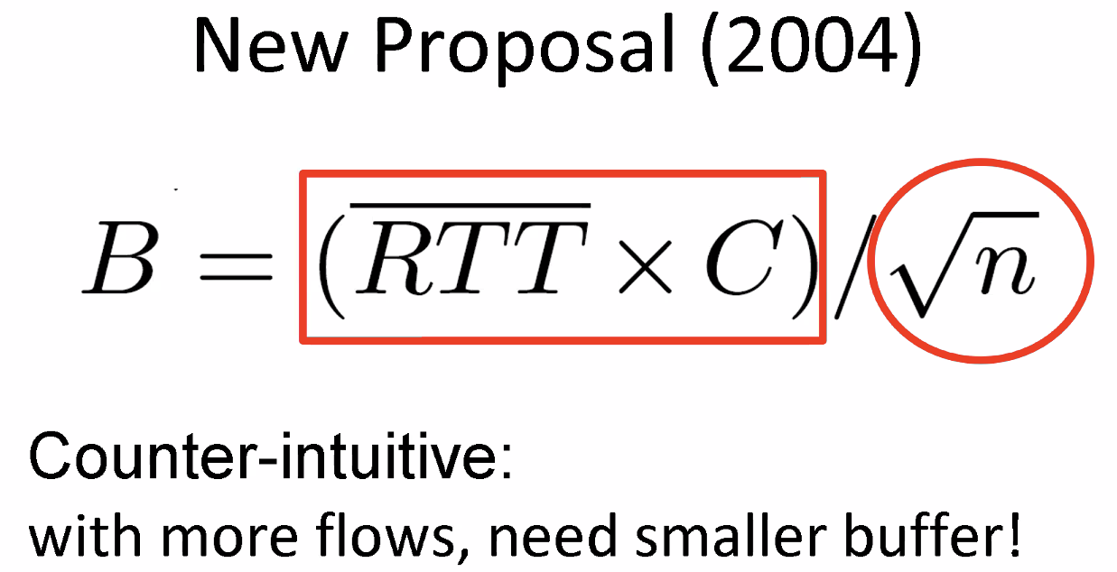
* 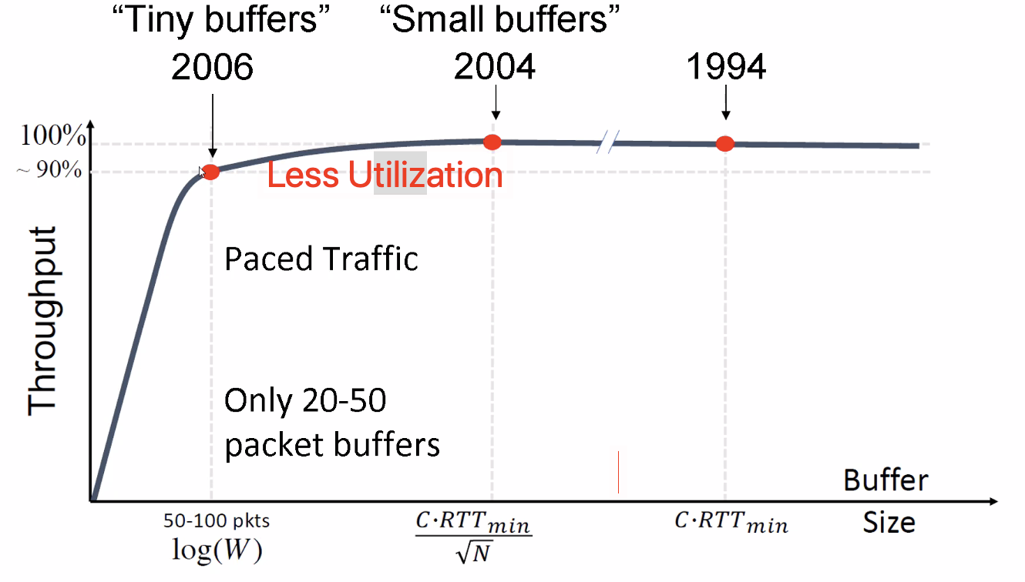
* Buffer bloat
  + 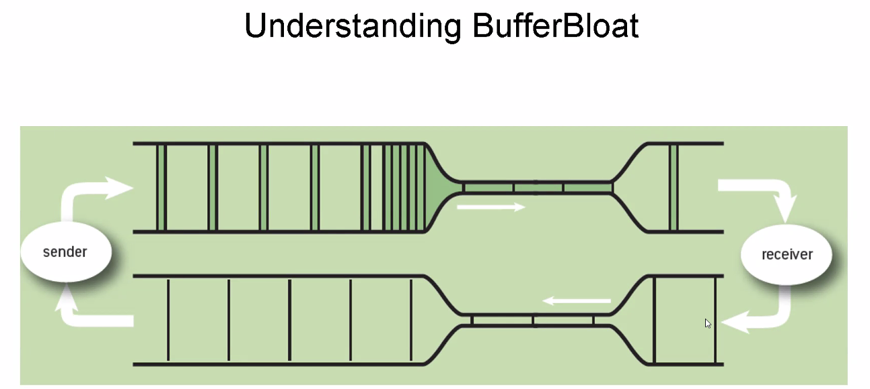
  + 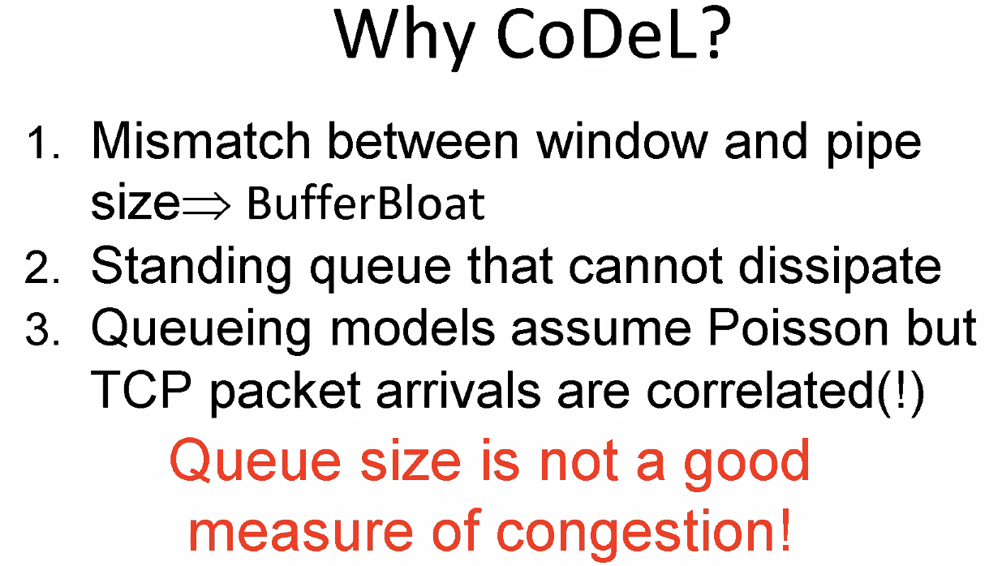
  + 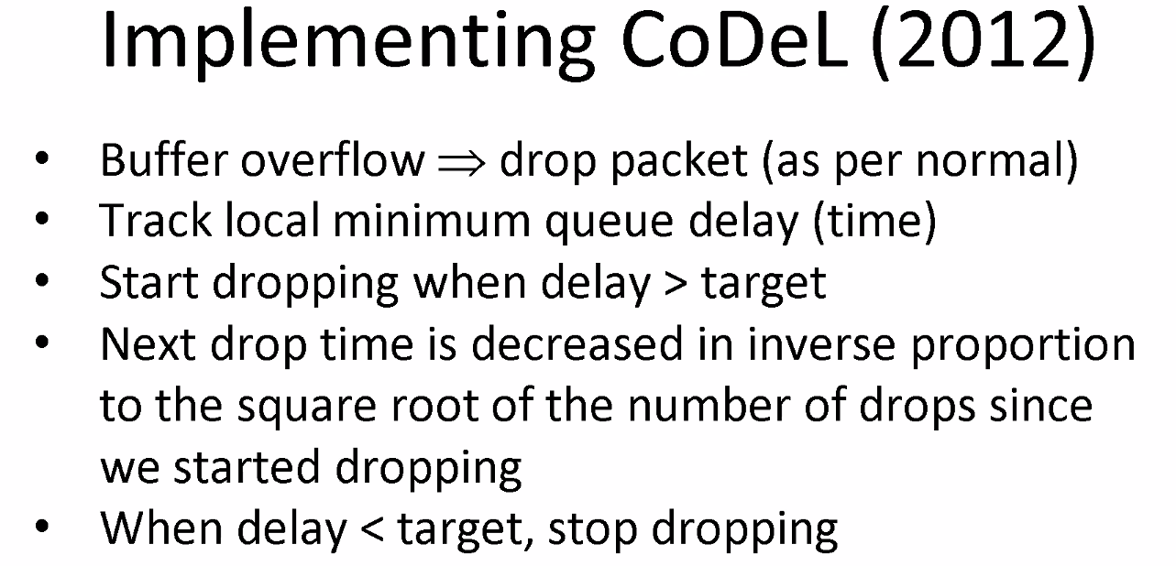
* 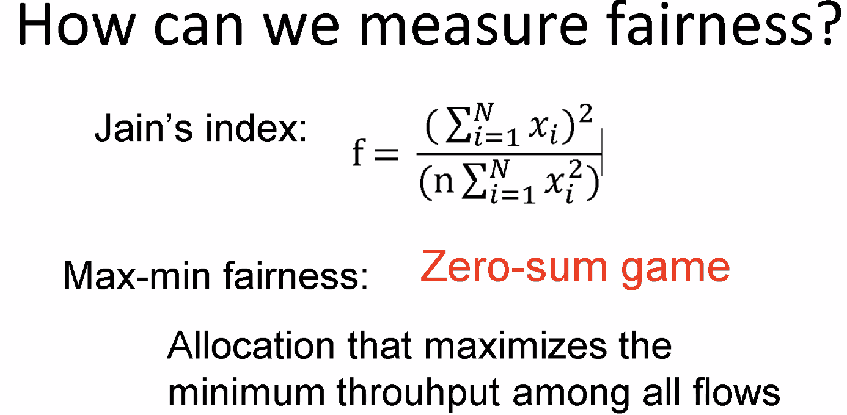
  + 尽量倾向于吞吐量最小的那个flow
  + 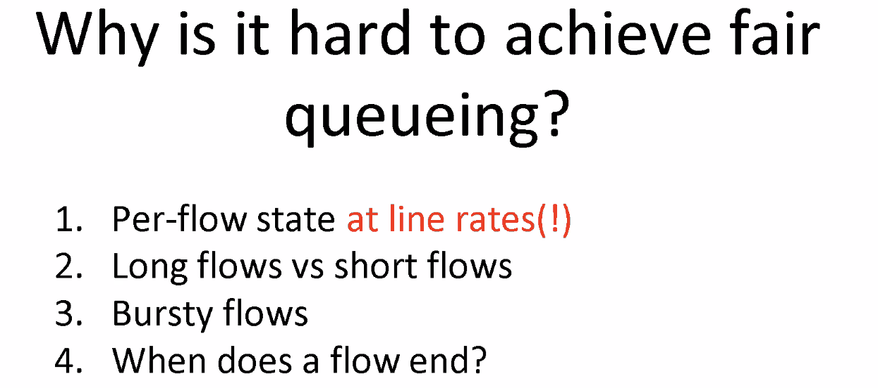
* 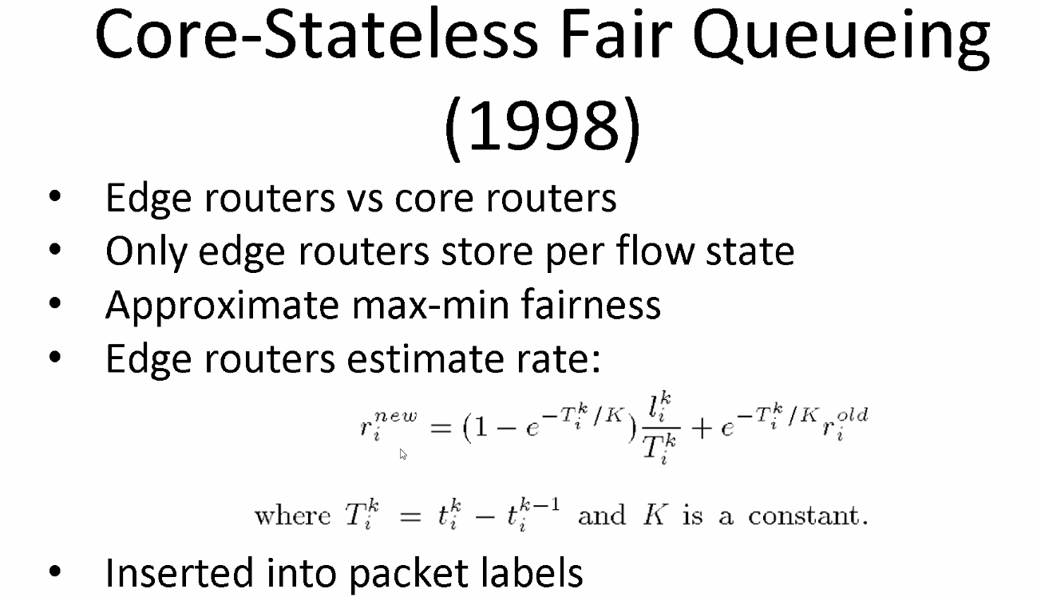
  + Track the rate of each flow from edge routers
  + 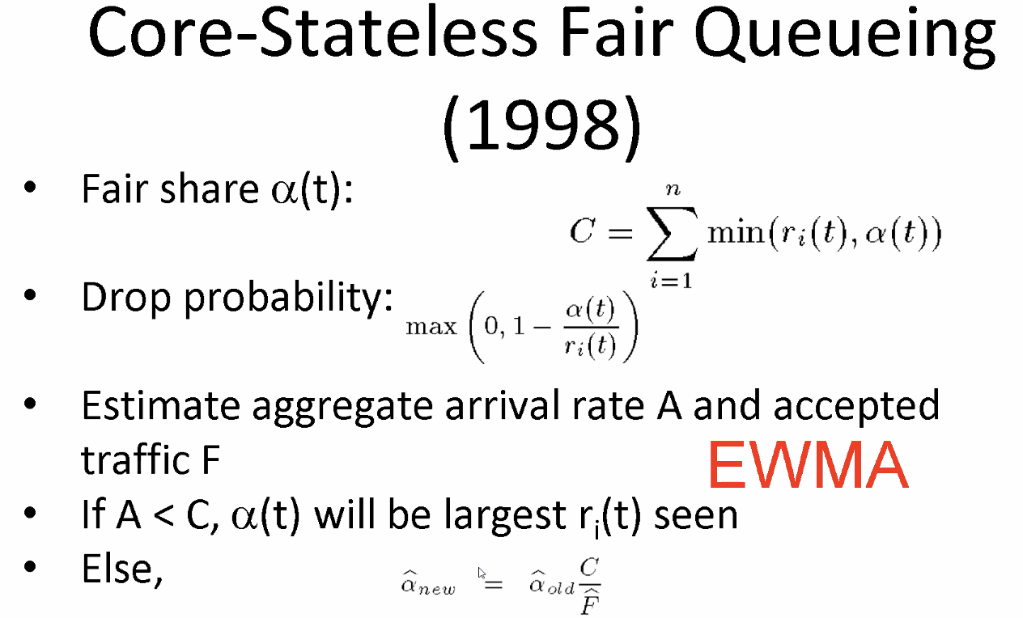

### **Lecture 4**

* 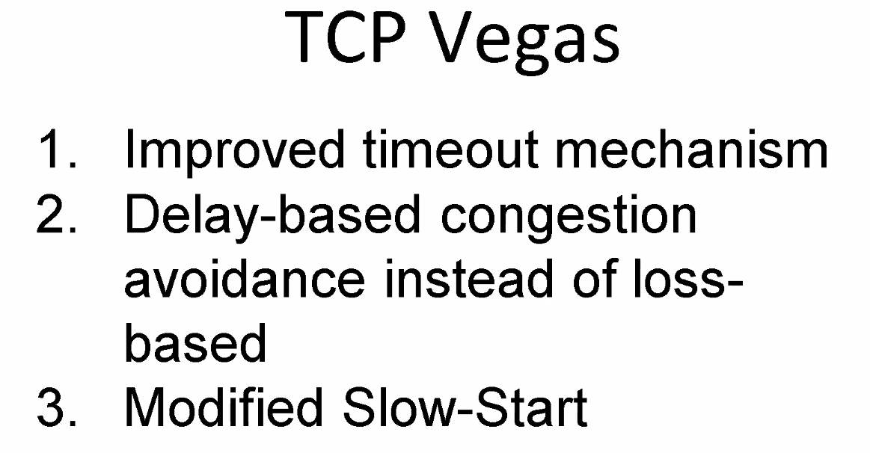
* 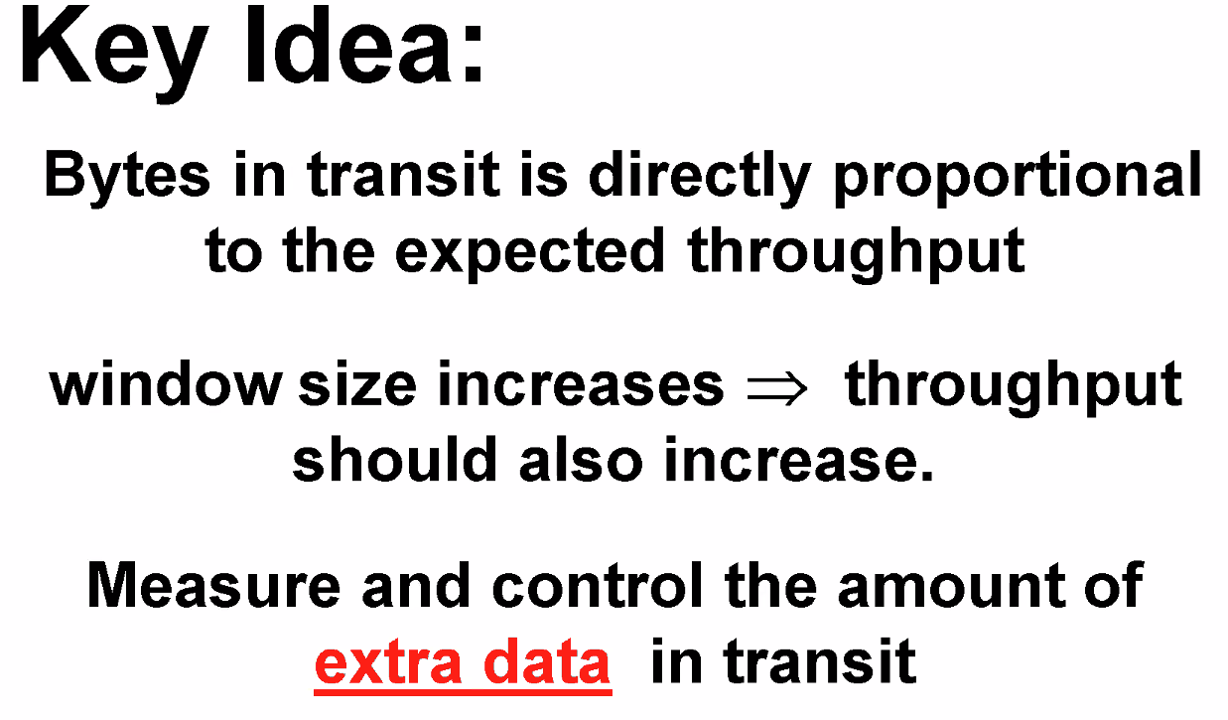
* 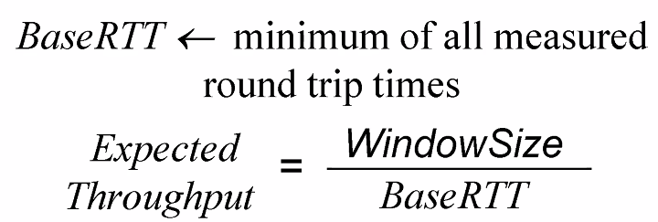
* 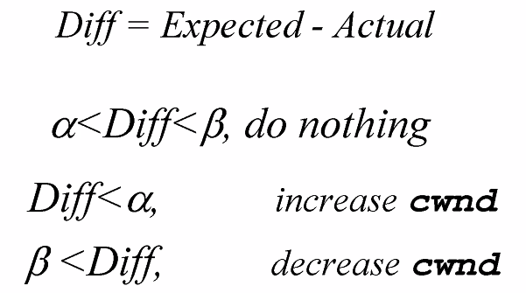
* 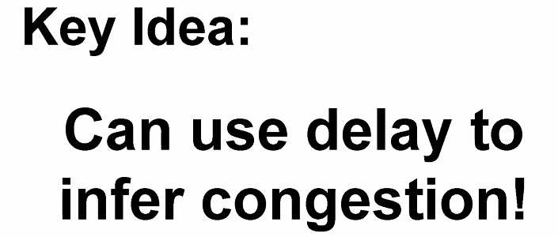
  + Make the effective RTT longer
* 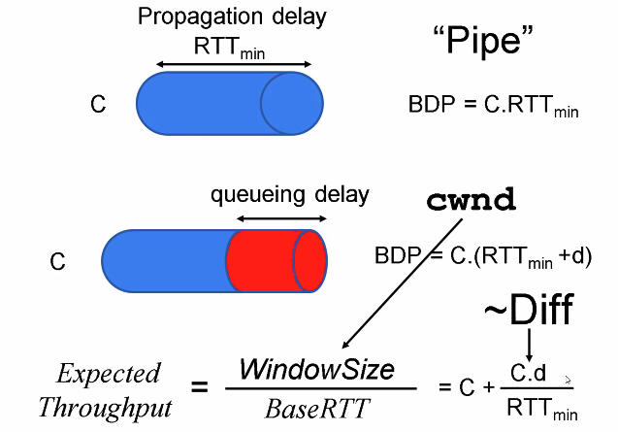
* 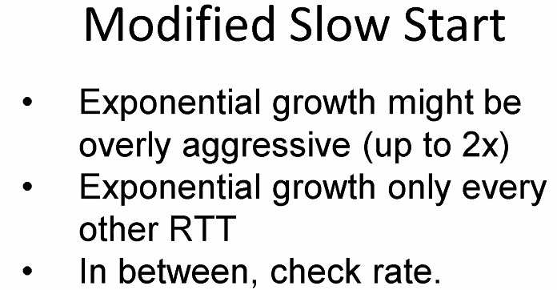
* 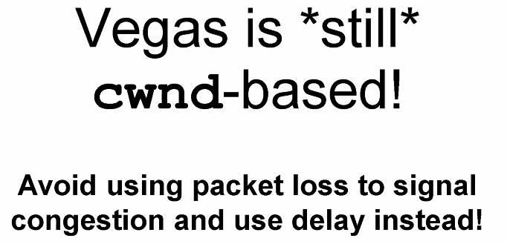
* 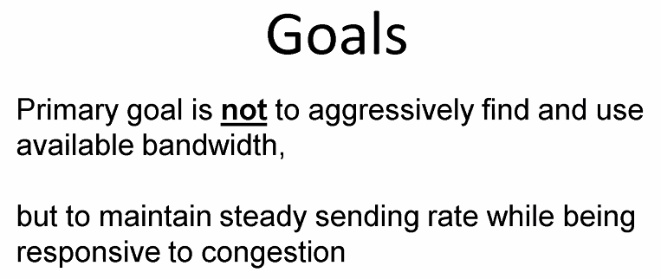
* 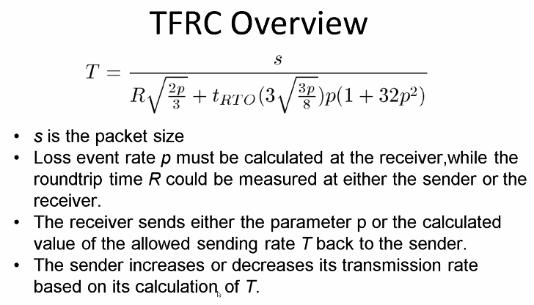
* 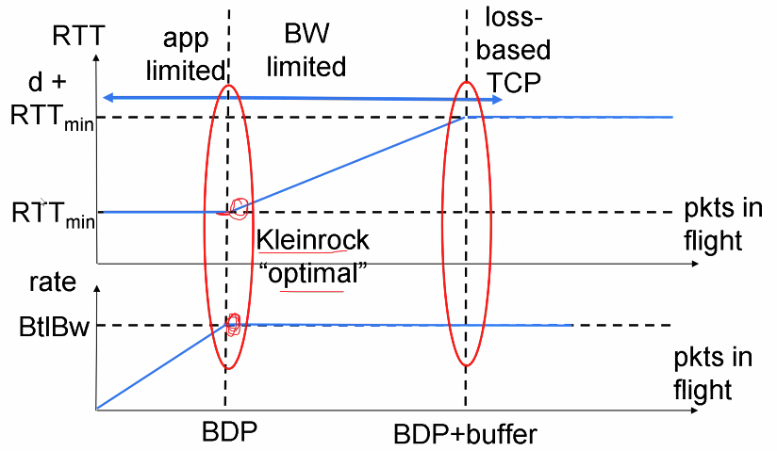
* 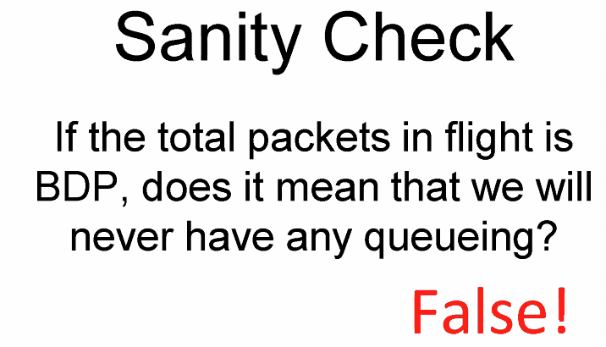 (burst)
* 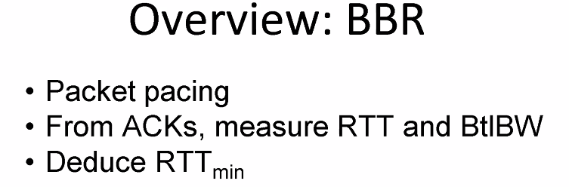
* 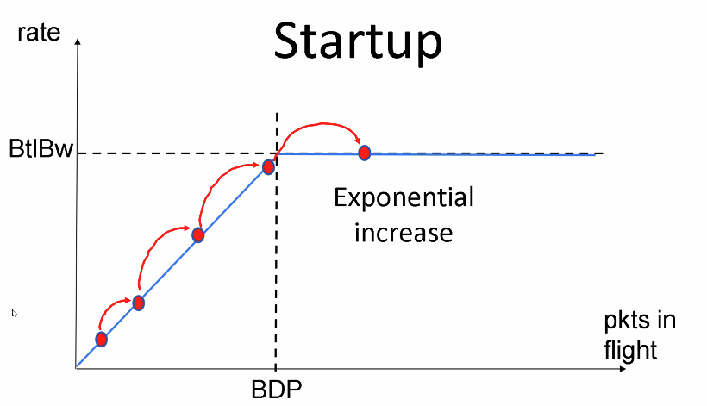
* 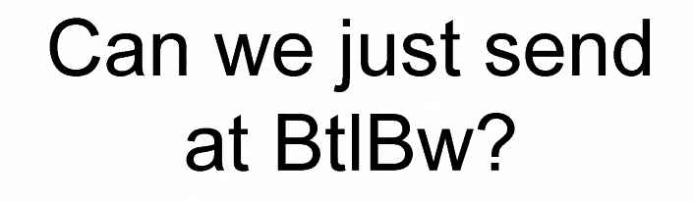
* 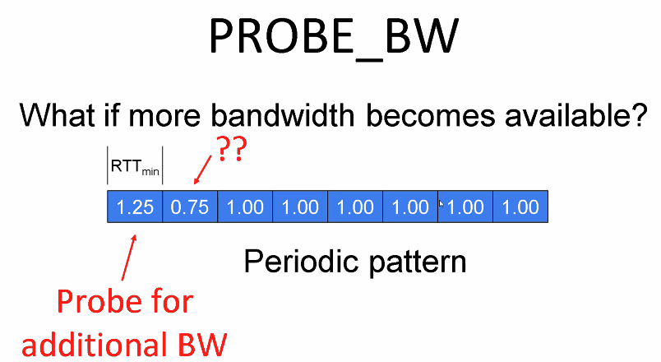
* 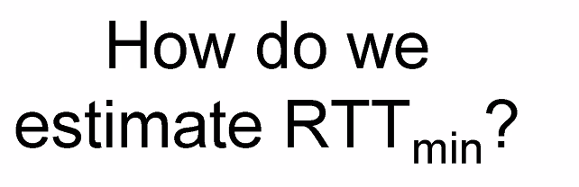
* 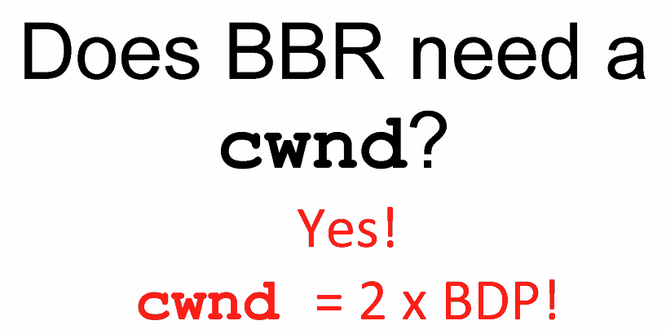
* 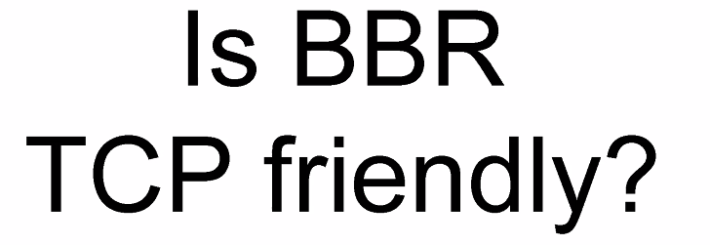
* 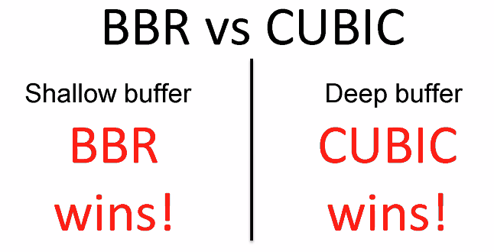
  + More BBR => less attractive
  + More CUBIC => more attractive
* 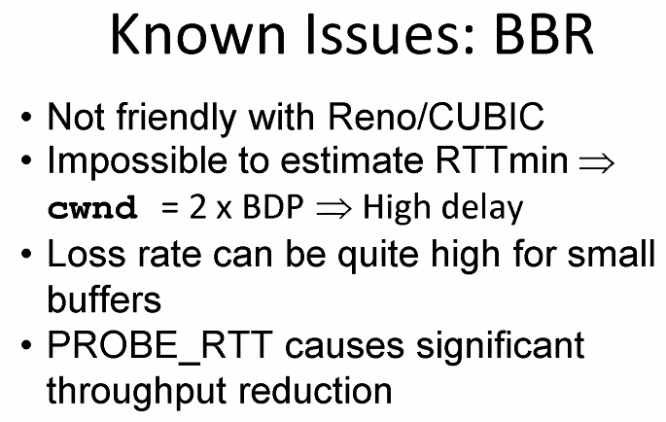
* 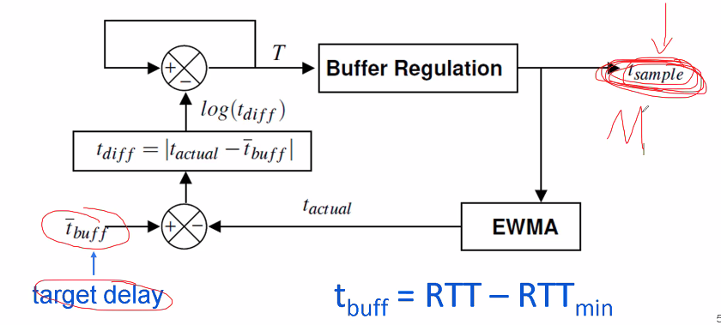
* 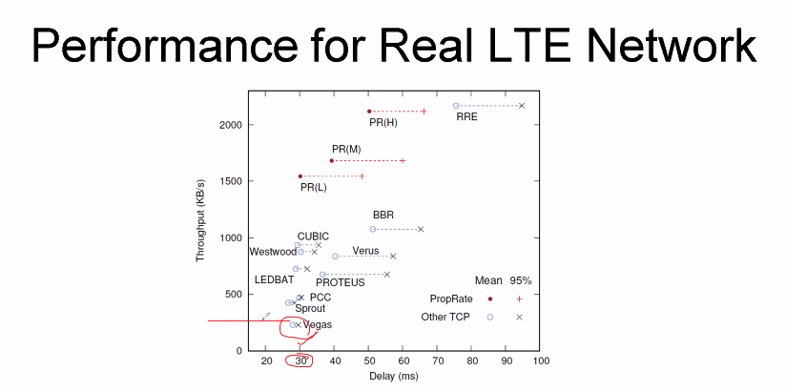
* 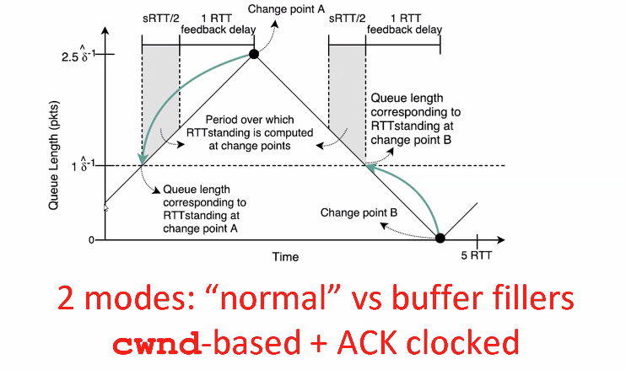
* 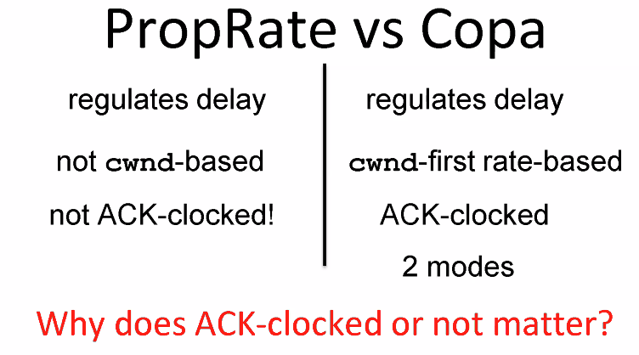
* 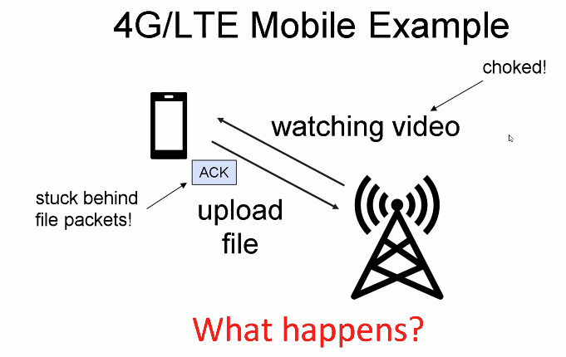
* 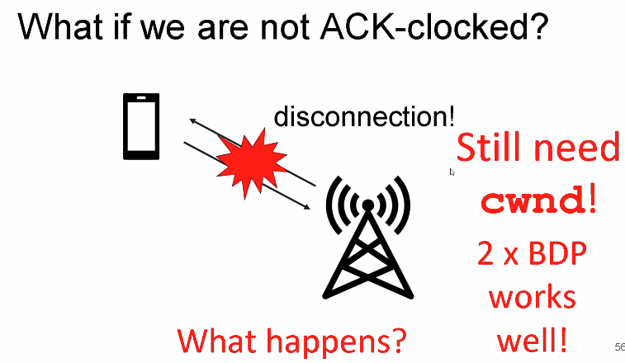
* 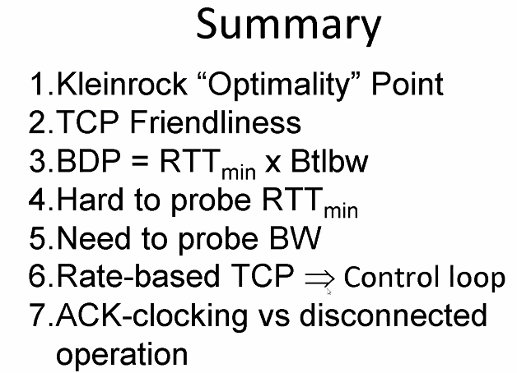
  + Bigger RTT gets more than smaller RTT BBR
* 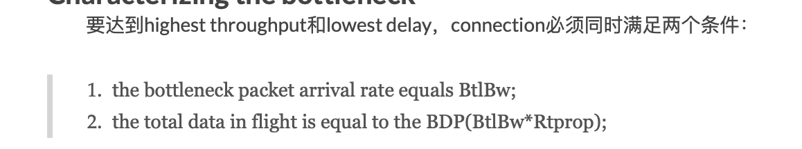
* 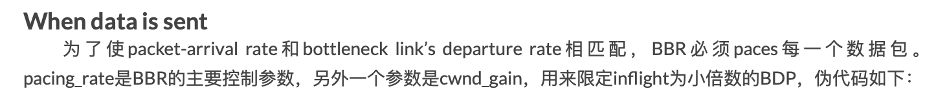
* [https://allen-kevin.github.io/2017/05/25/TCP拥塞控制之BBR/](https://allen-kevin.github.io/2017/05/25/TCP%E6%8B%A5%E5%A1%9E%E6%8E%A7%E5%88%B6%E4%B9%8BBBR/)
* <https://zhuanlan.zhihu.com/p/180481154>
* 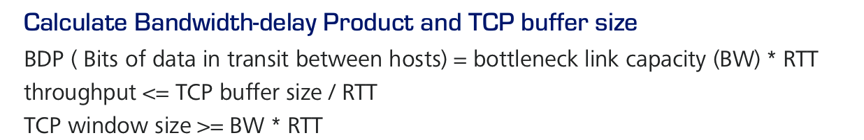

### **Lecture 5**

* 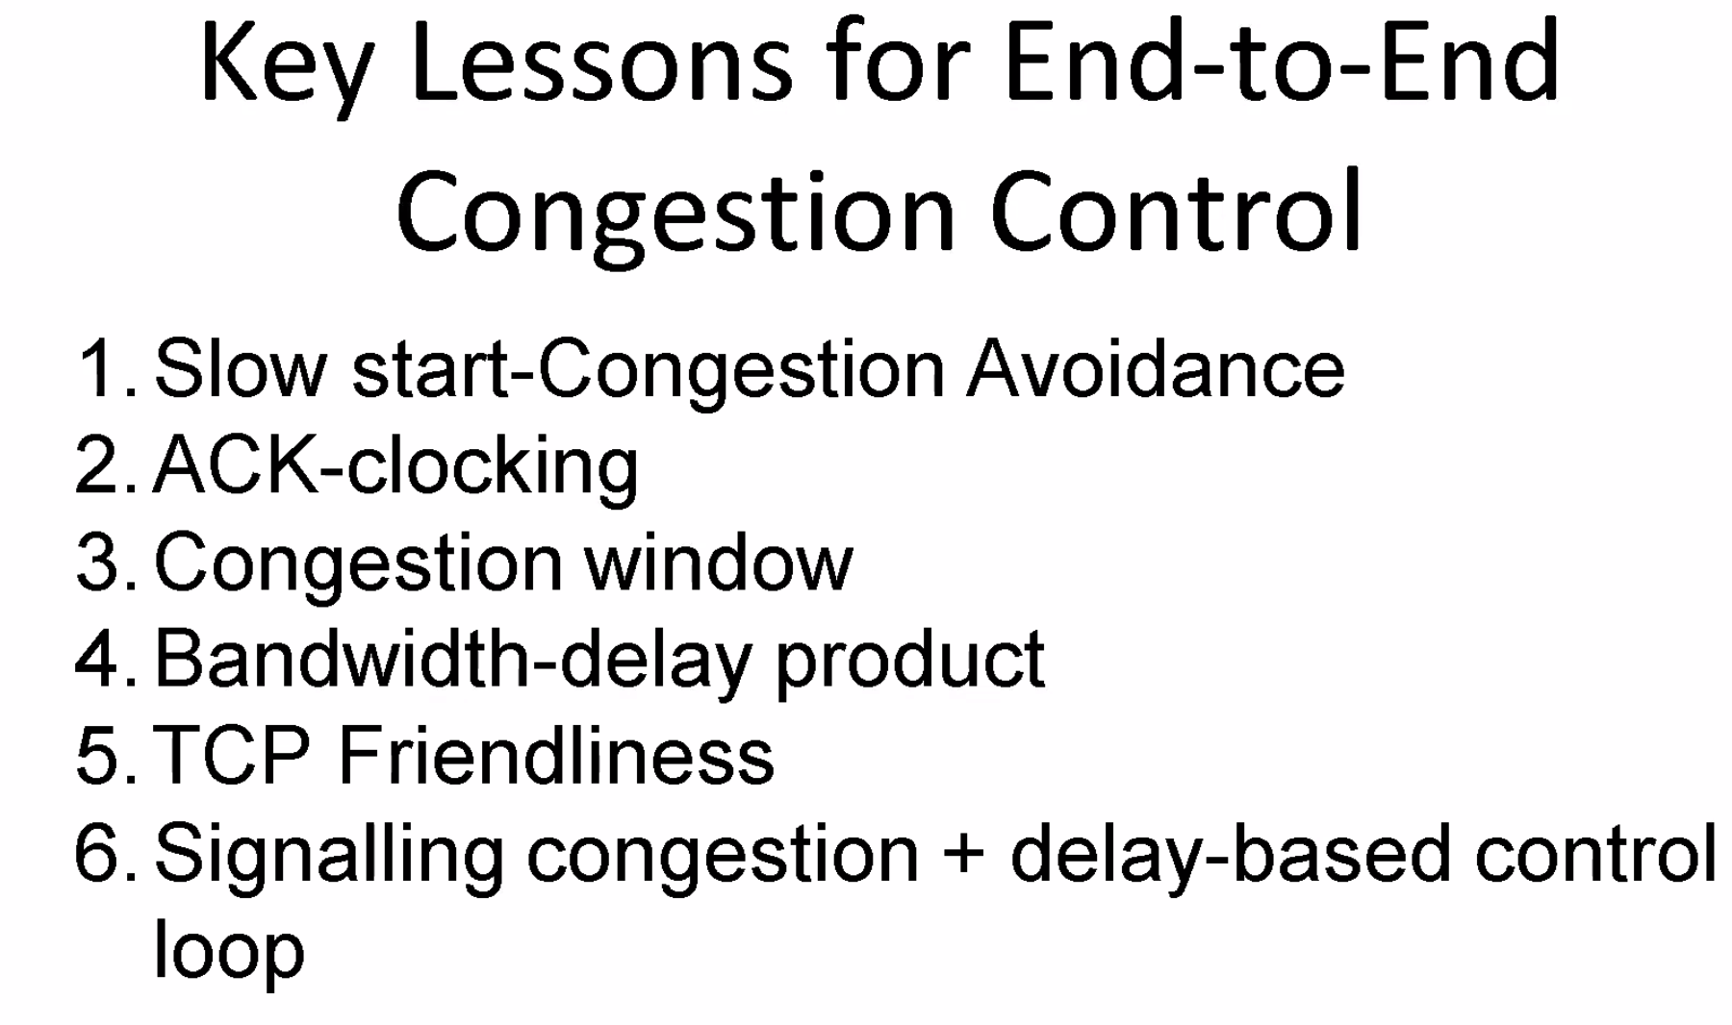
* 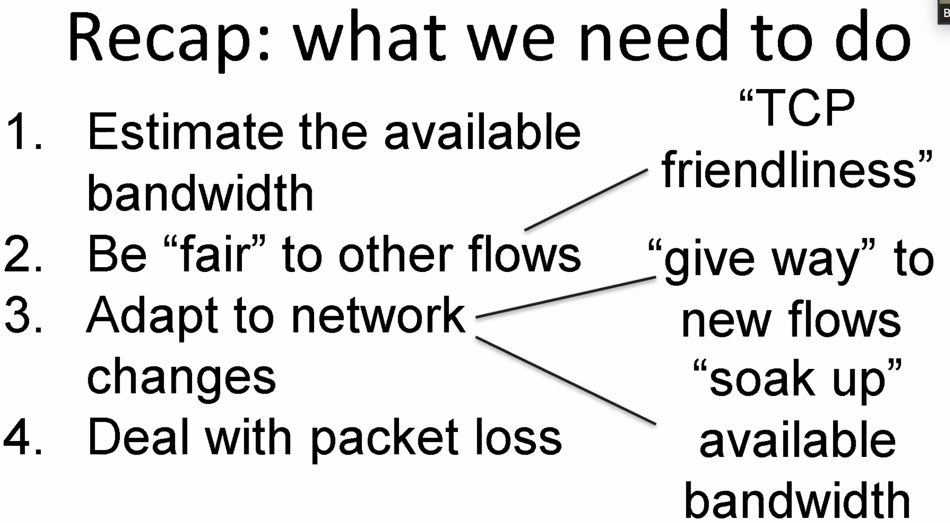
* 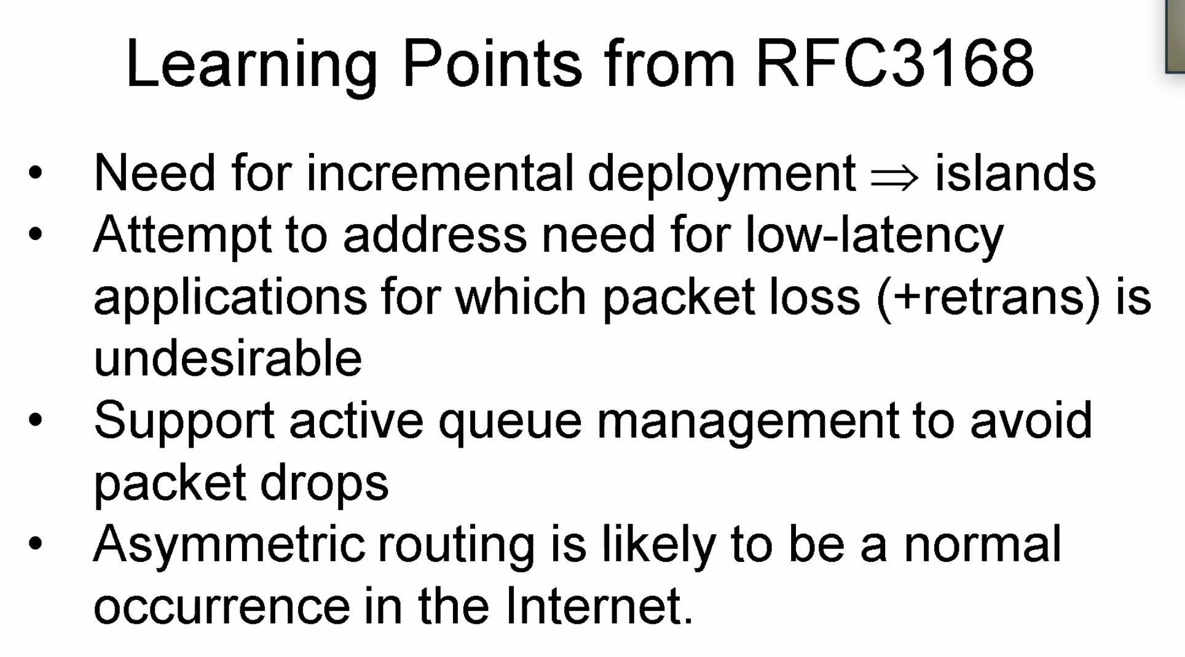
  + 可能routing发送和接收的path不同
* 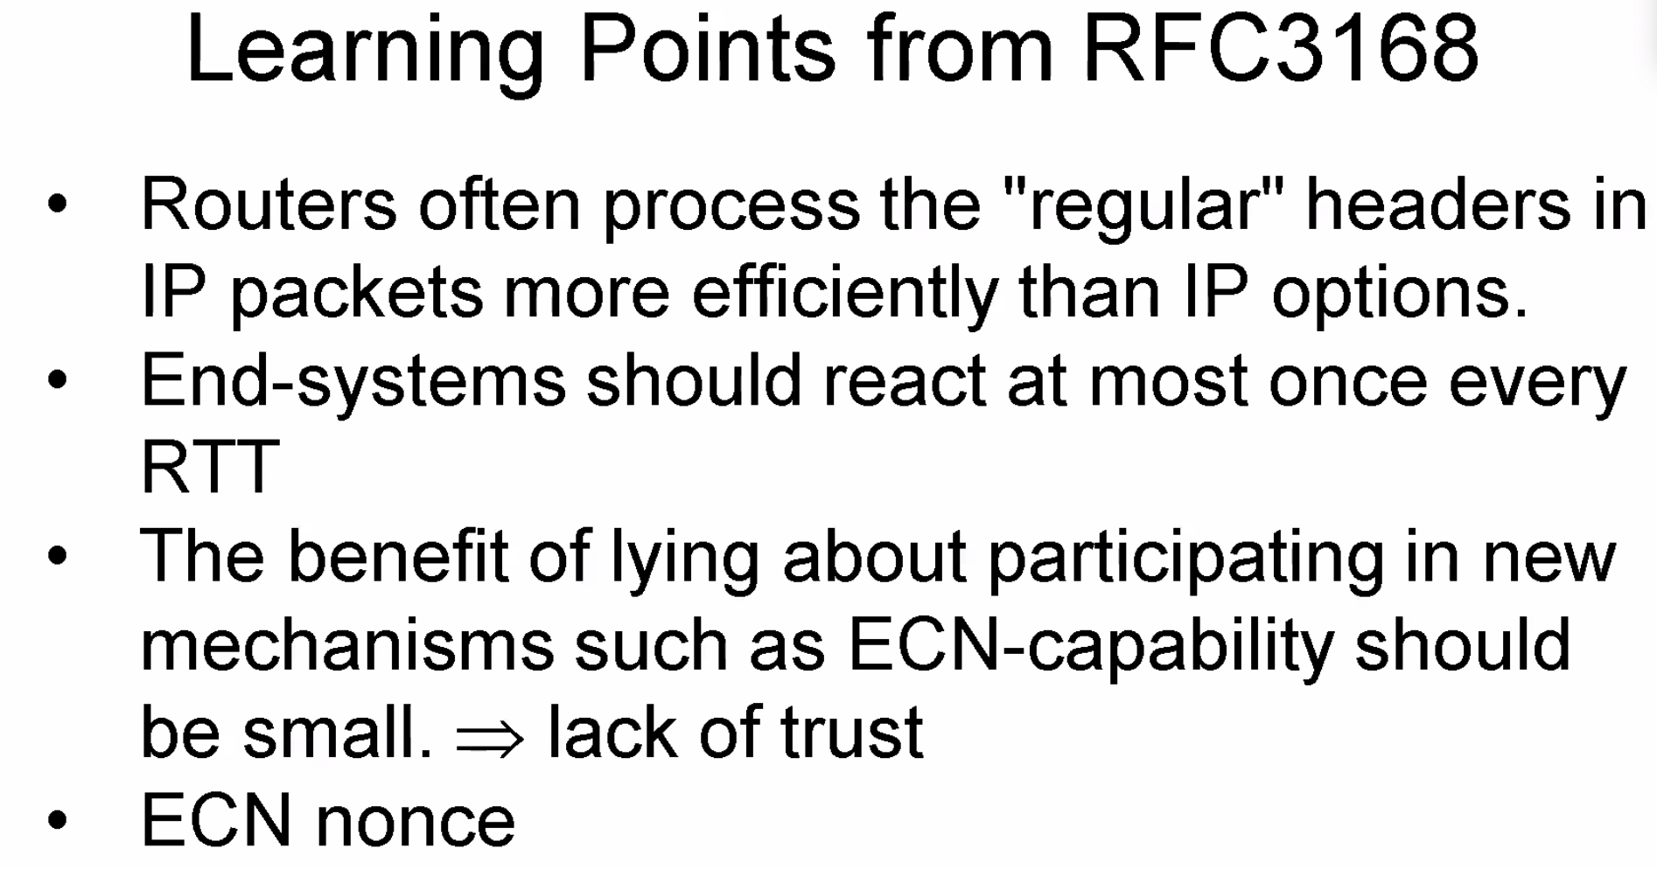
* 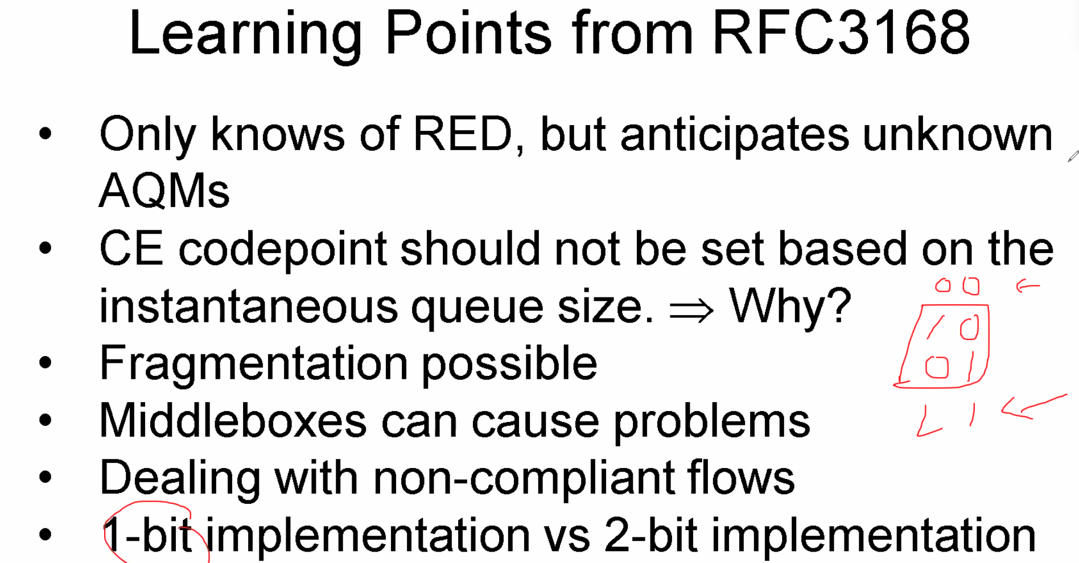
* Xcp
  + 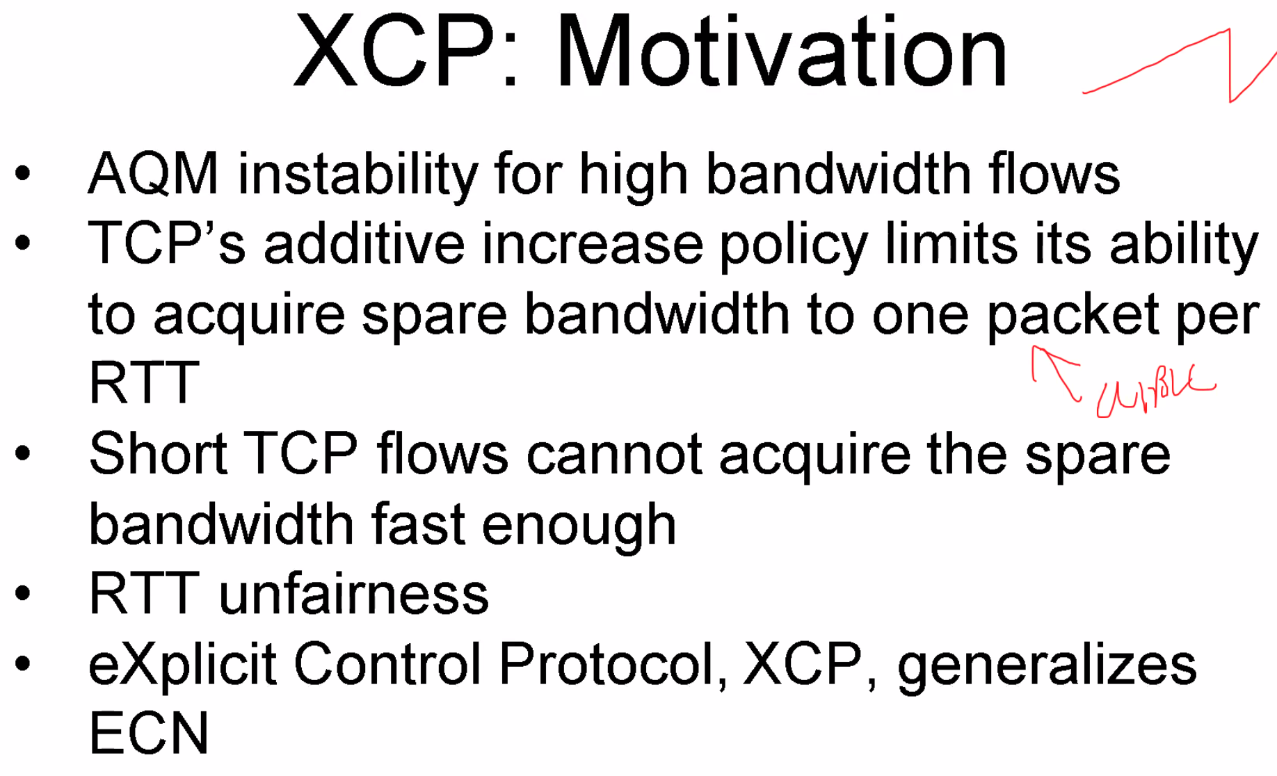
  + 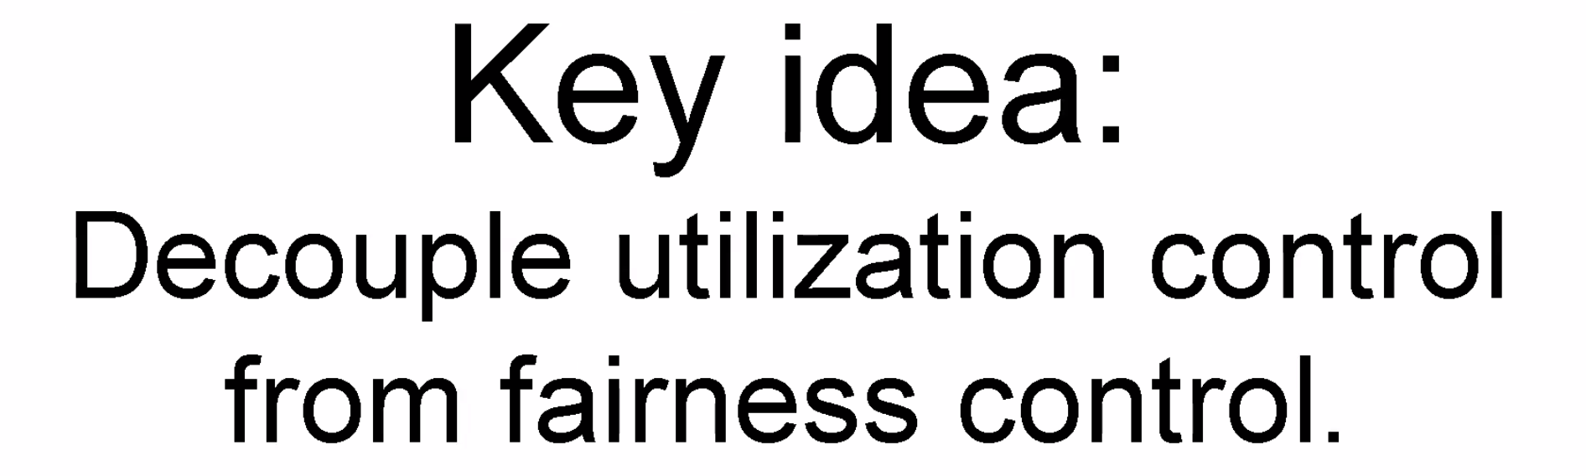
  + 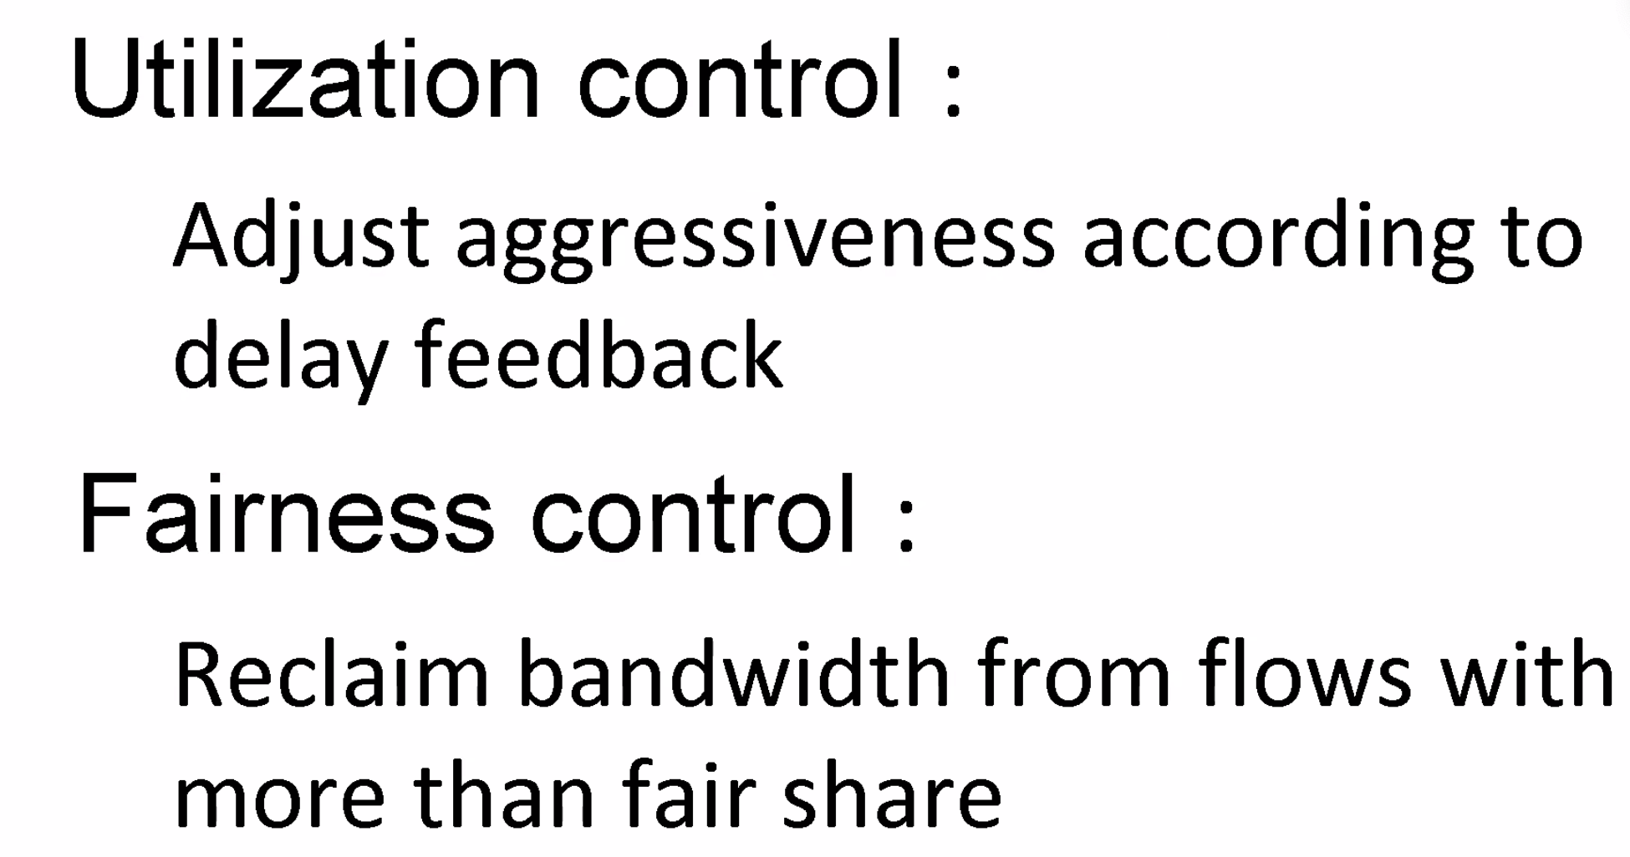
  + 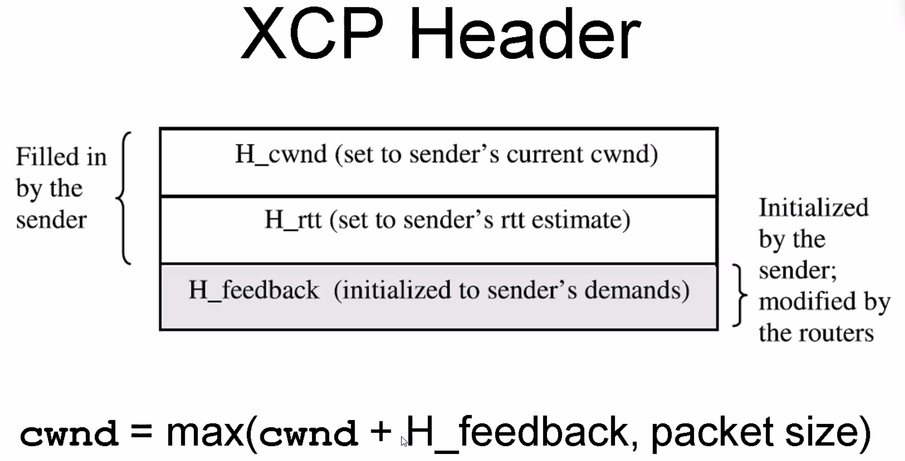
  + 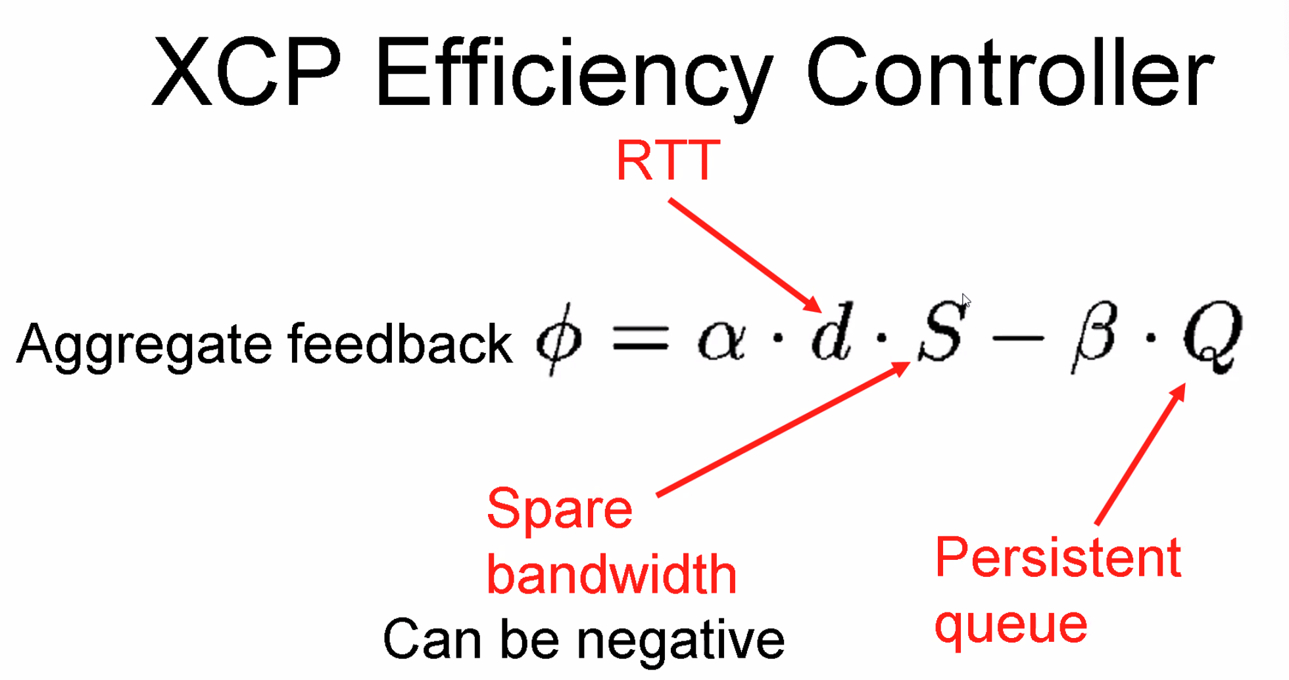
  + 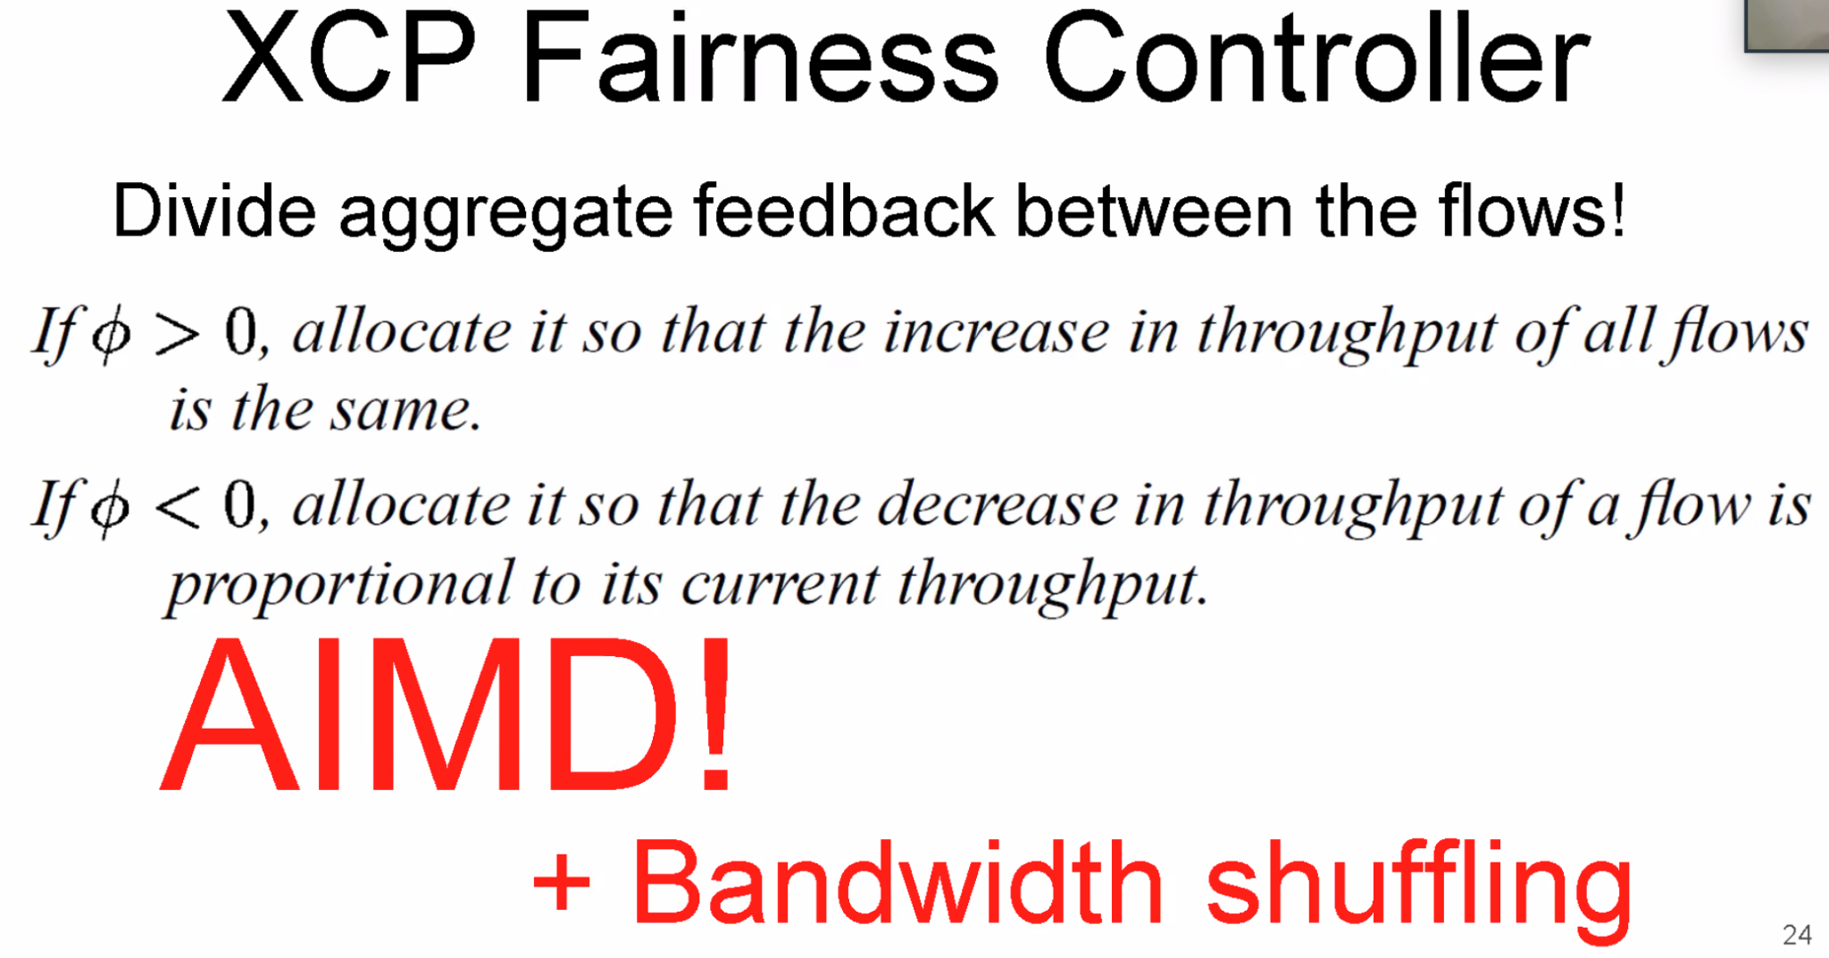
  + 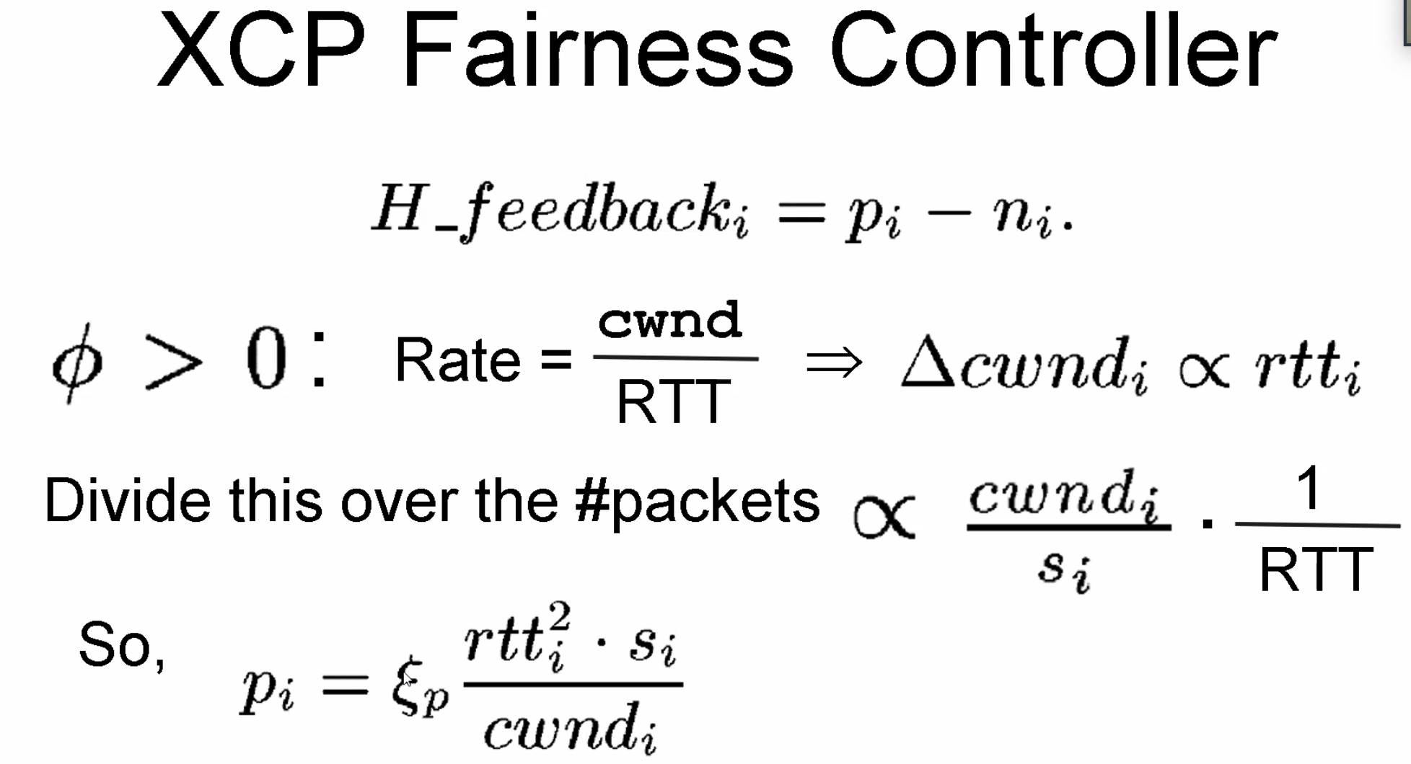
  + 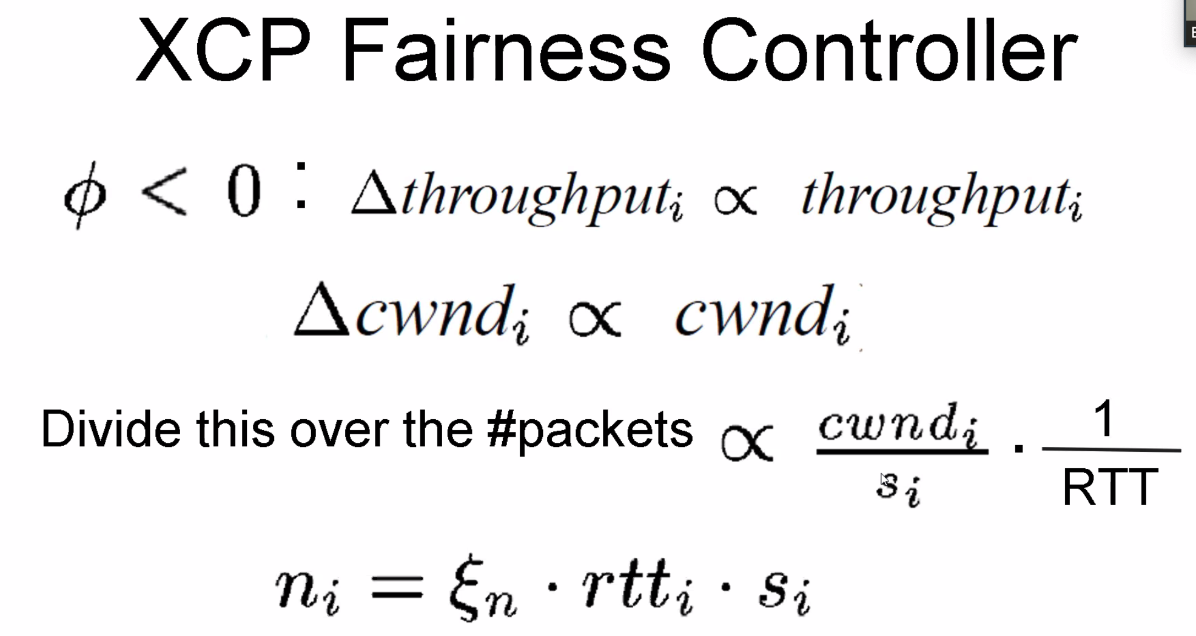
  + 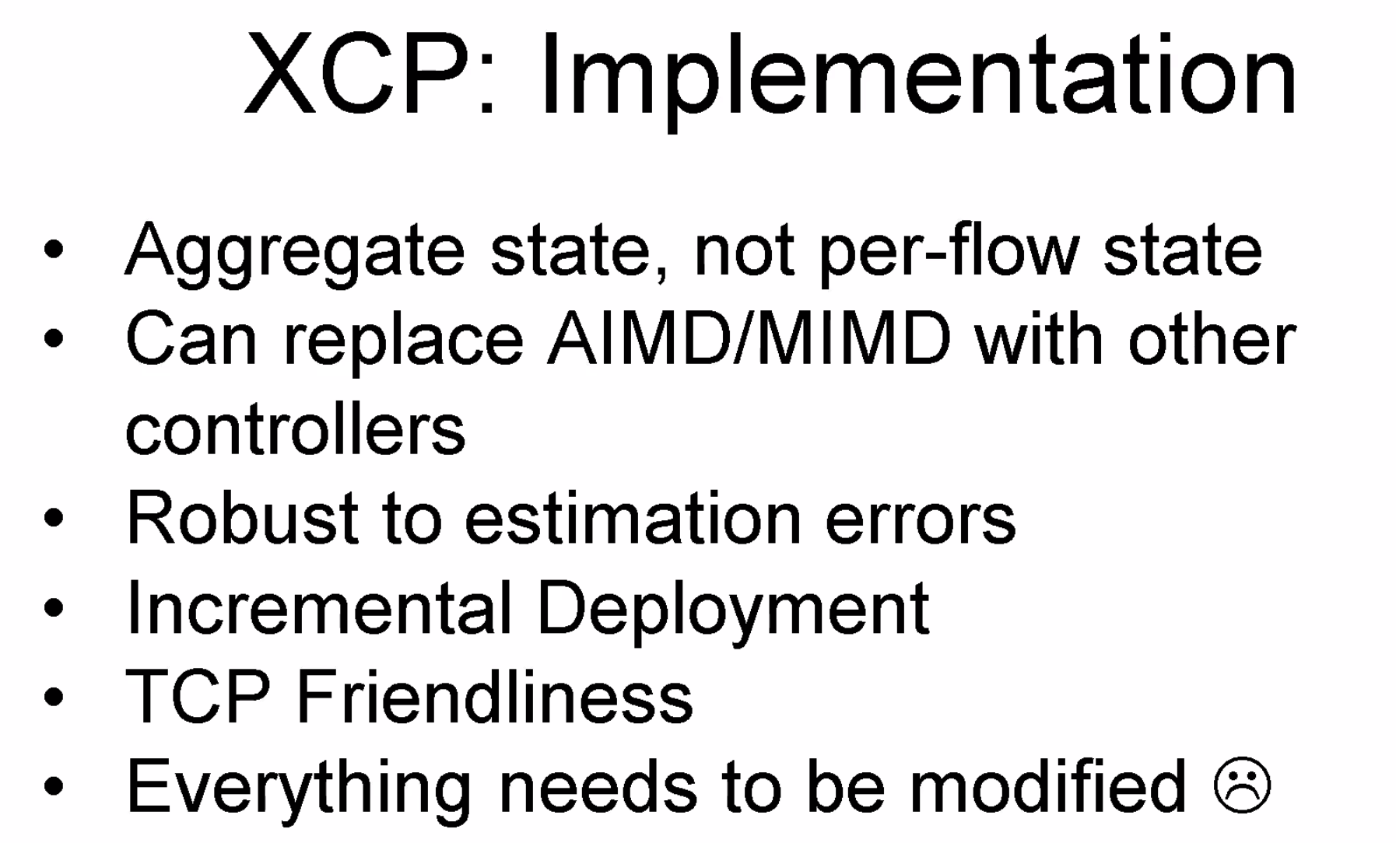
  + 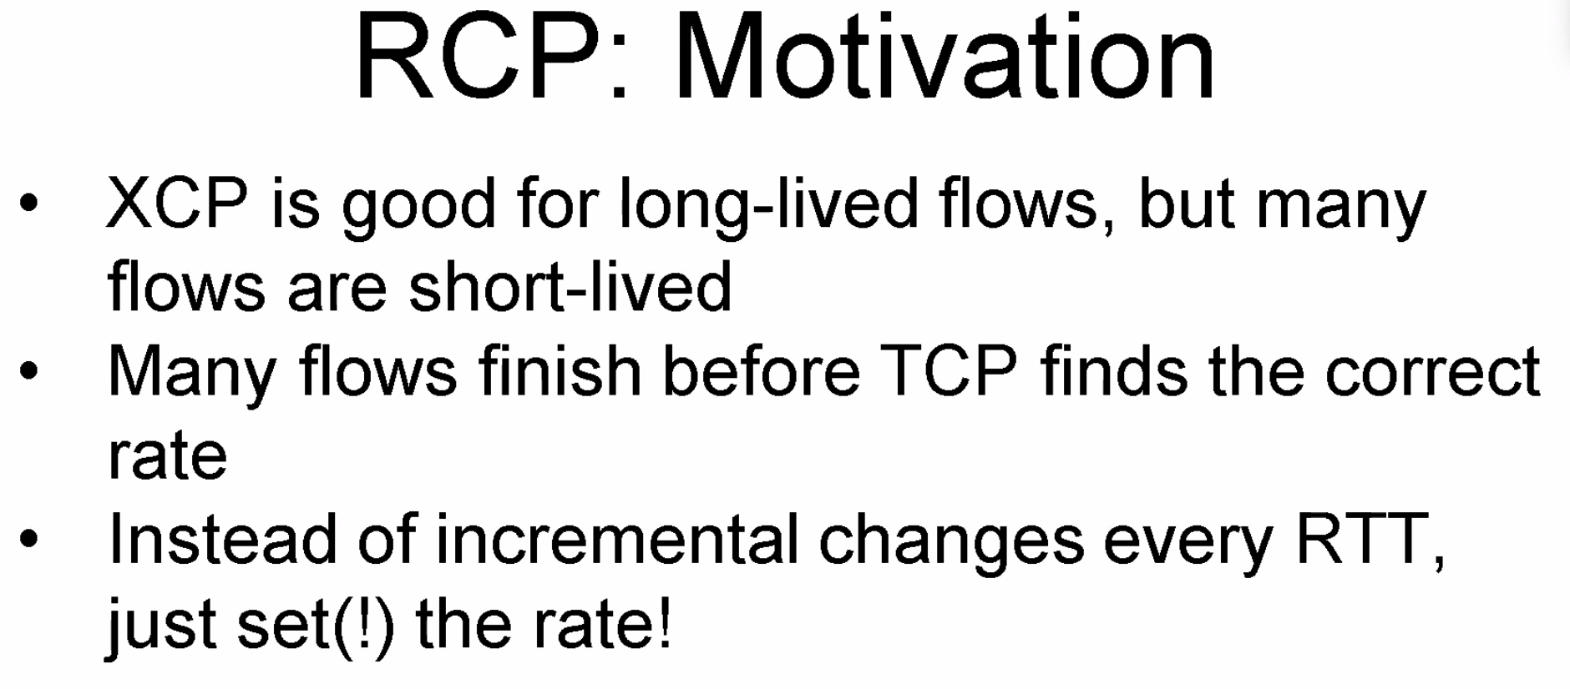
  + 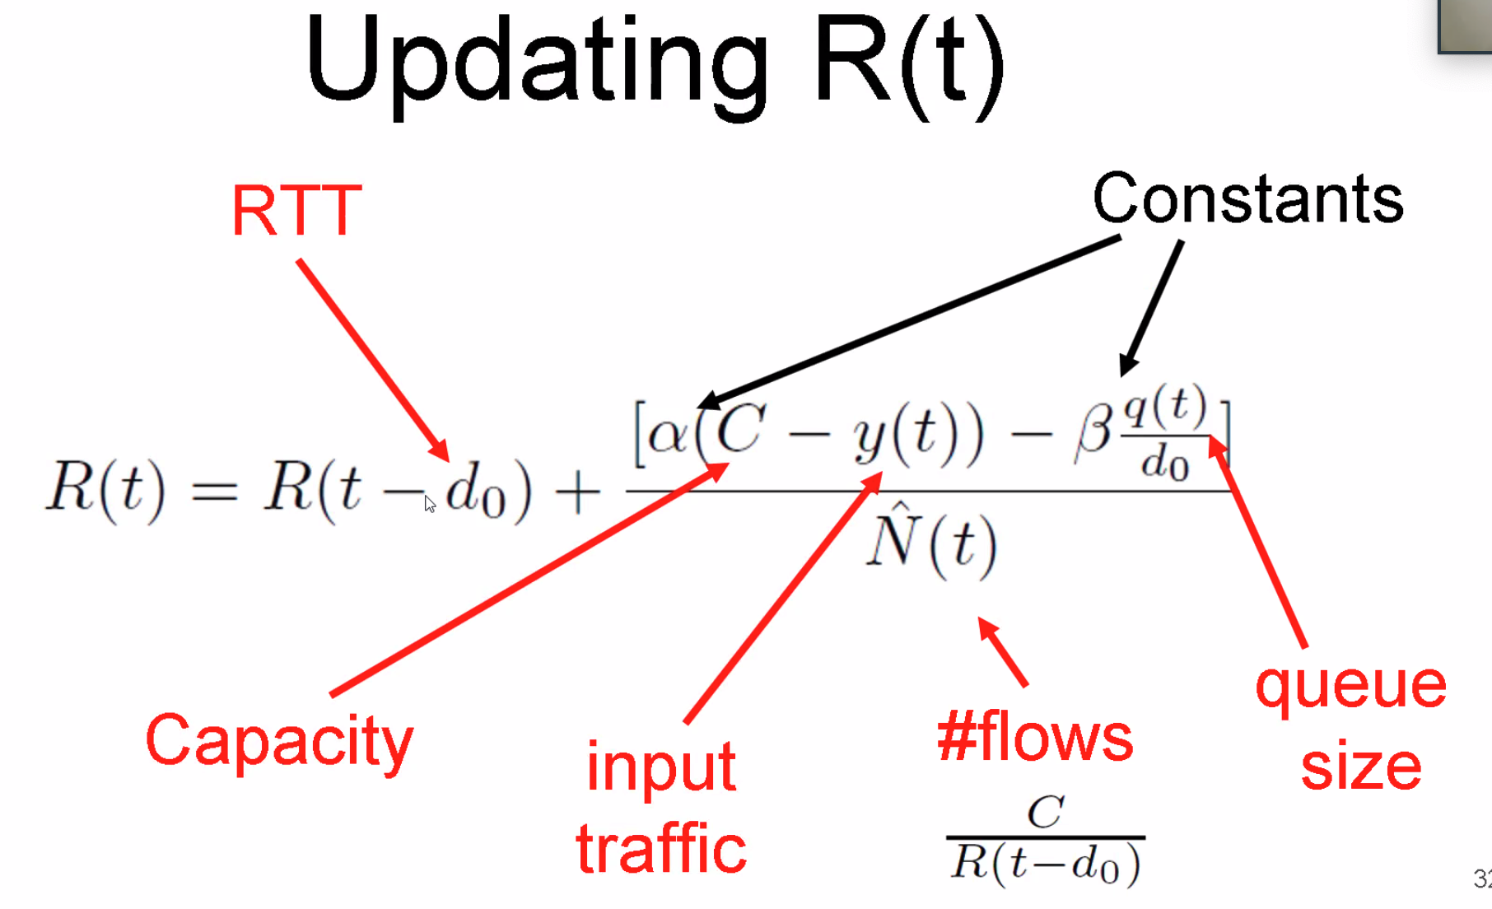
  + 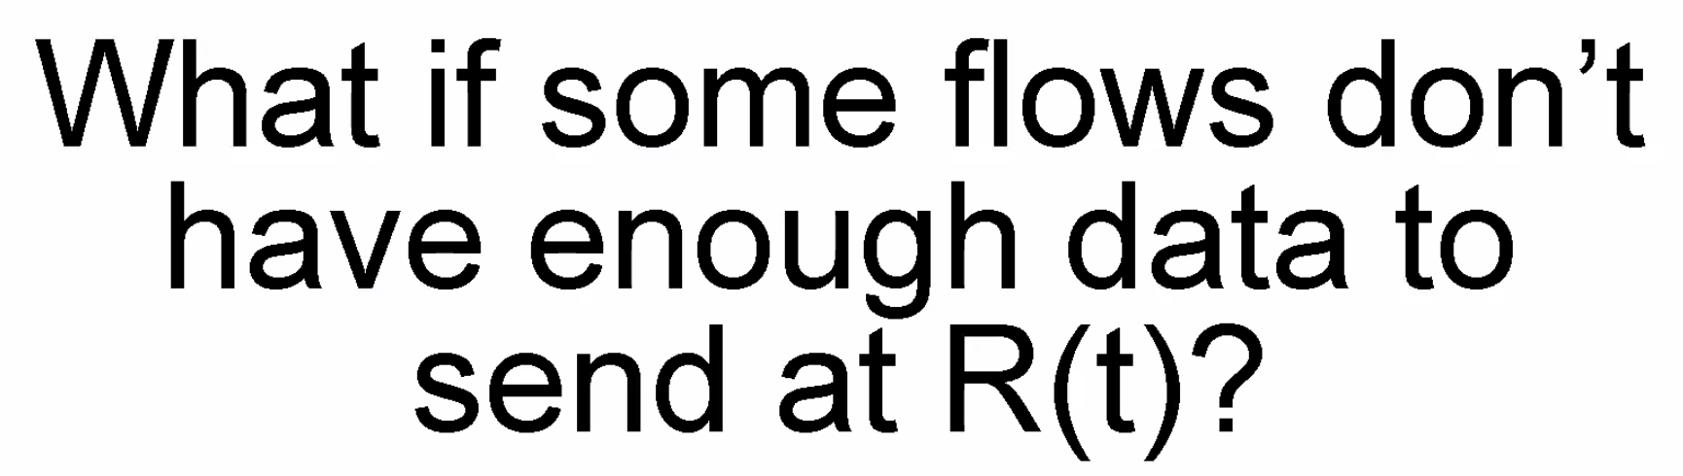 (max-min fairness)
  + 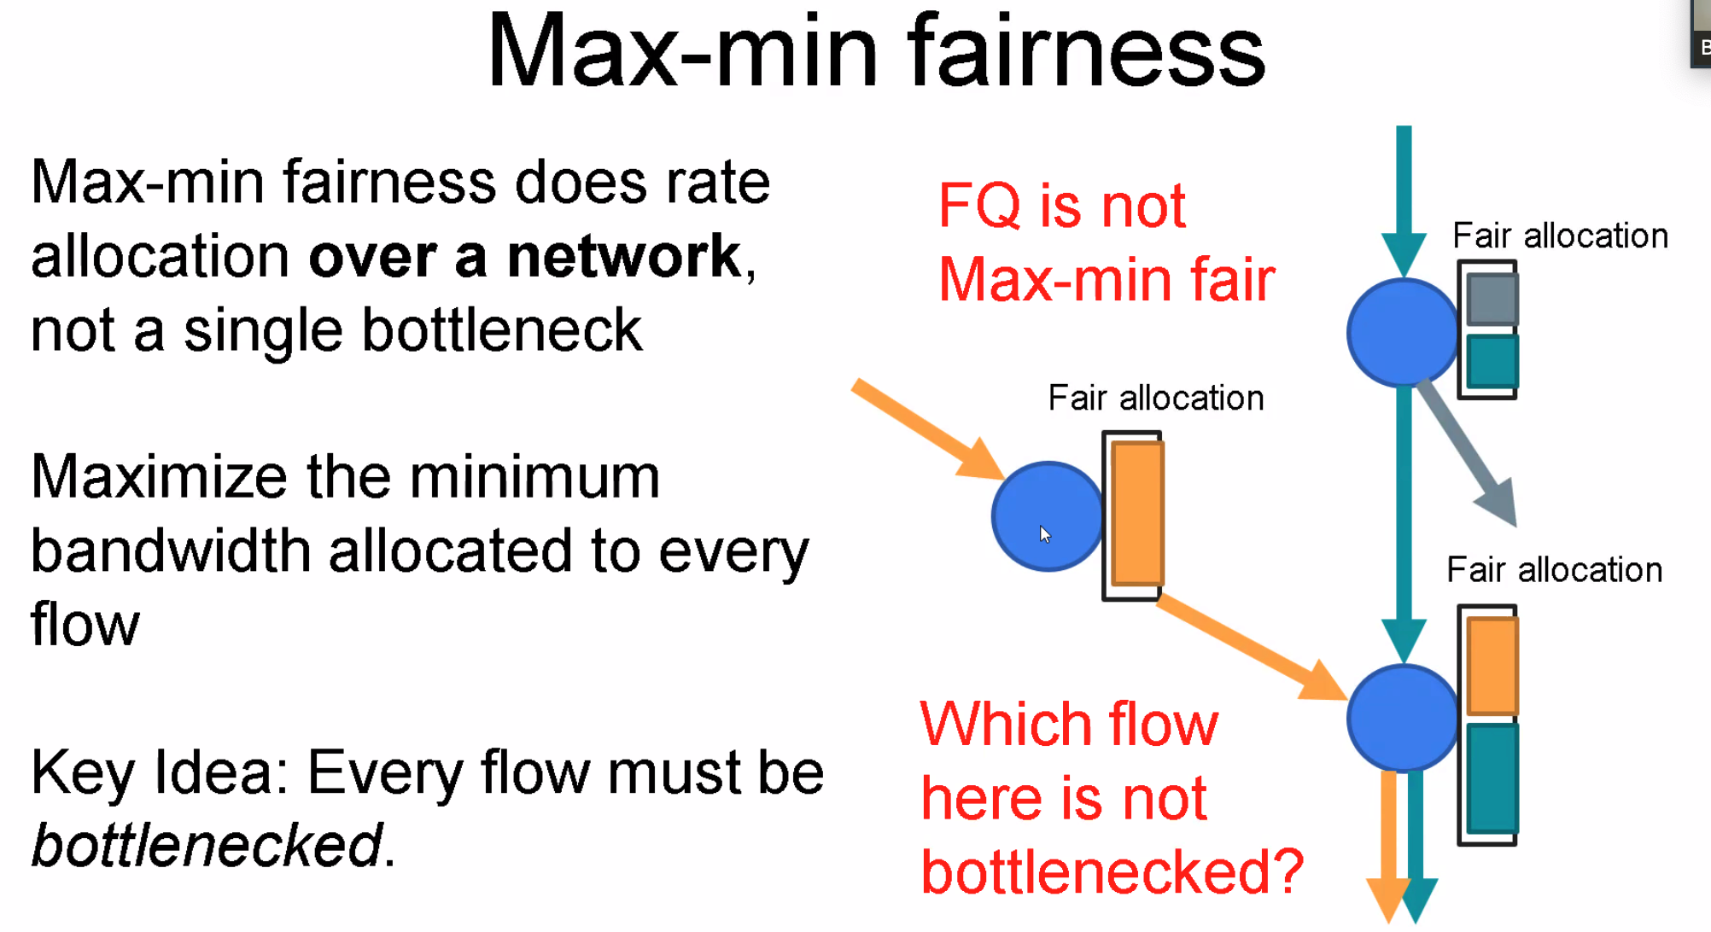
  + 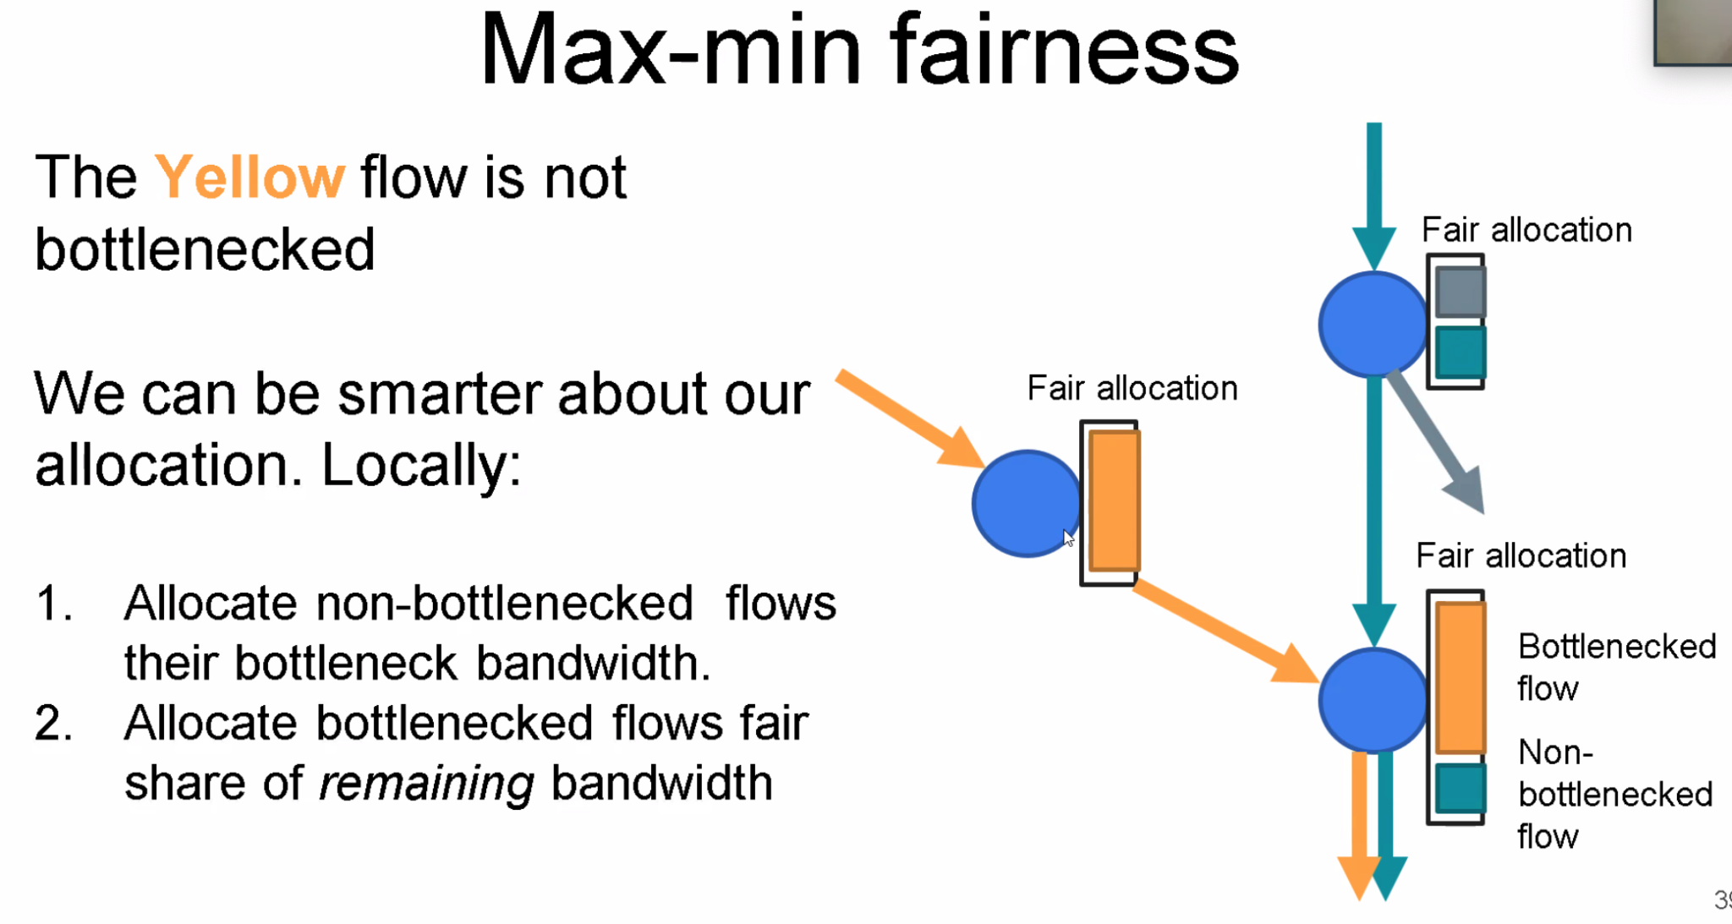
* 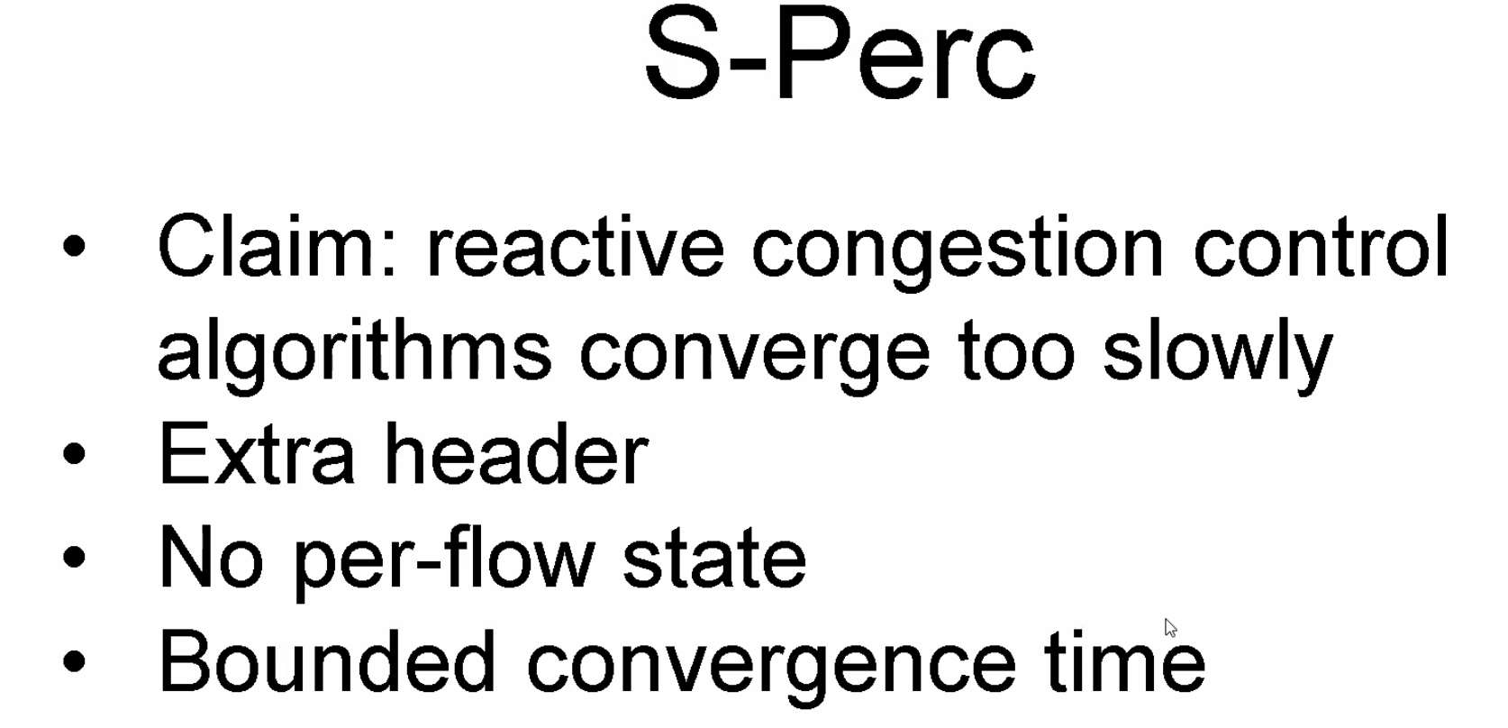
* 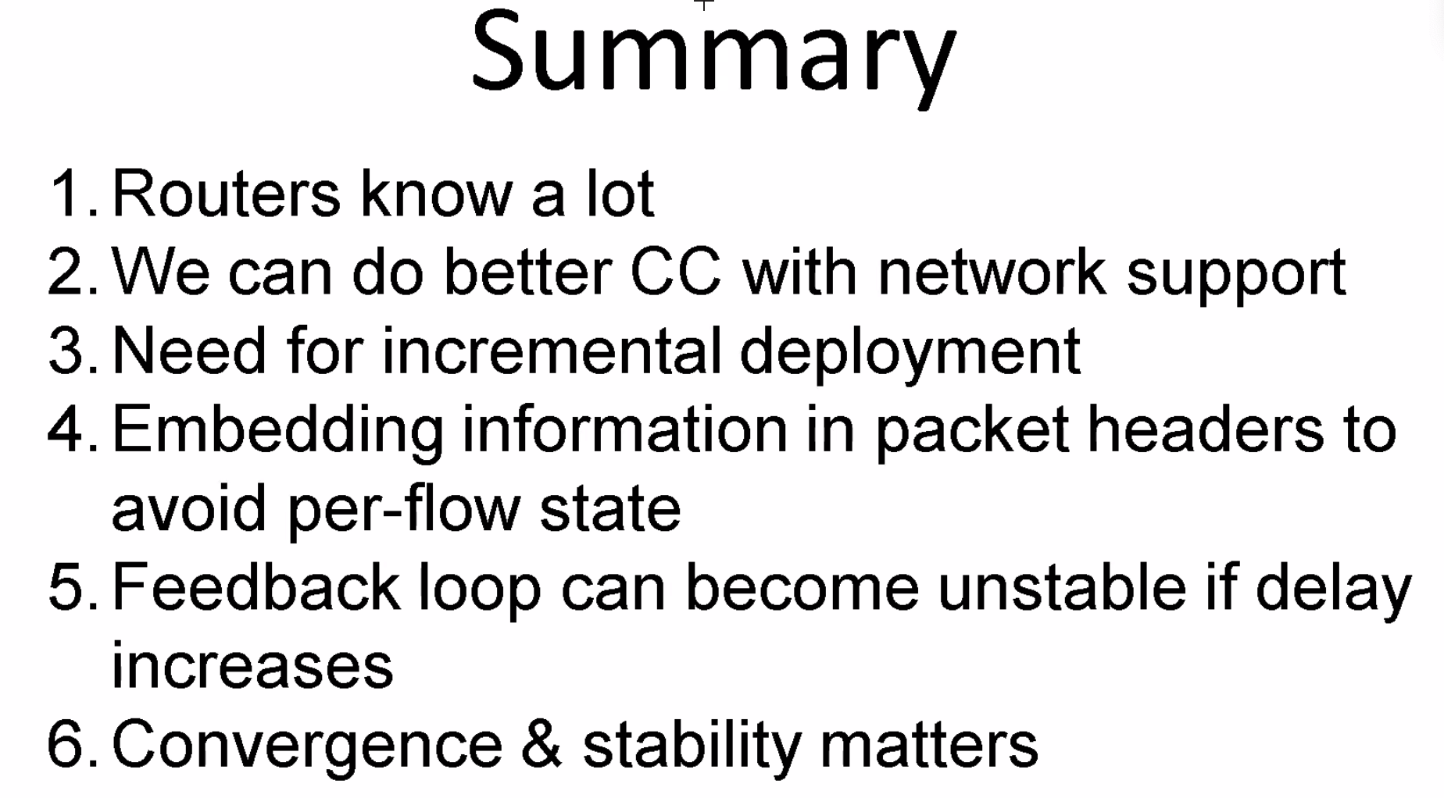
* 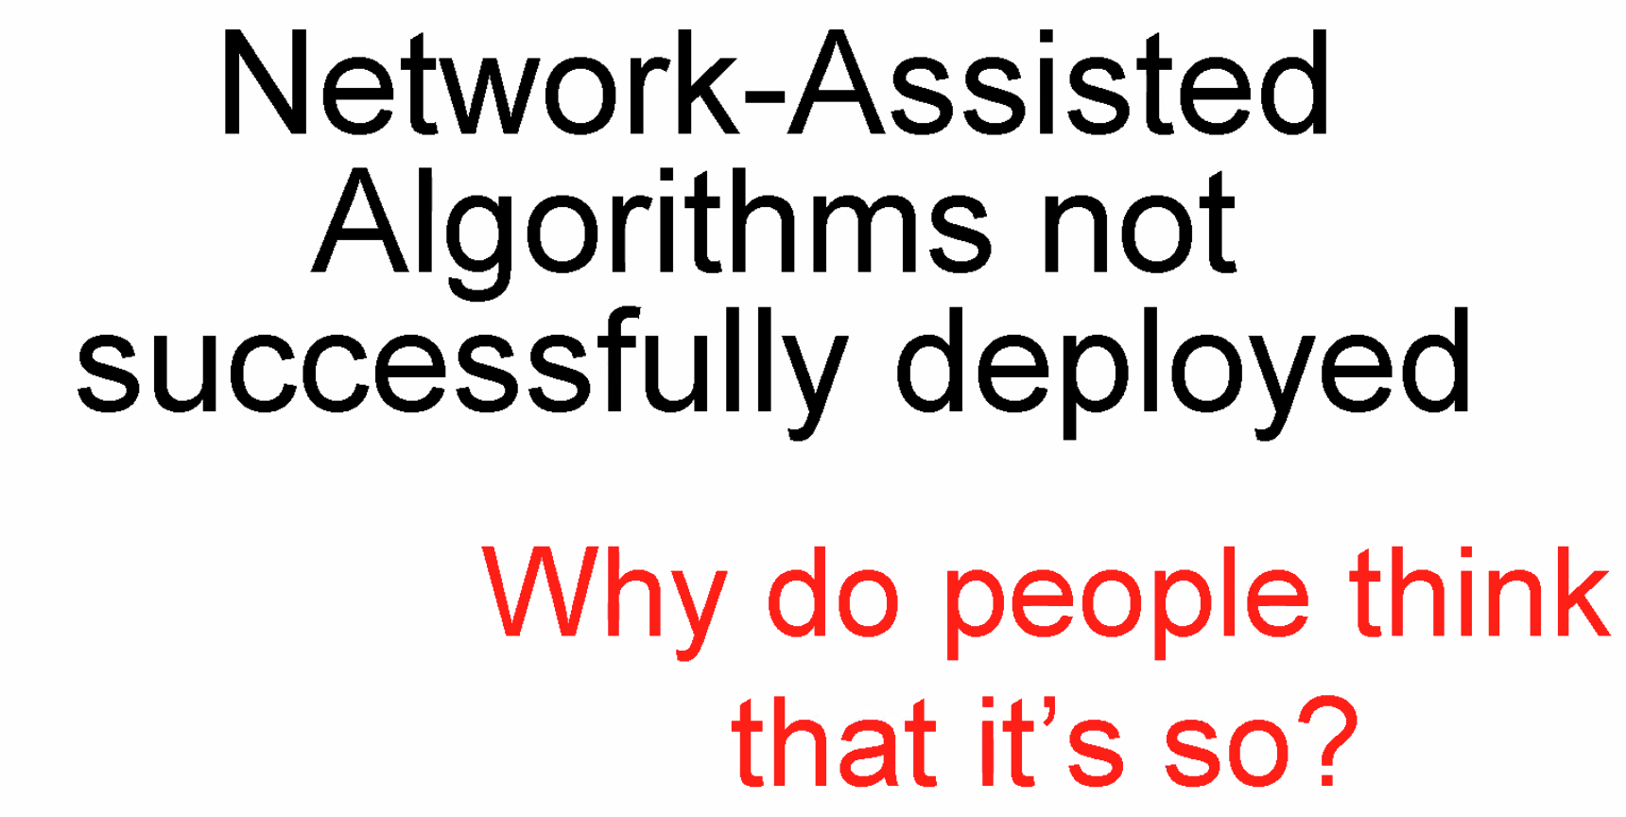
  + Can Deploy incrementally
  + Not harm other guys (fair to both enabled/ not enabled)新protocol对现有p的兼容（不强不被占便宜）
  + Hardware
  + Need add Nasty headers

### **Lecture 6**

* <https://cloud.tencent.com/developer/news/101499>
* 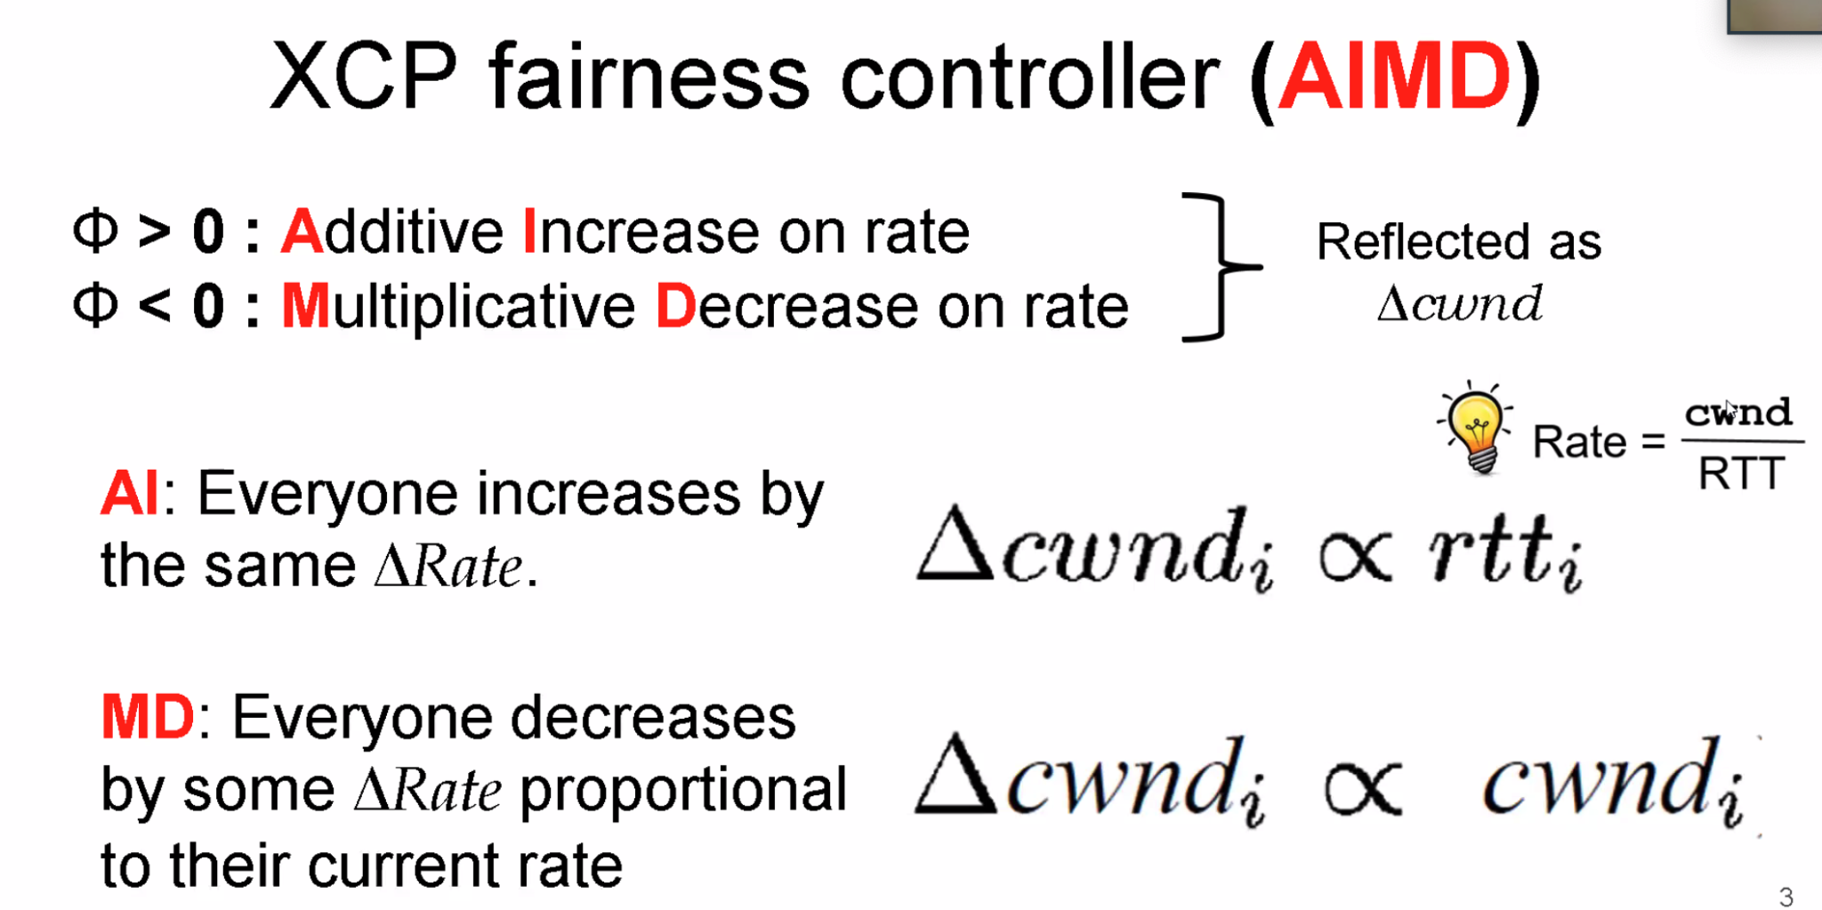
* 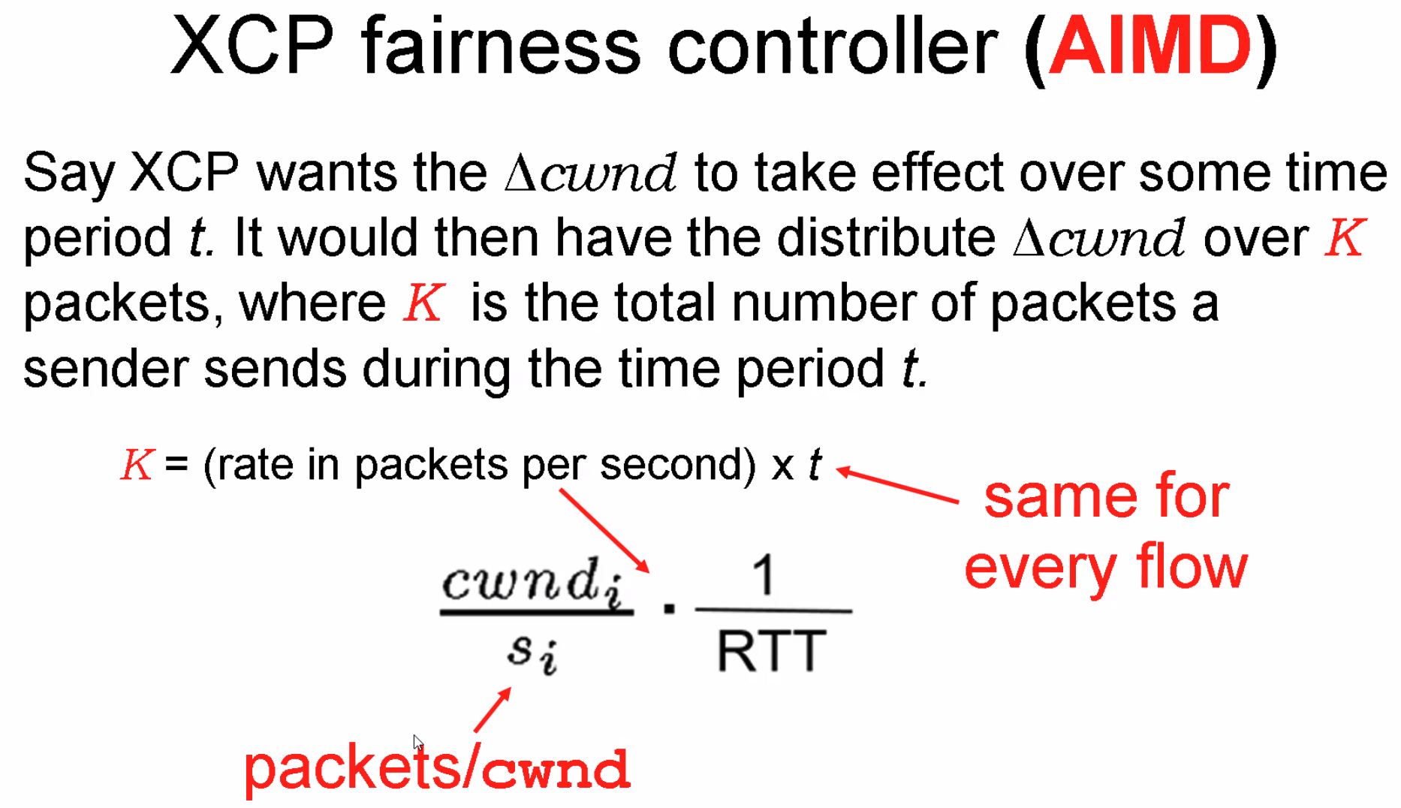
* 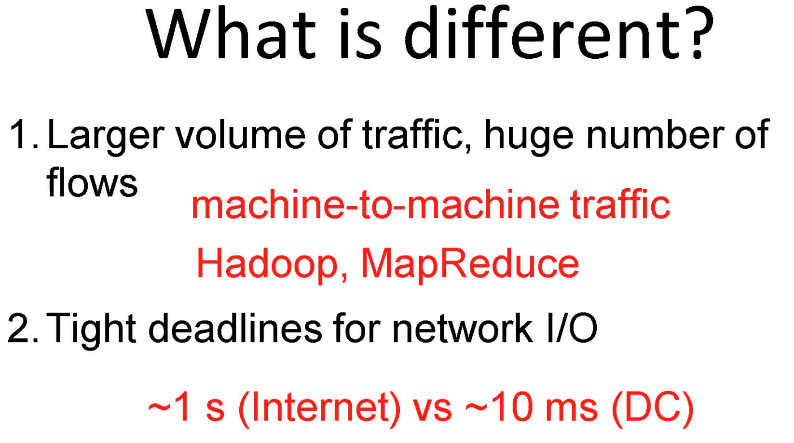
* 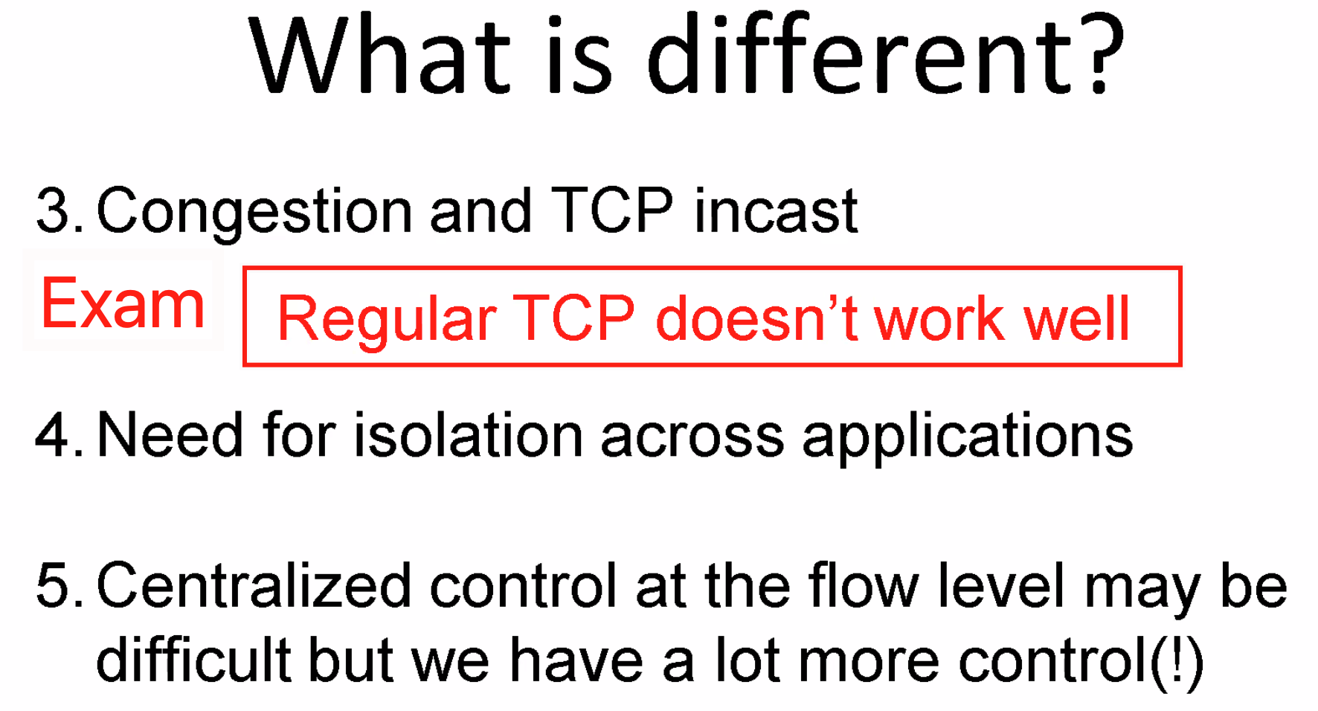
* 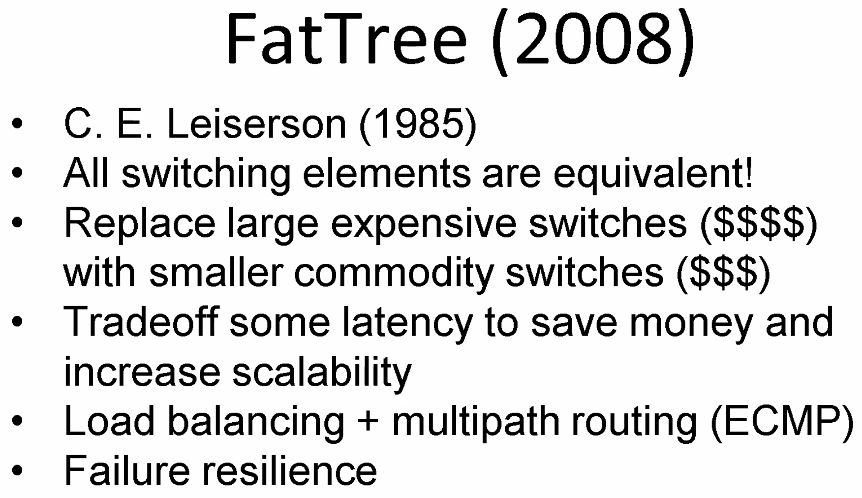
* 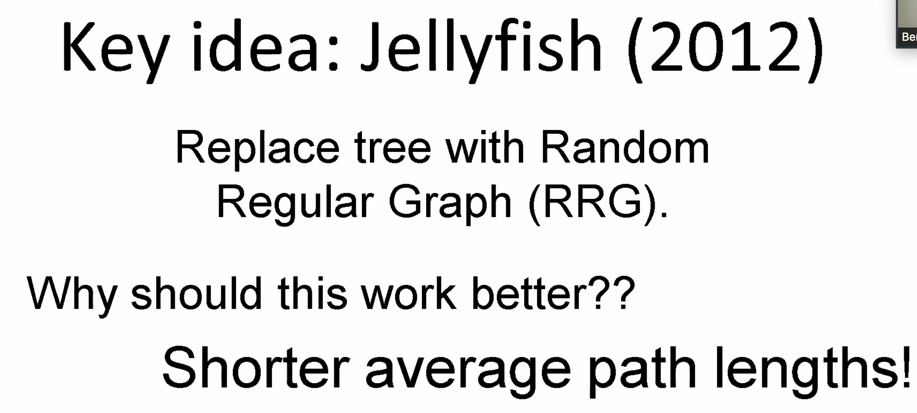
* 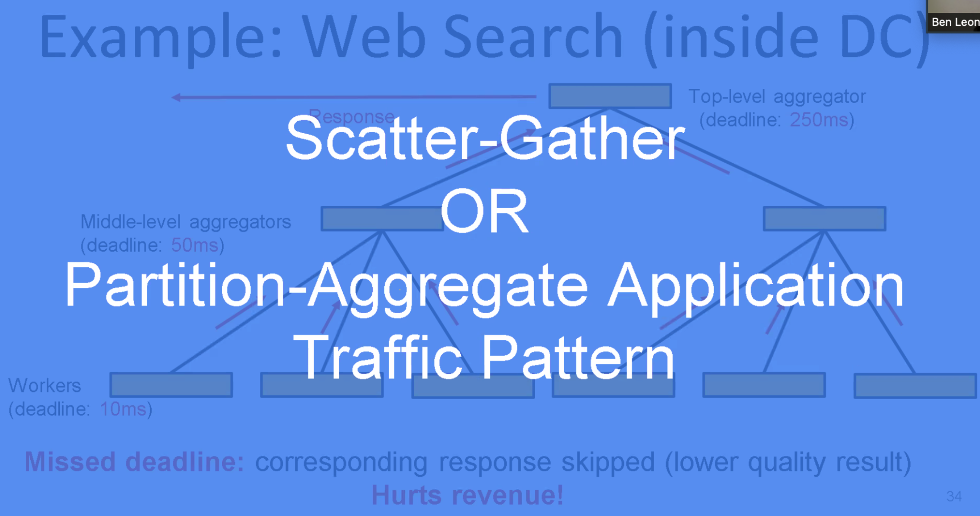
* 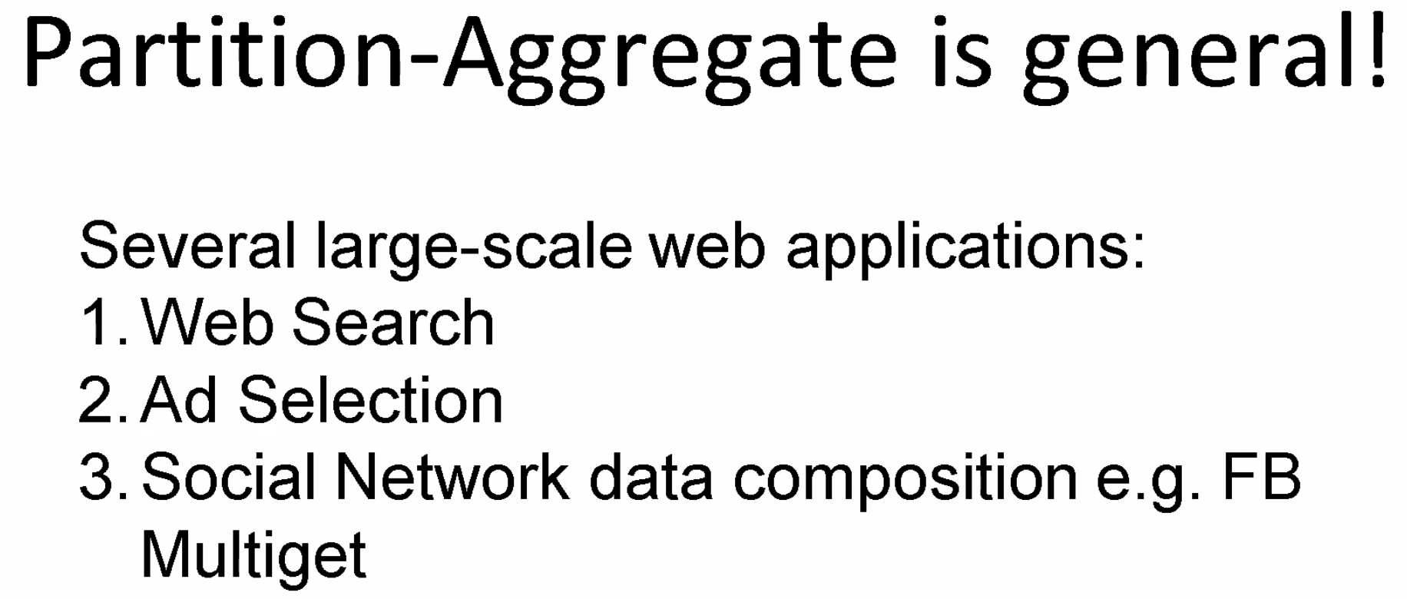
* 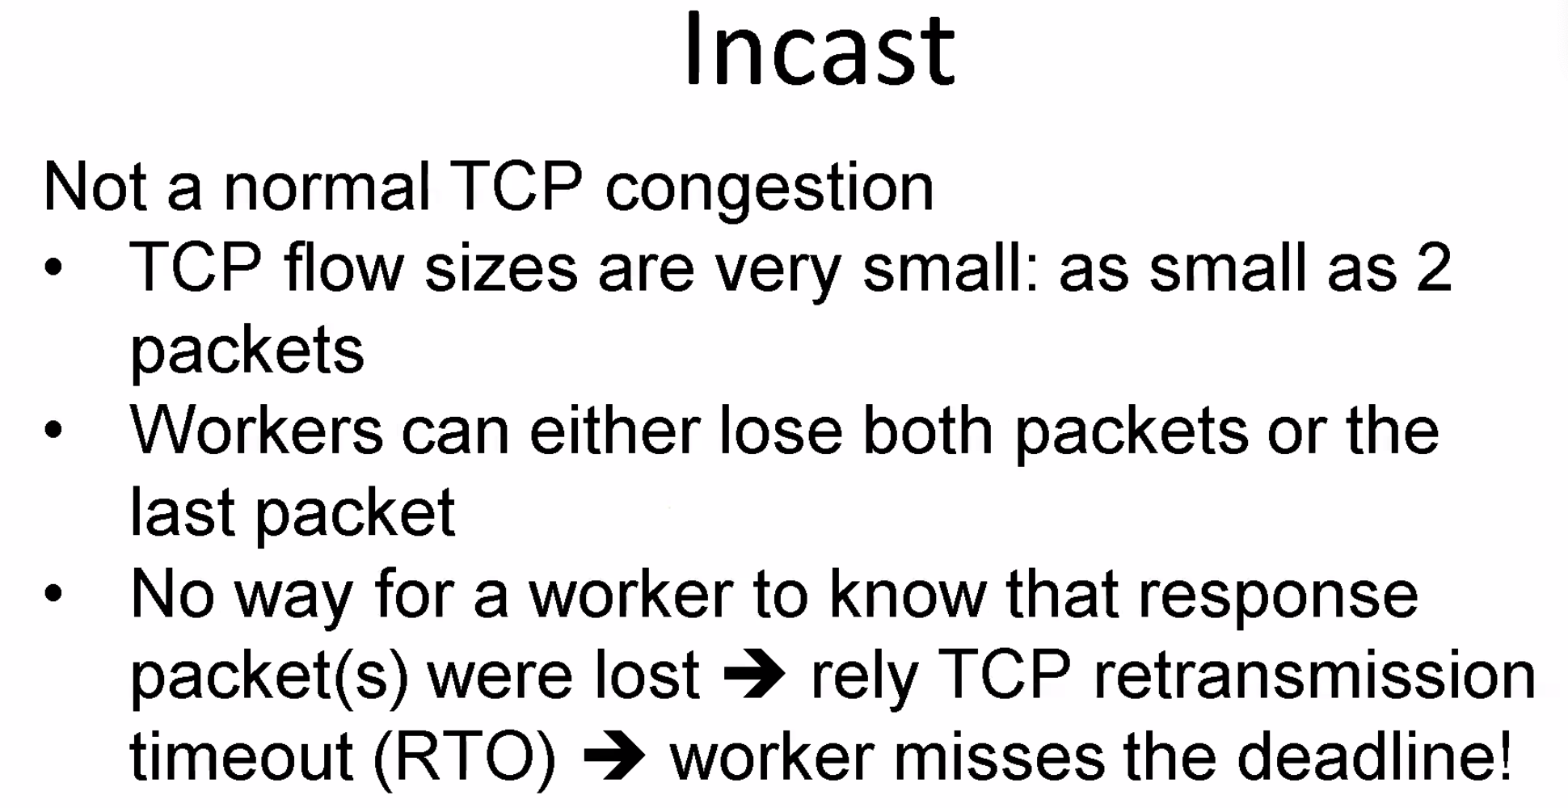
* 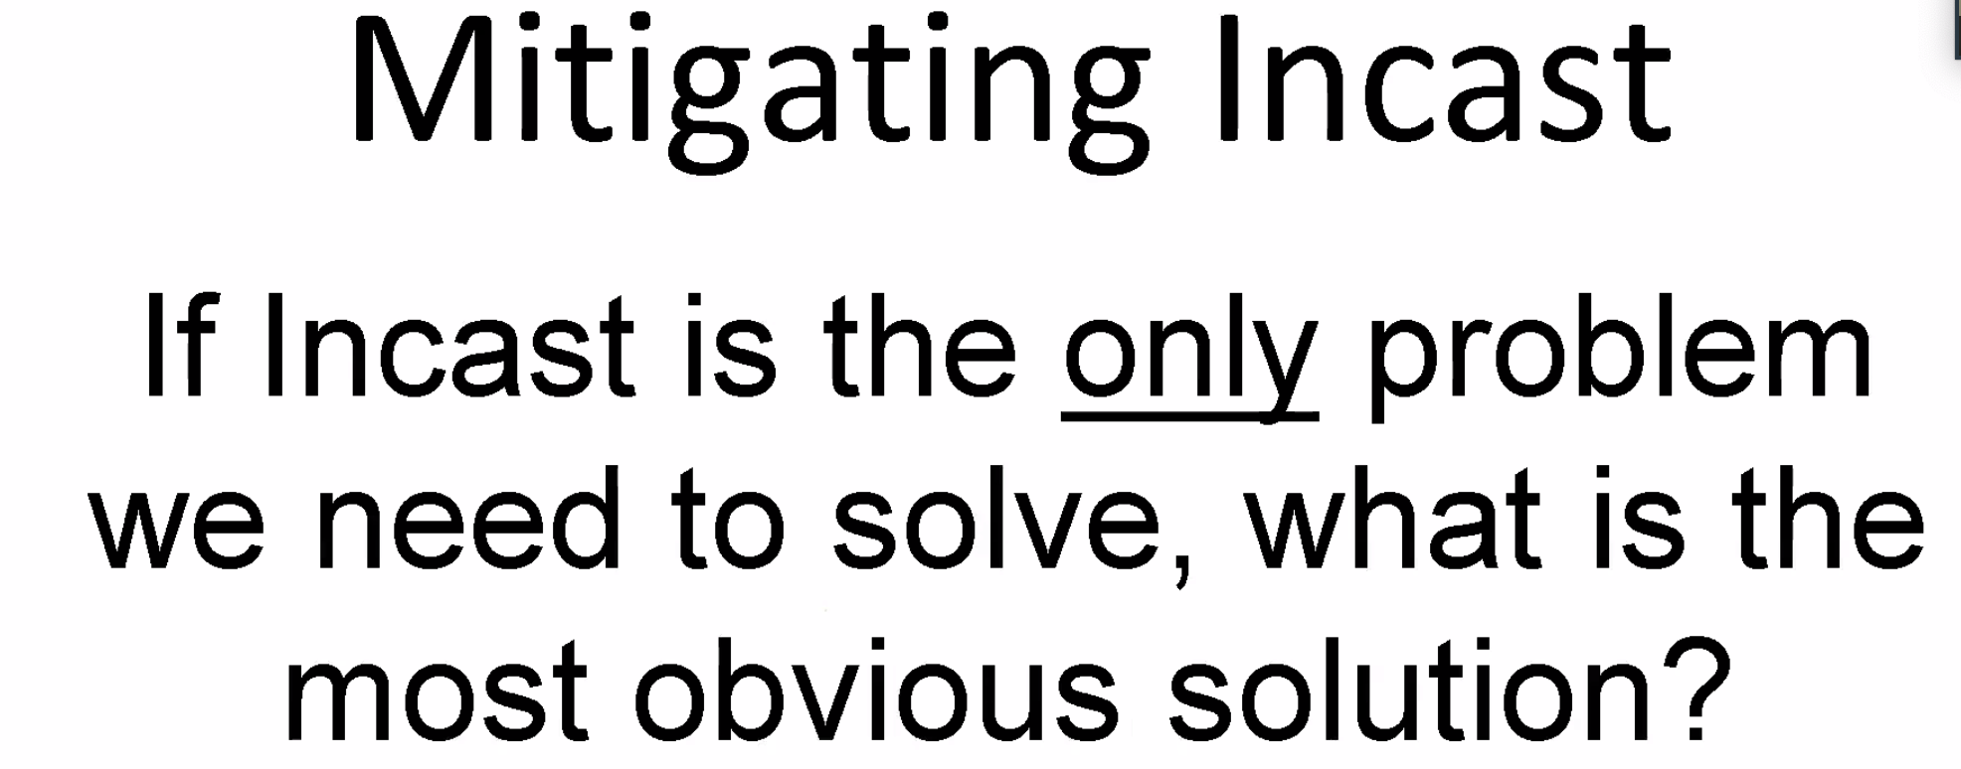
  + Deep buffer → buffer bloat
* 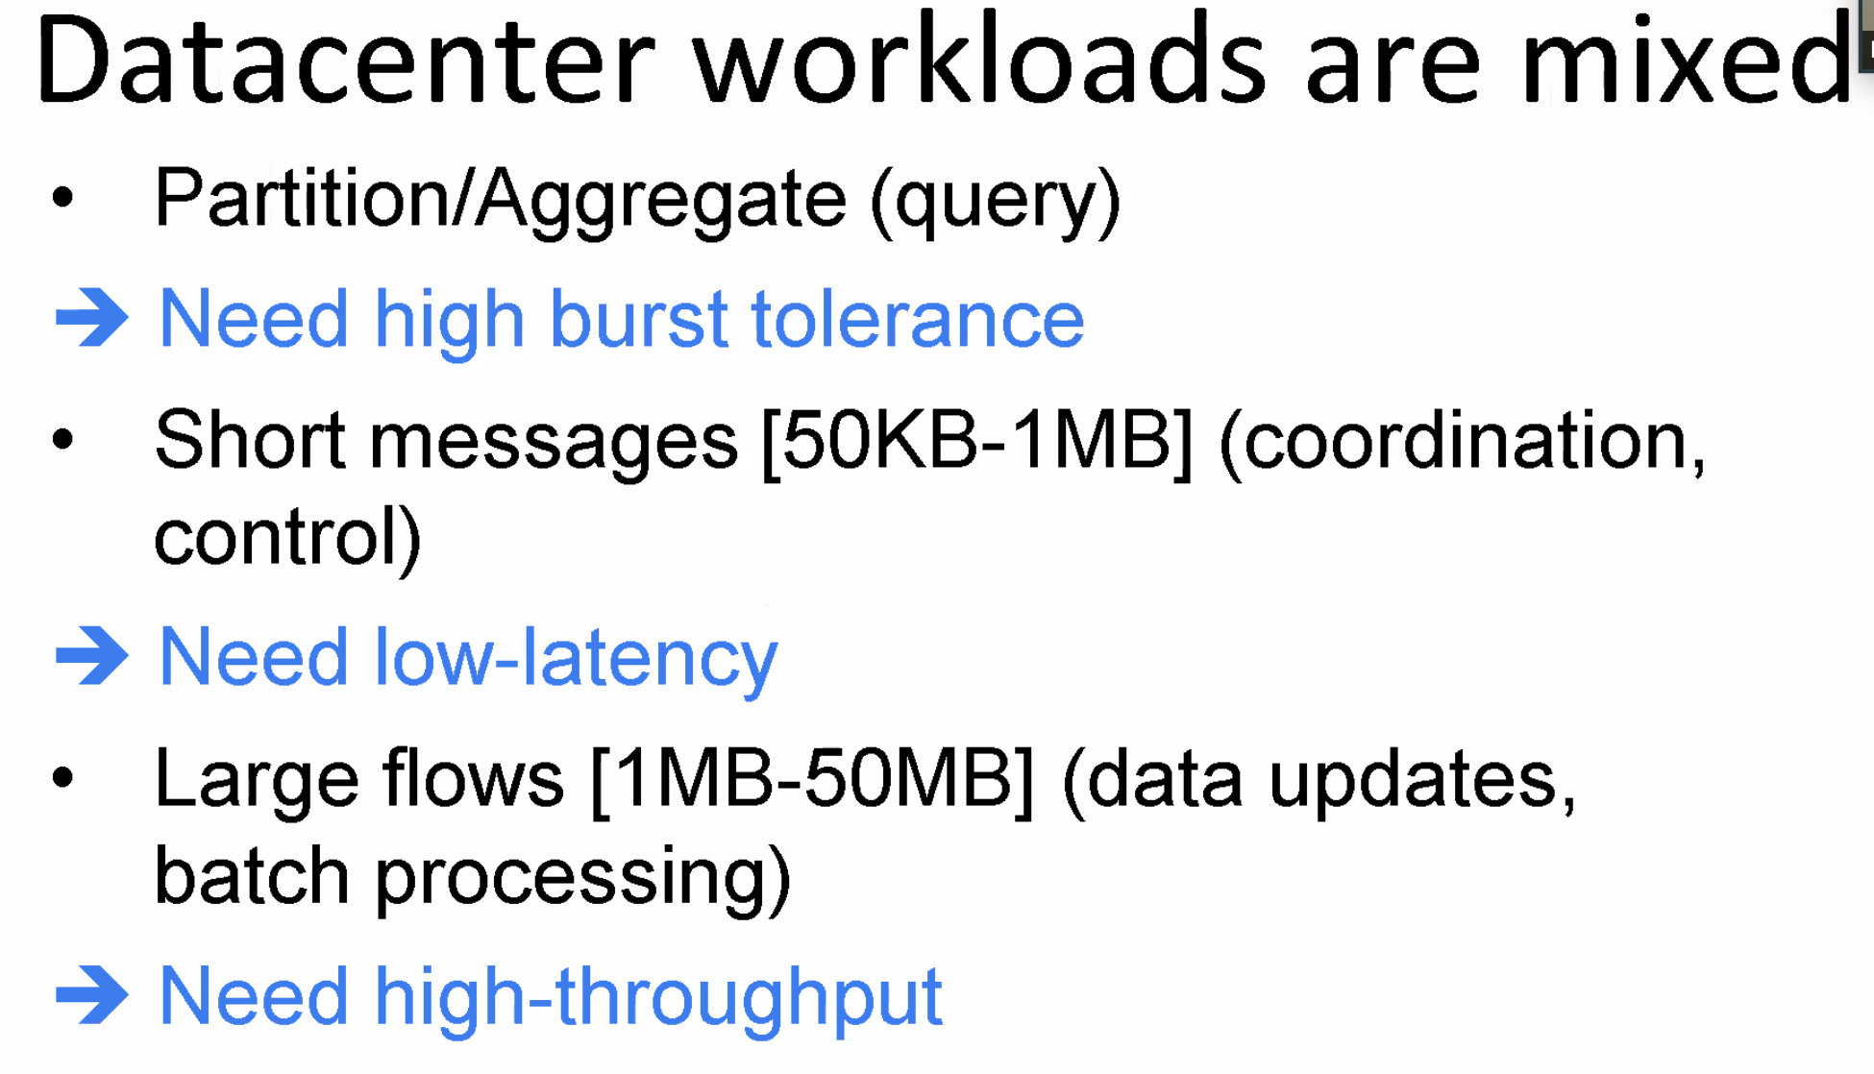
* 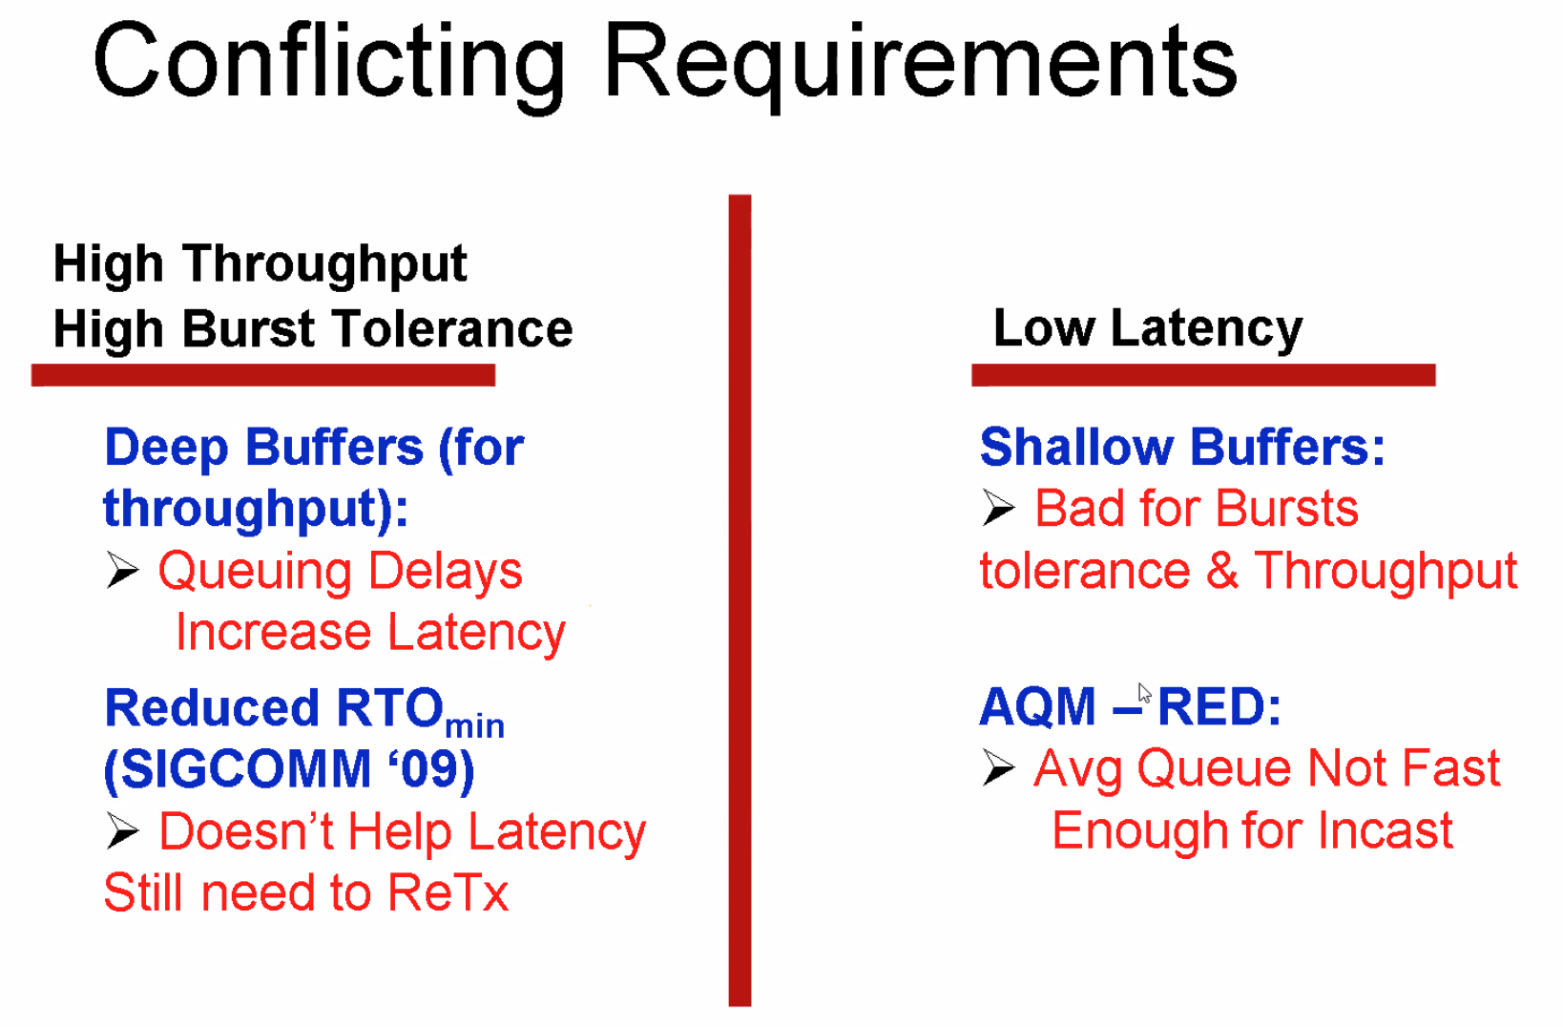
  + RTO ???
* 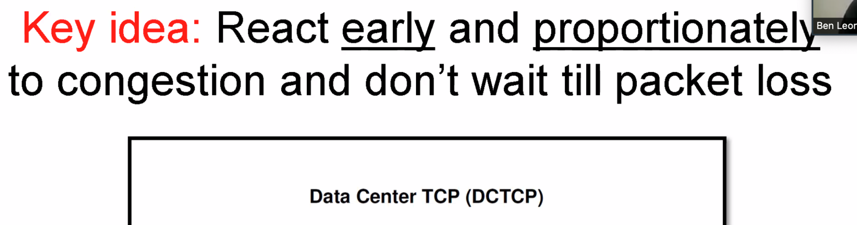
* 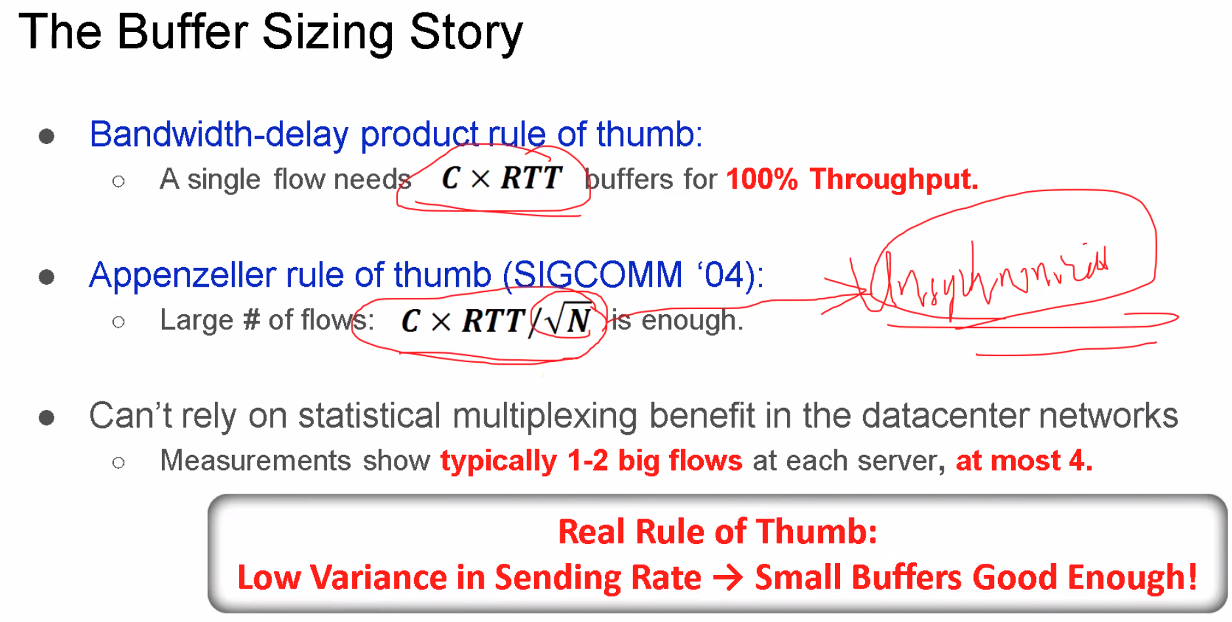 ???(17)
  + Unsynchronized
* 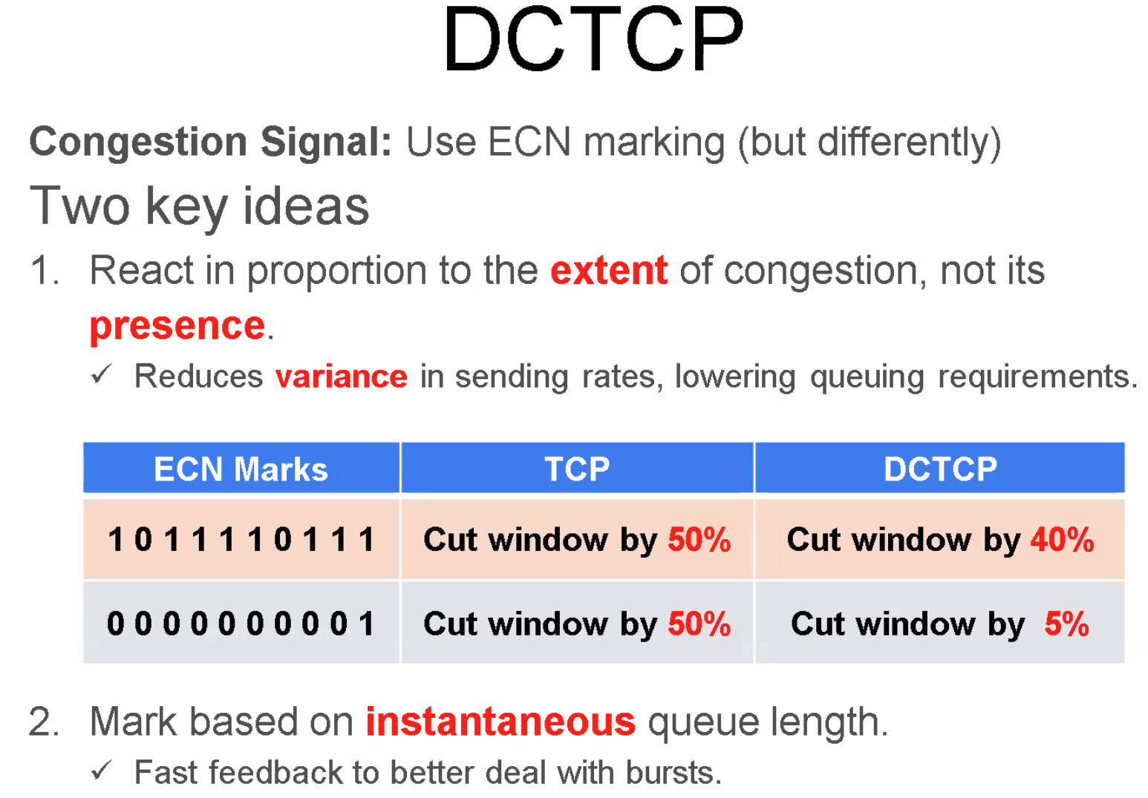
* 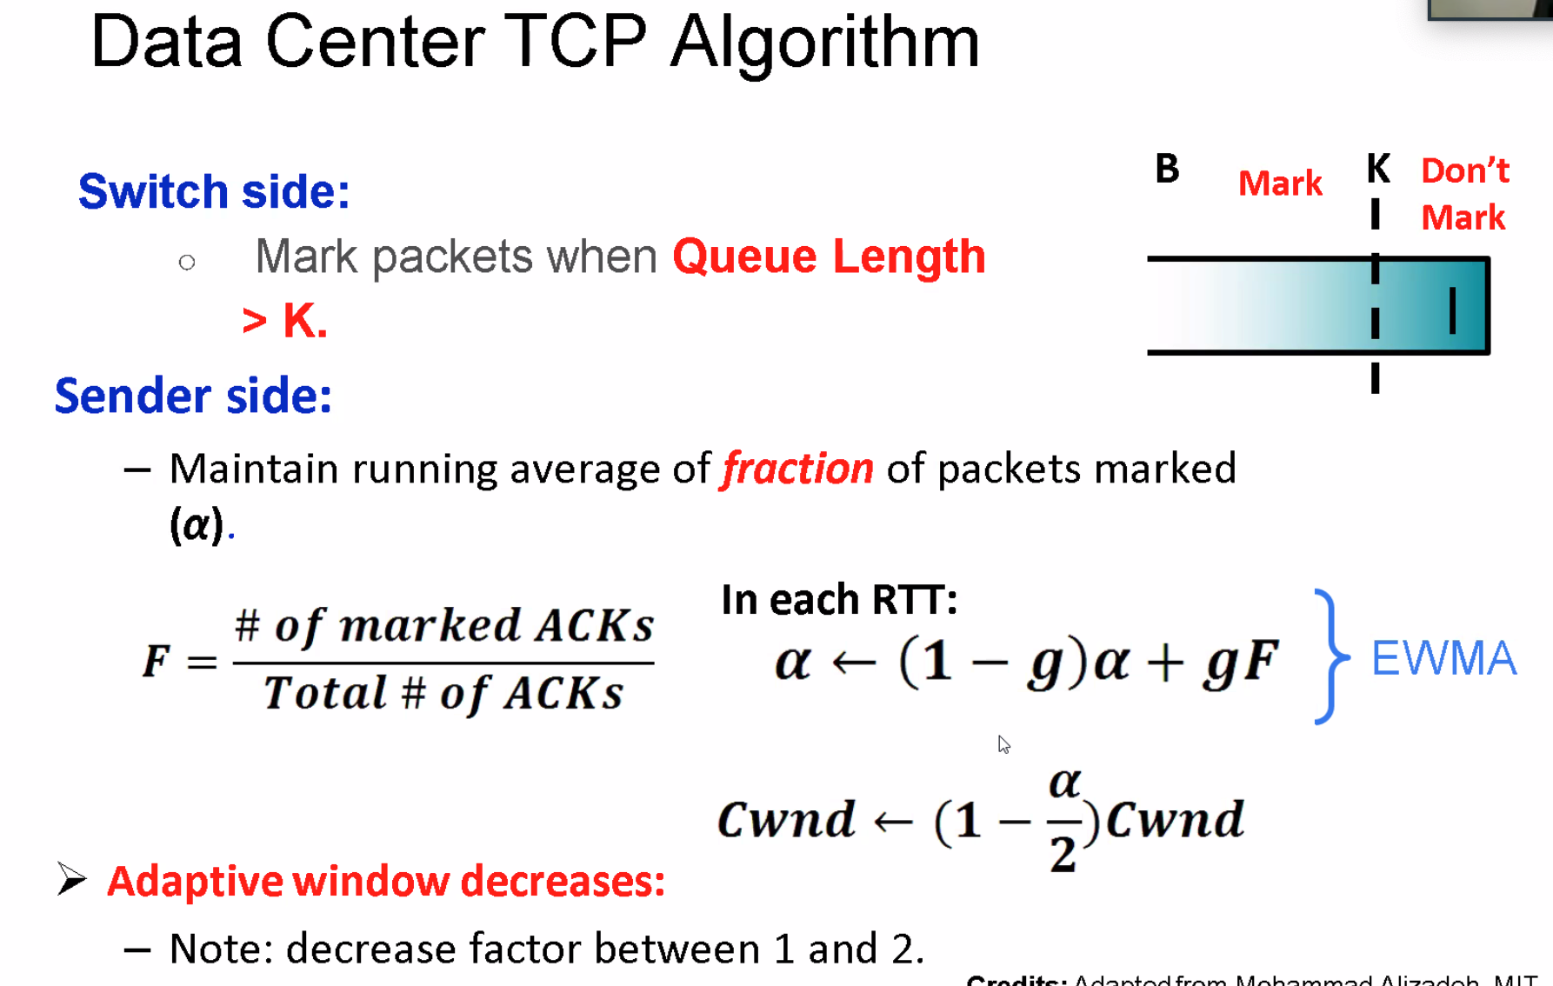 g??
* 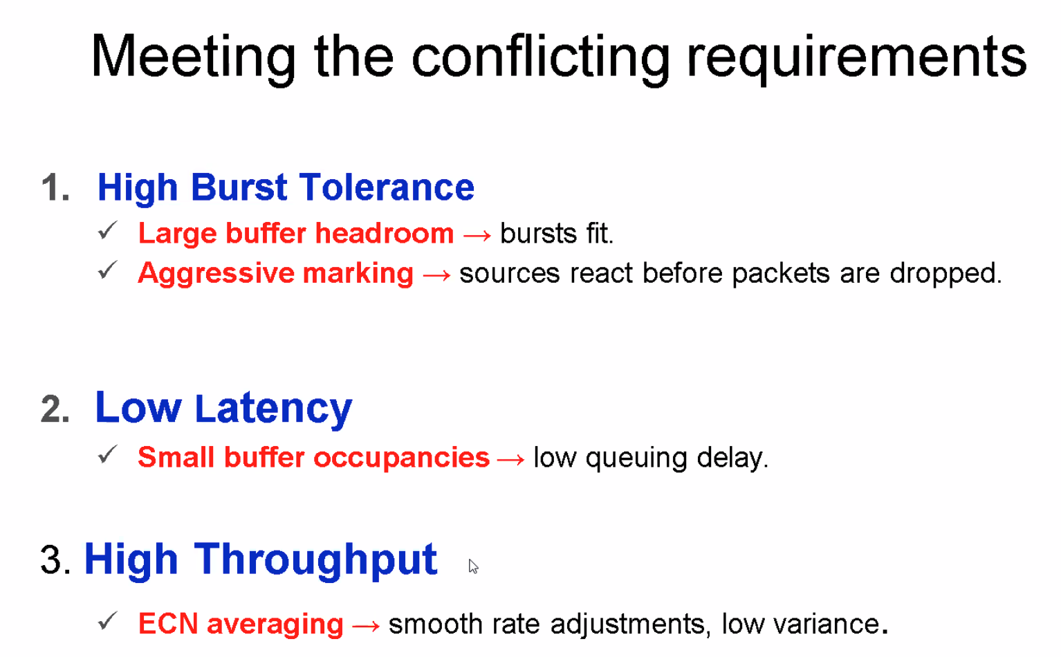
* 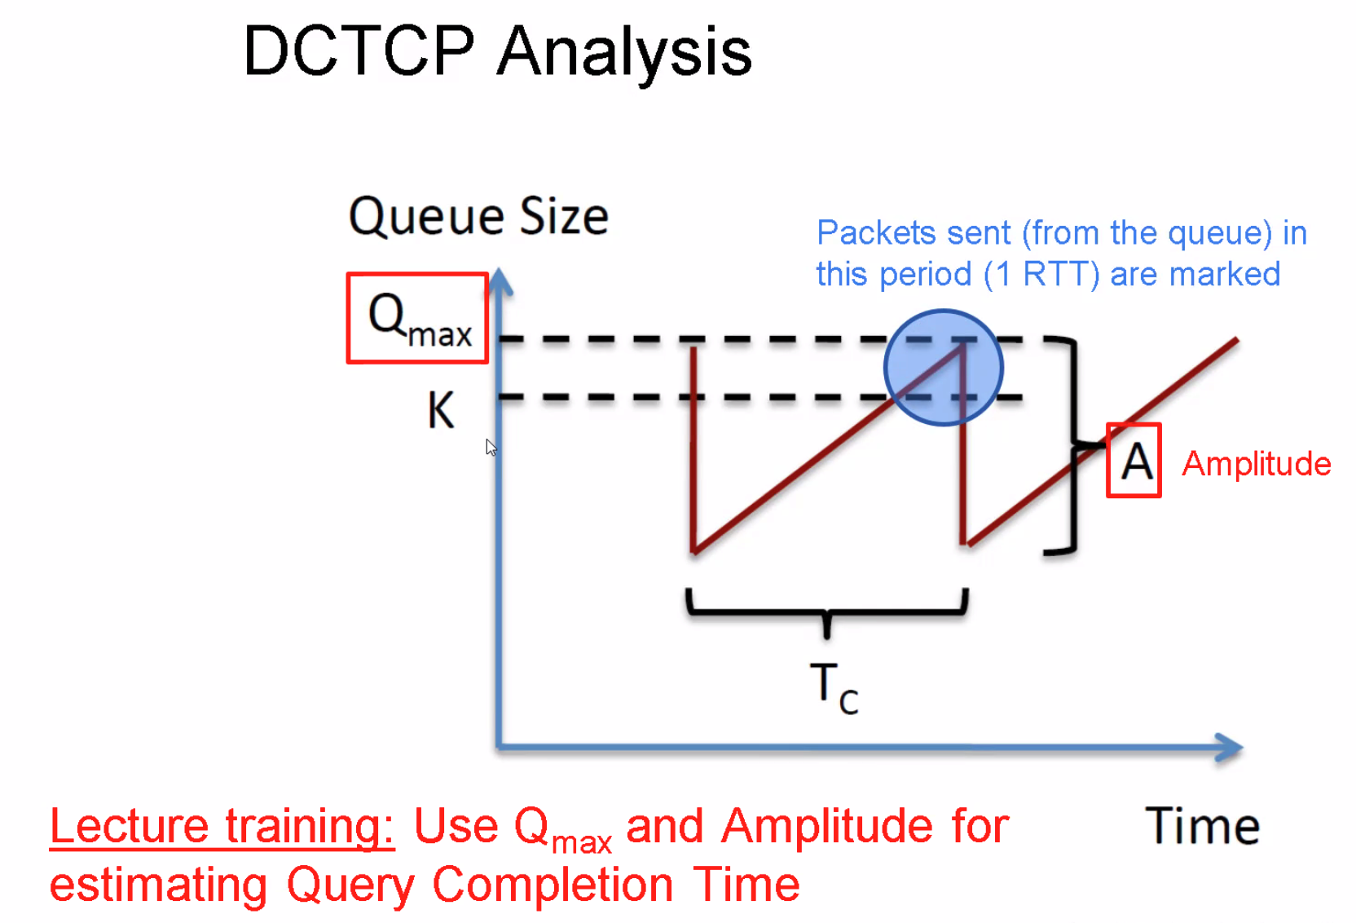
* 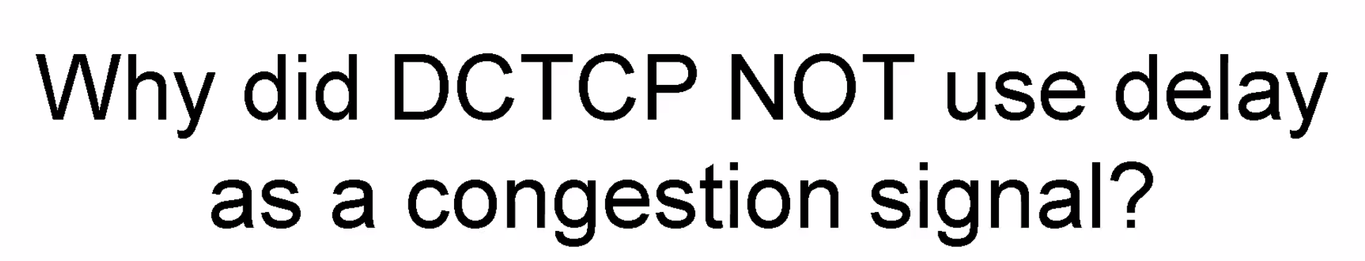
  + Delay is very small → Hard for the normal kernel to measure
* 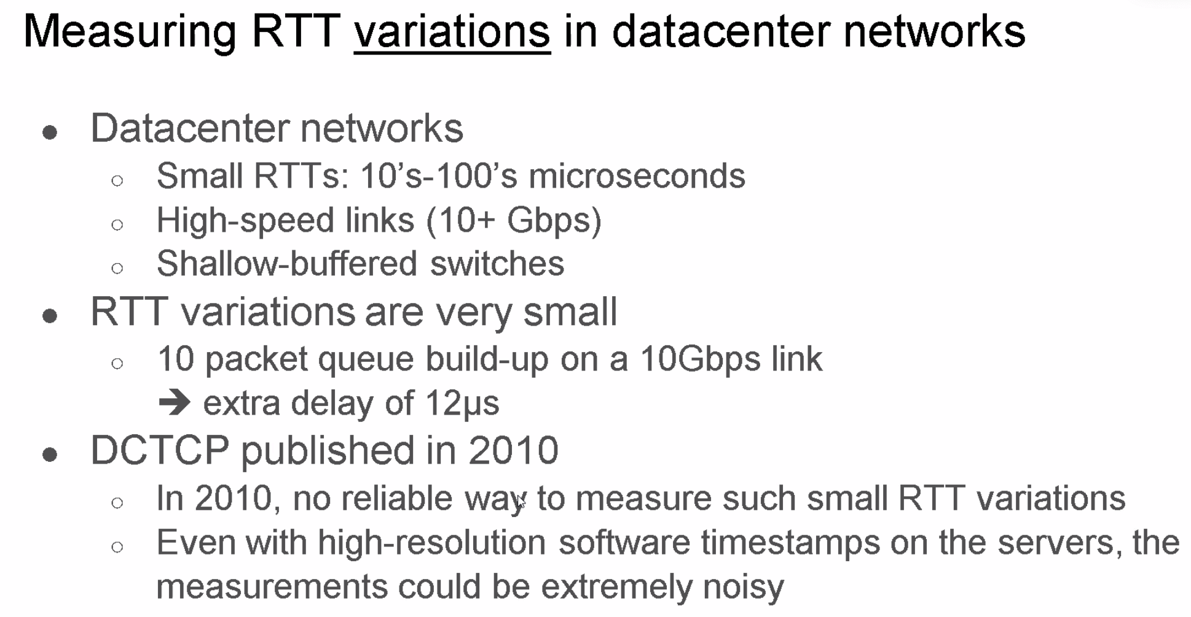
* 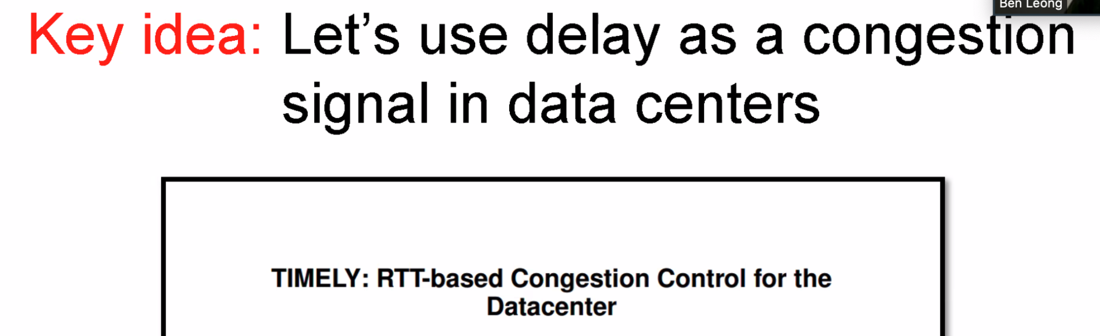
* 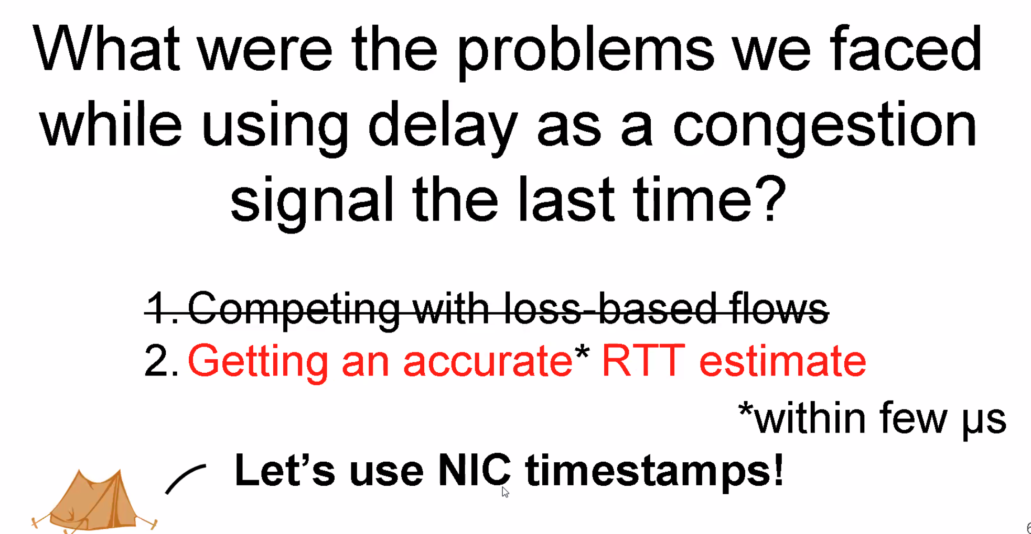
* 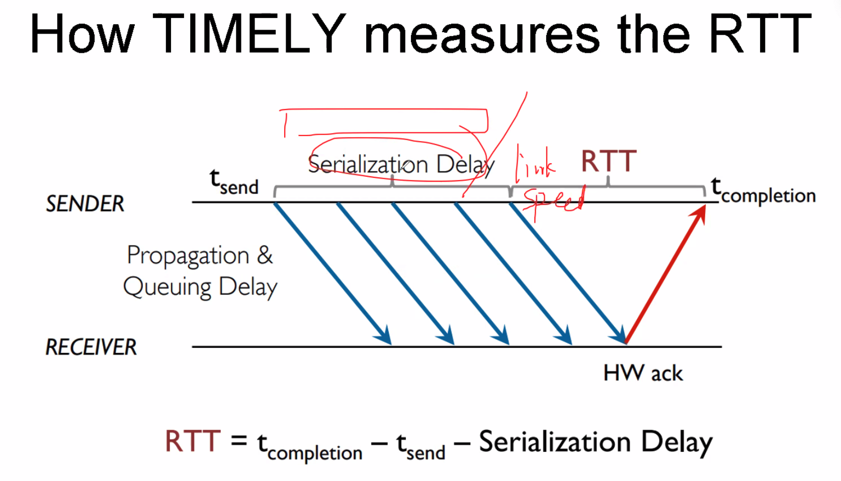
* 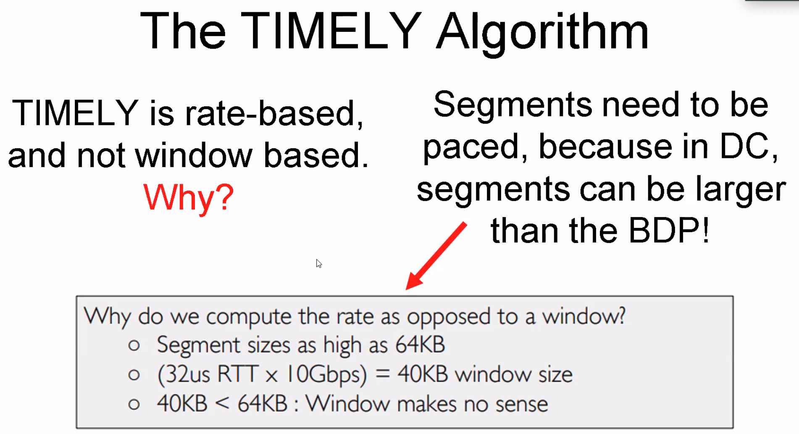
* 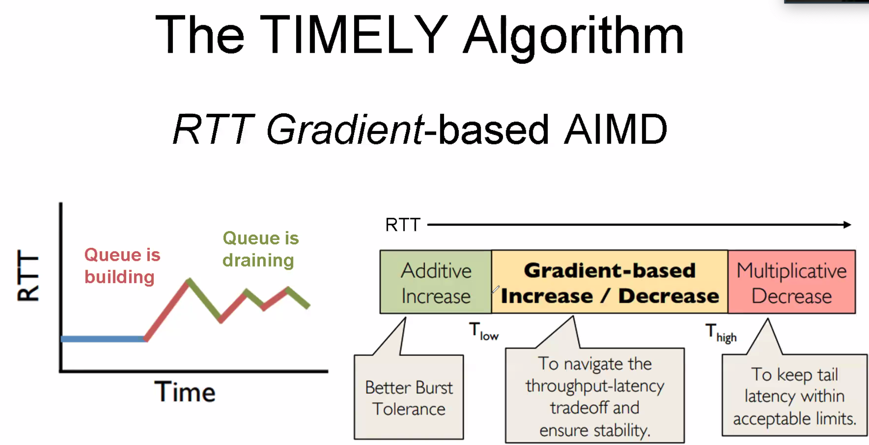
* 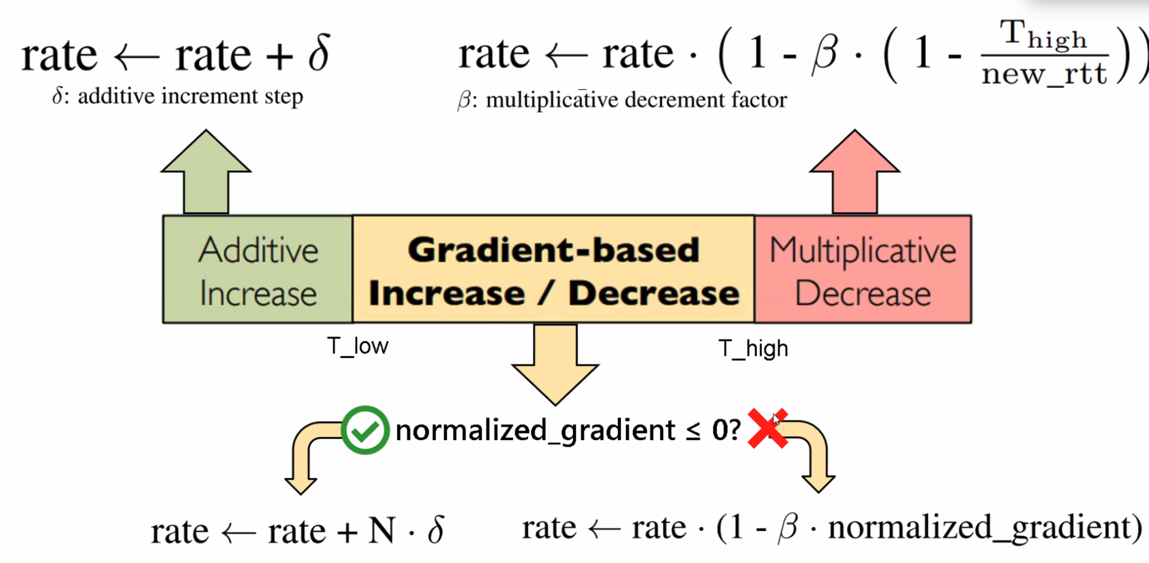
* 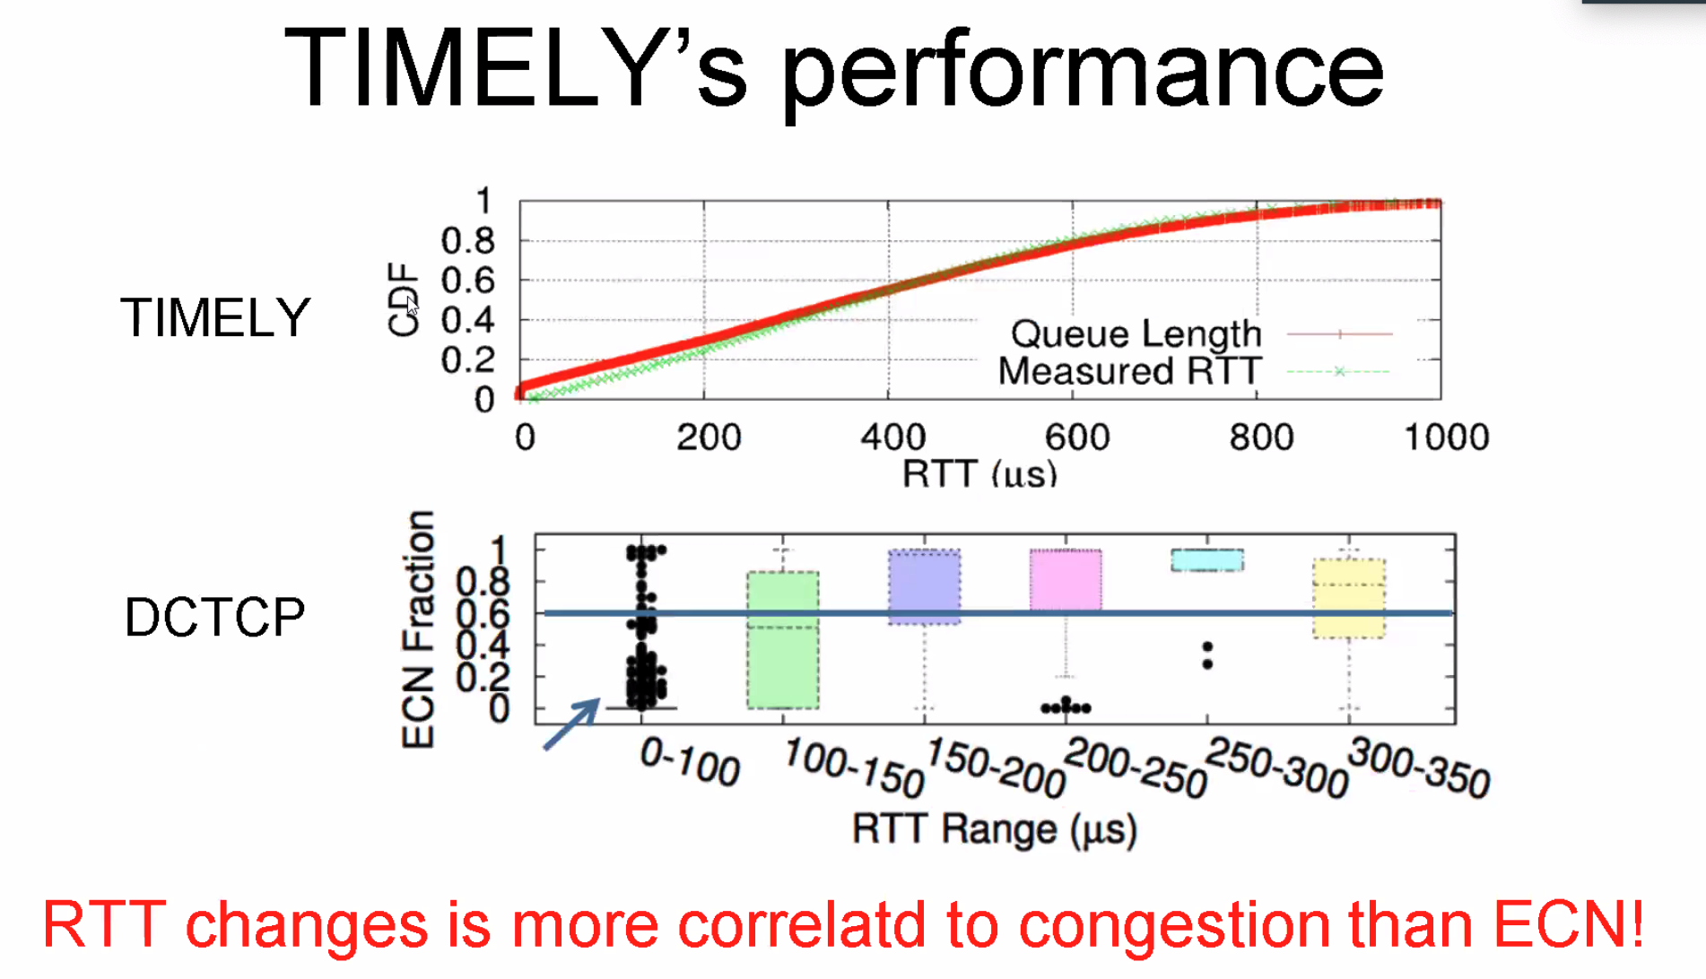
  + ECN可能没有明显congestion的情况下也会有标记，出现outlier
* 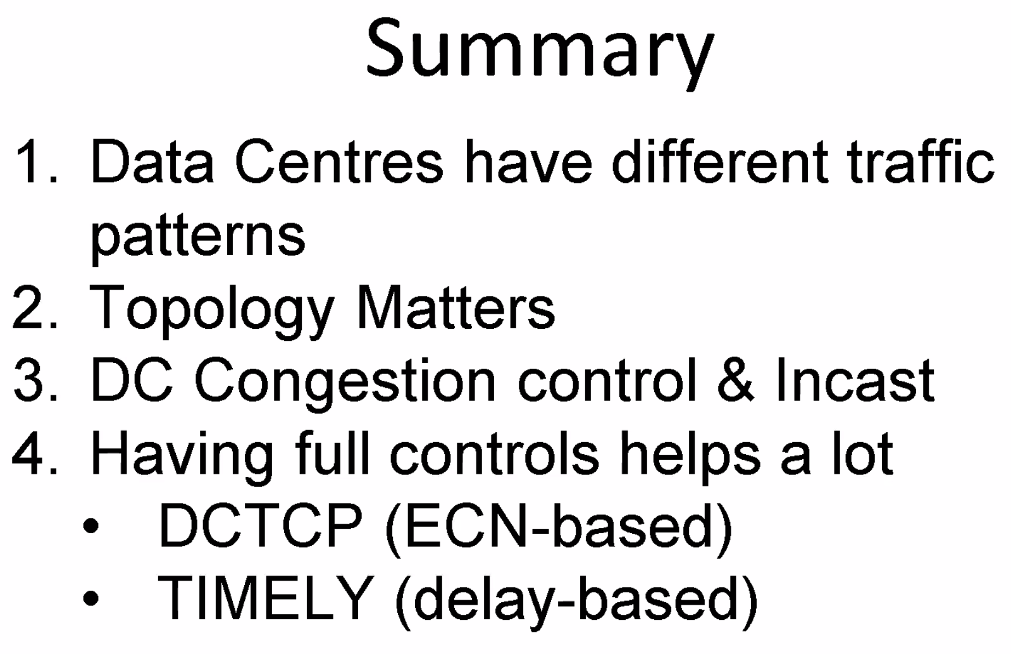

### **Lecture 7**

* 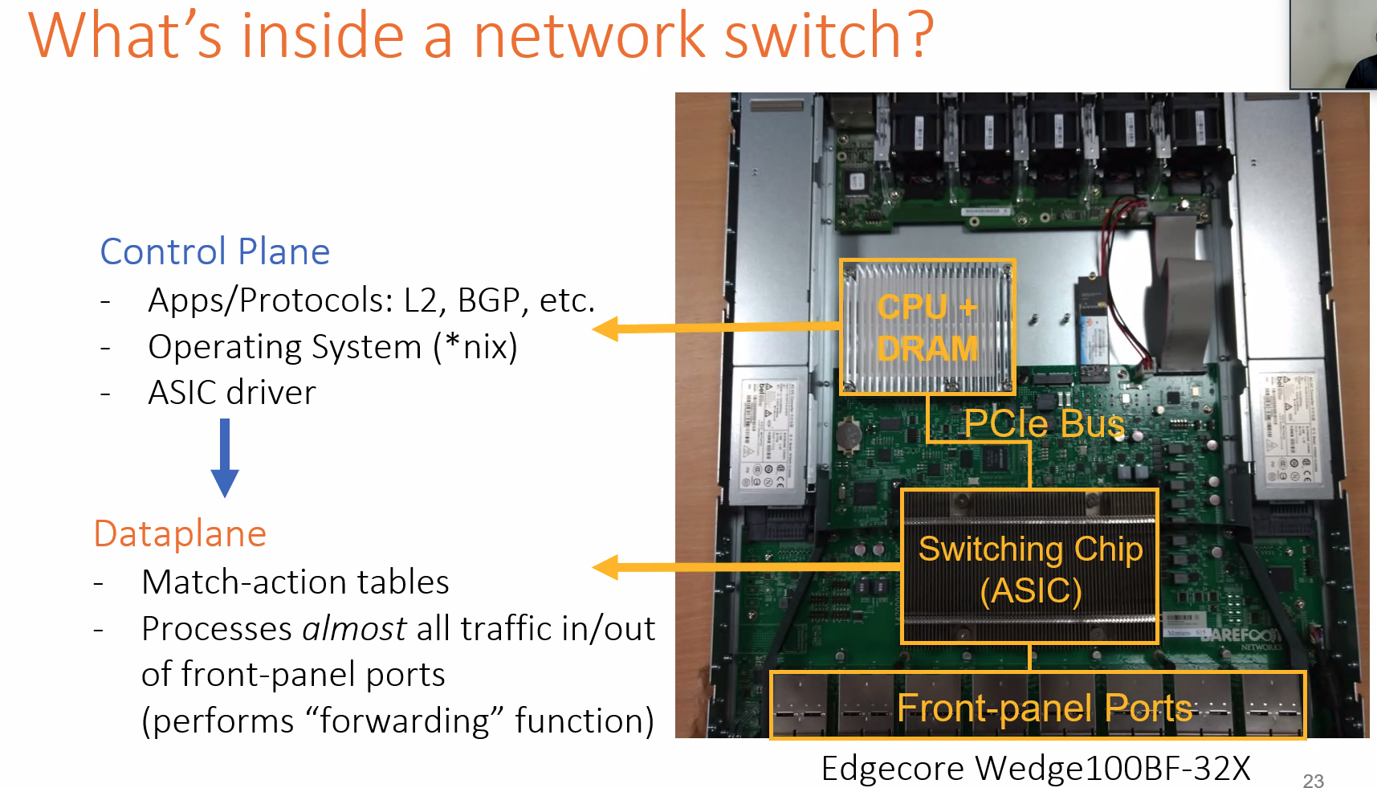
* 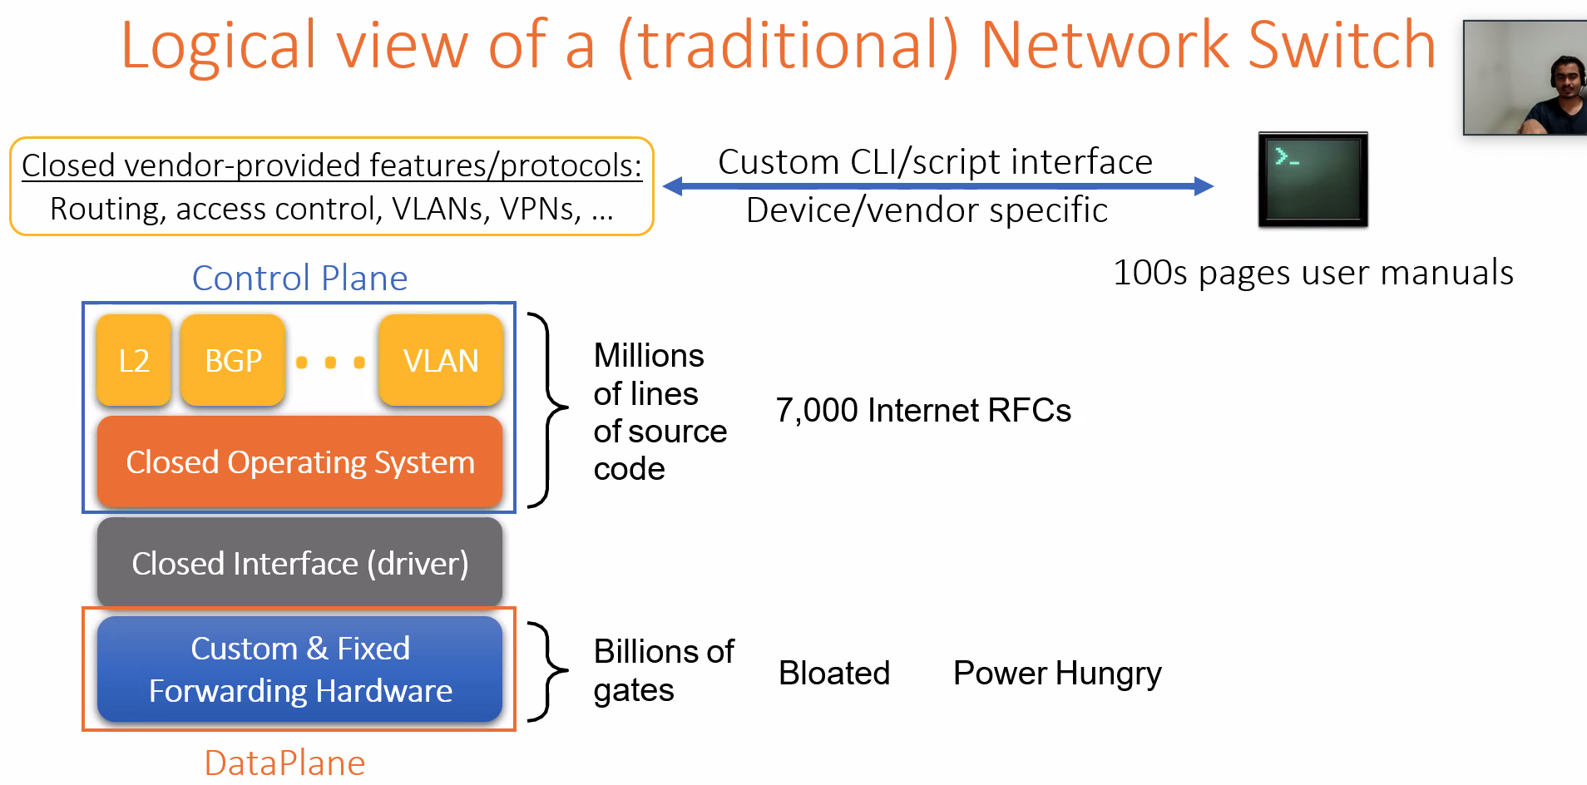
* 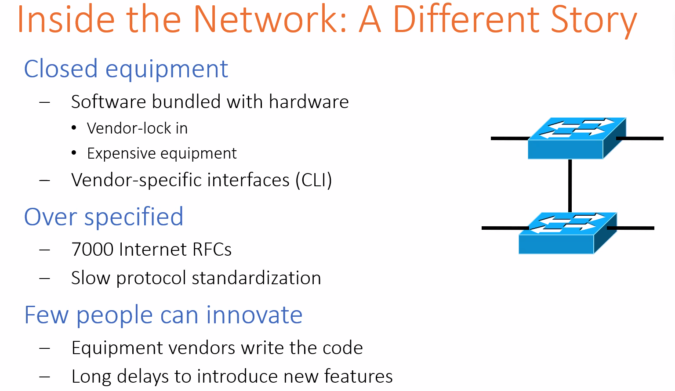
* 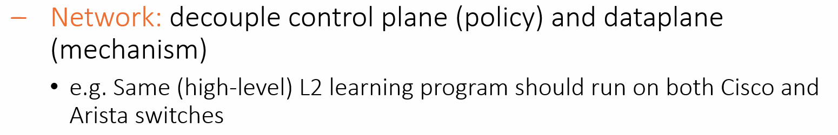
* 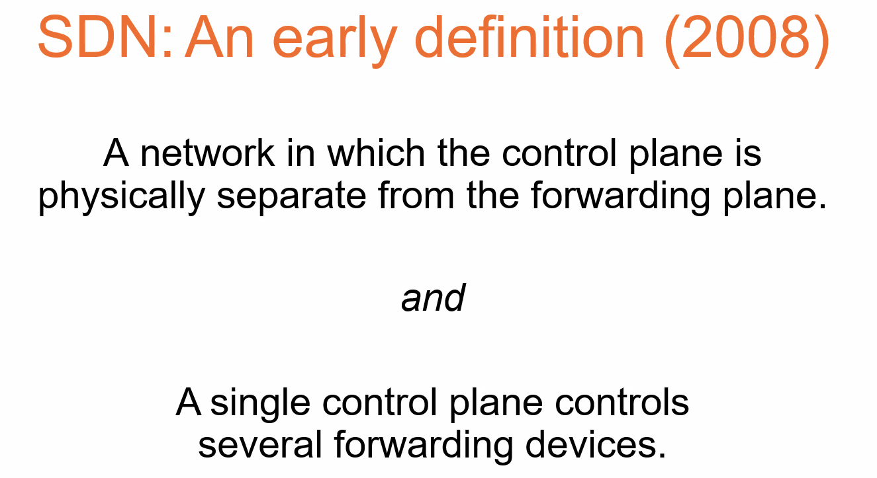
* 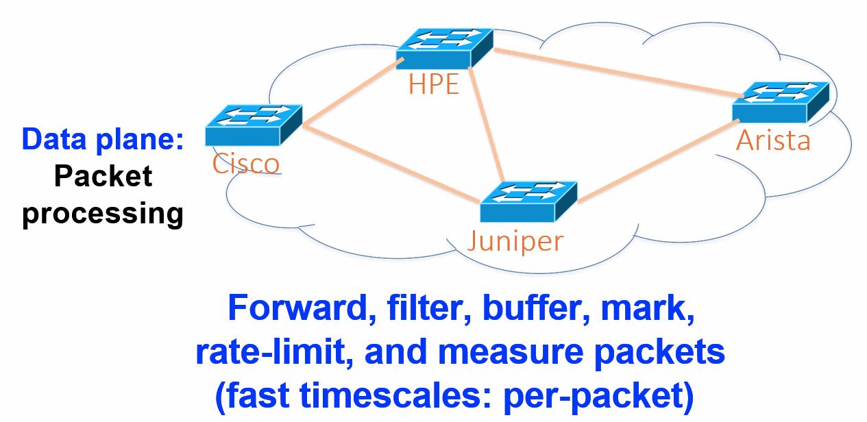
* 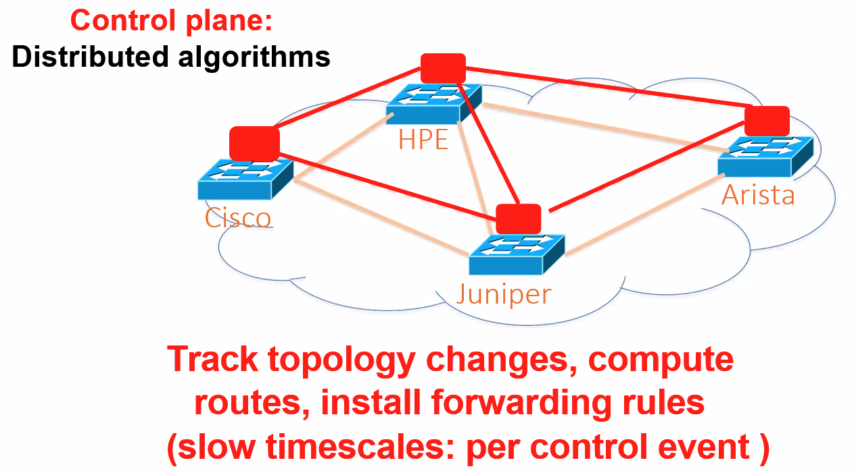
* 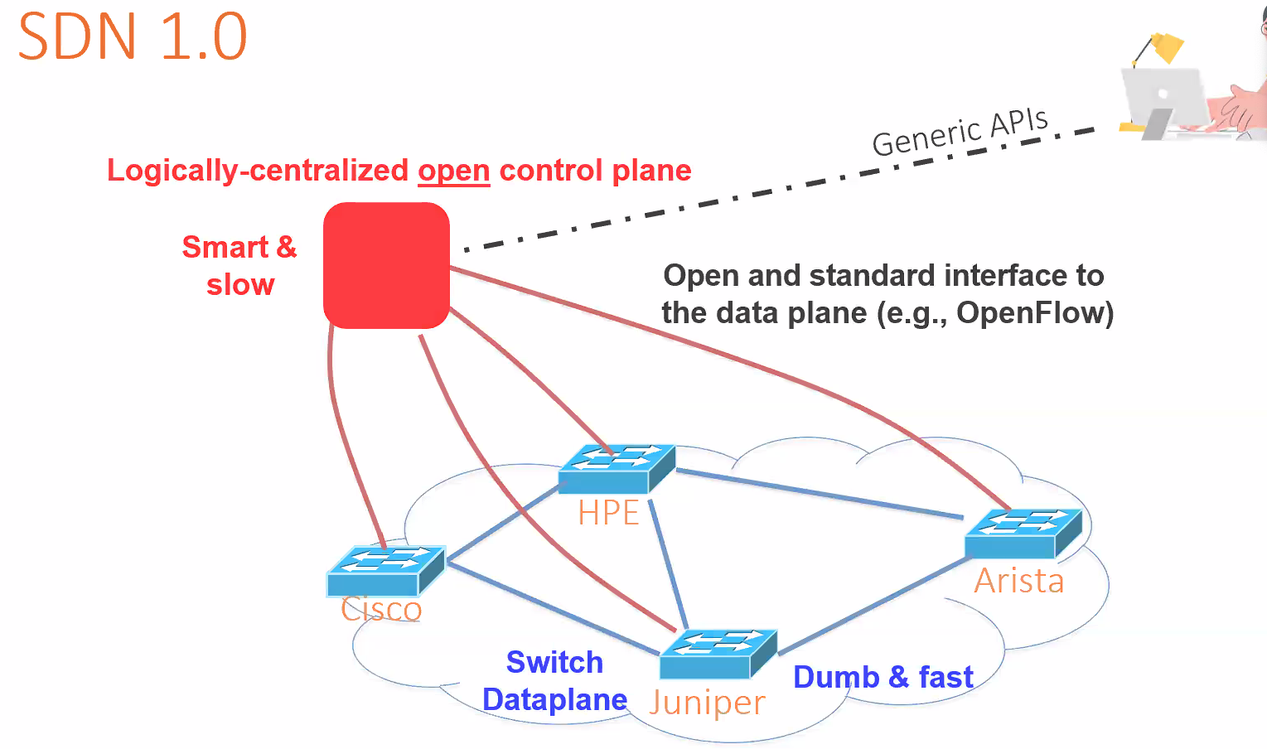
* 
* 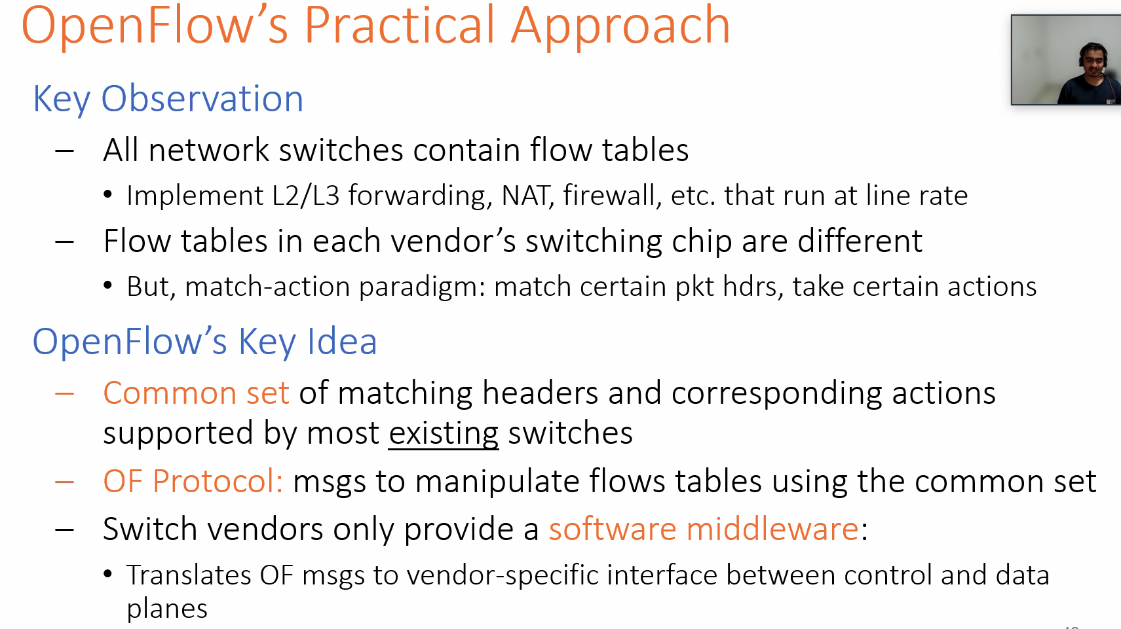
* 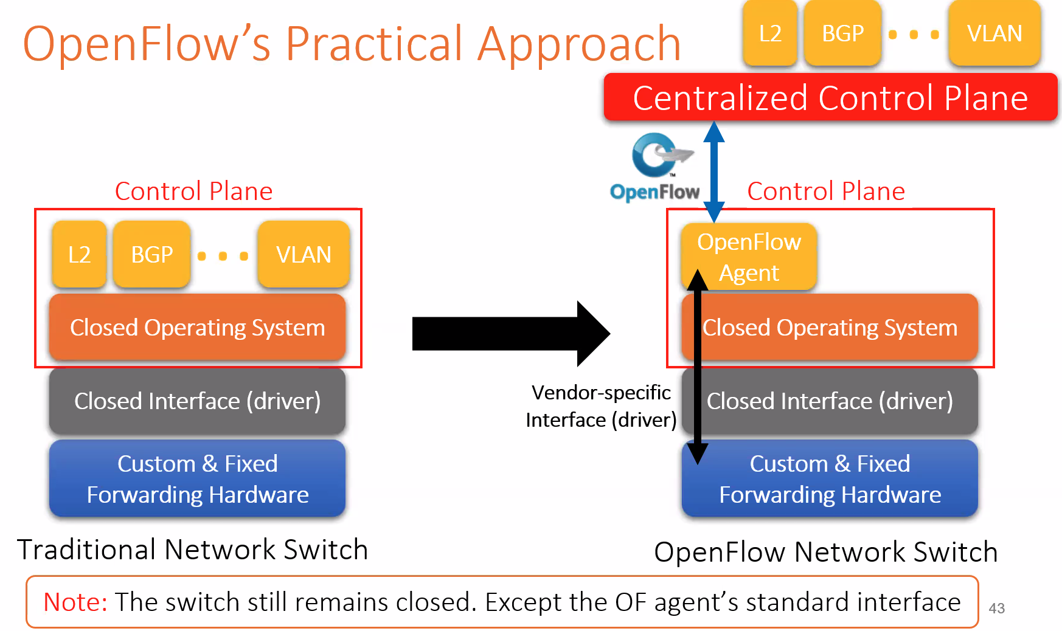
* 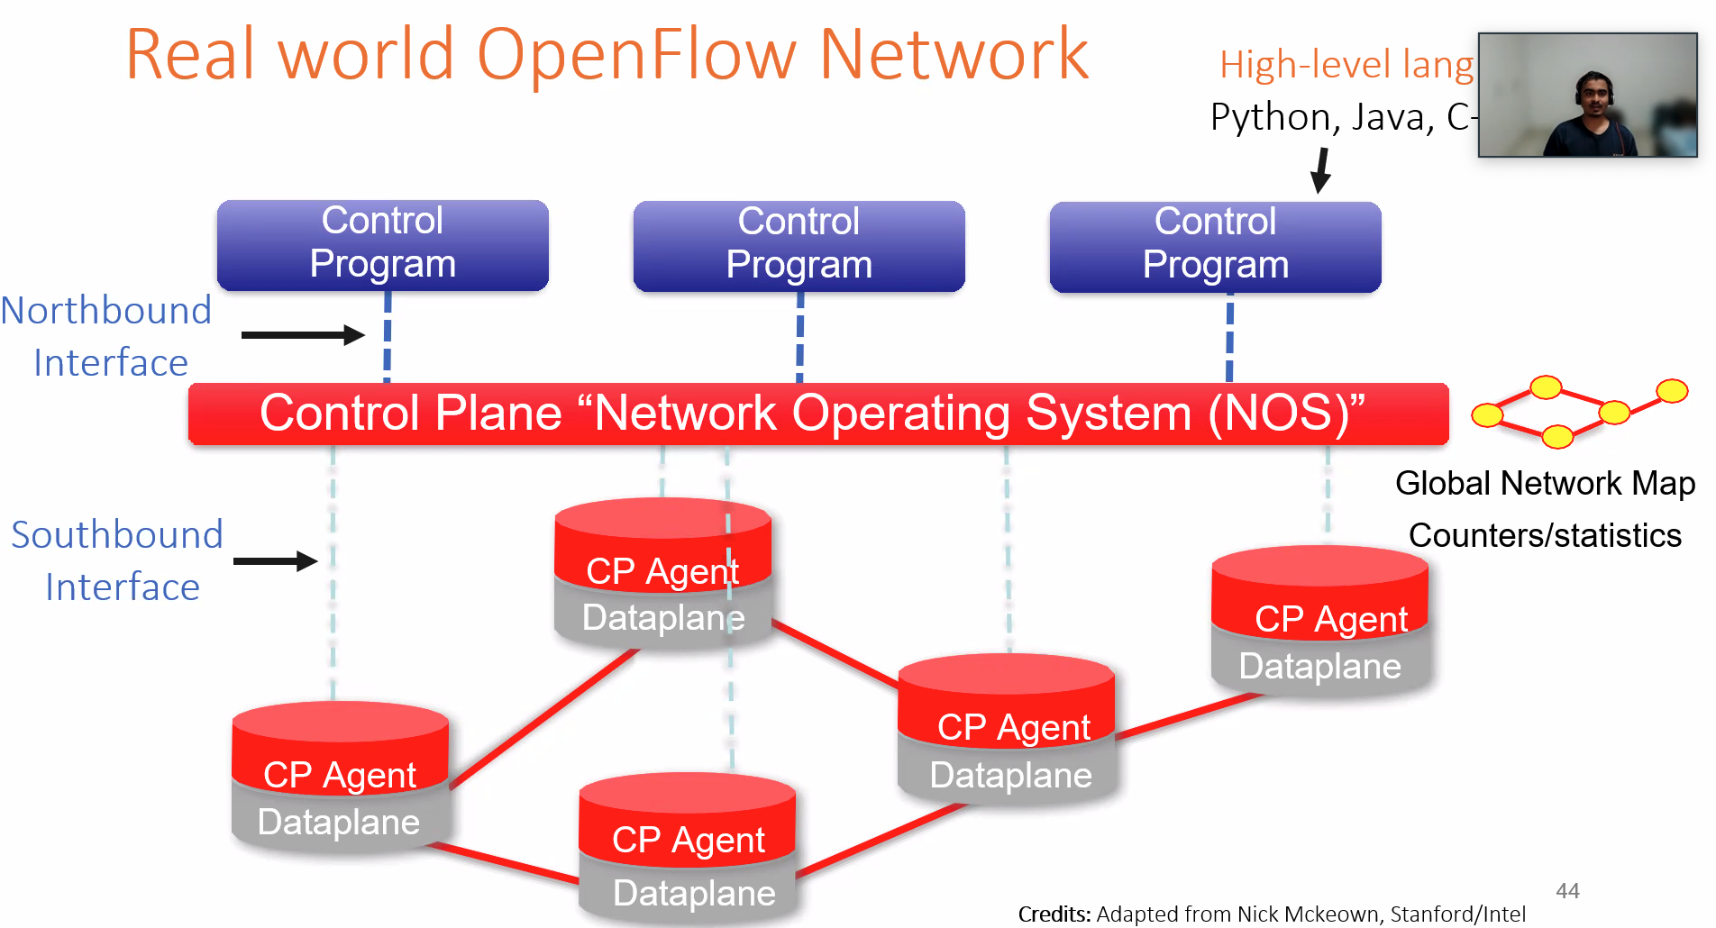
  + Python -- rest -- floodlight -- OpenFlow
* 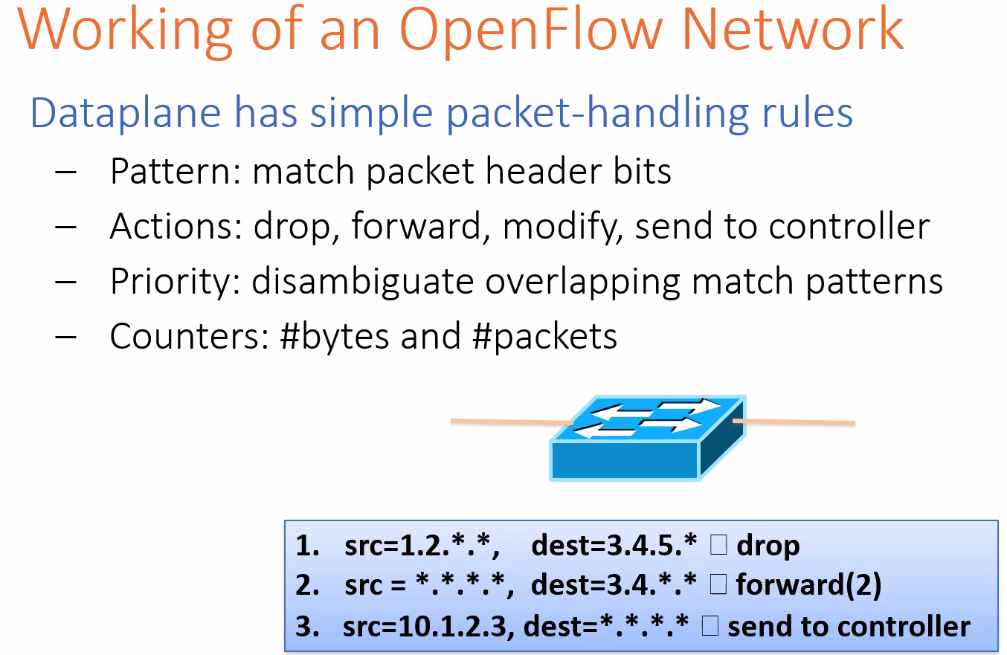
* 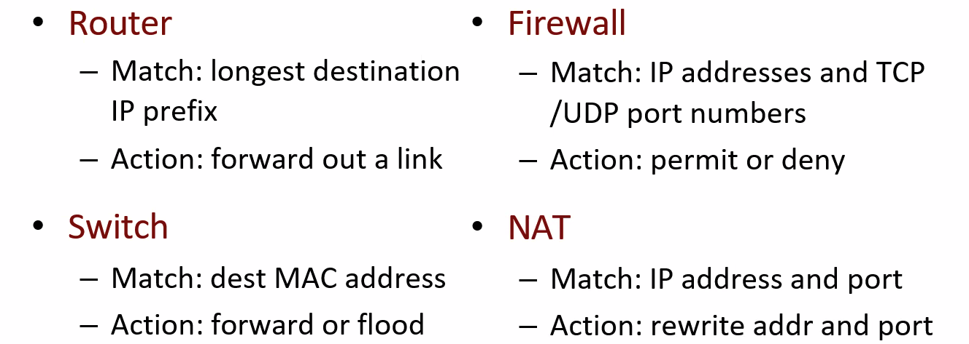
* 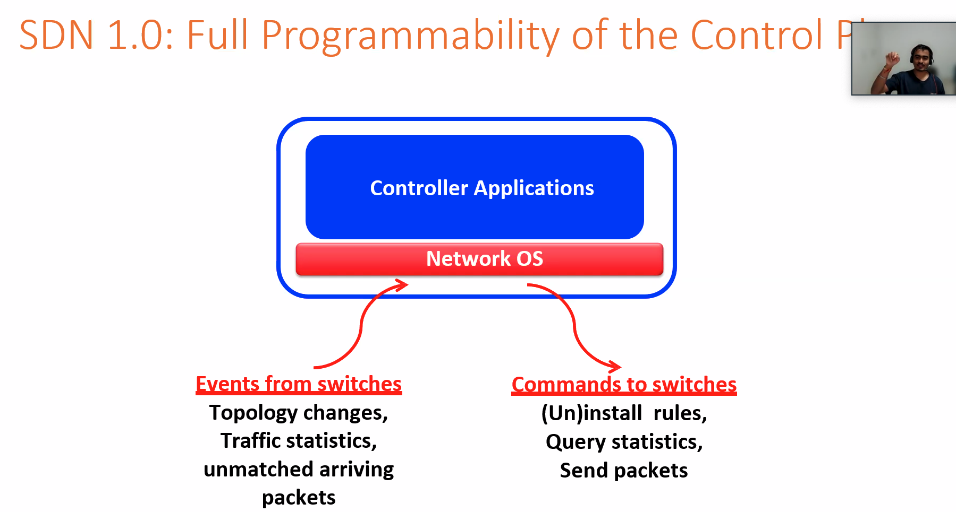
* SDN 1.0
  + Load balancing
  + Network virtualization

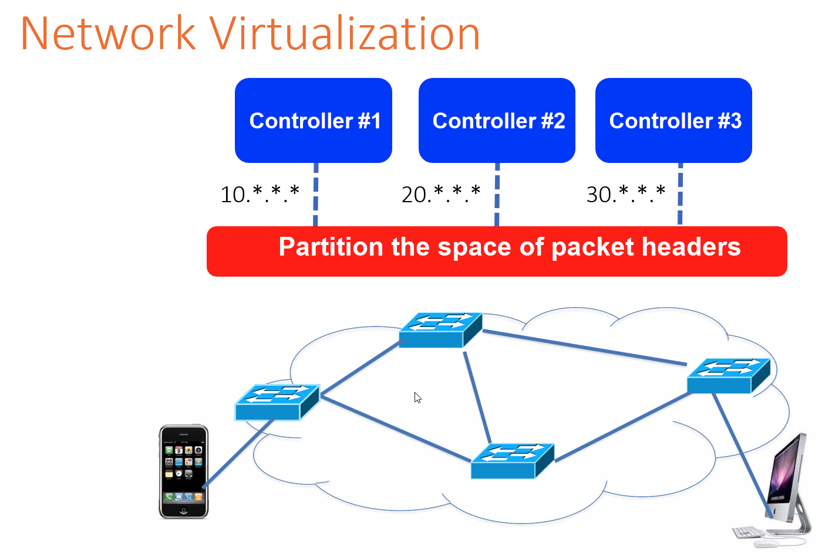

* 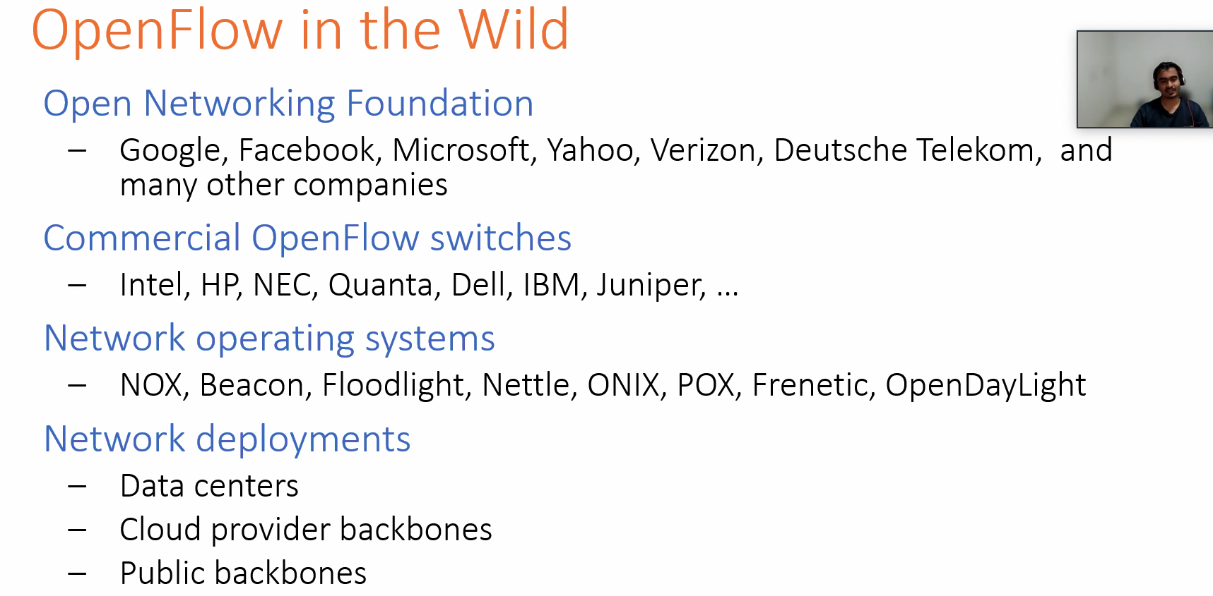
* 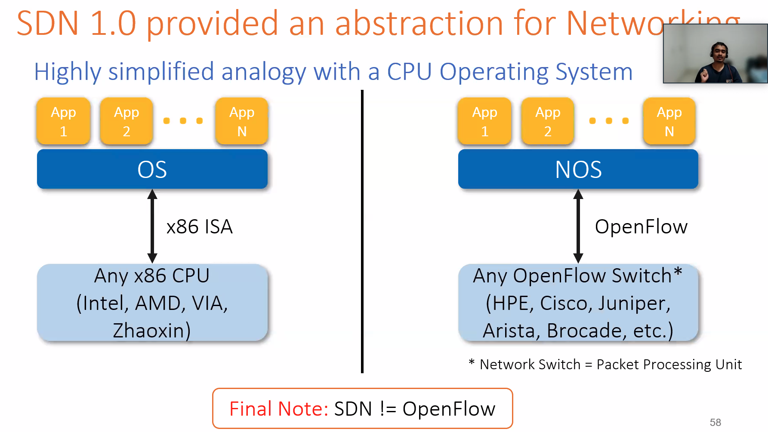
* 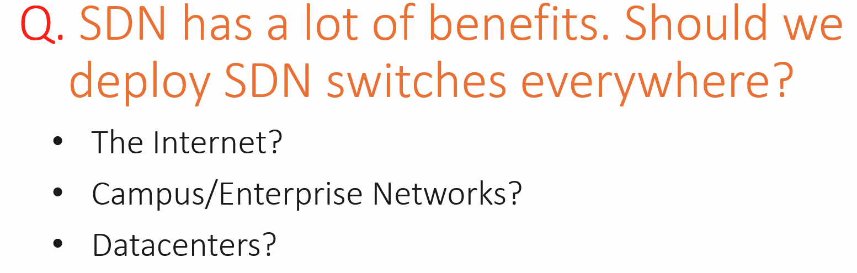
* 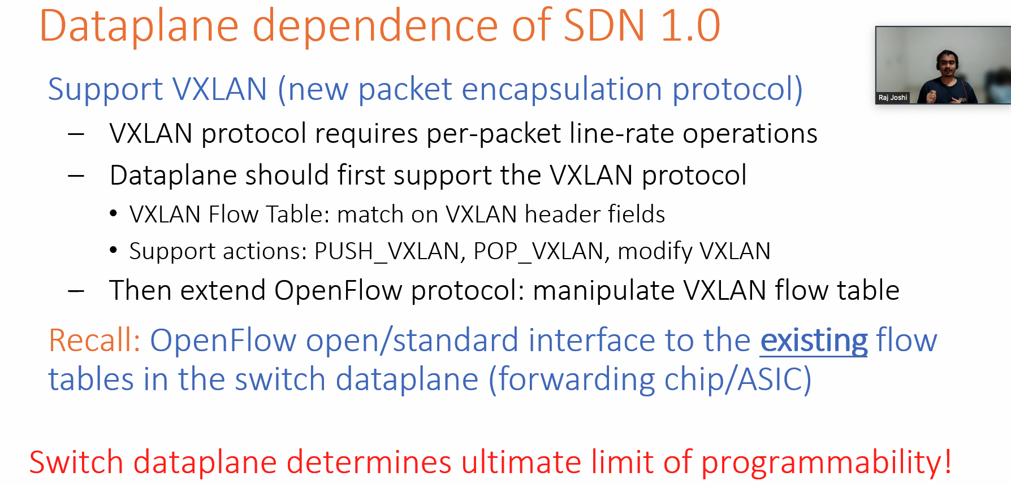
* 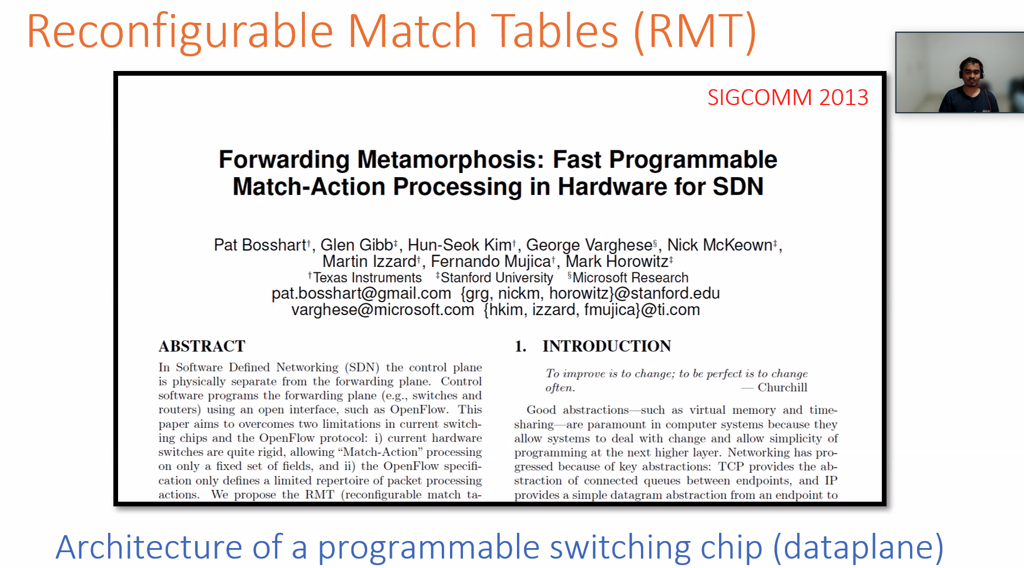
* 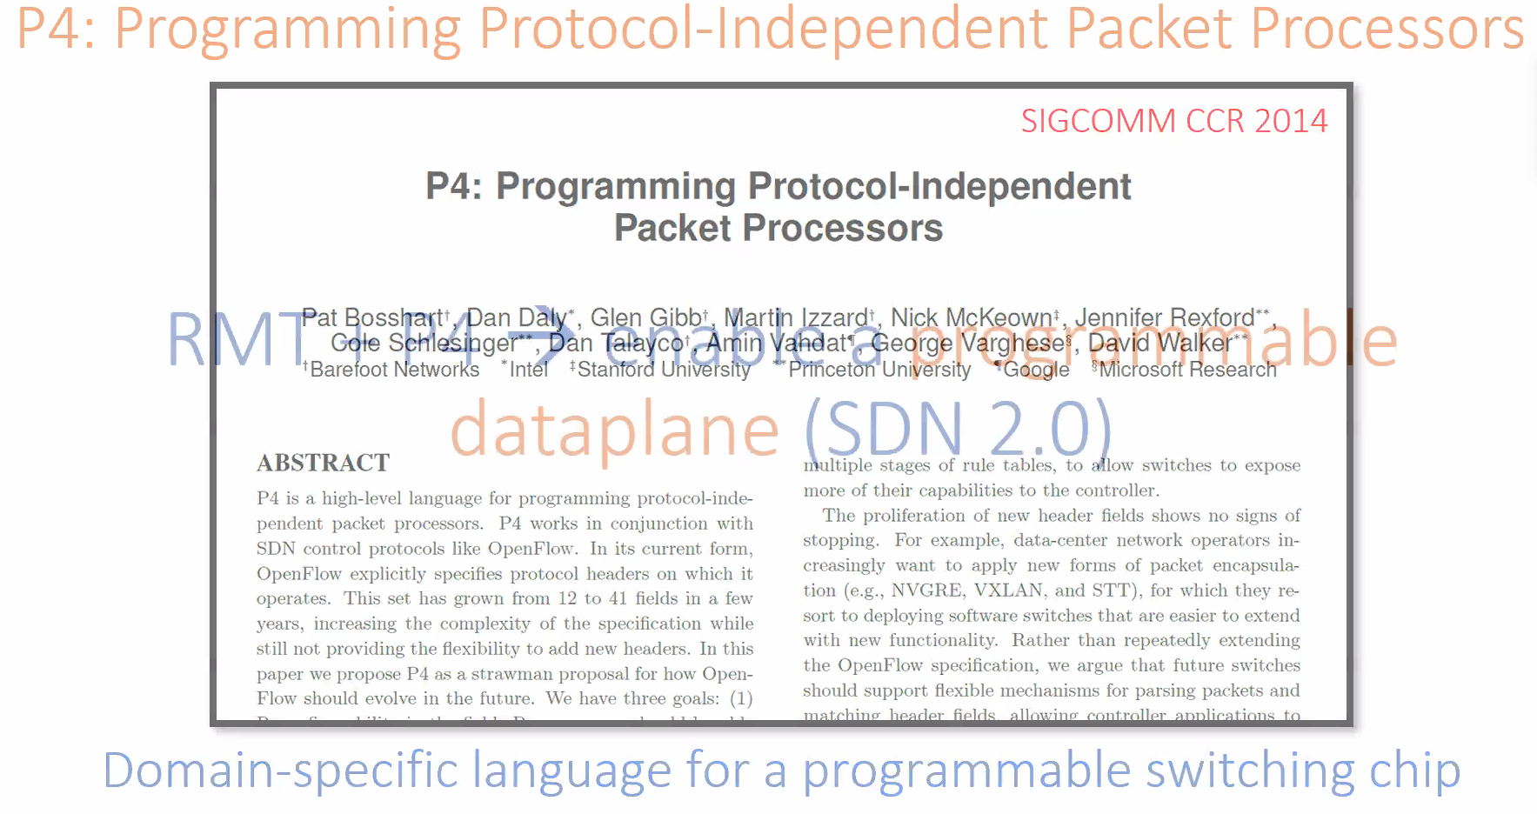
  + P4 to programmable data plane = Cuda to GPU
* 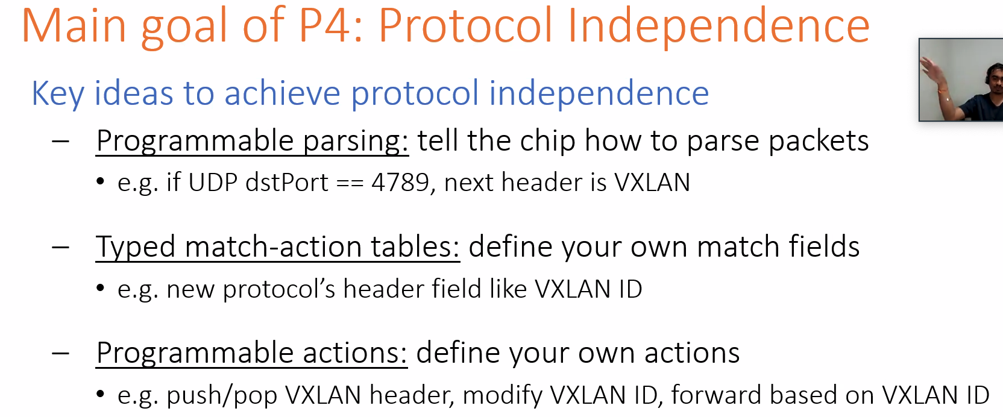
* 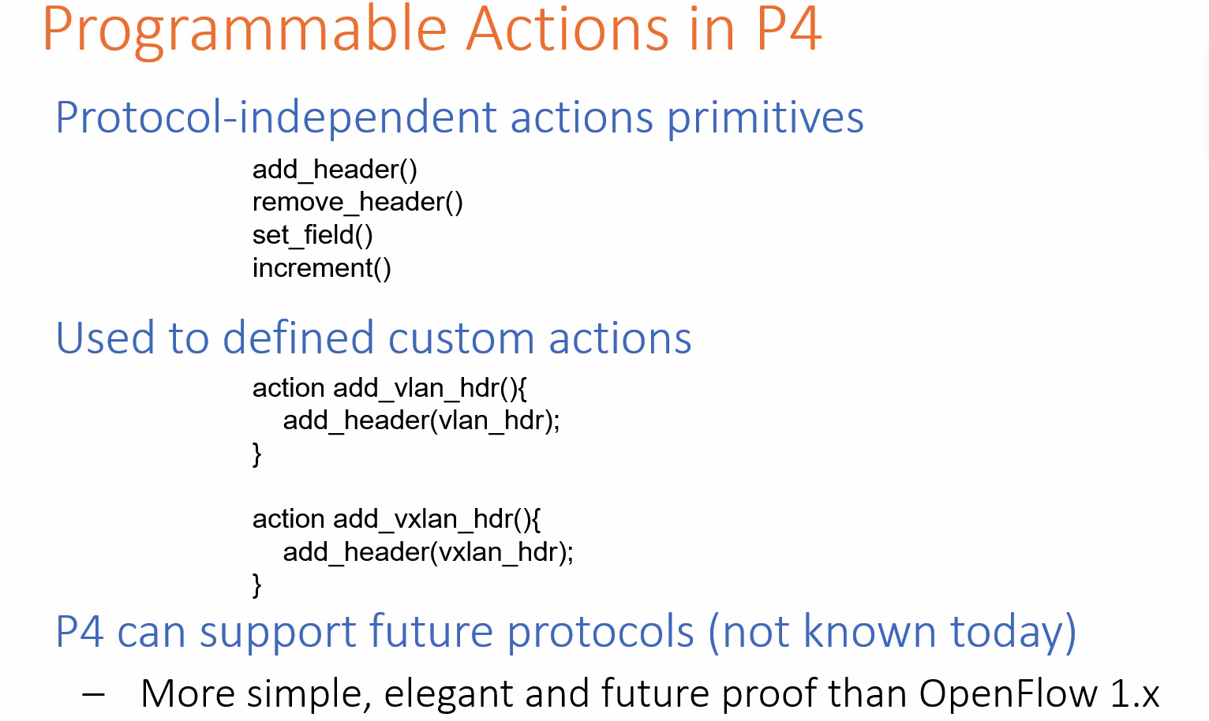
* 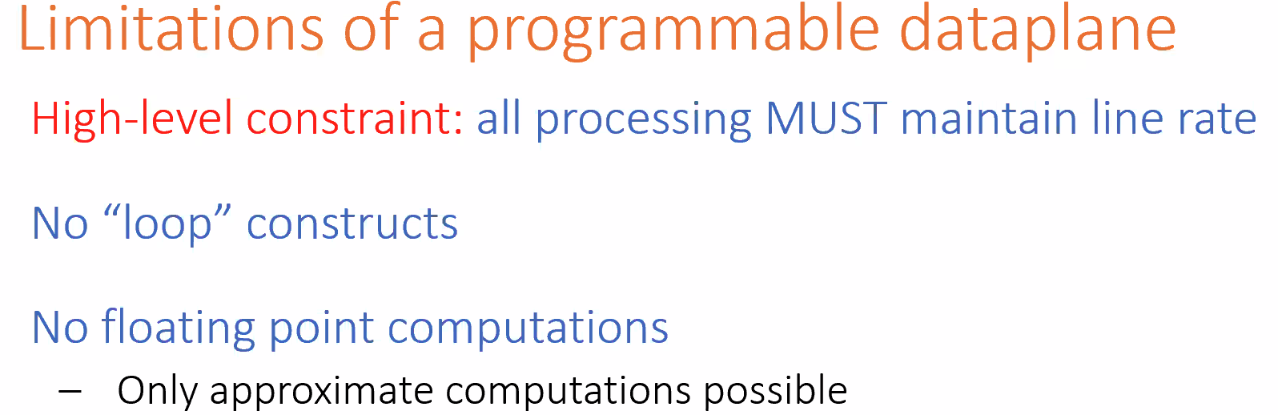
  + Fixed-function chip -- limit to packet processing
* 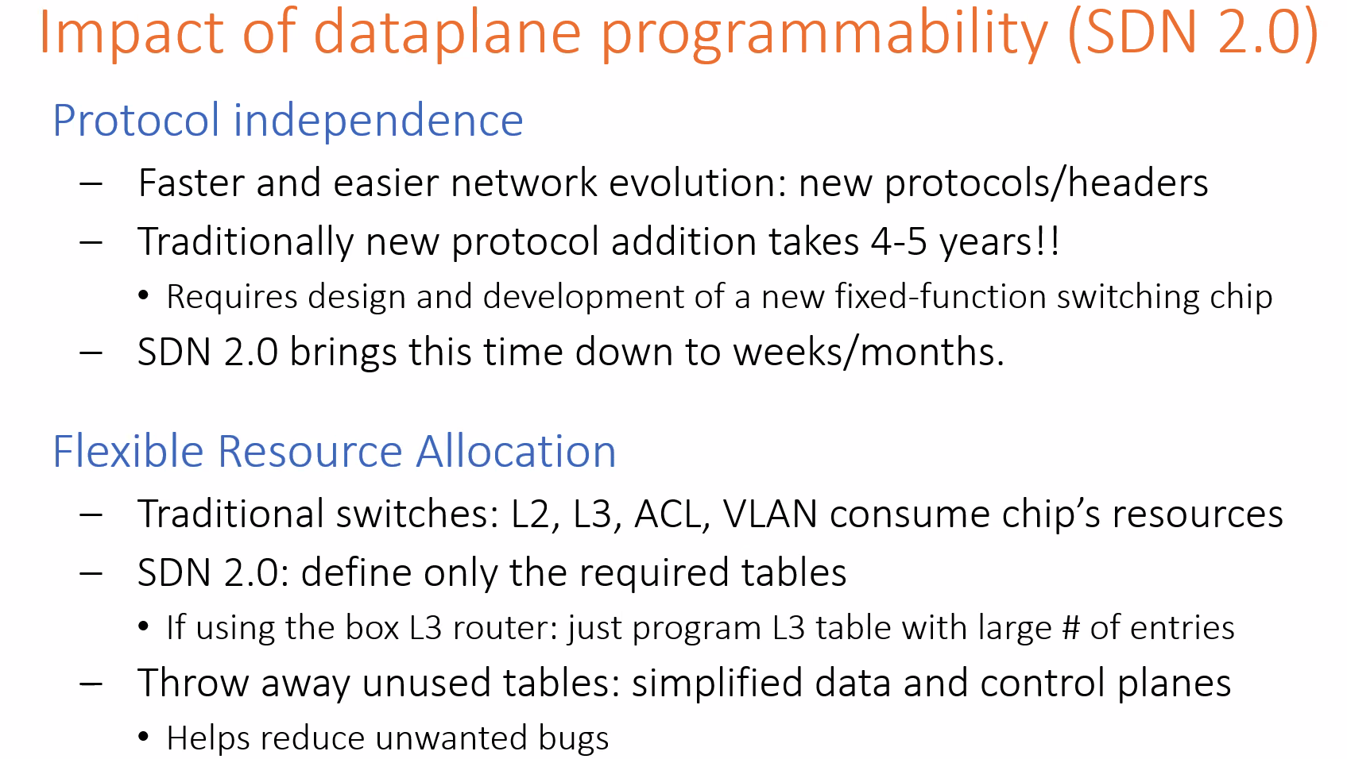
* 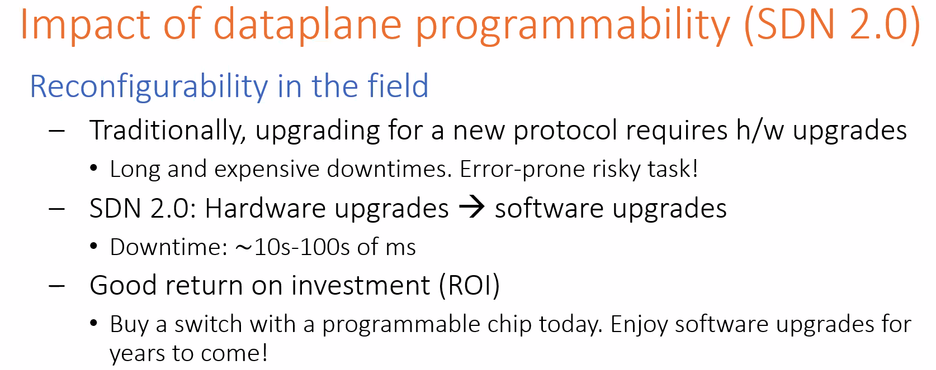
* 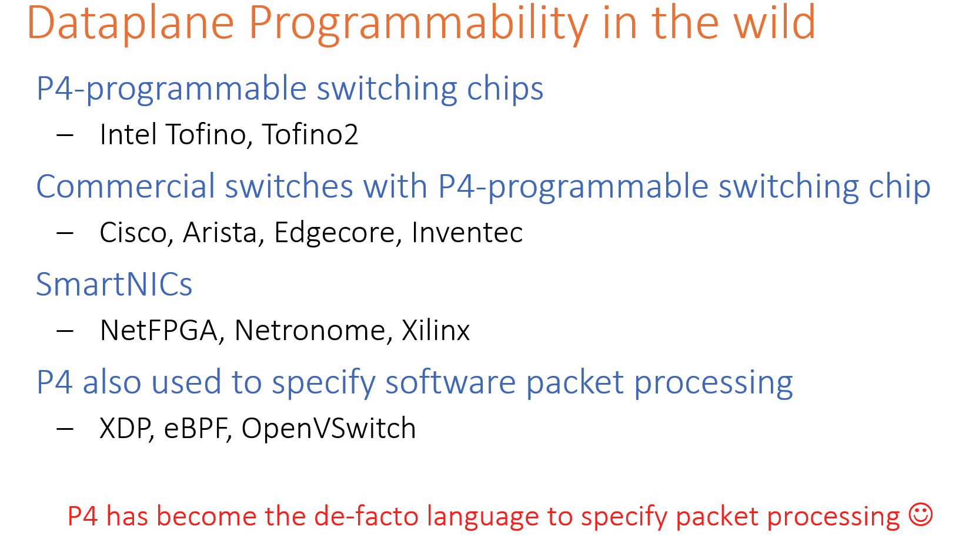
* 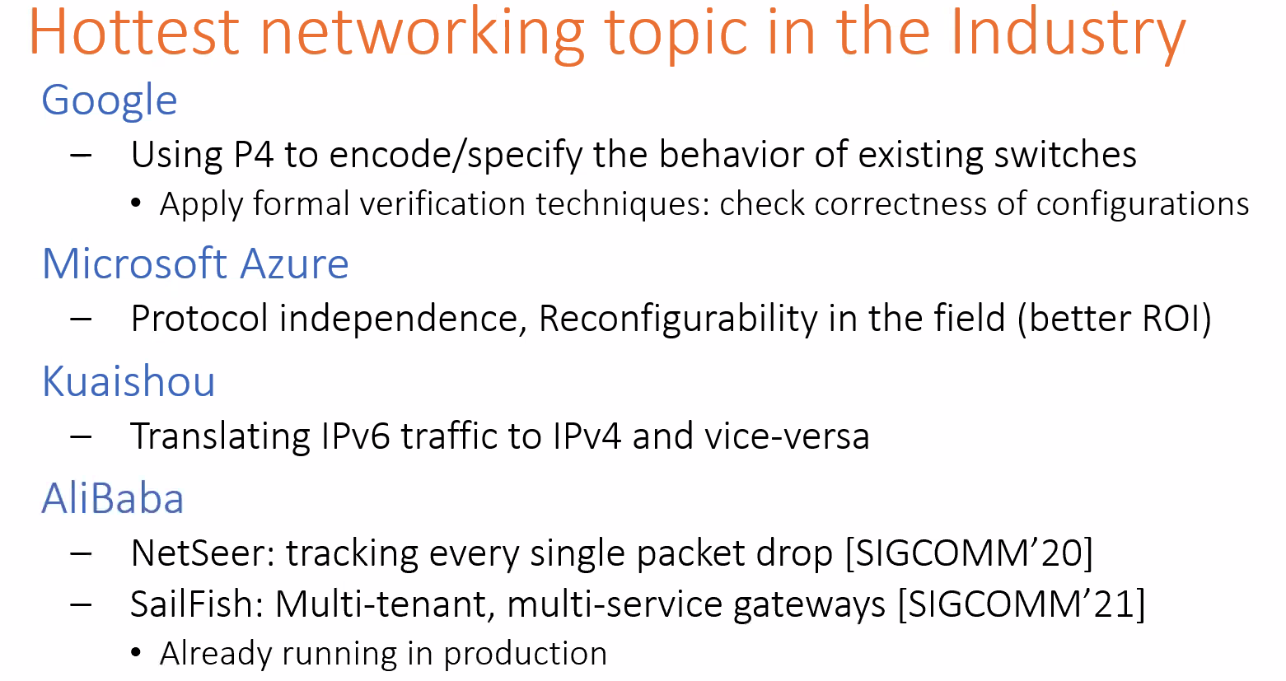
* 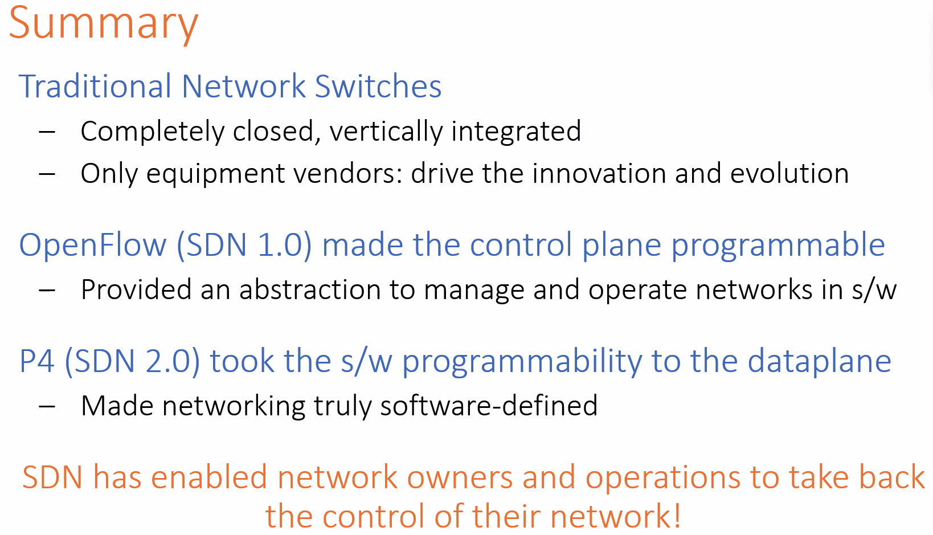

### **Lecture 8**

* 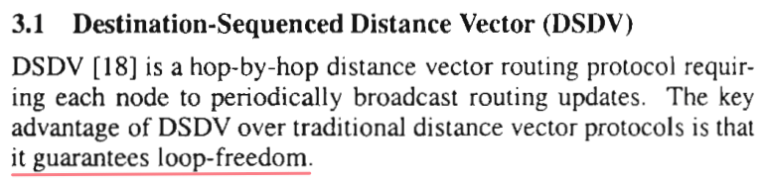
* 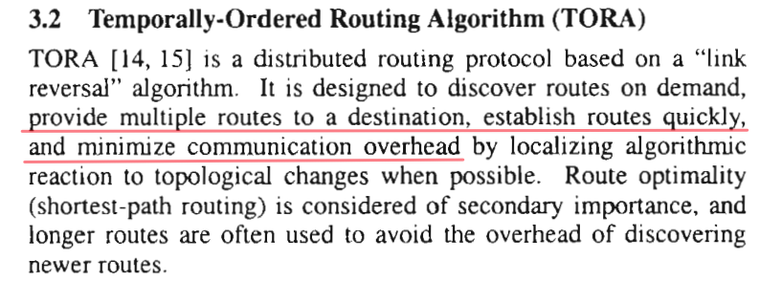
* 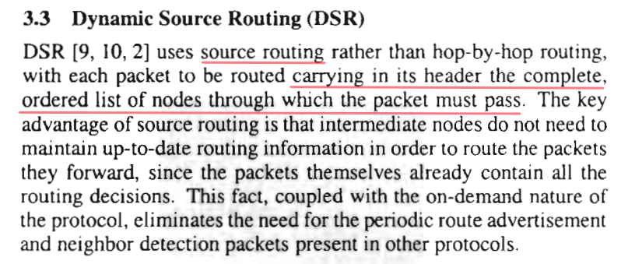
* 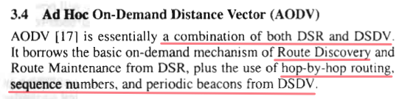
  + Spread? How to find the shortest?
* 
* 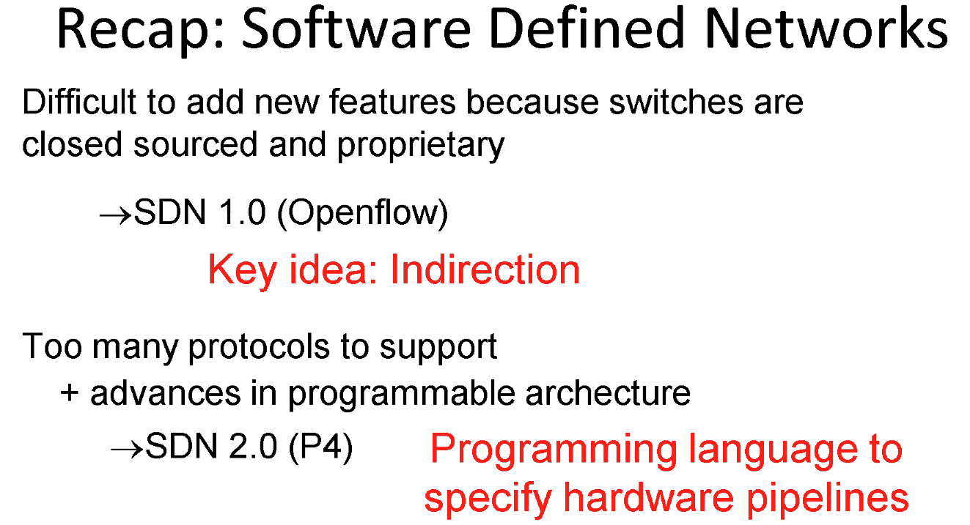
* 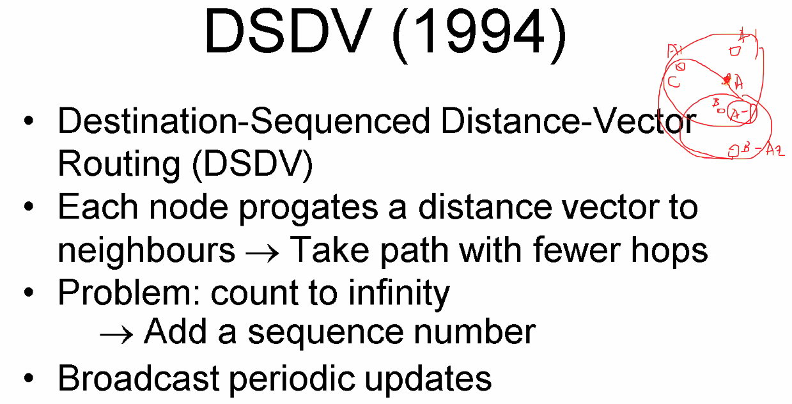
  + Sequence number: check recent (similar to timestamp)
* 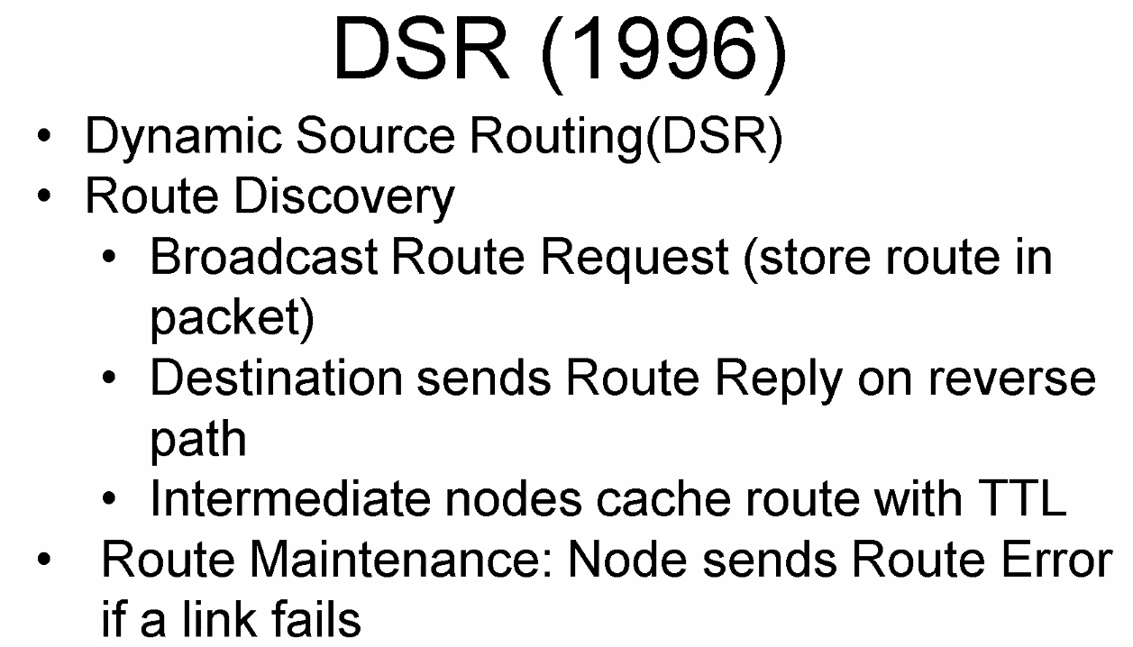
* 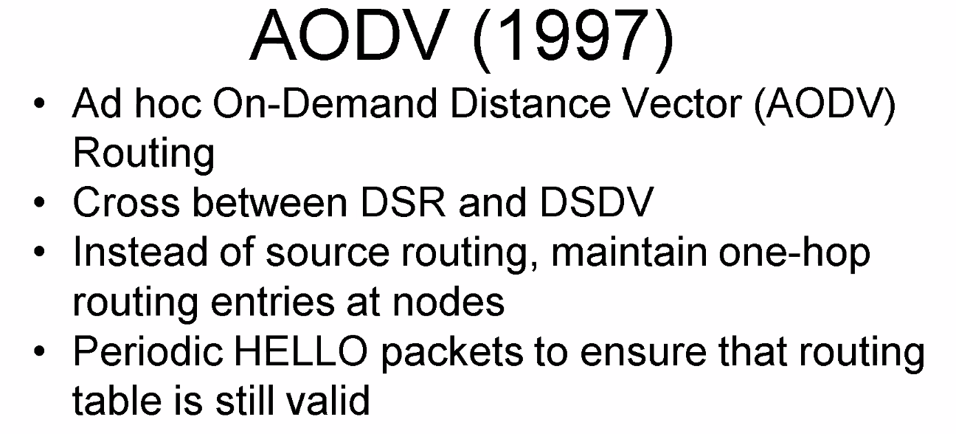
* 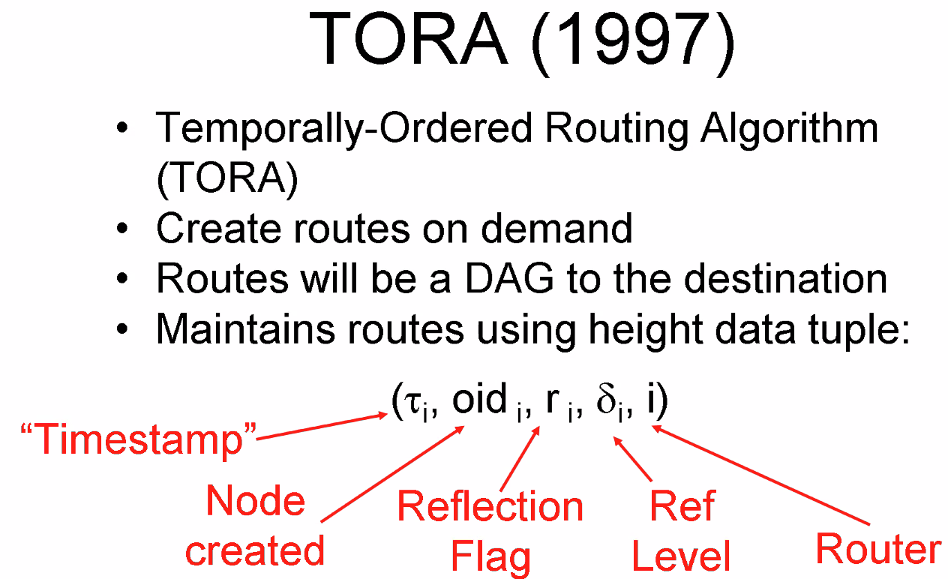
* 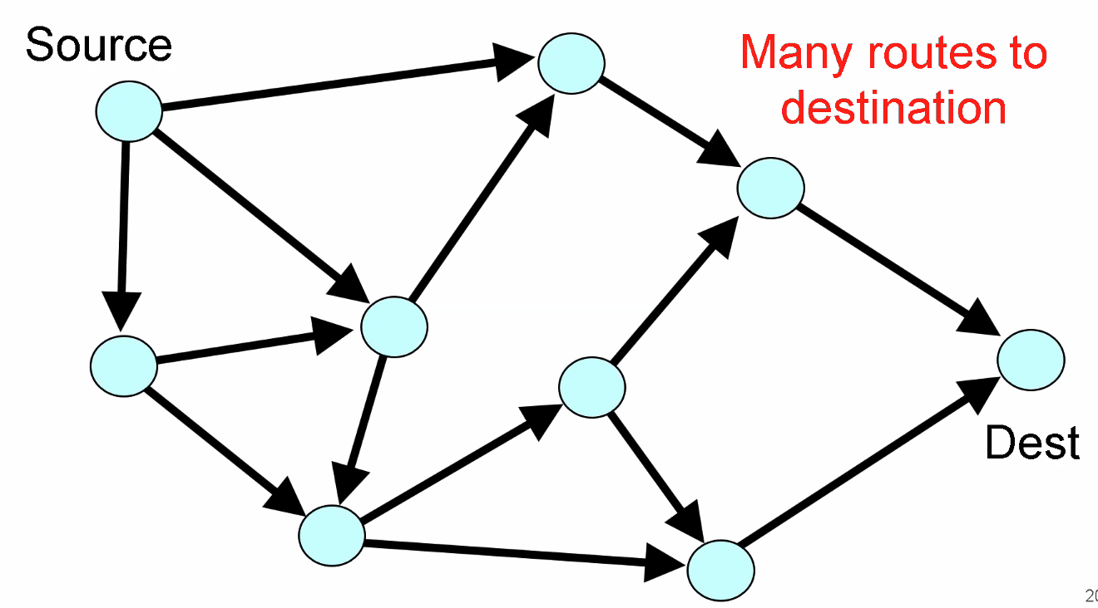
* 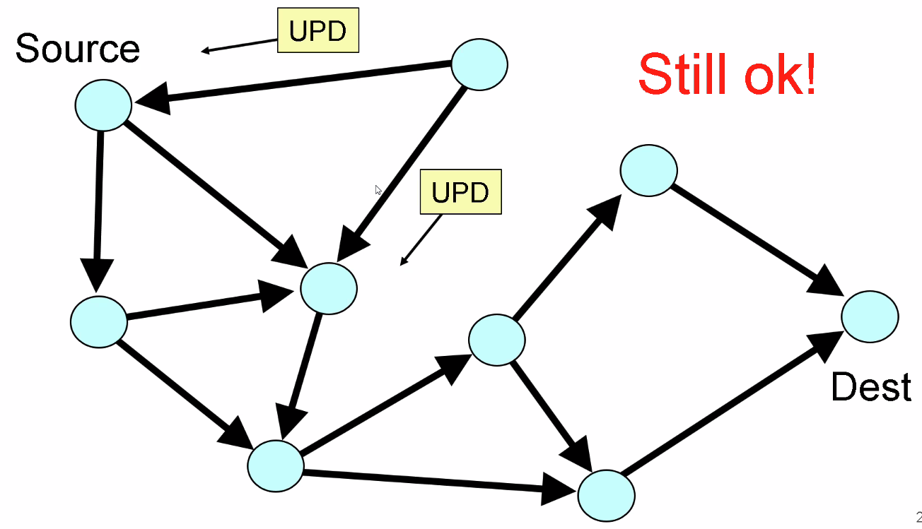
* 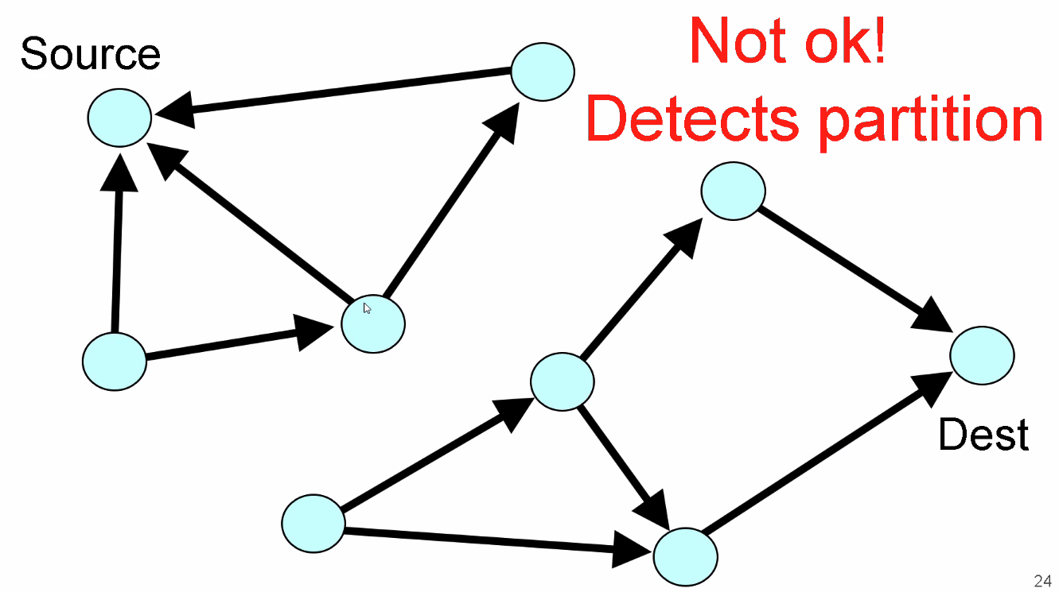
* 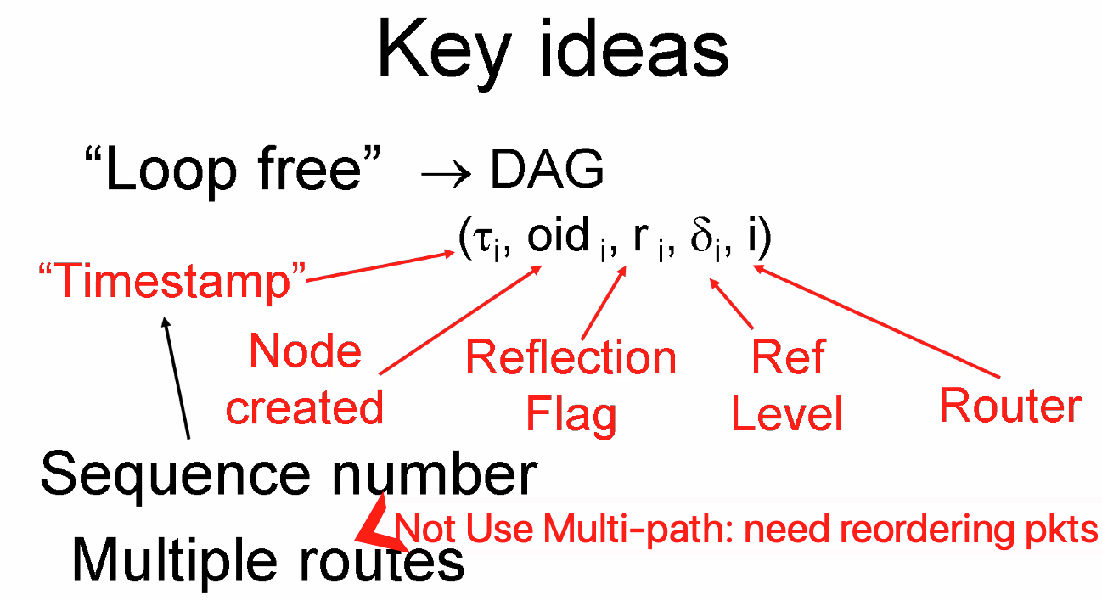
* 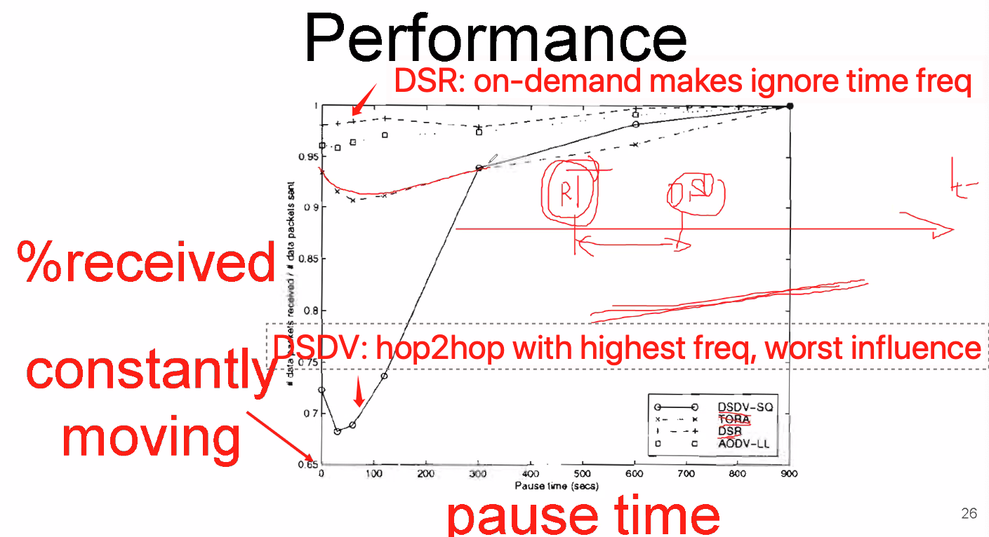
* 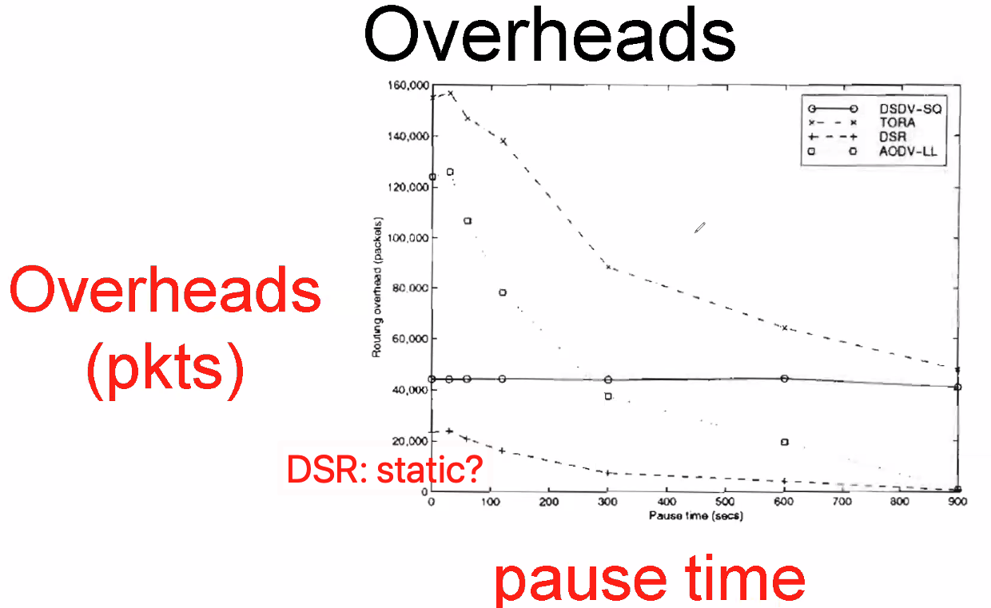
* 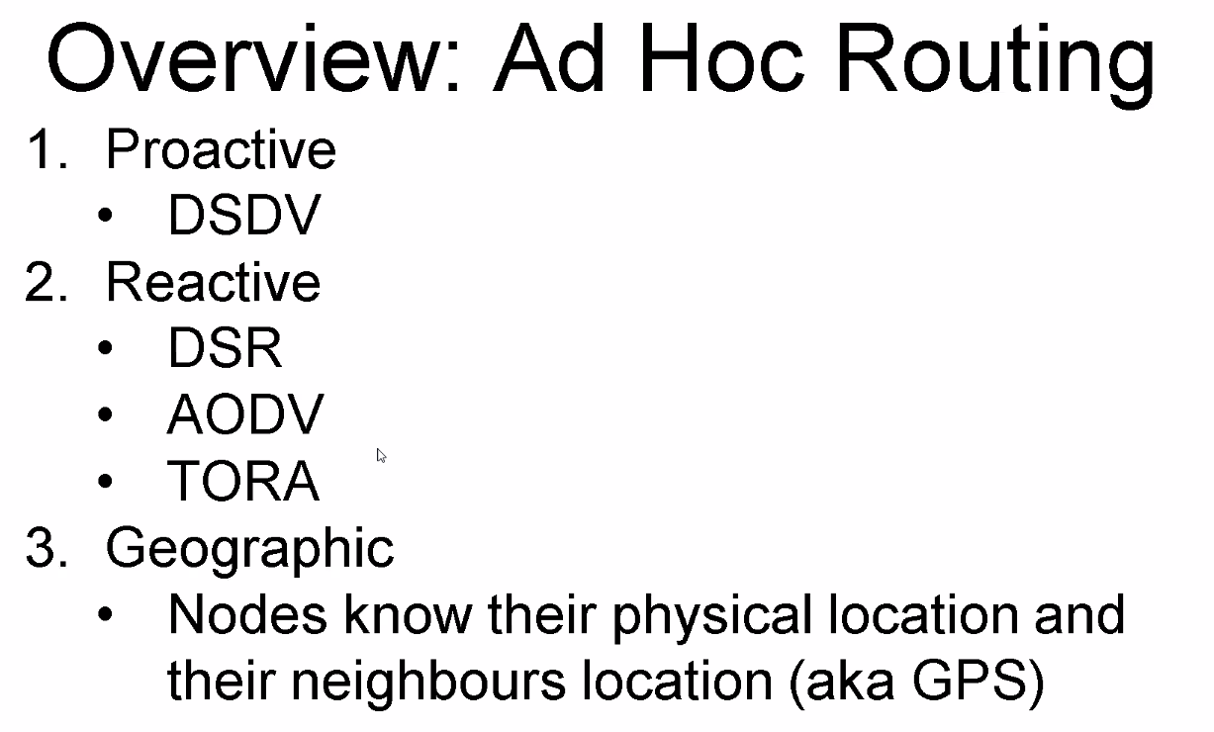
* 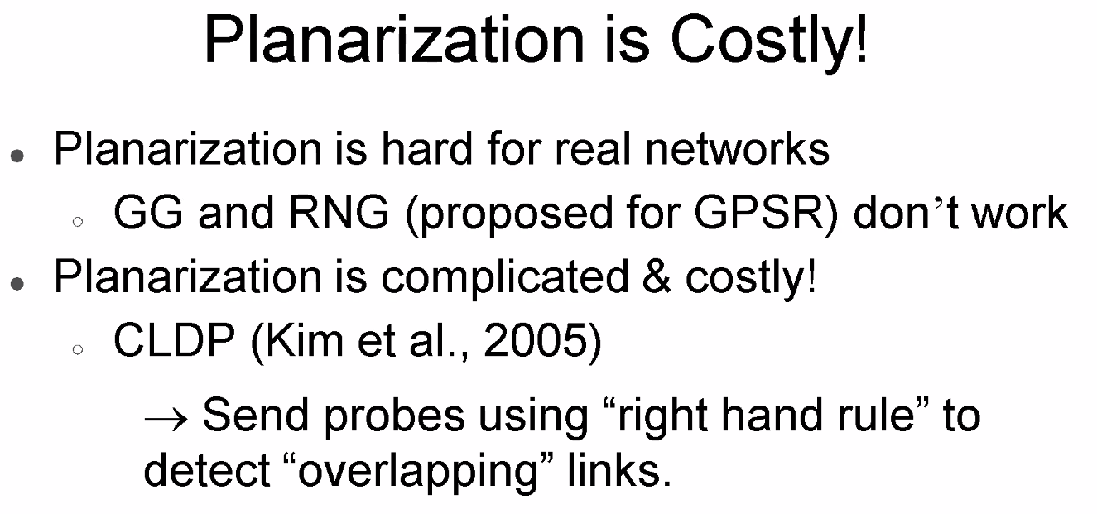
* 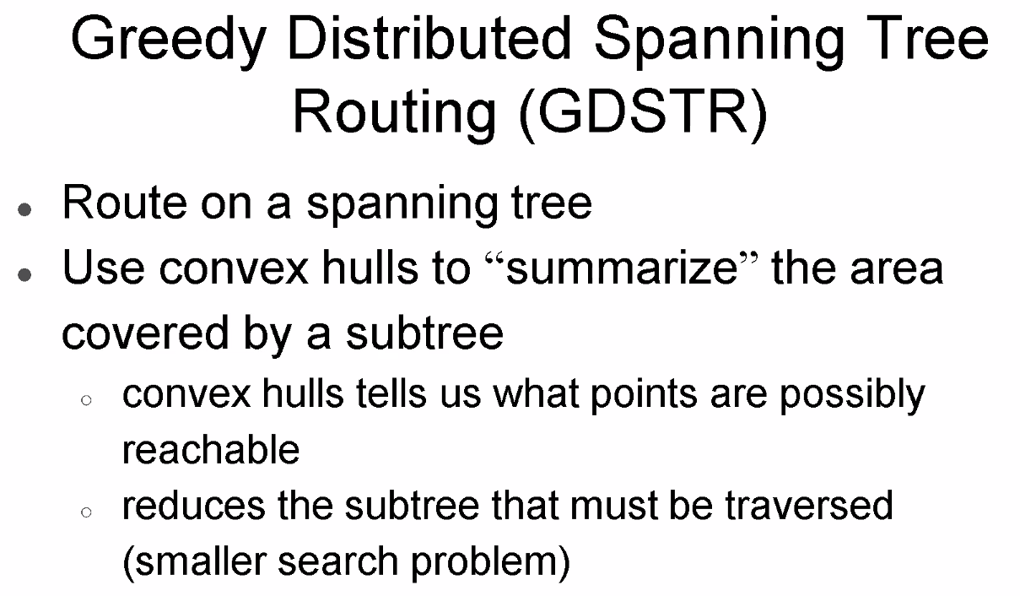
* 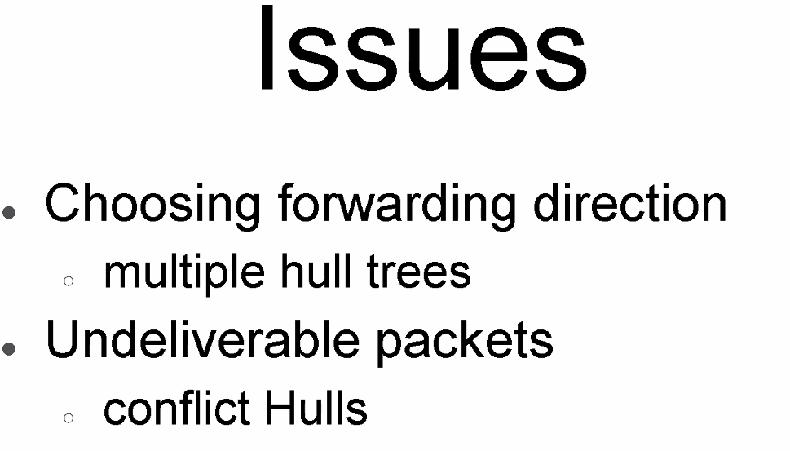
* 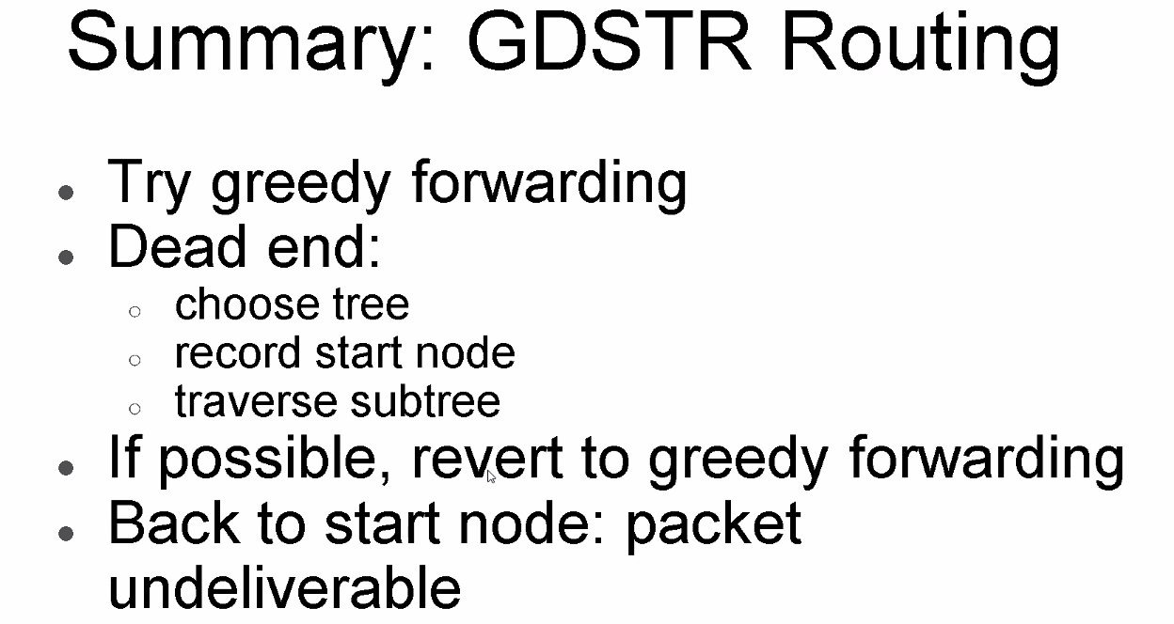
* 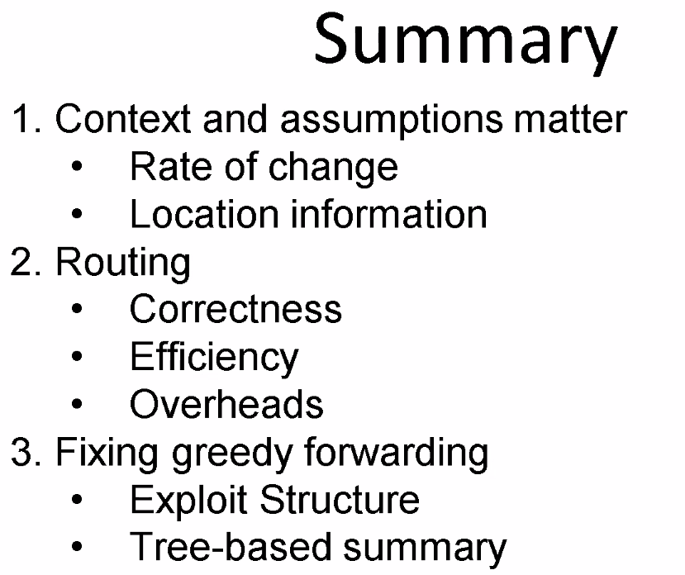
  + Tree to summarize space spread
* 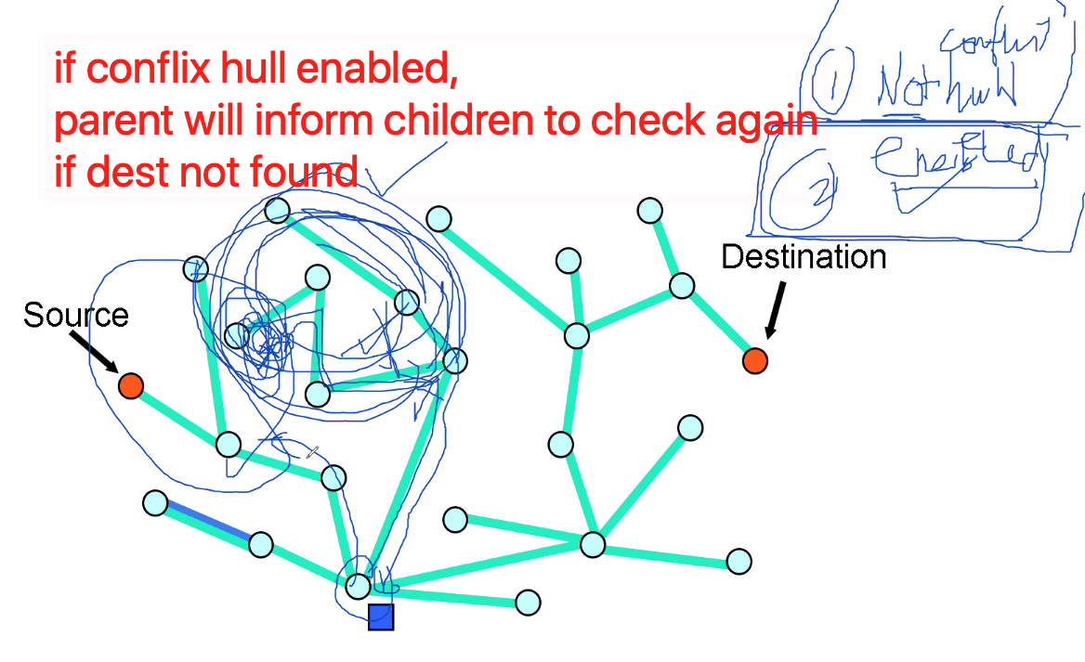

### **Lecture 9**

* 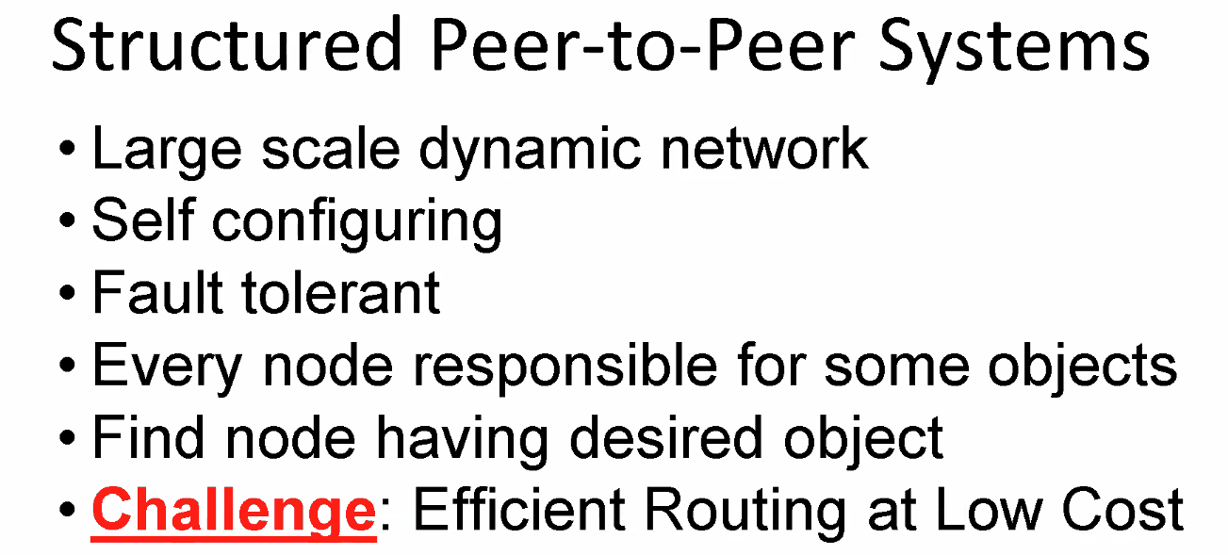
* 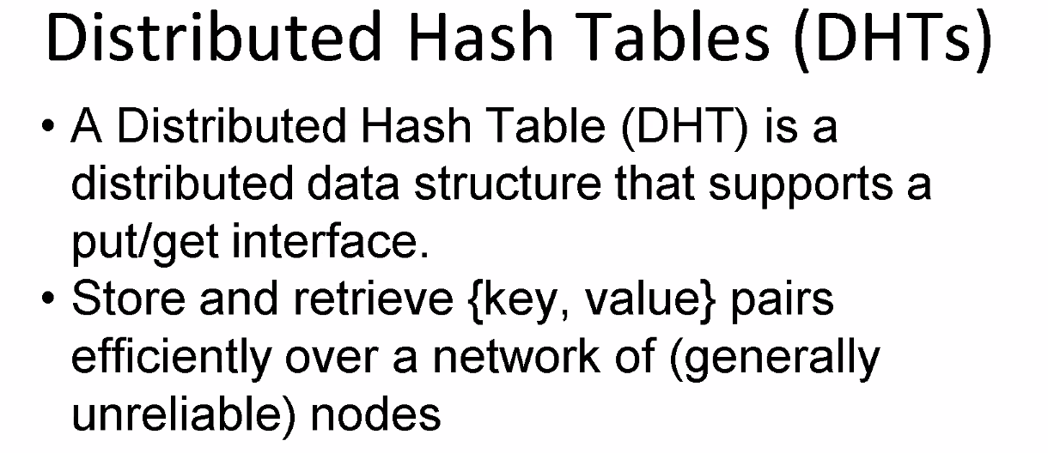
* 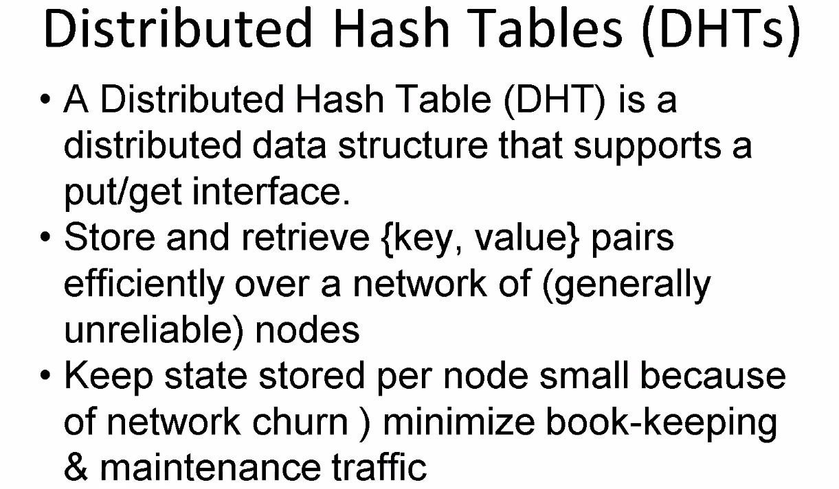
* 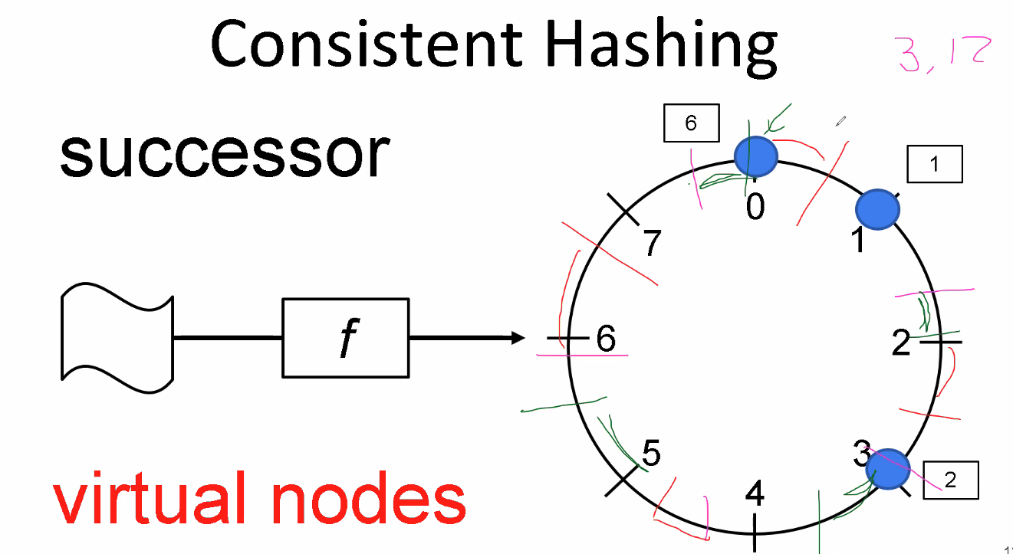
  + Make nodes in charge of the space equally
    - 每个node平分空间
  + Uniform hash function not lead to balanced hashing
* 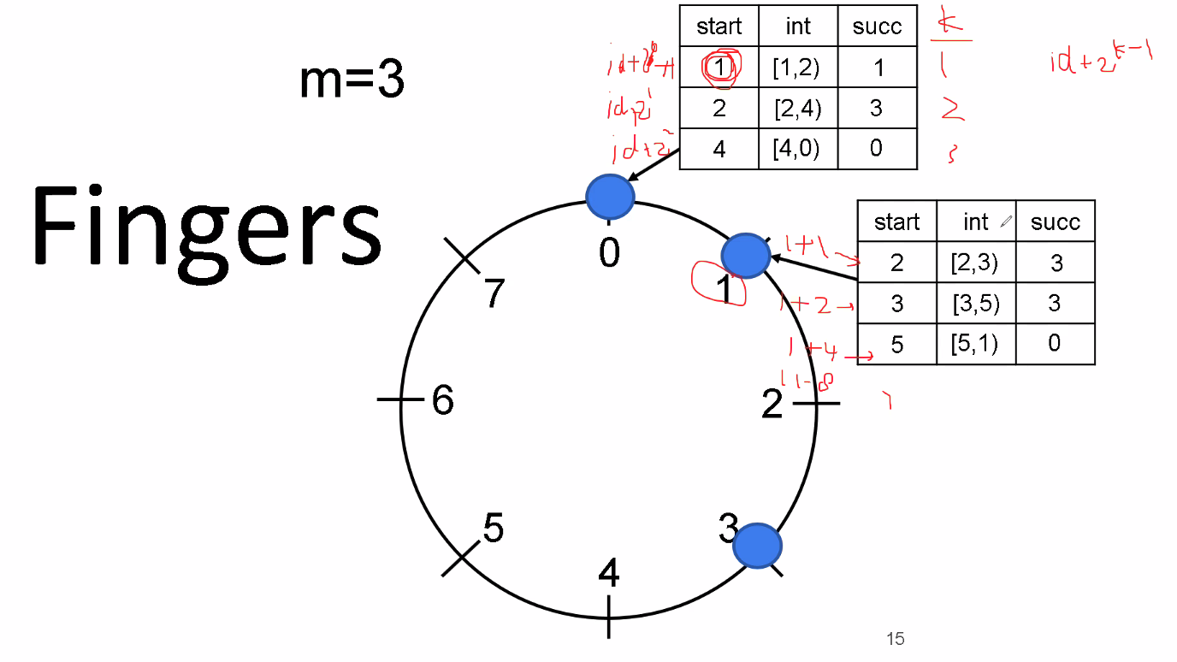
* 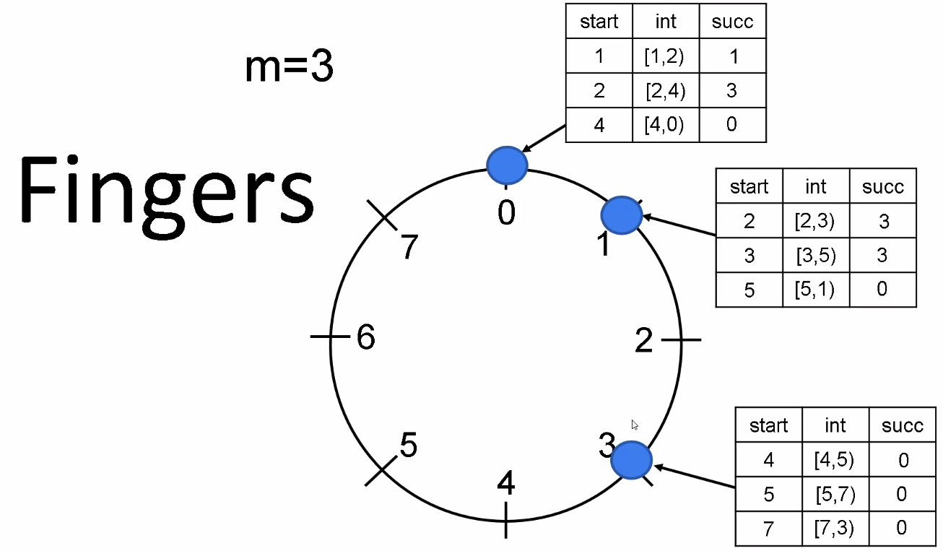
  + 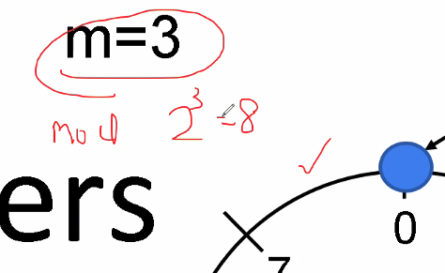
* 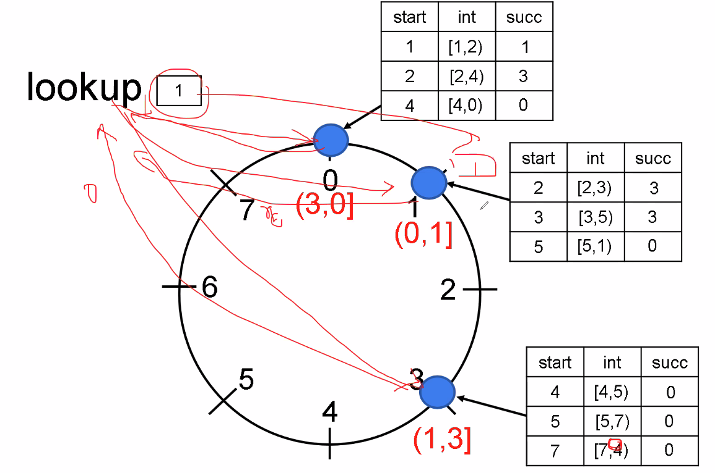
* 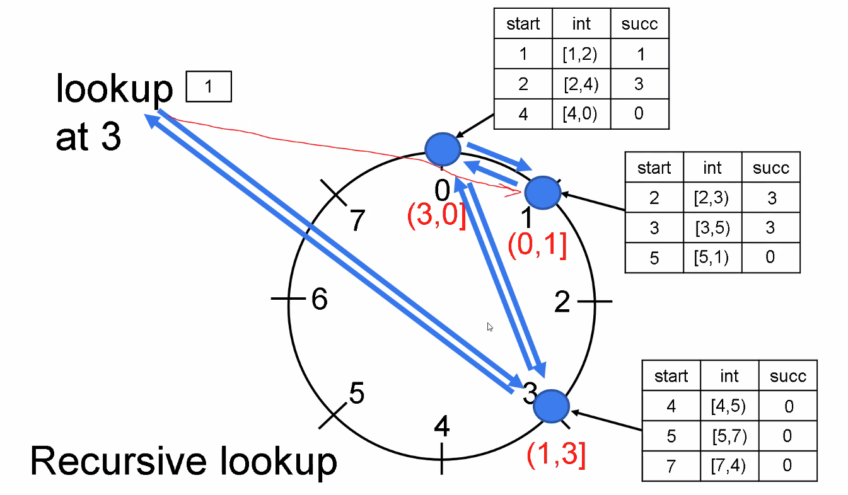
* 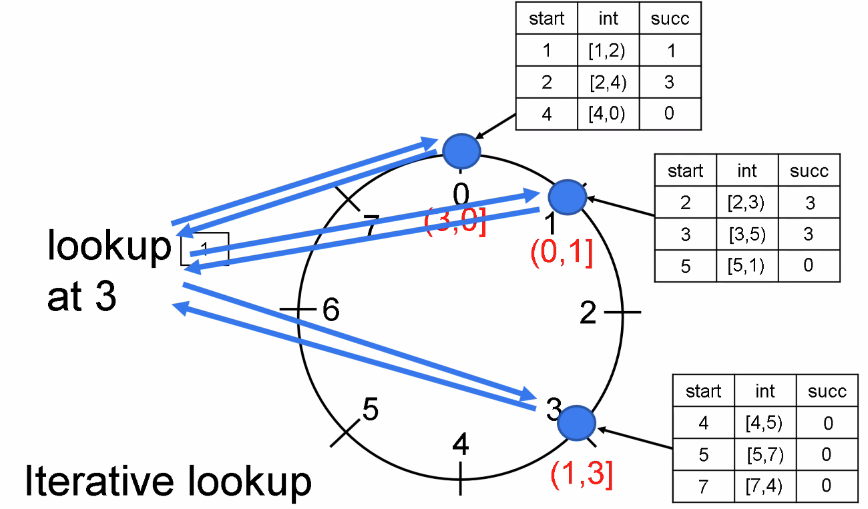
* 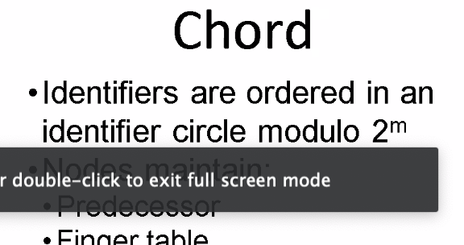
* 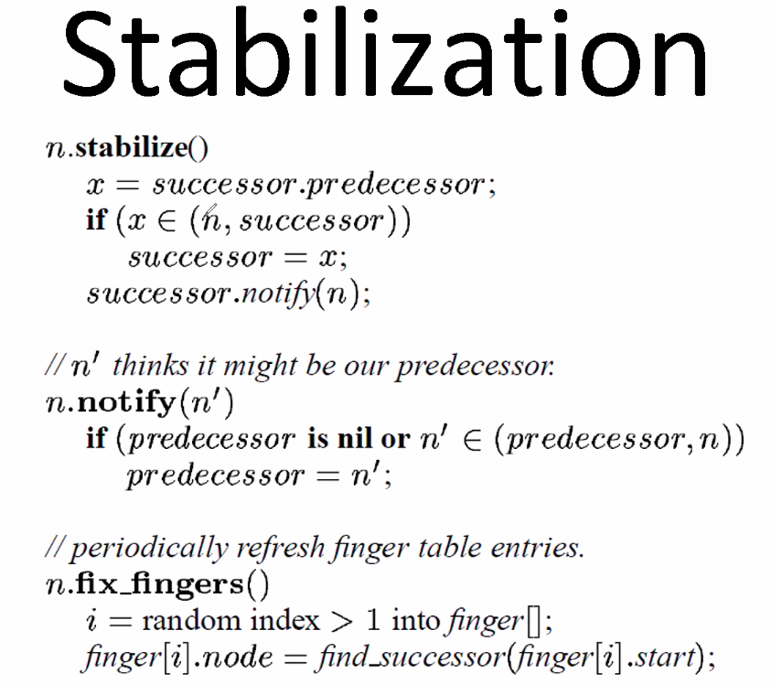
* 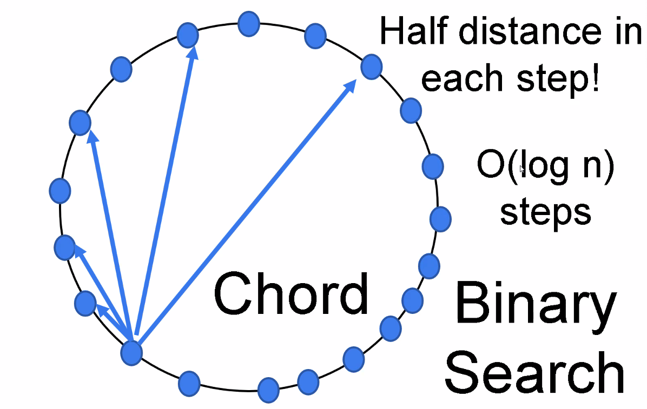
* 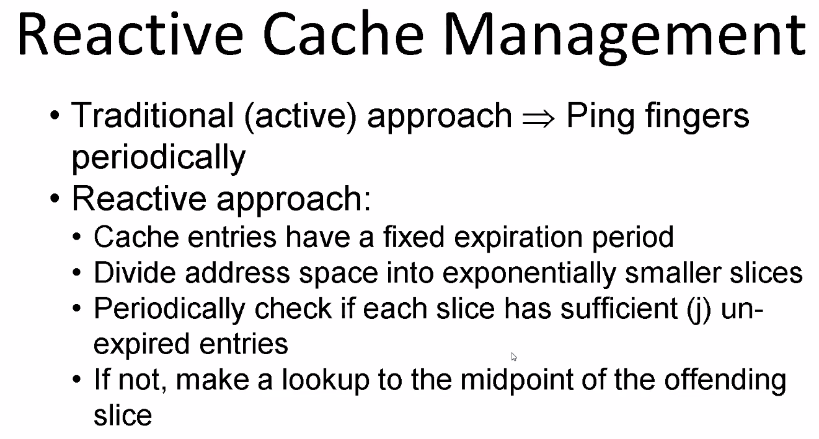
* 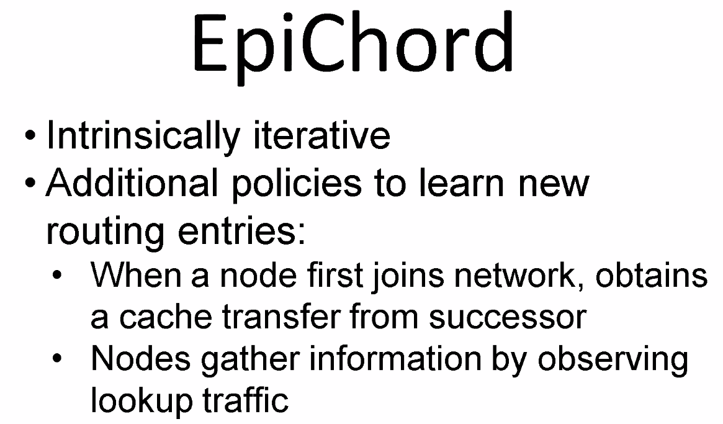
* 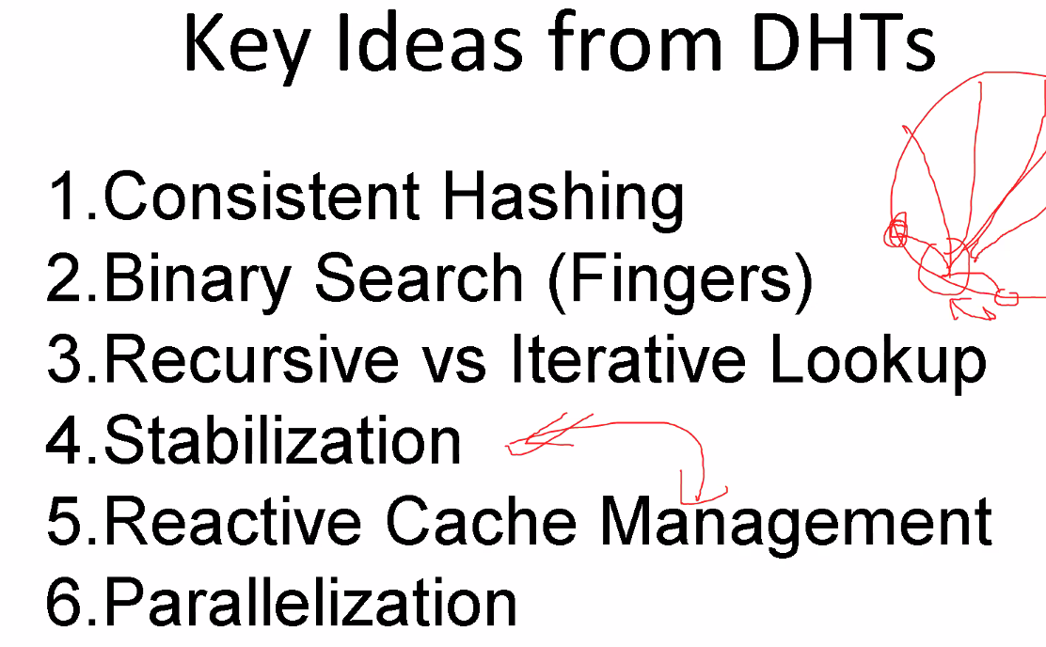
* 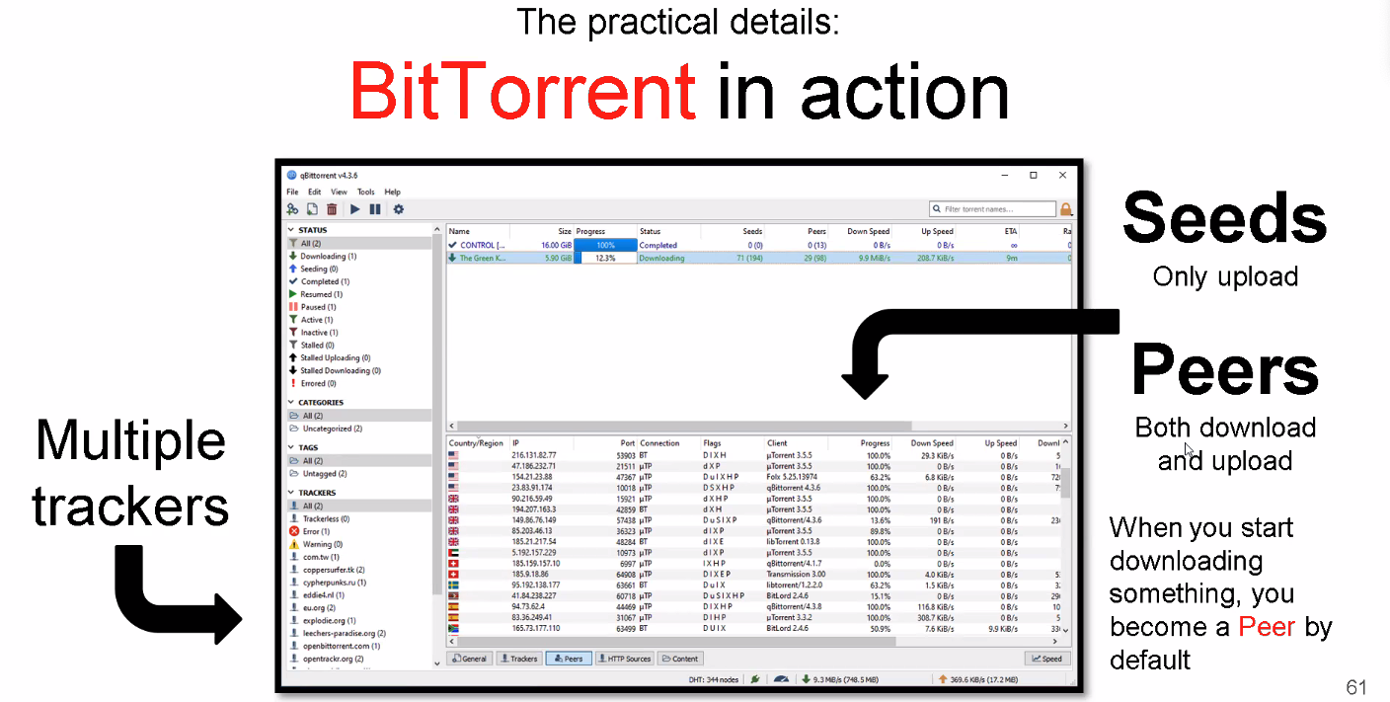
* 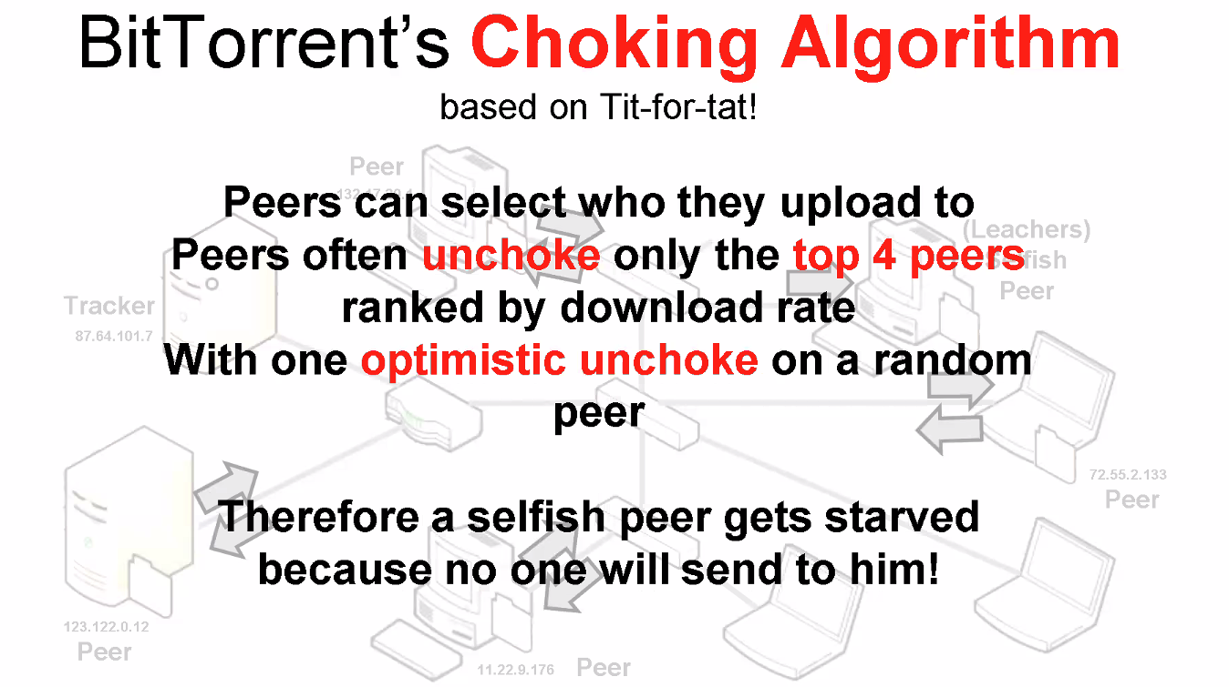
* 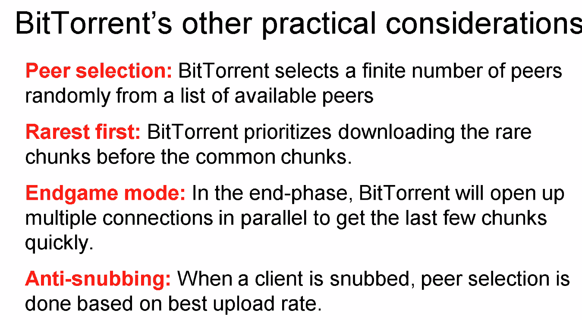
* 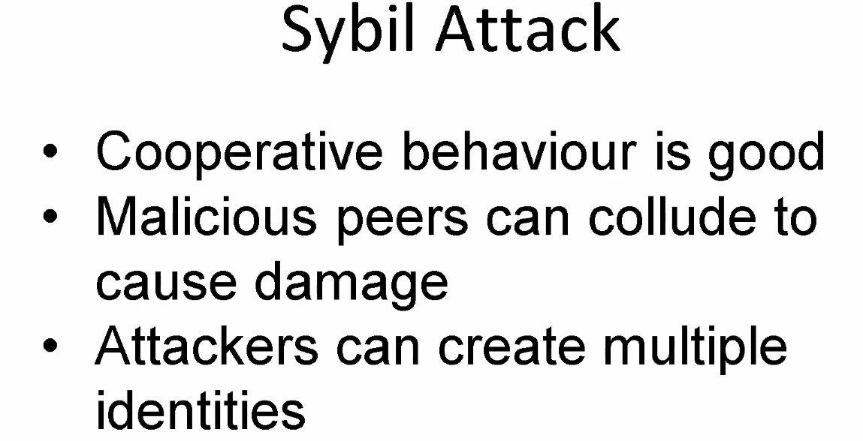
* 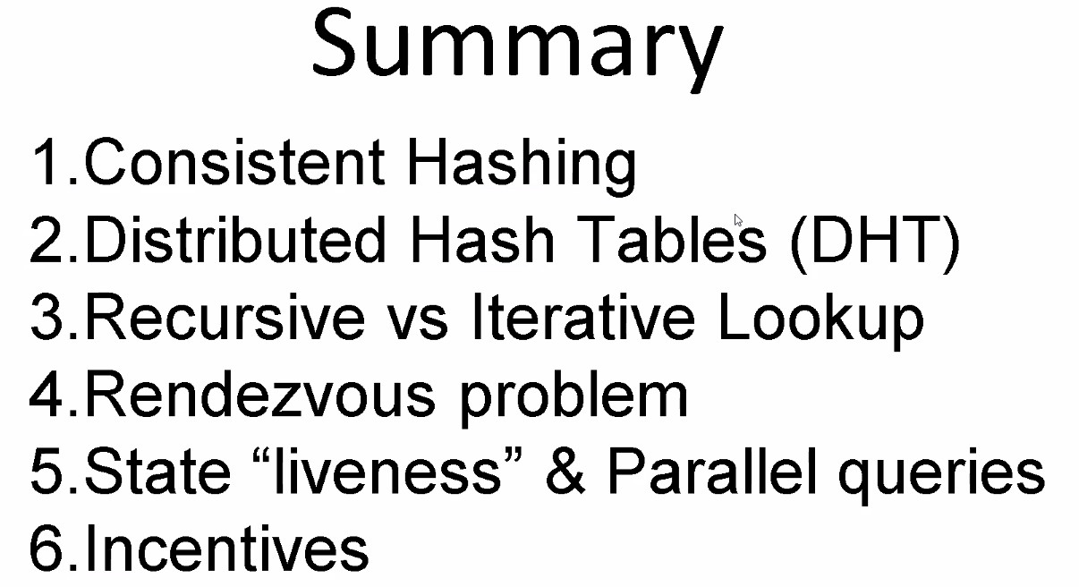

### **Lecture 10**

* 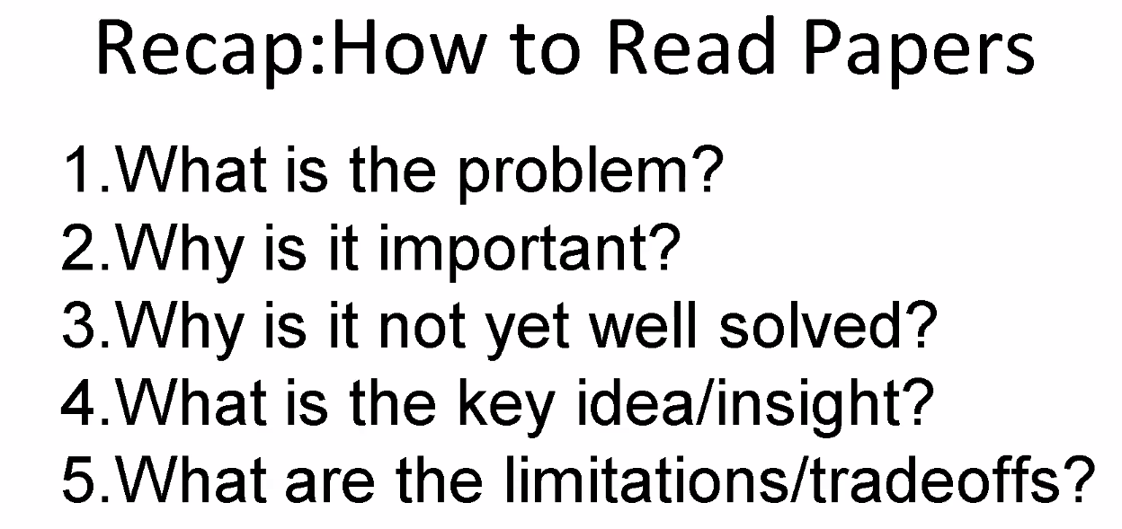
* 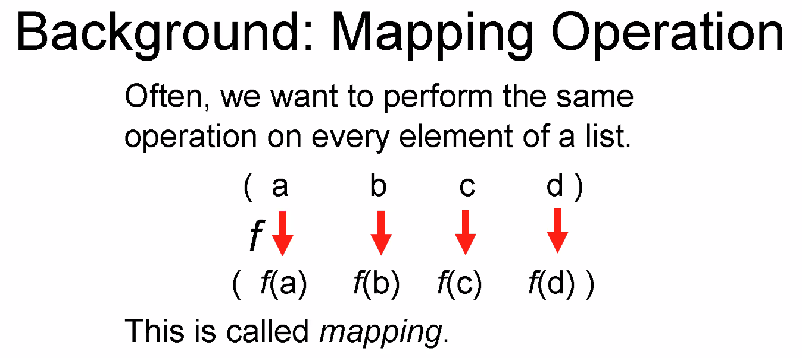
* 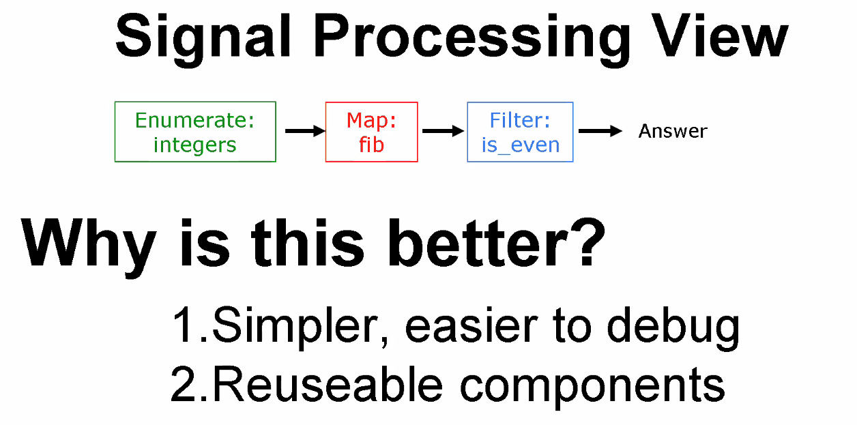
* 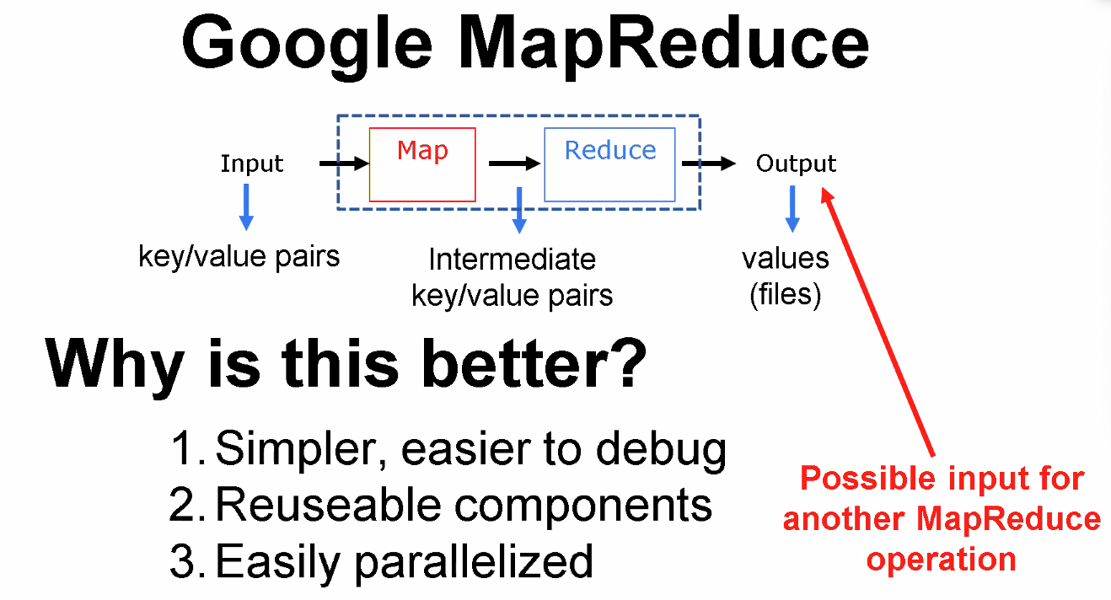
* 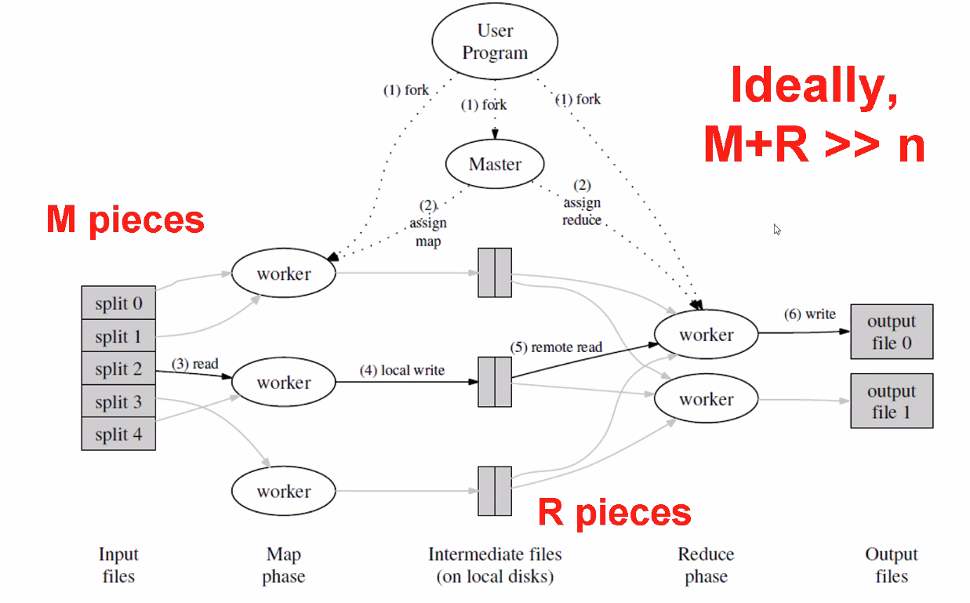
* 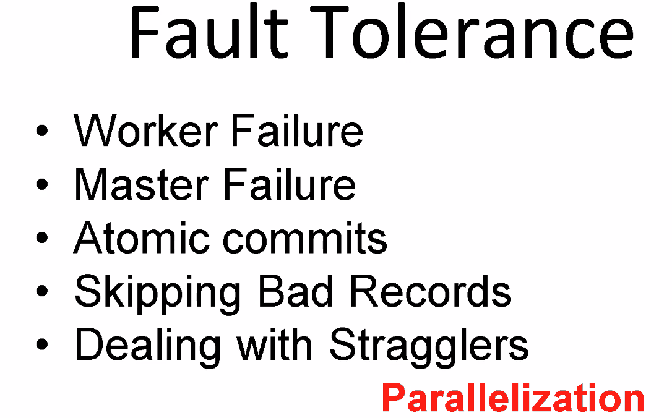
* 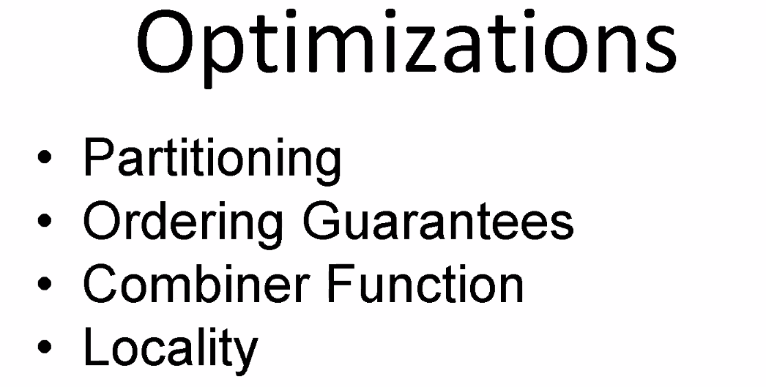
* 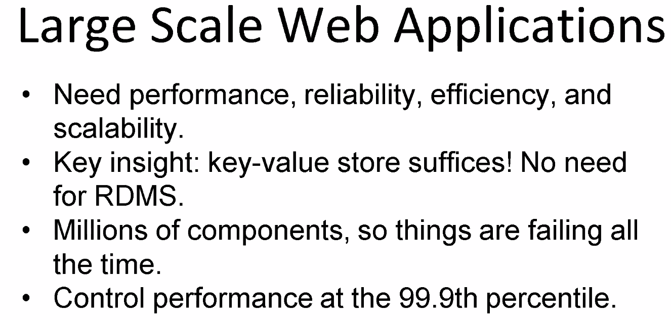
* 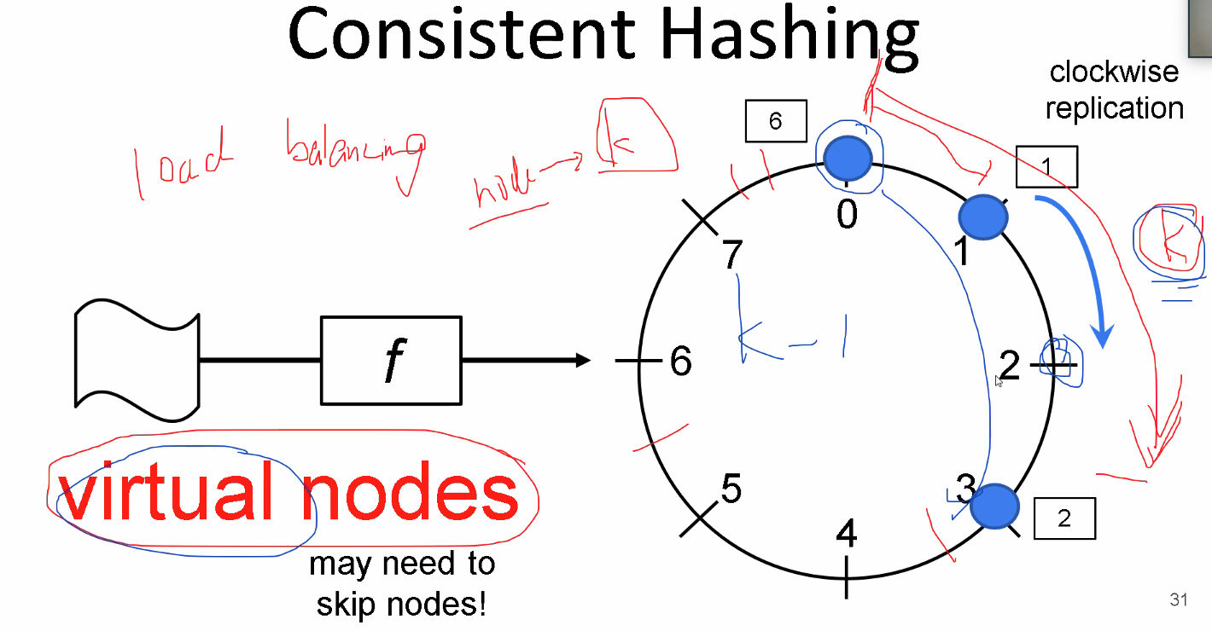
* 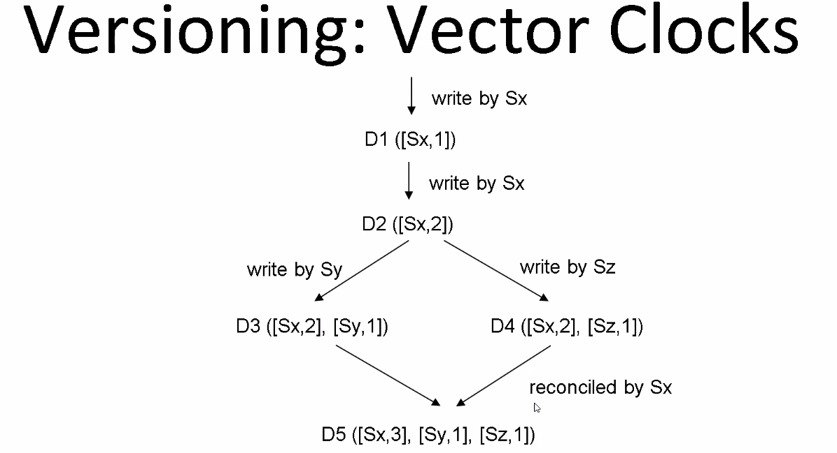
* 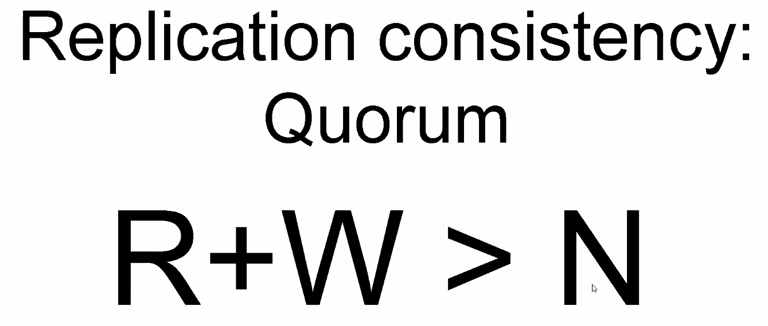
* 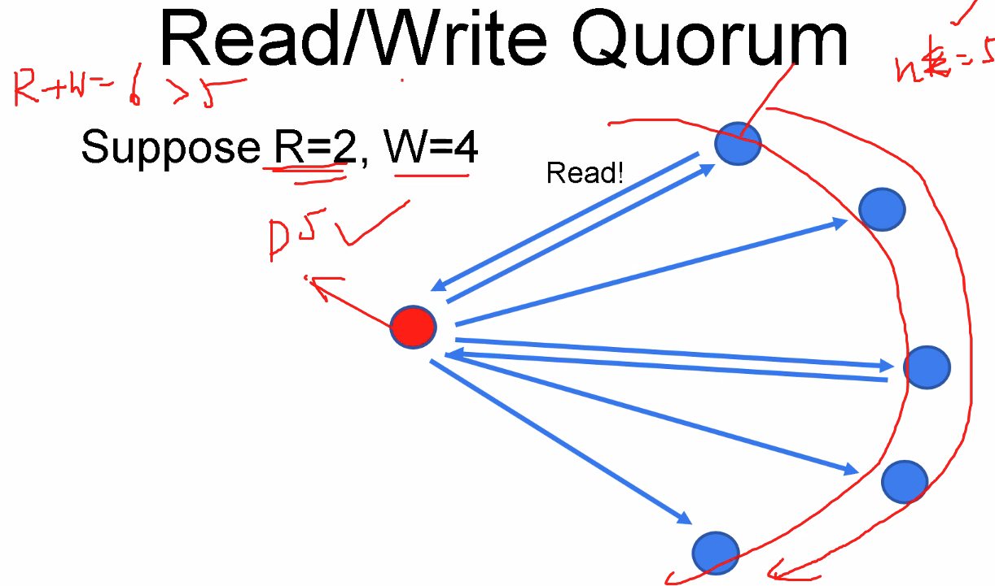
* 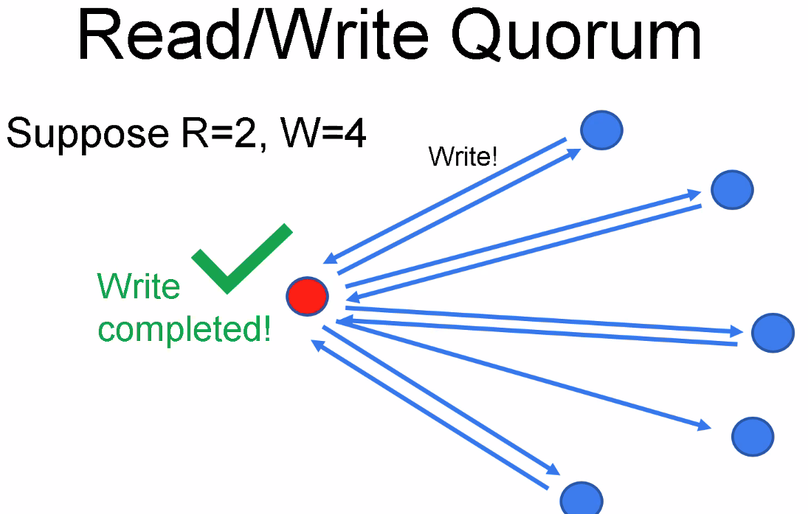
* 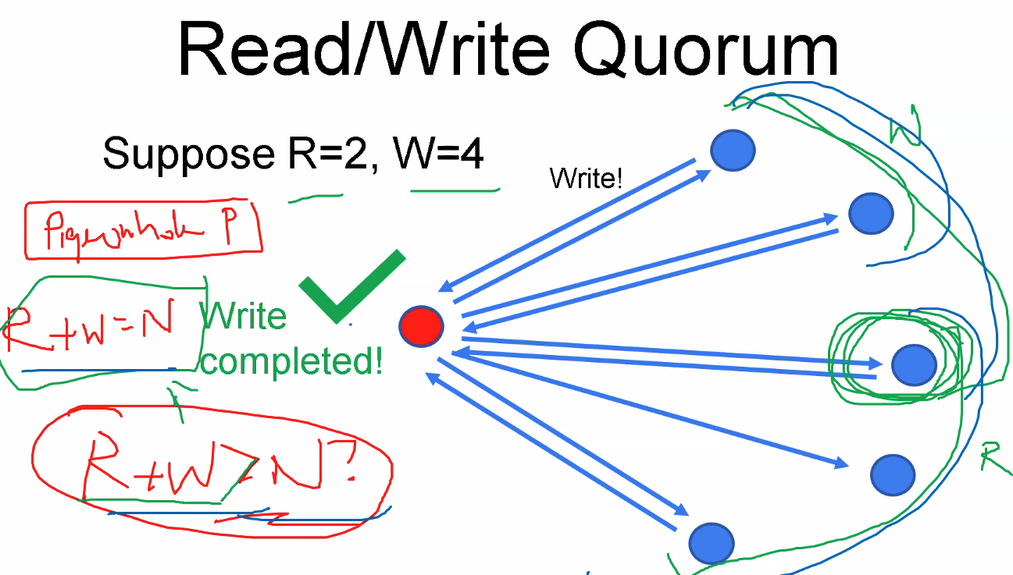
* 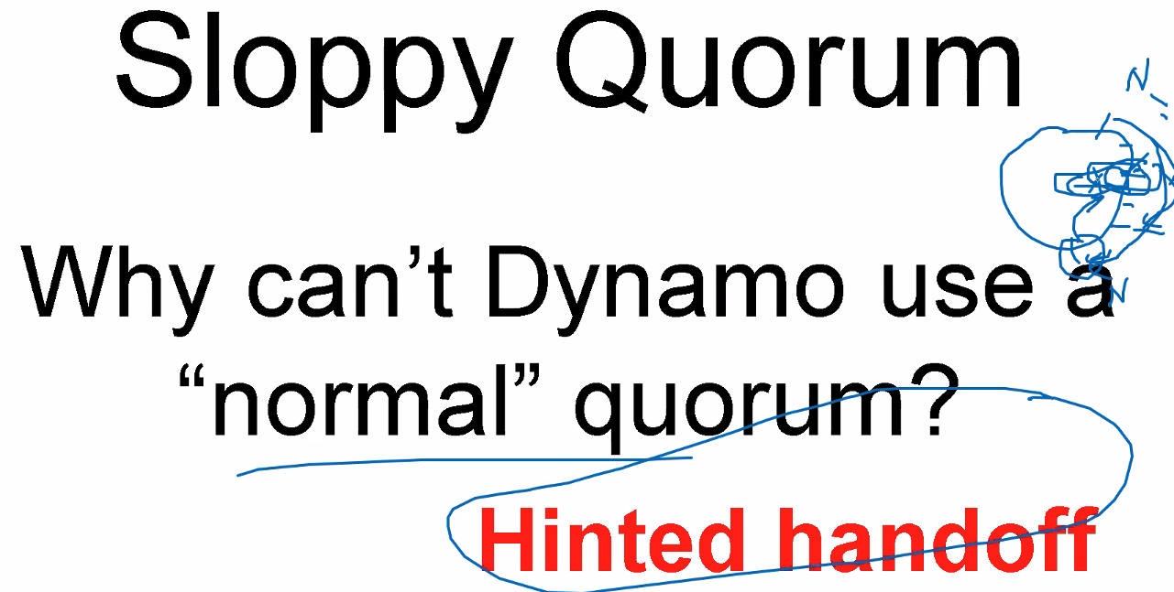
* 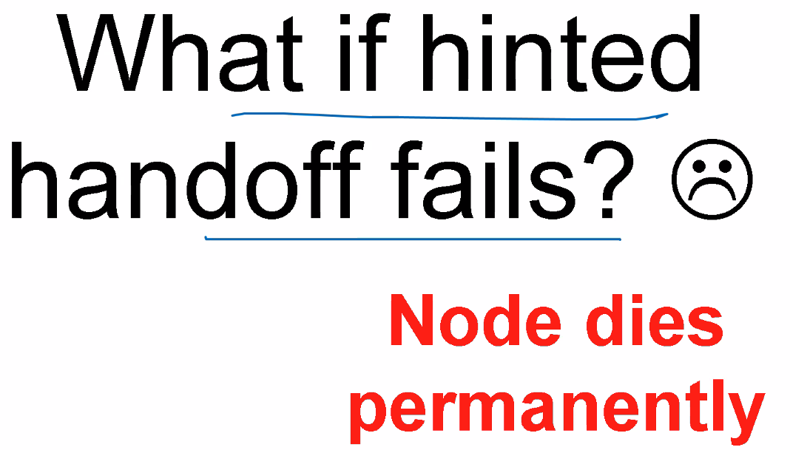
* 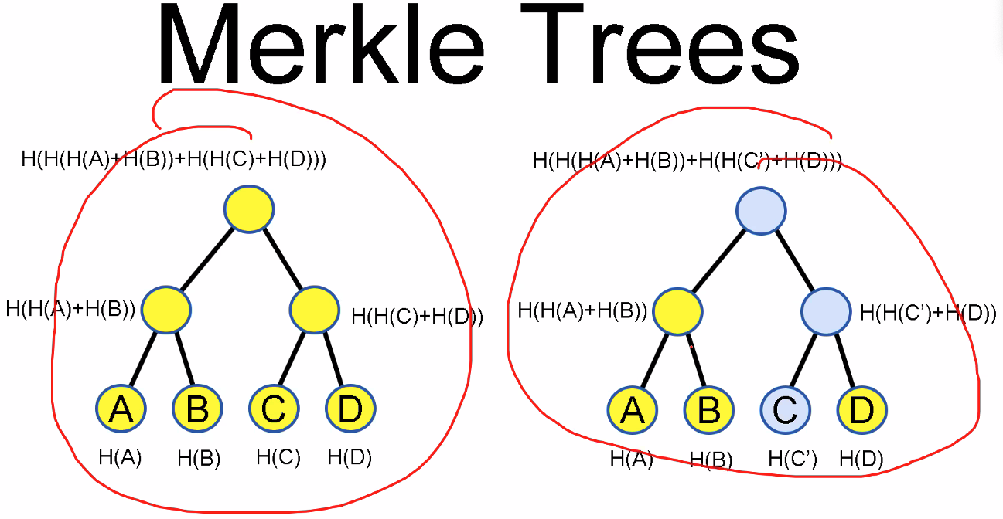
* 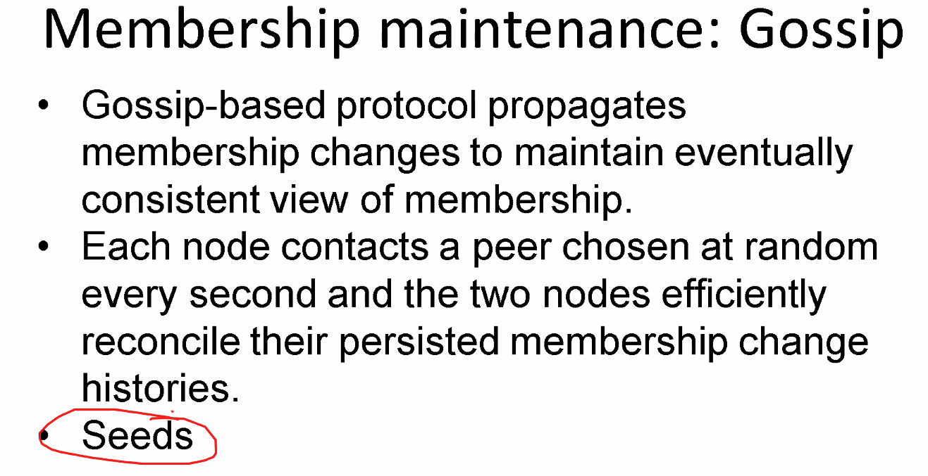
* 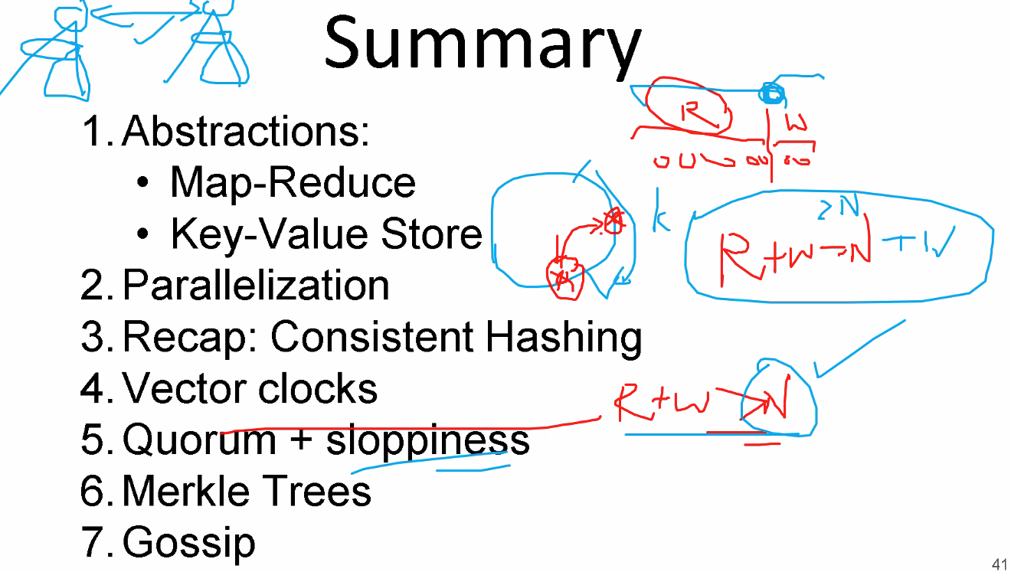

### **Lecture 11**

* 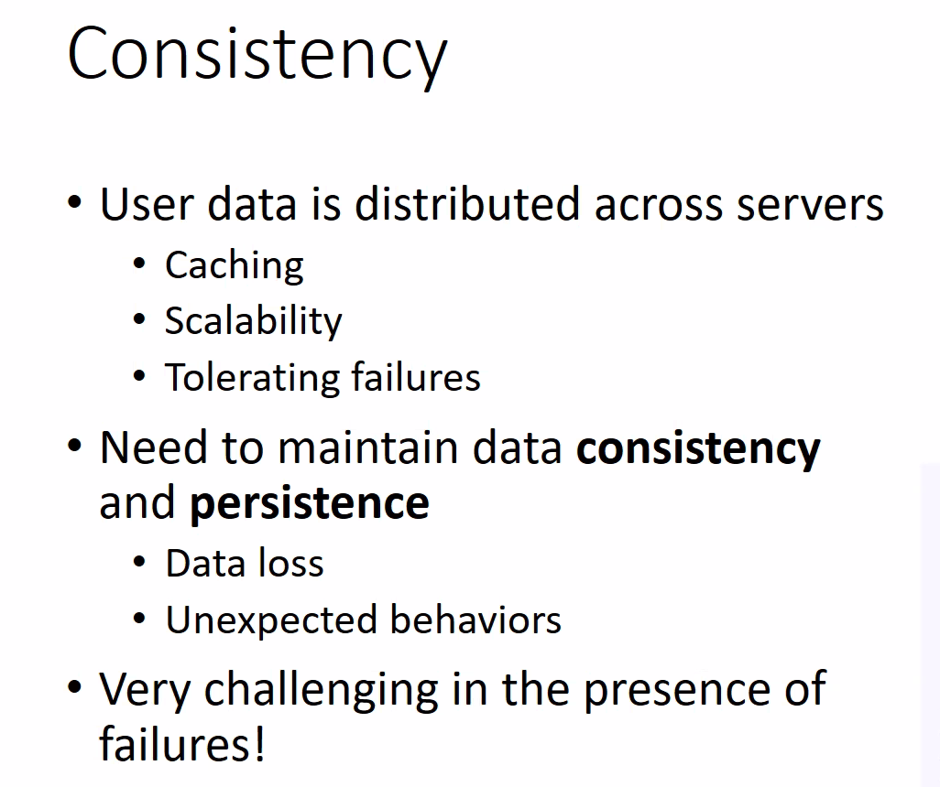
* 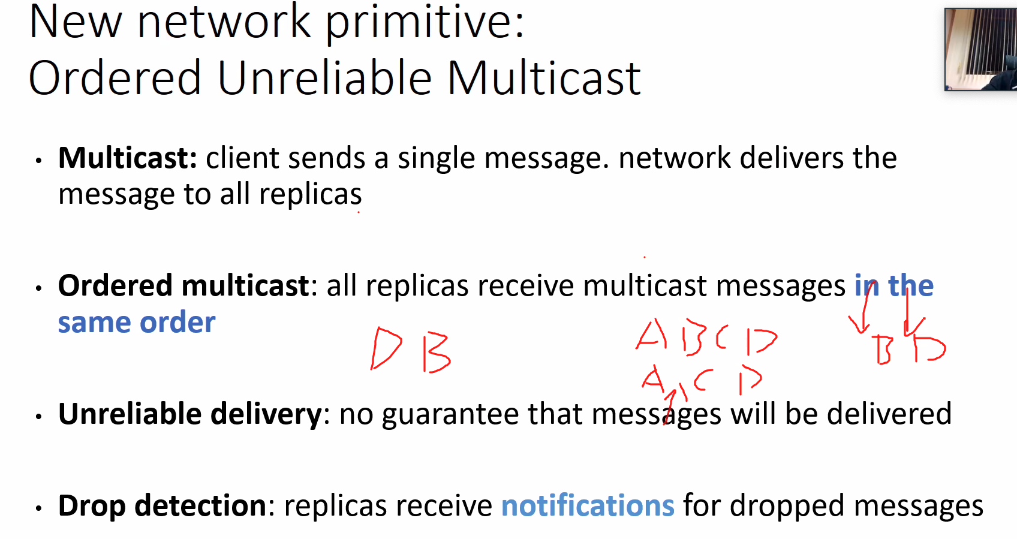
* 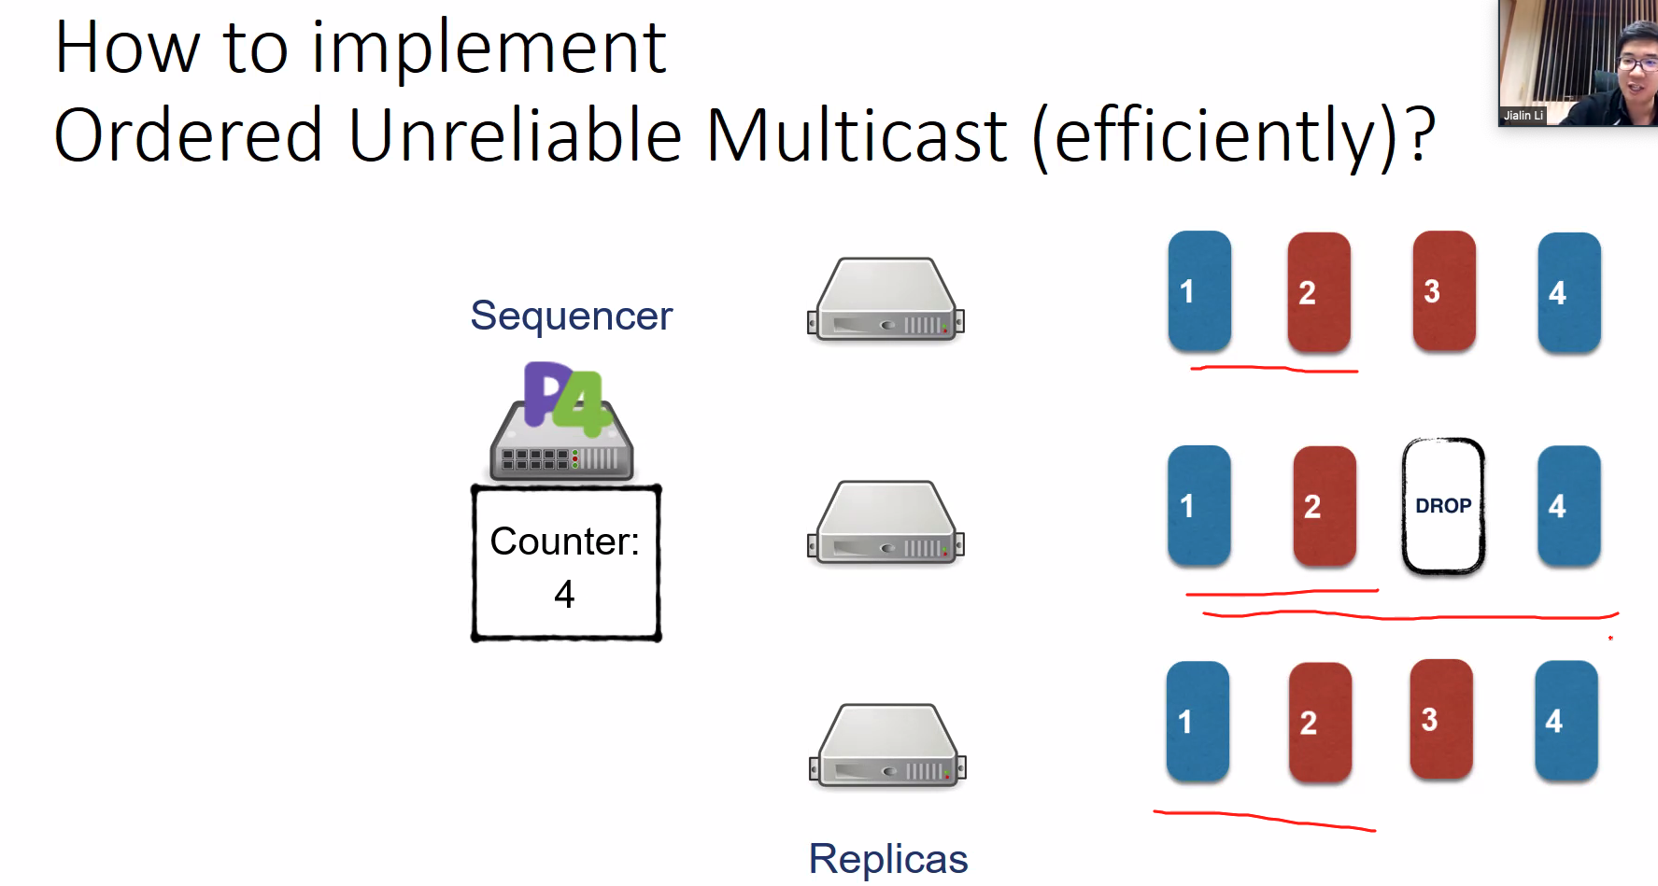
* 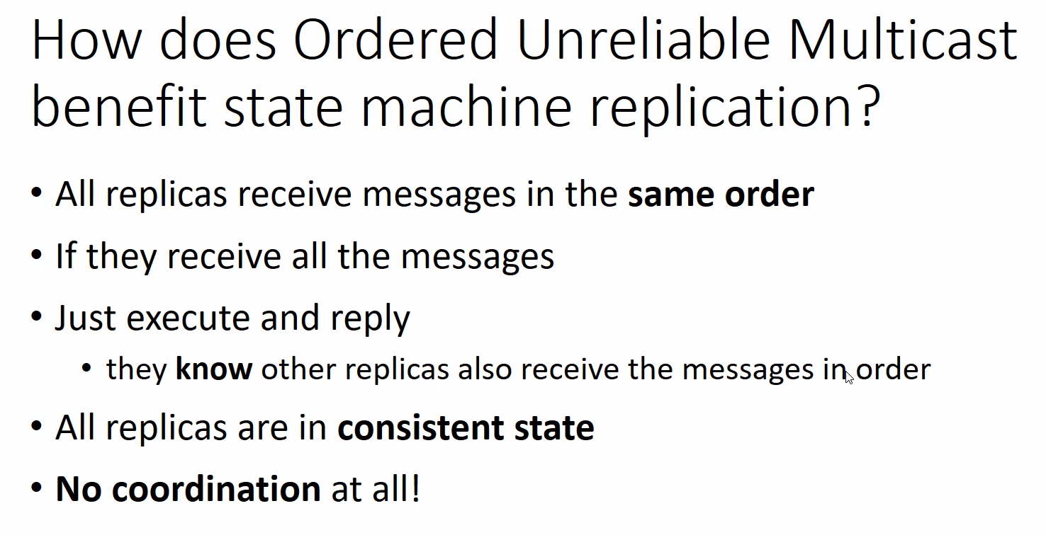
* 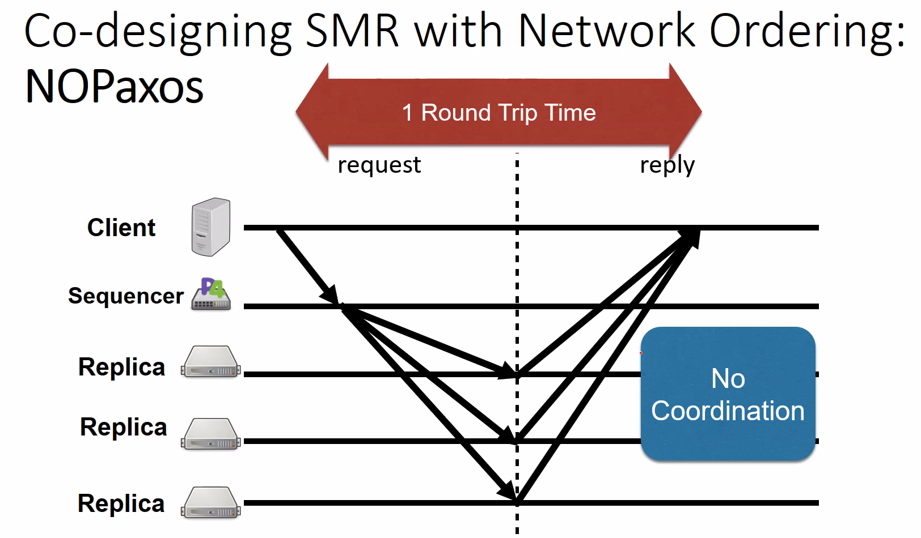
* 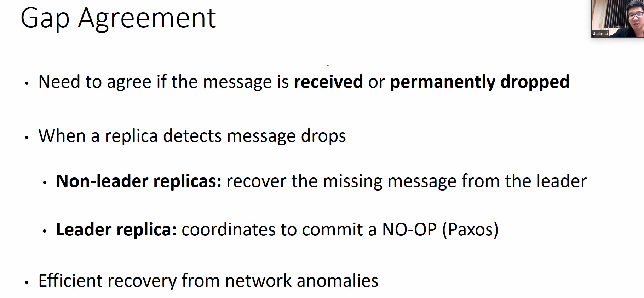
* 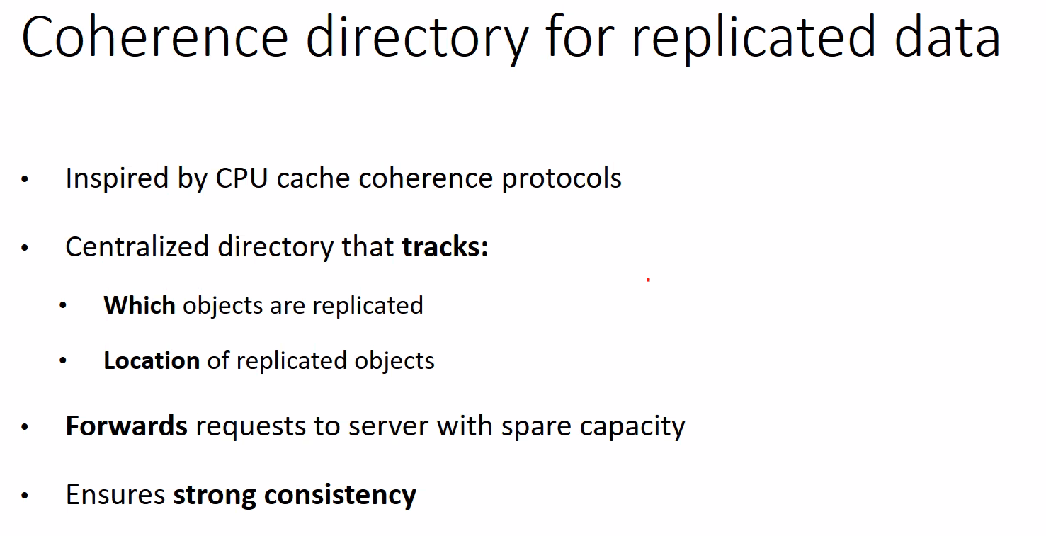
* 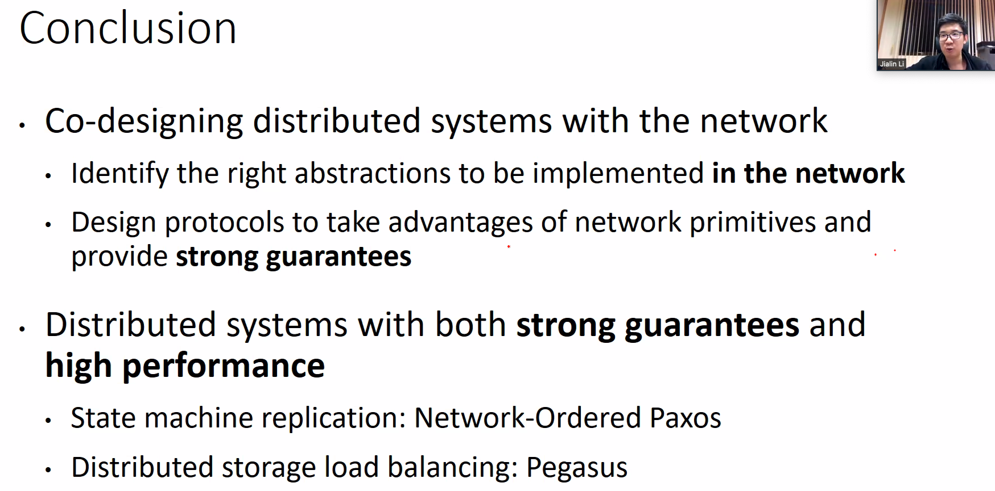

### **Lecture 12**

* 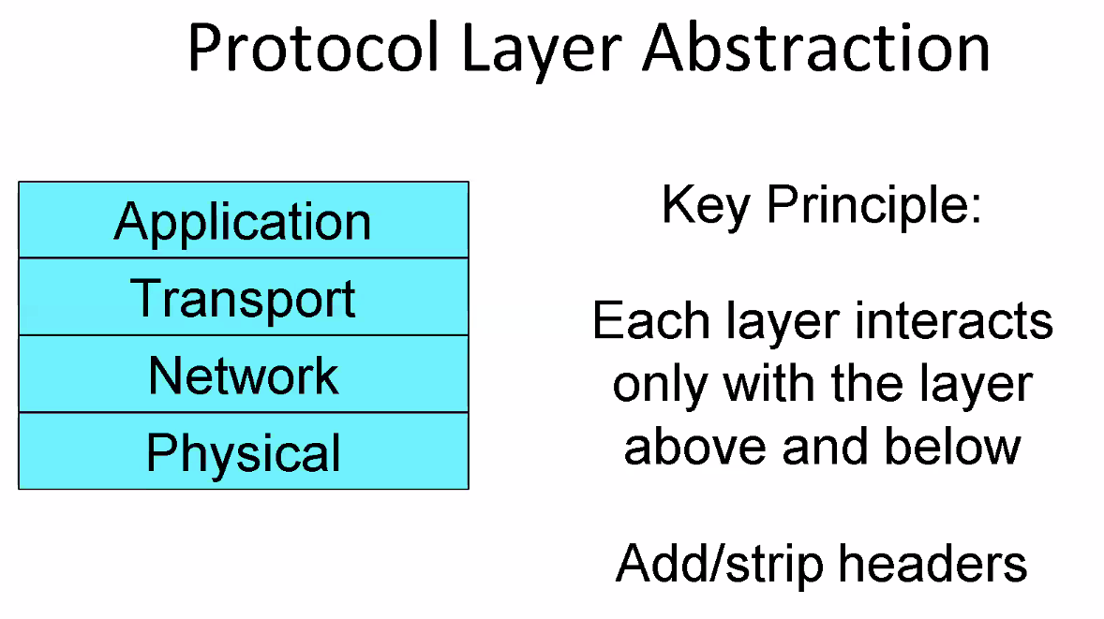
* 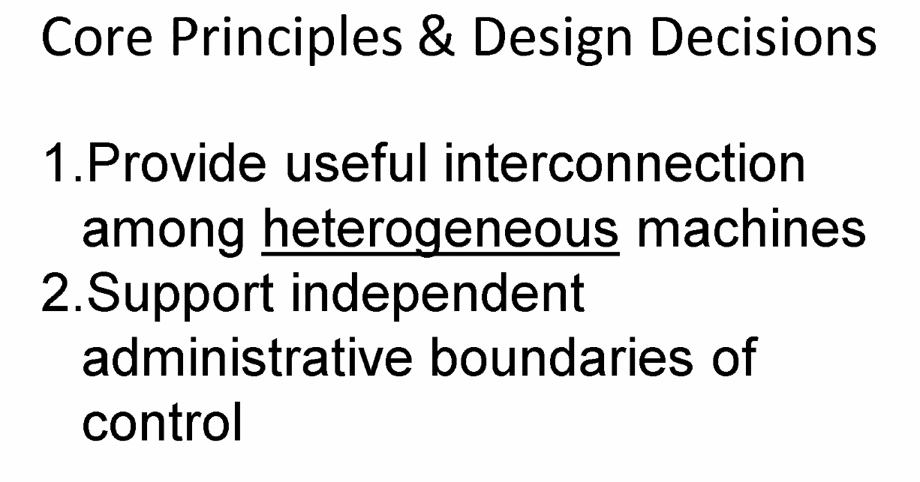
* 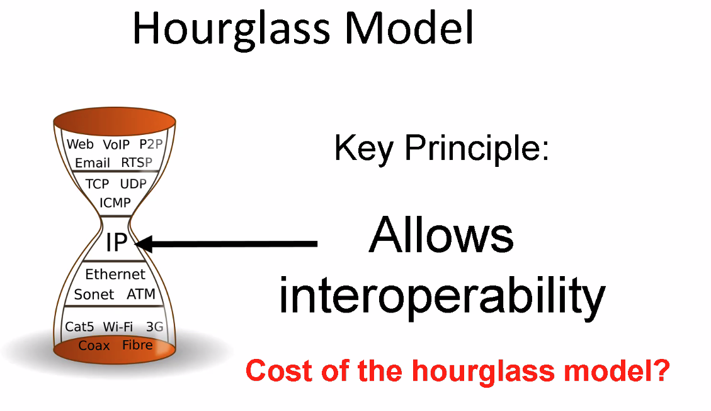
* 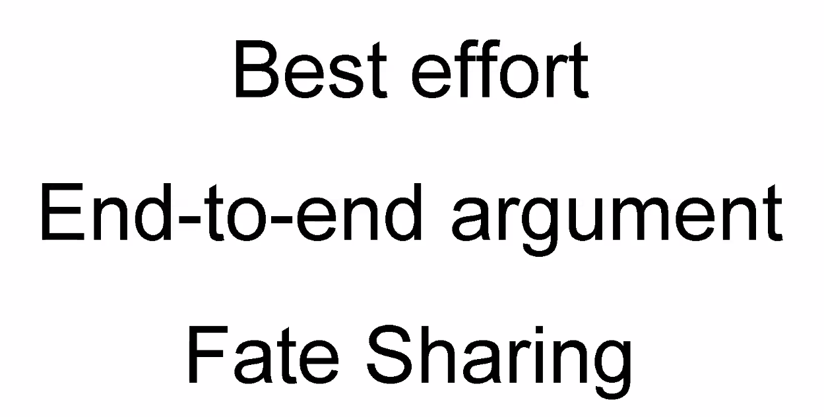
* 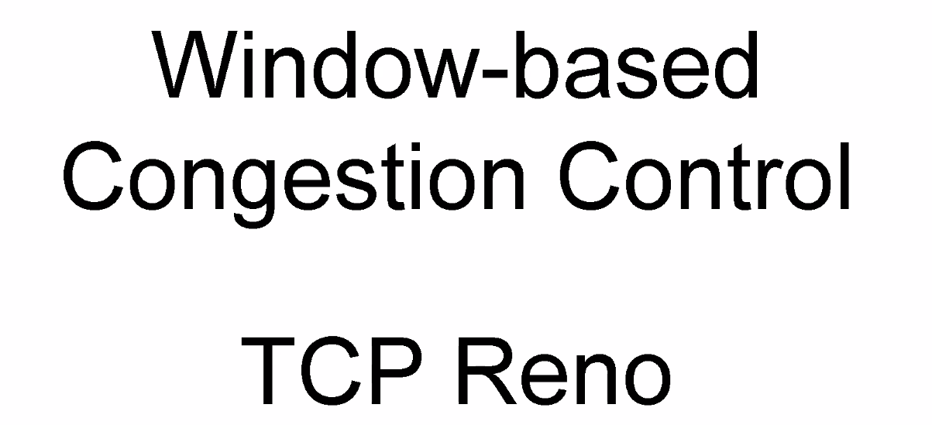
* 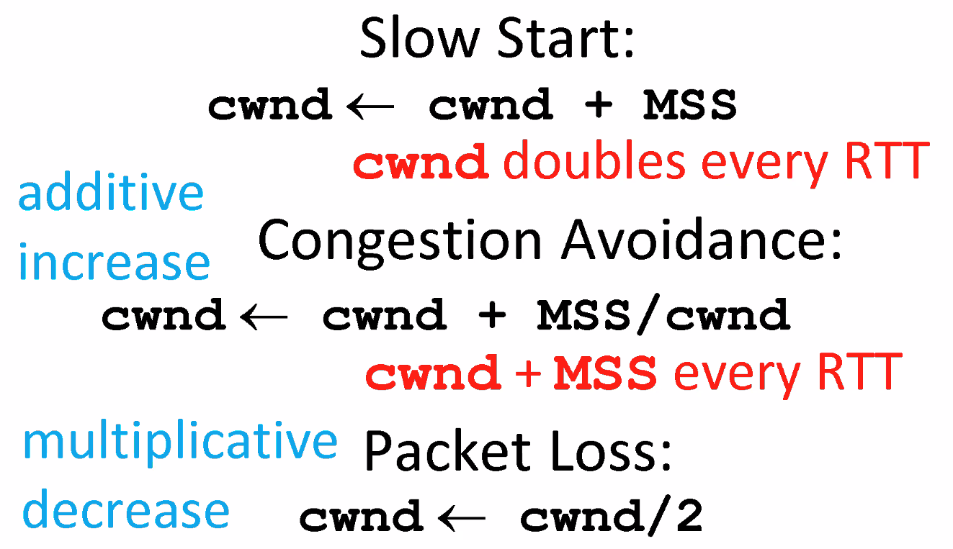
* 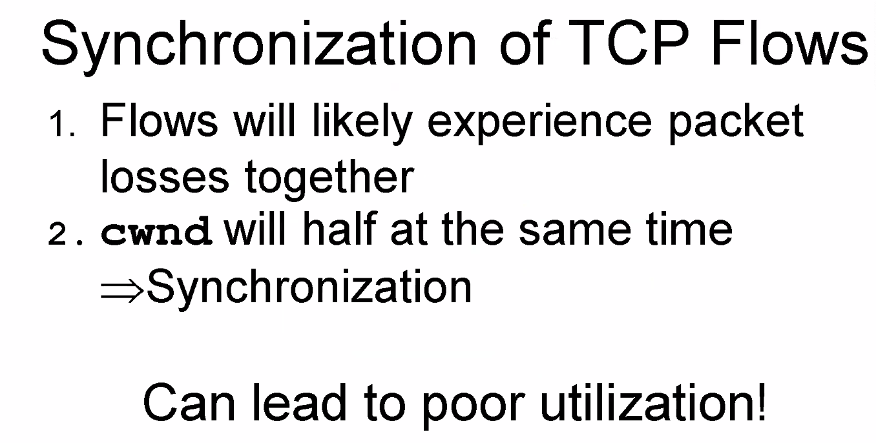
* 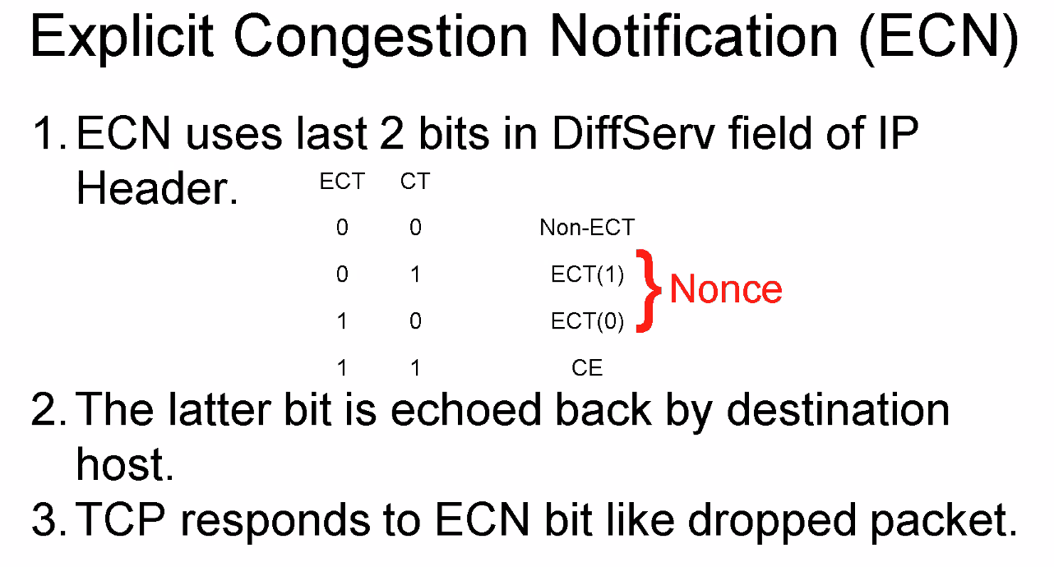
* 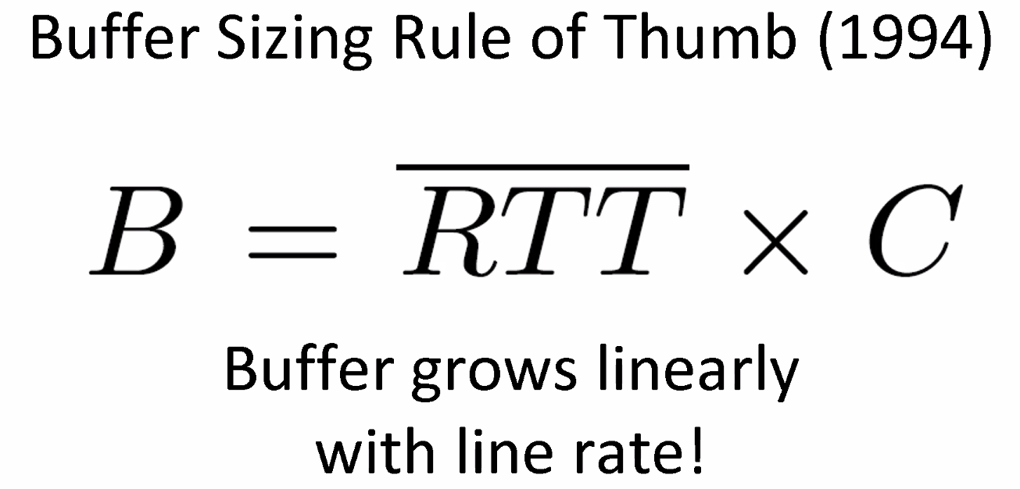
* 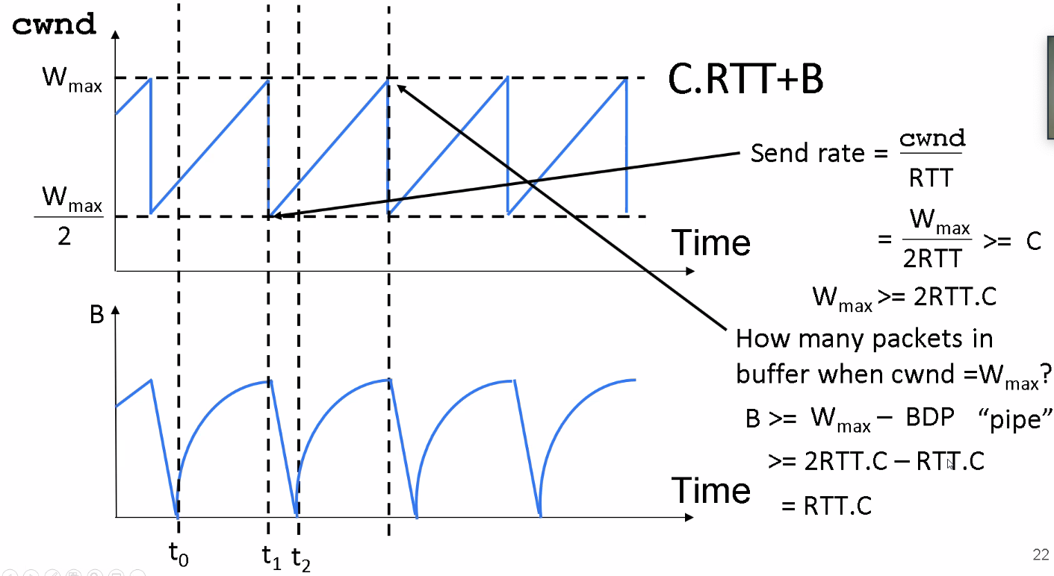
* 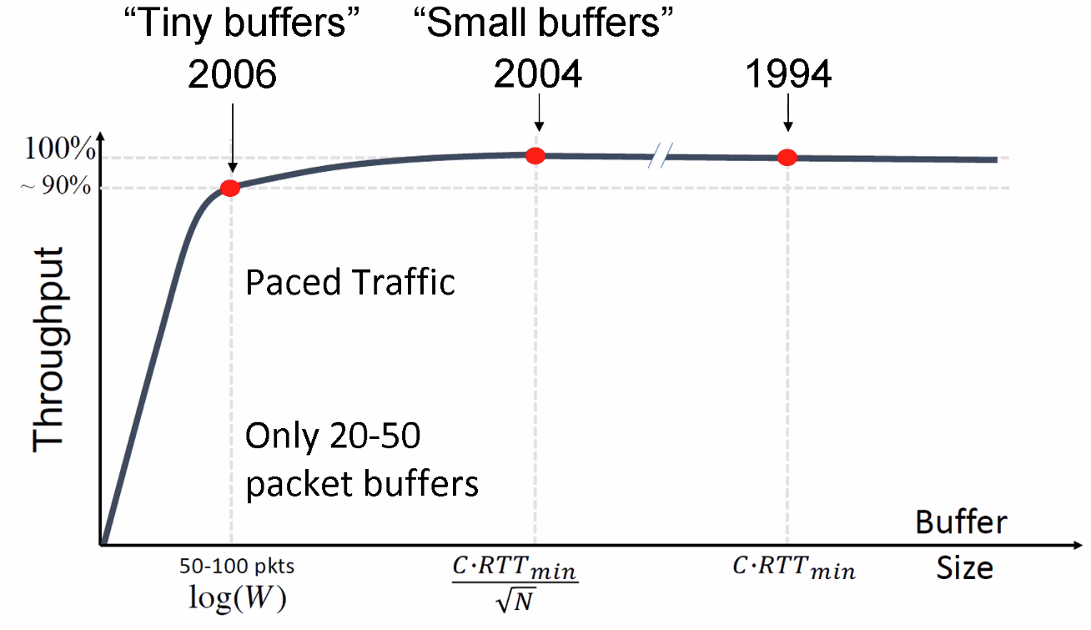
* 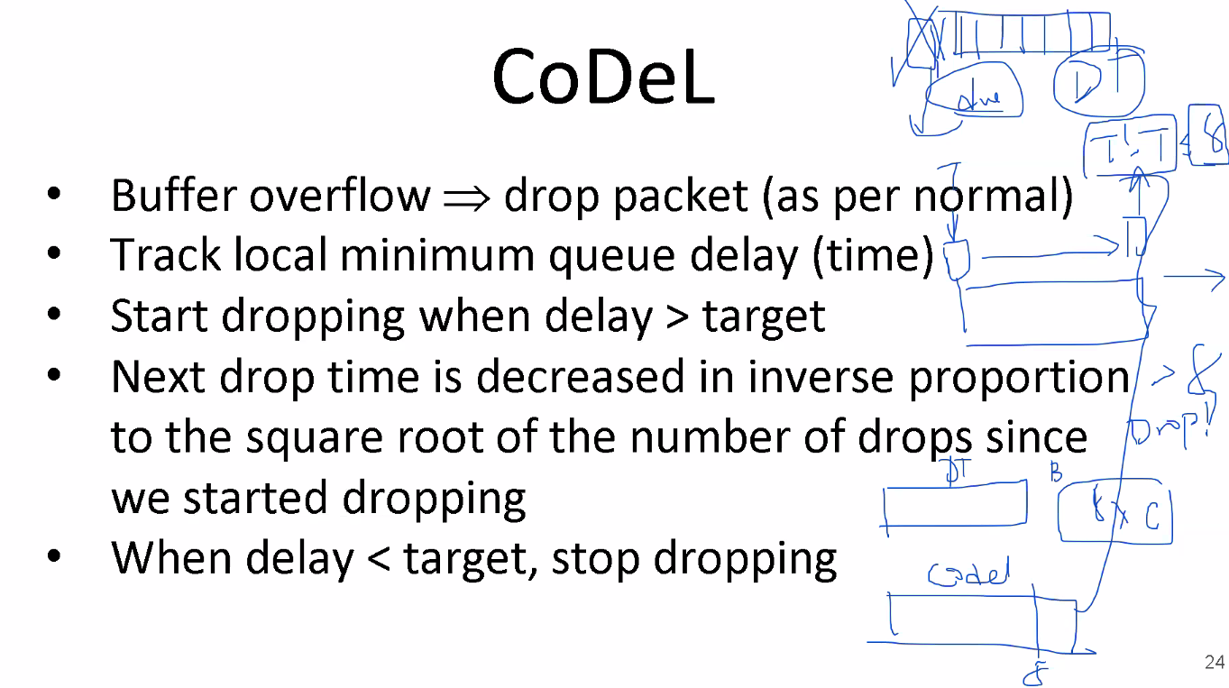
* 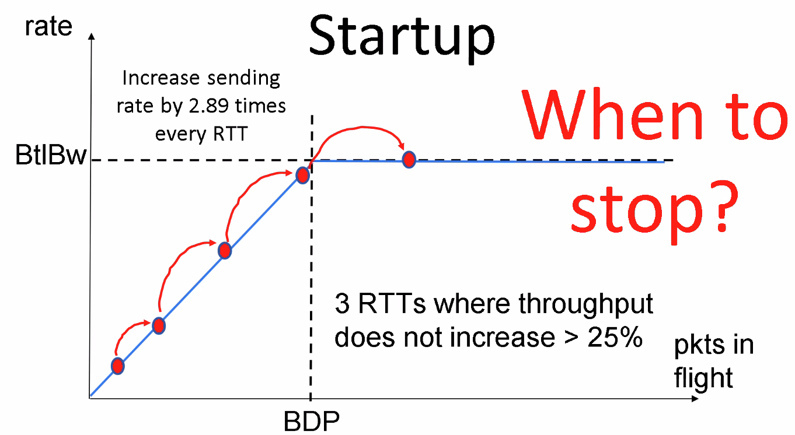
* 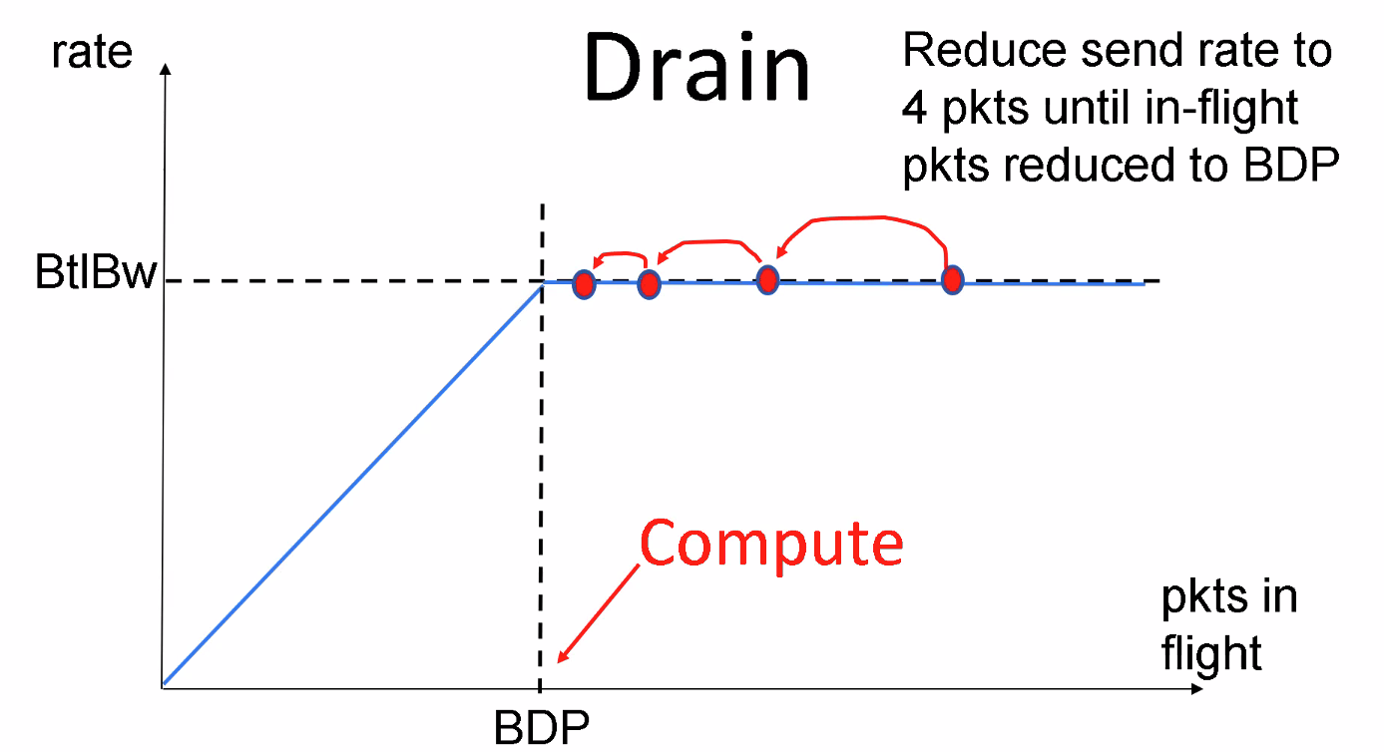
* 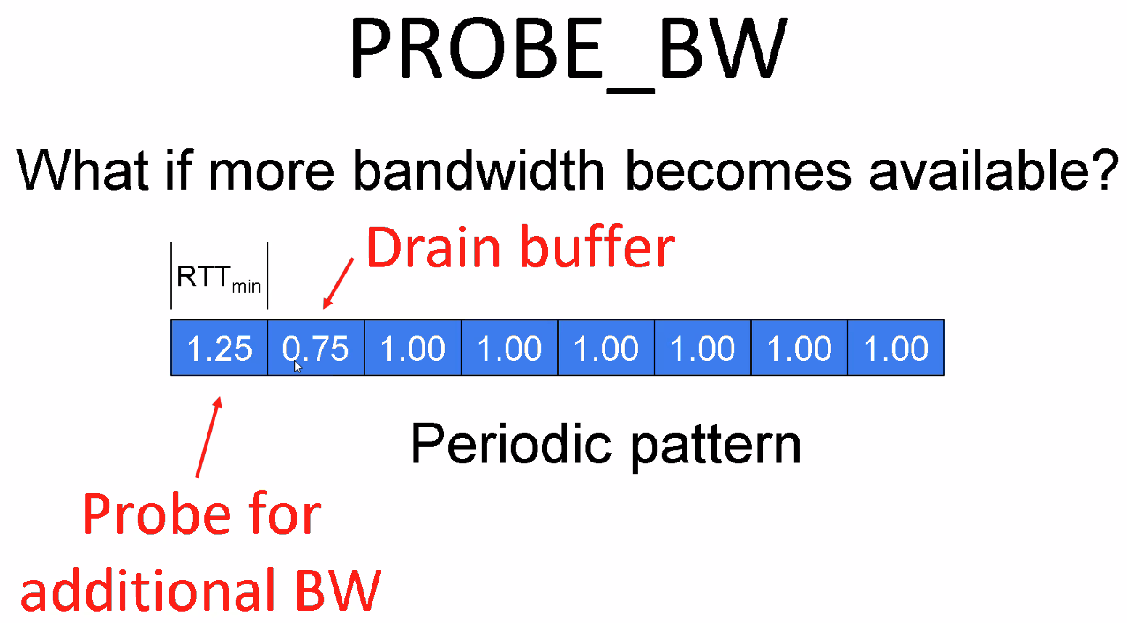
* 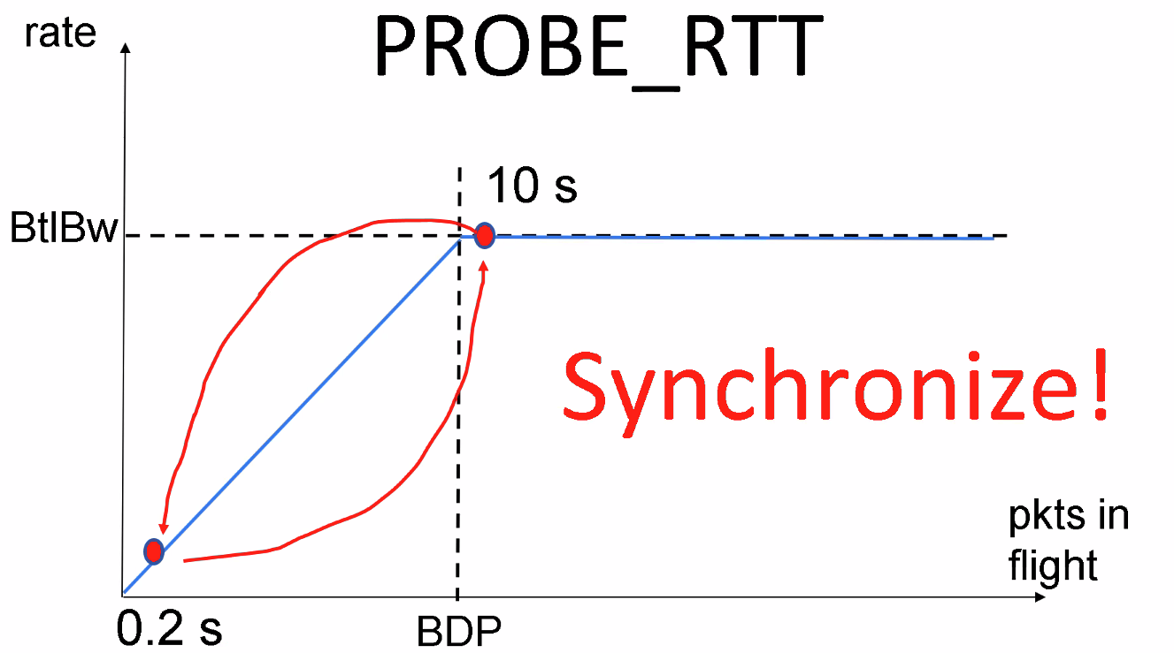
* 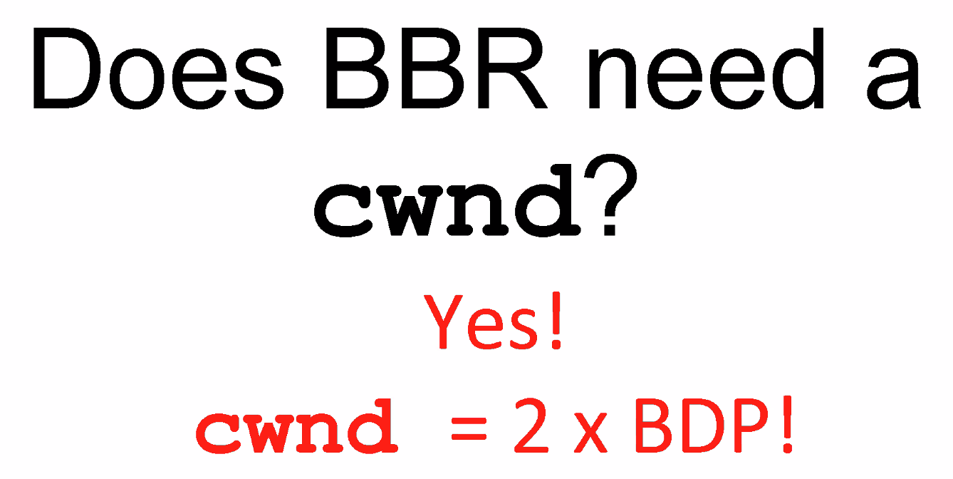
* 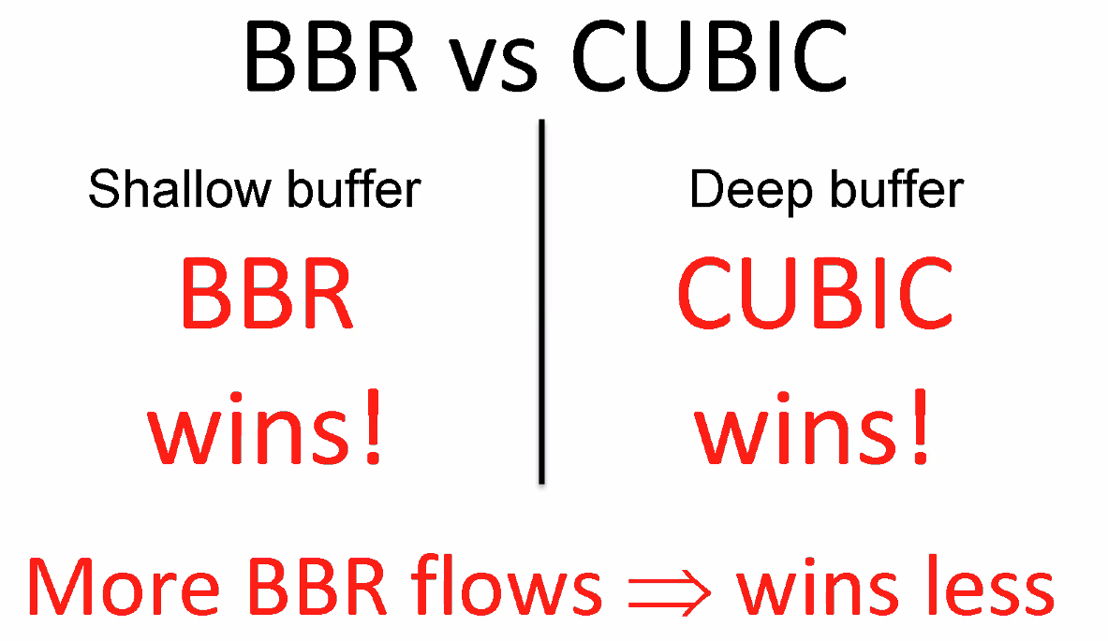
* 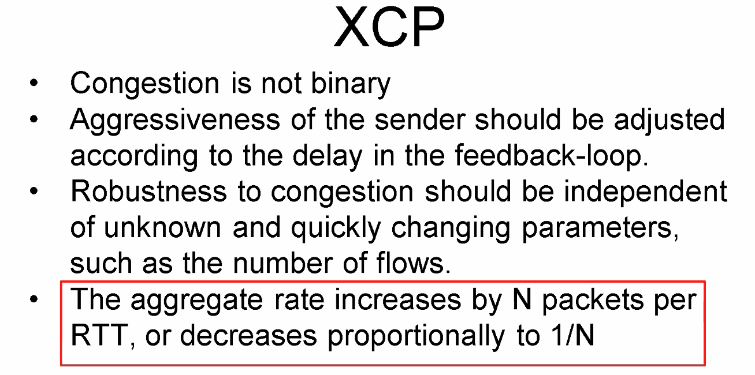
* 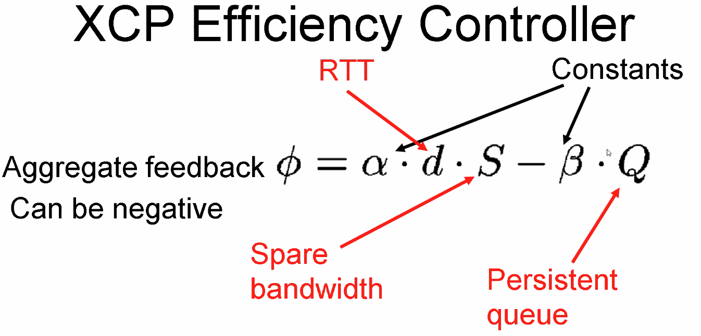
* 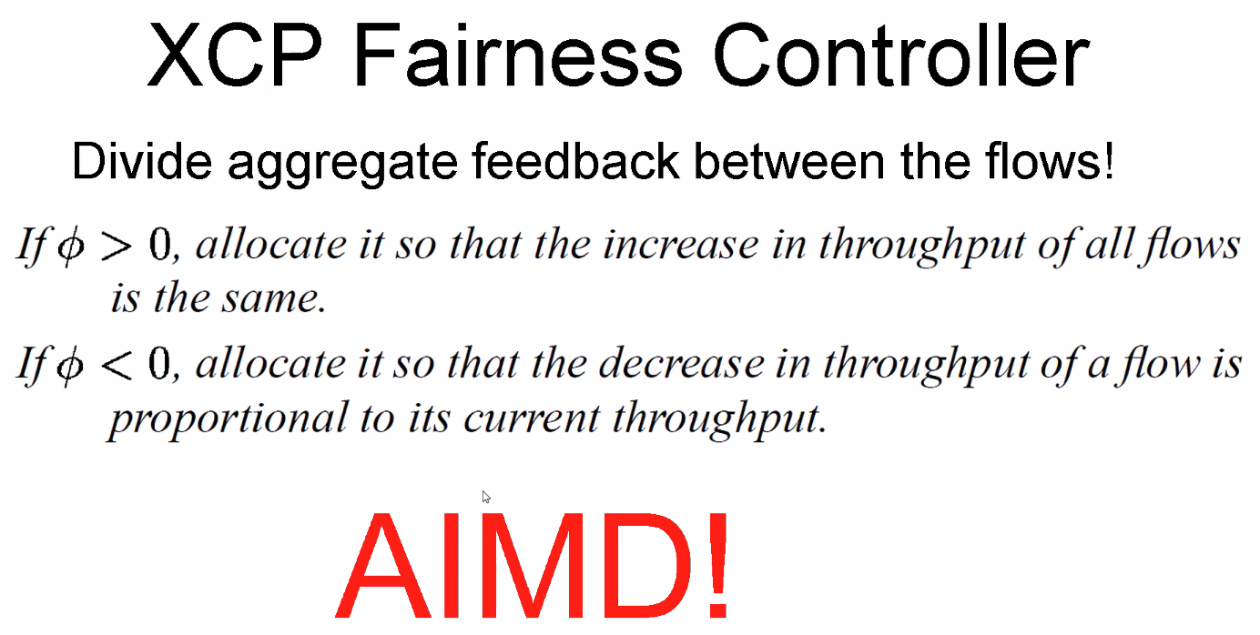
* 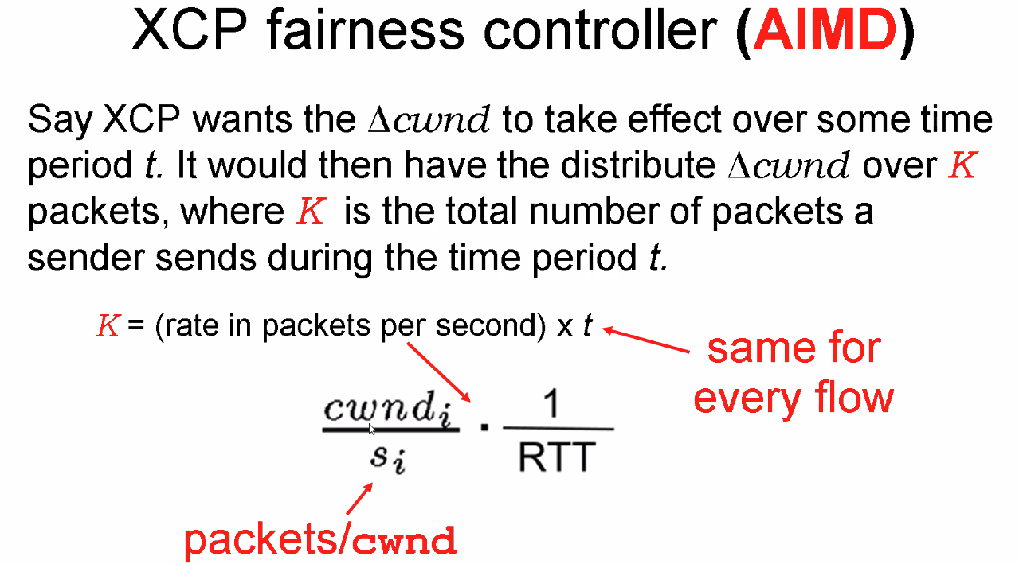
* 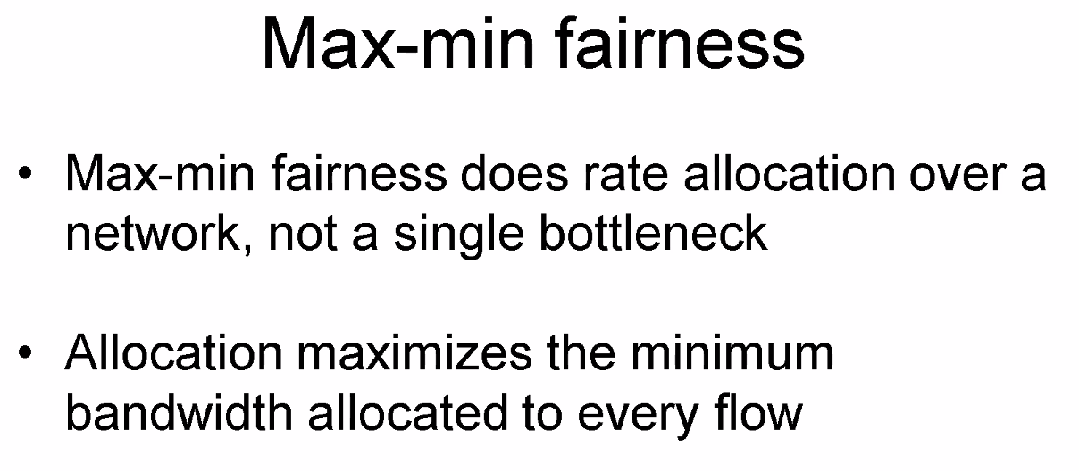
* 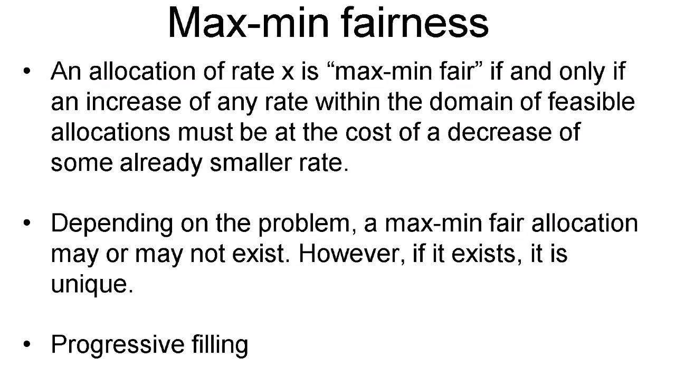
* 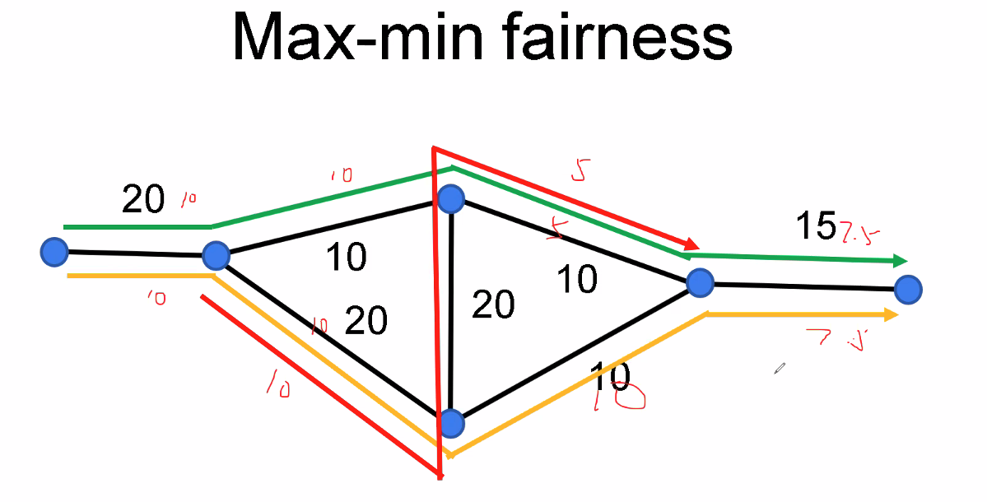
* 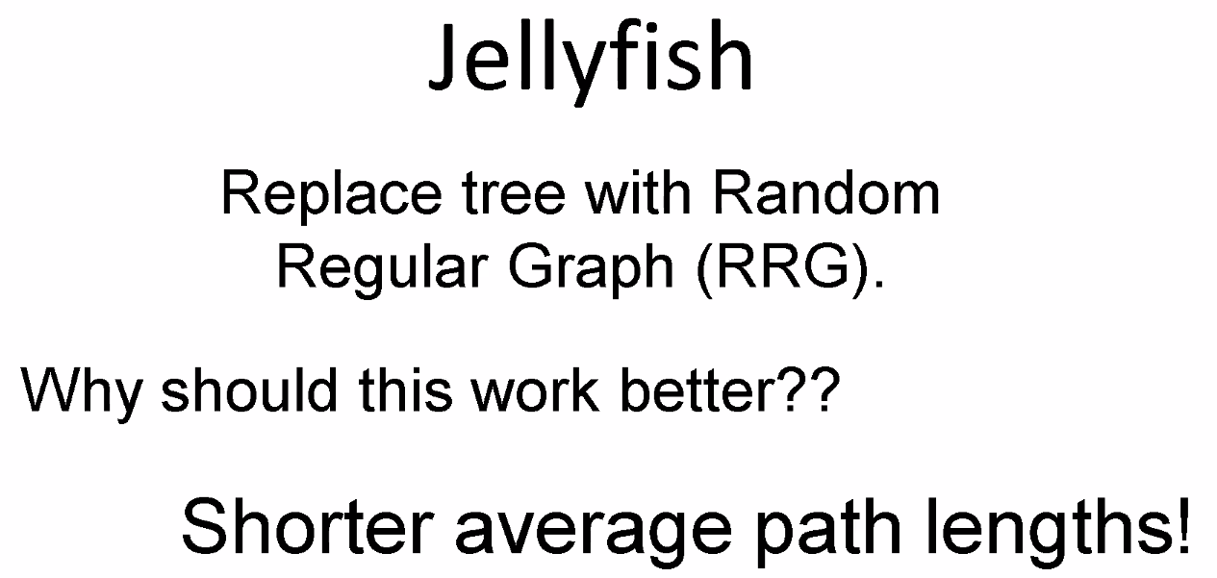
* 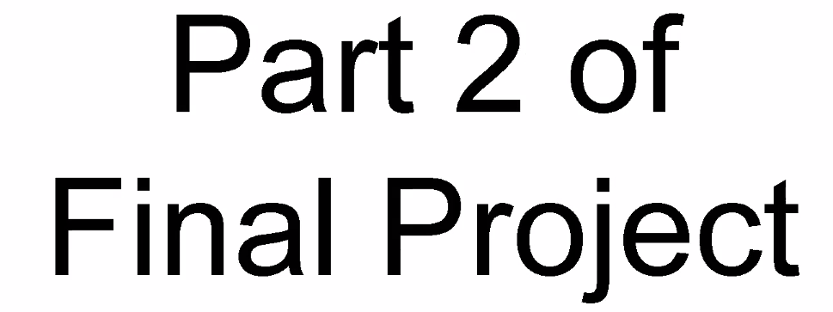
* 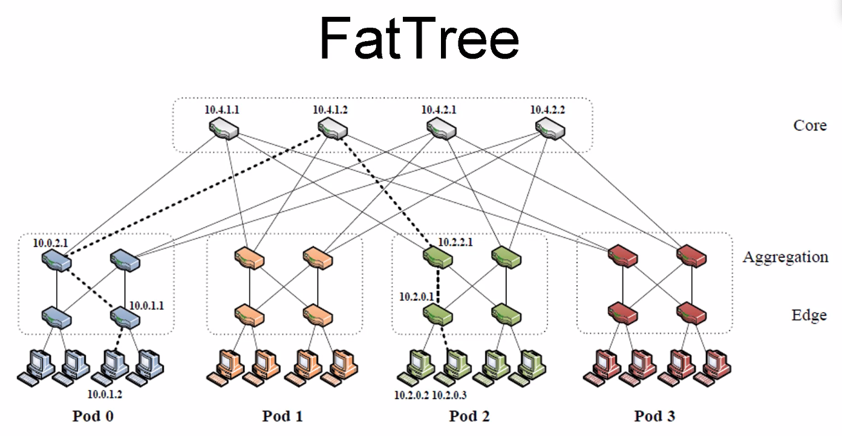
* Bi-section bandwidth
* 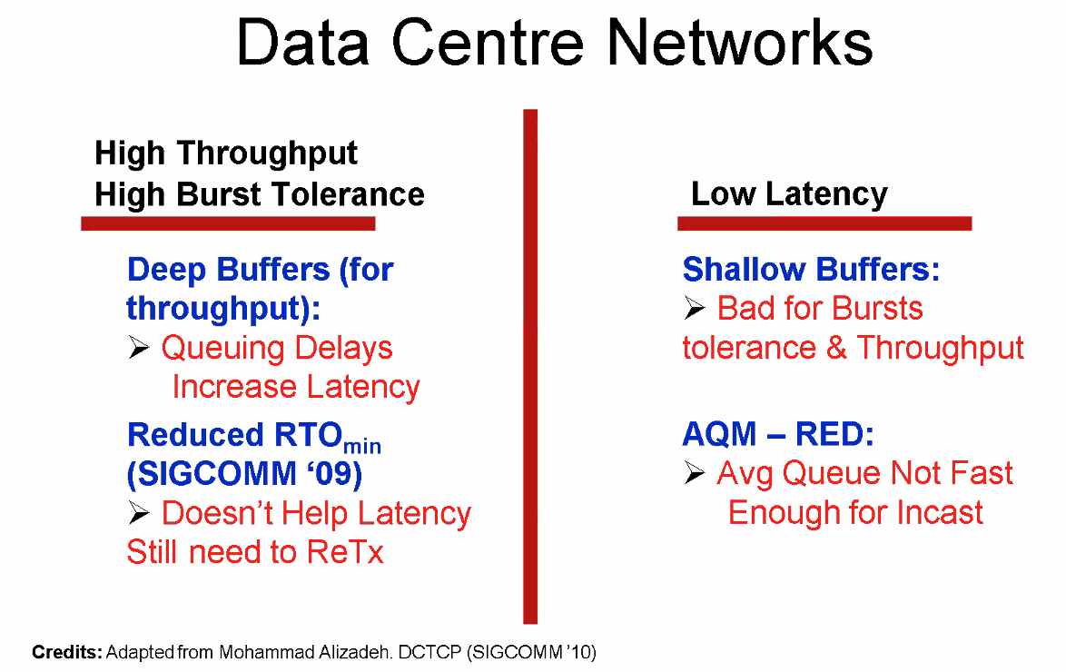
* 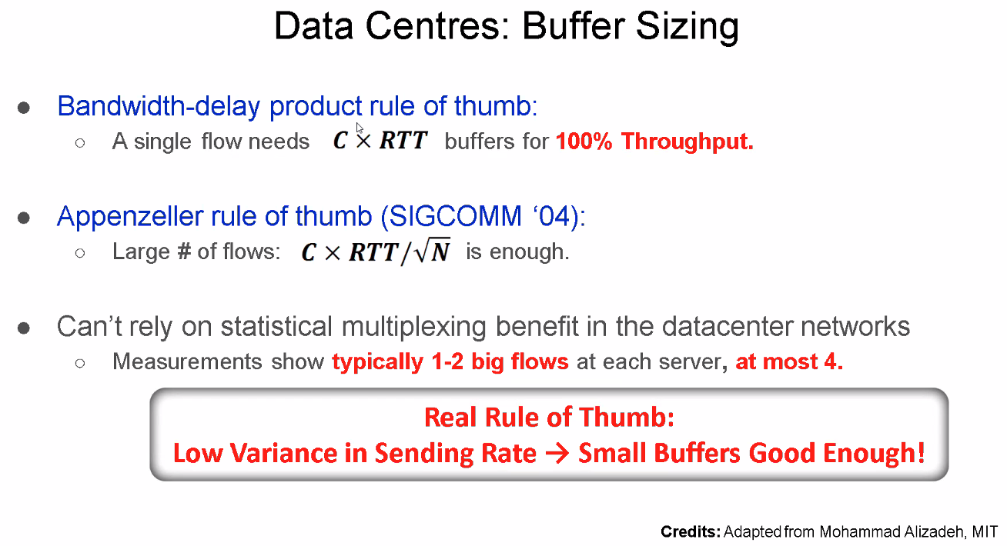
* 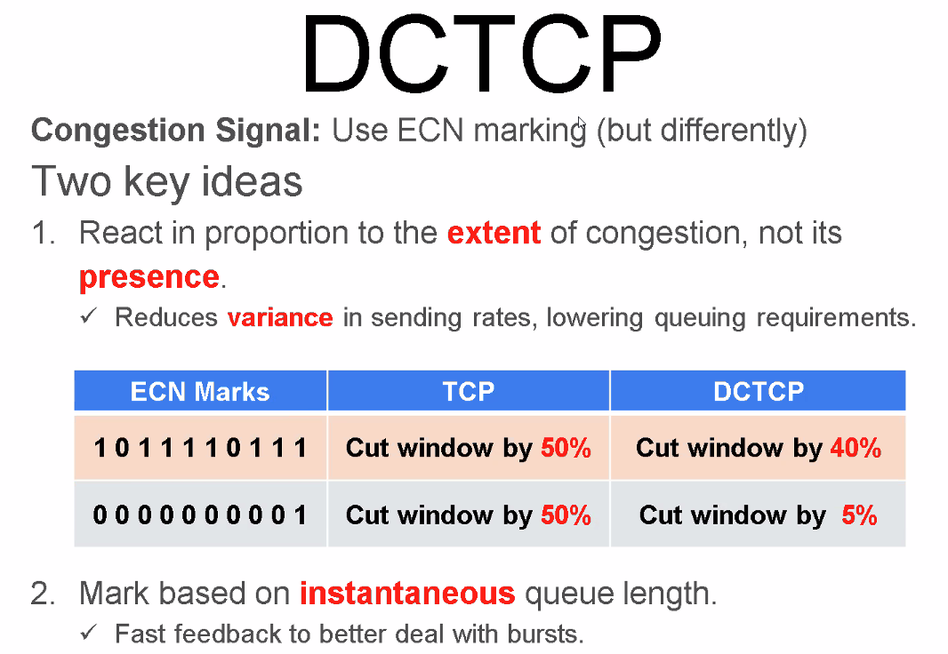
* 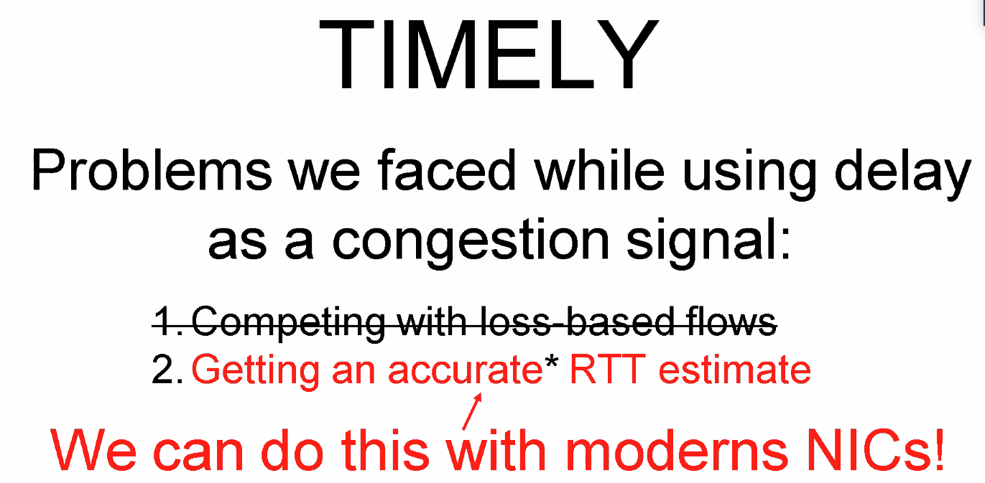
* 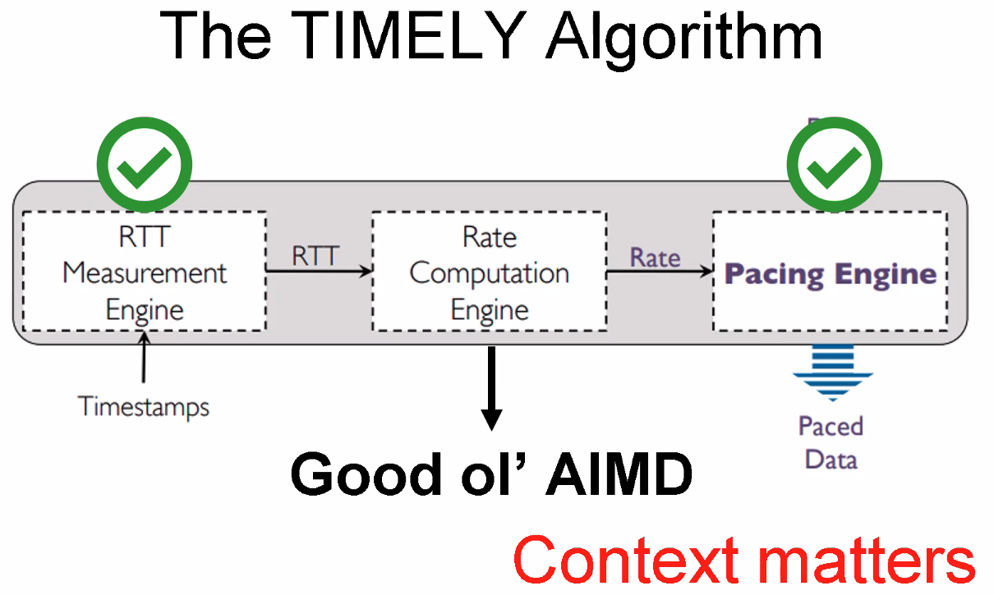
* 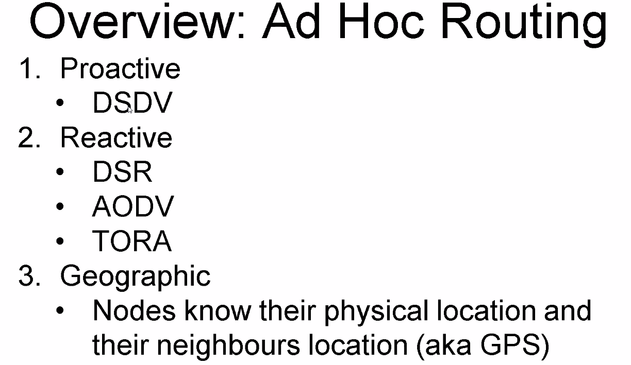
* 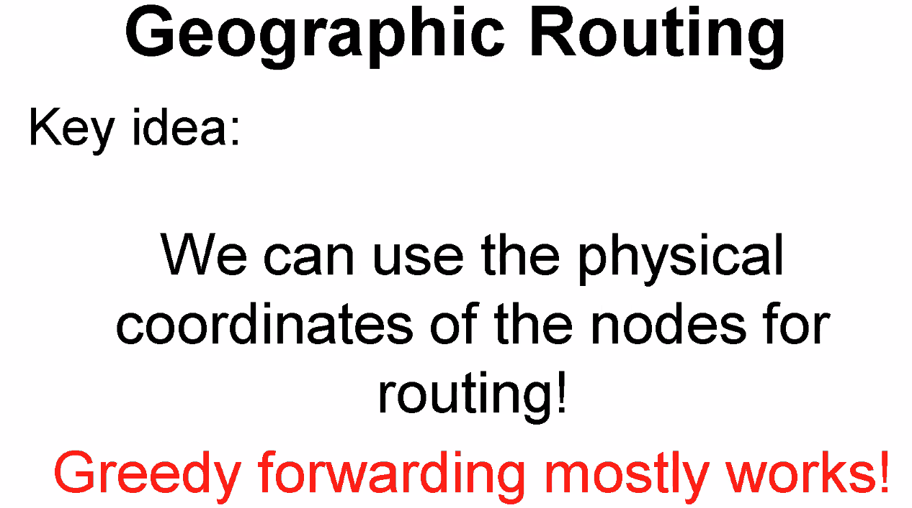
* 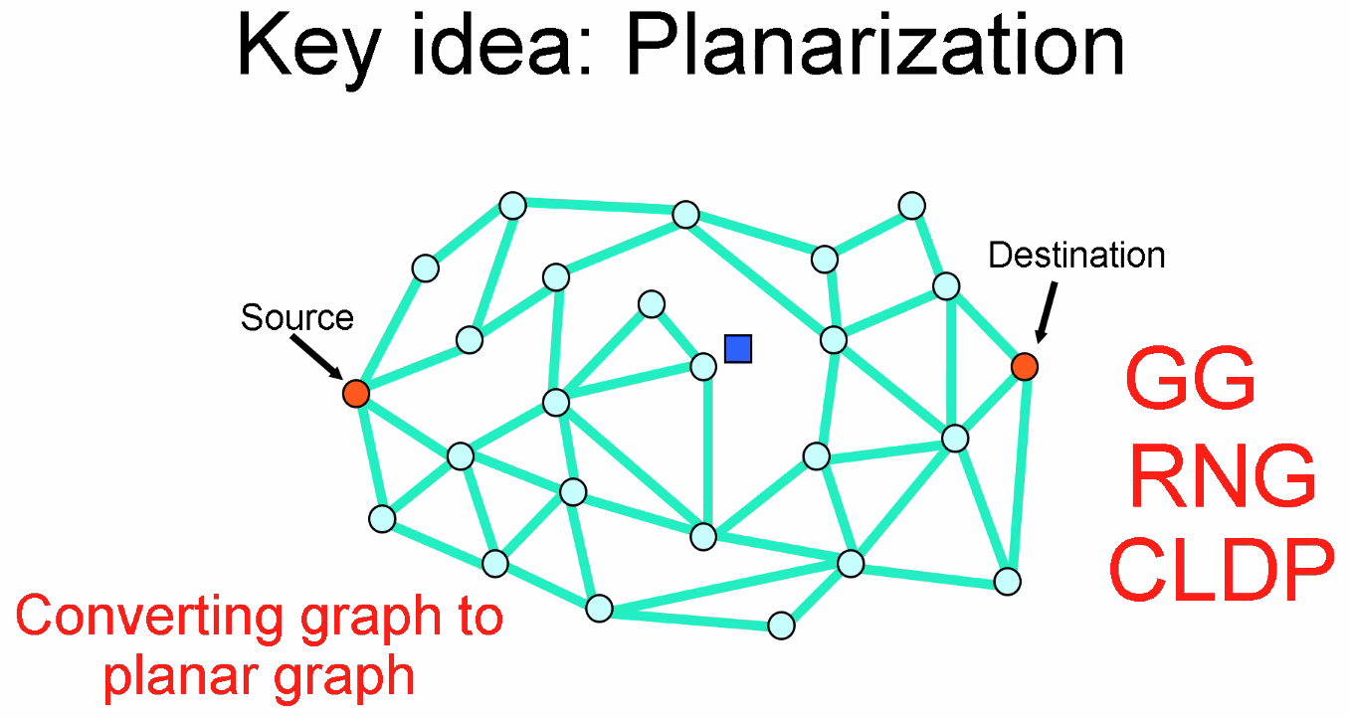
* 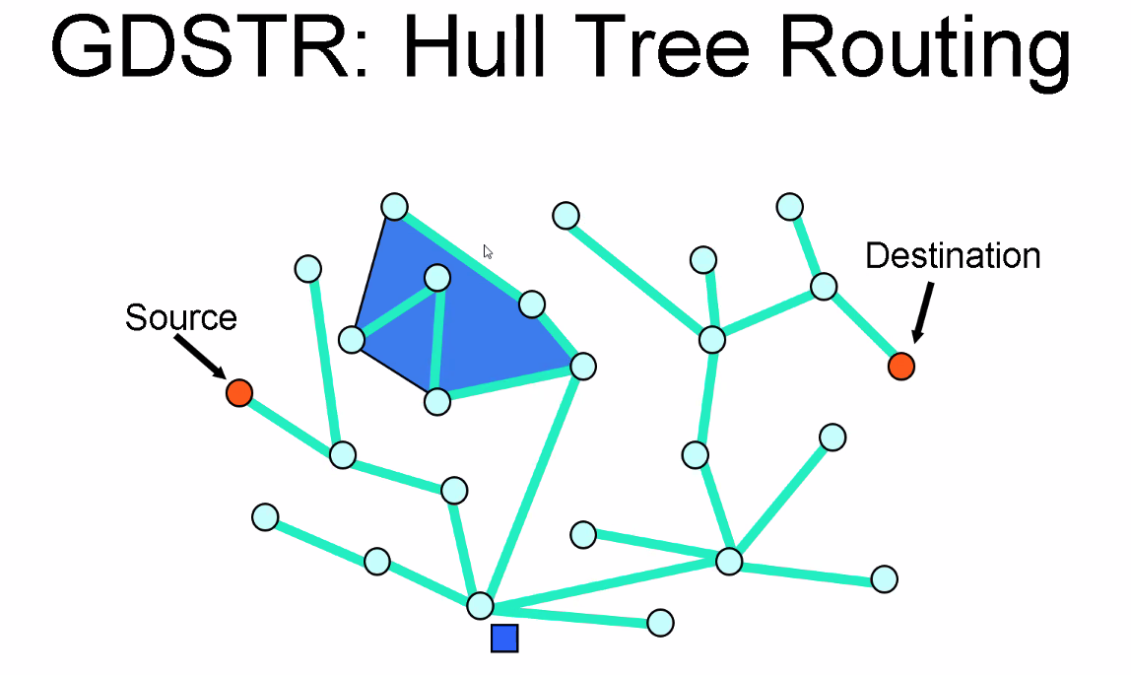
* 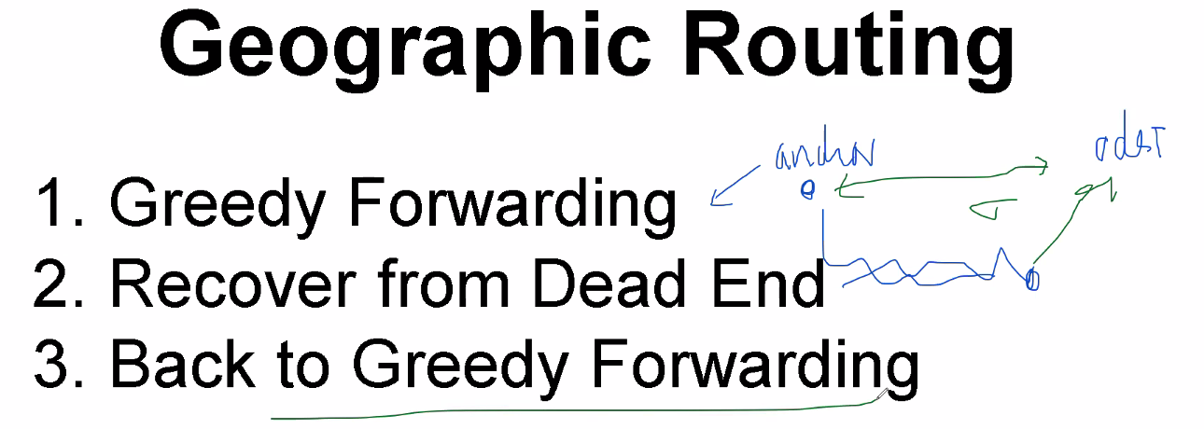
* 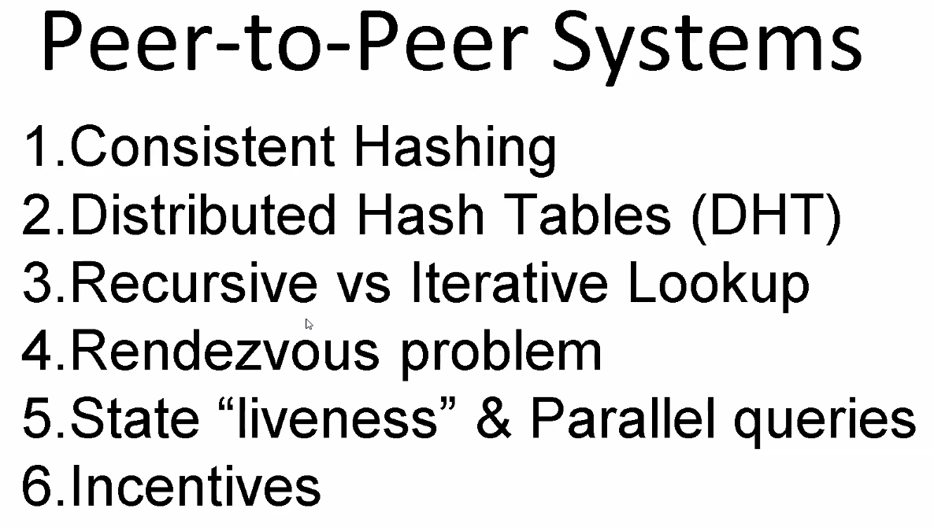
* 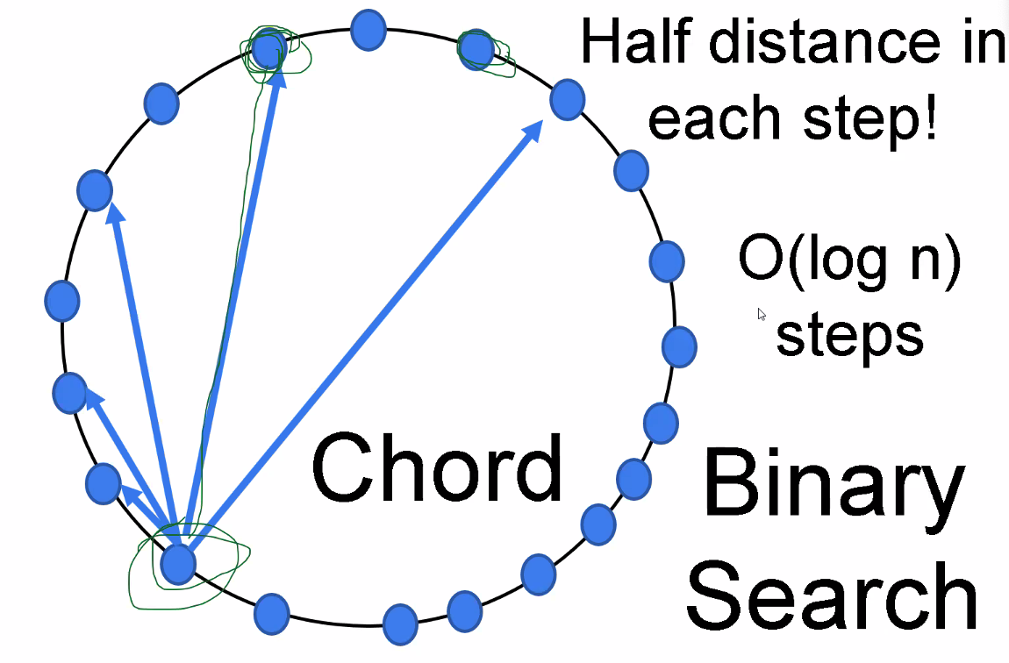
* 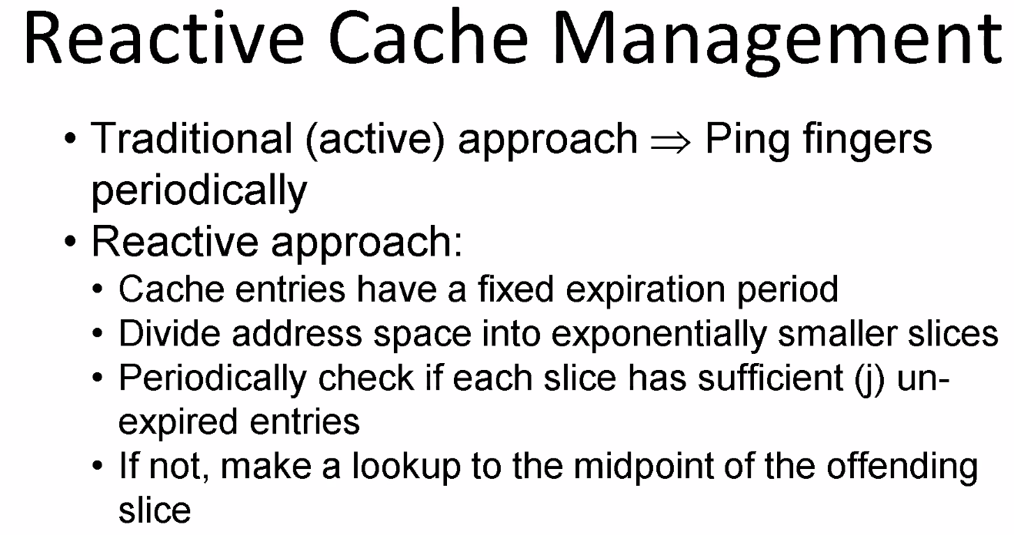
* 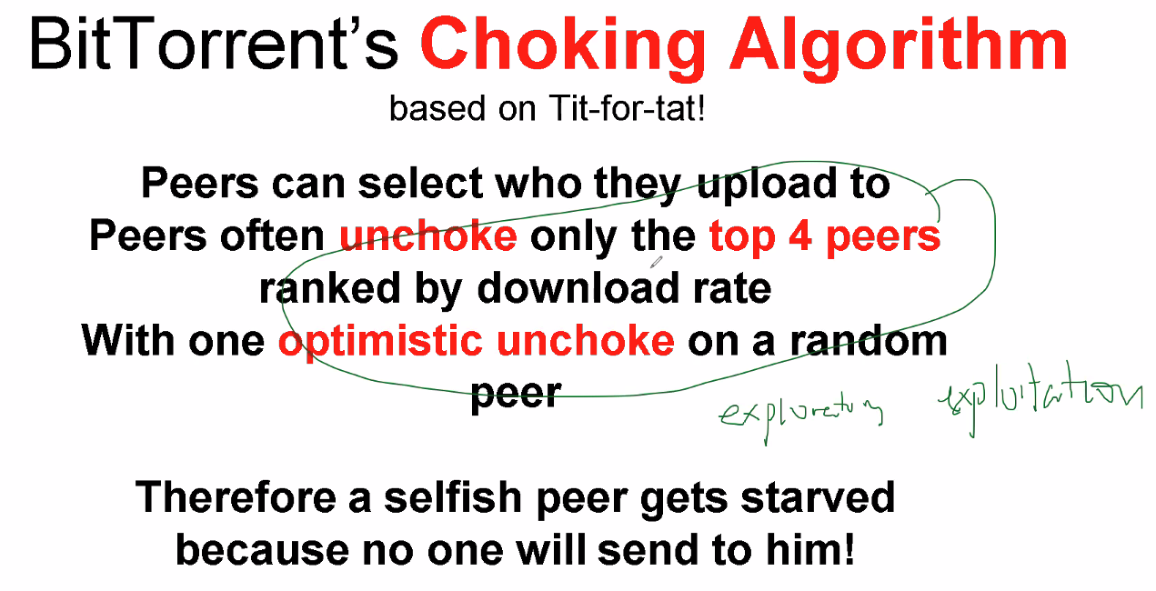
* 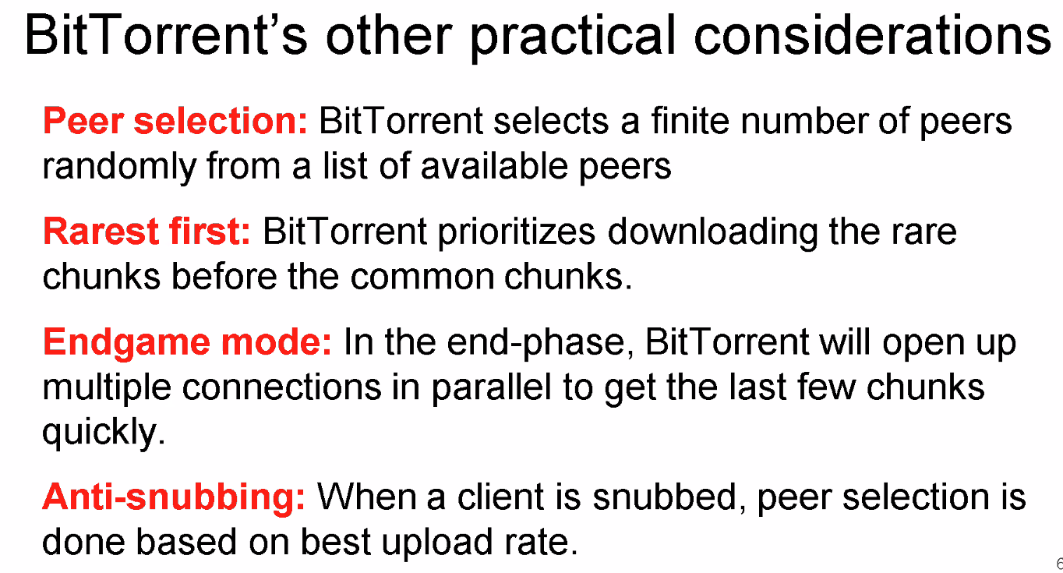
* 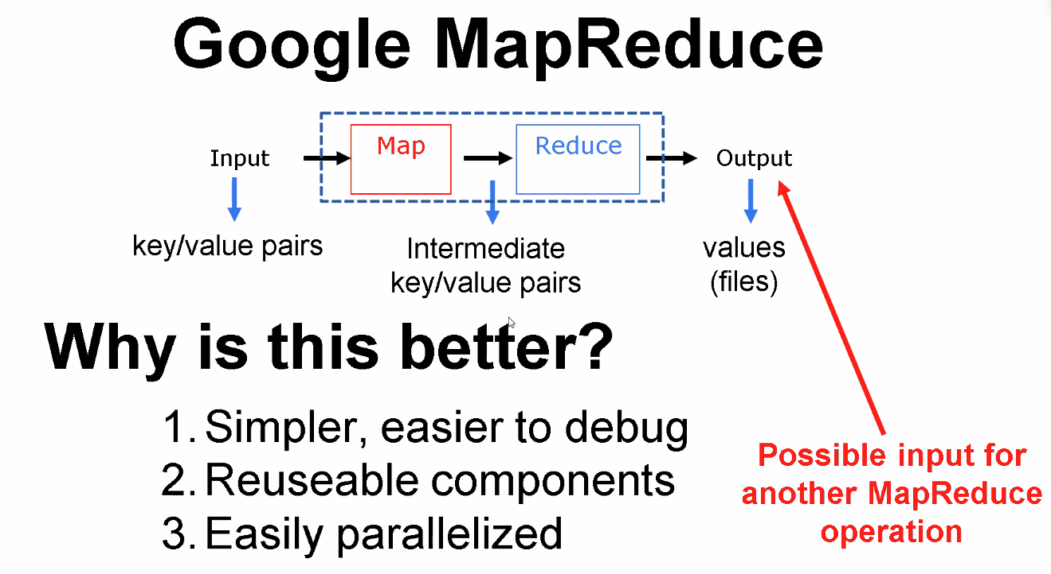
* 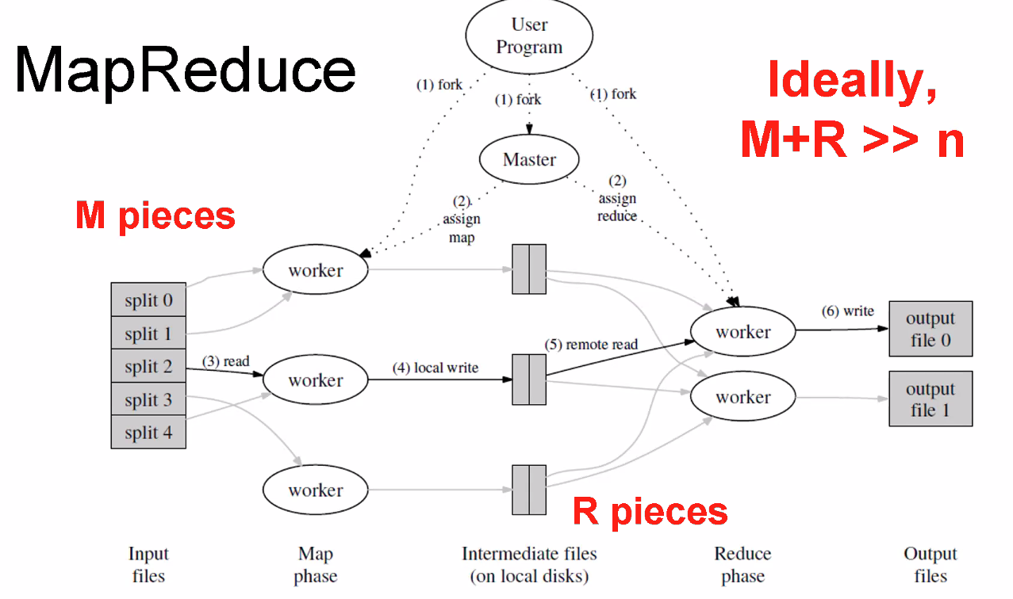
* 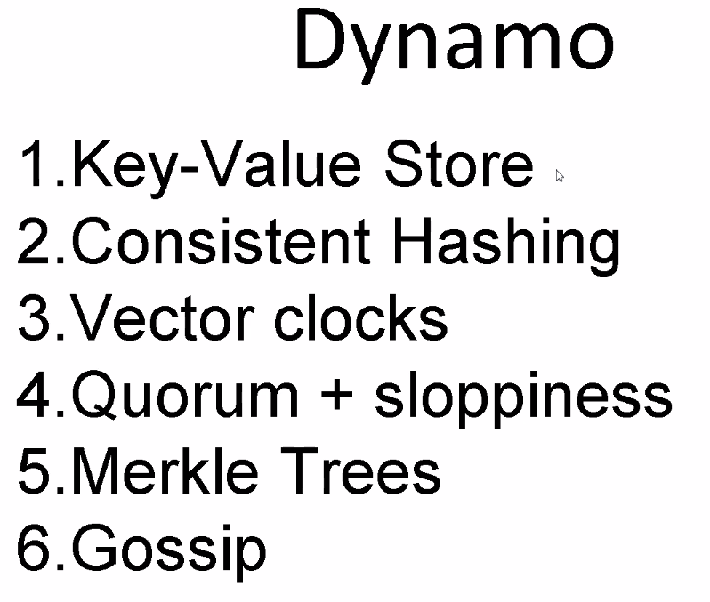
* 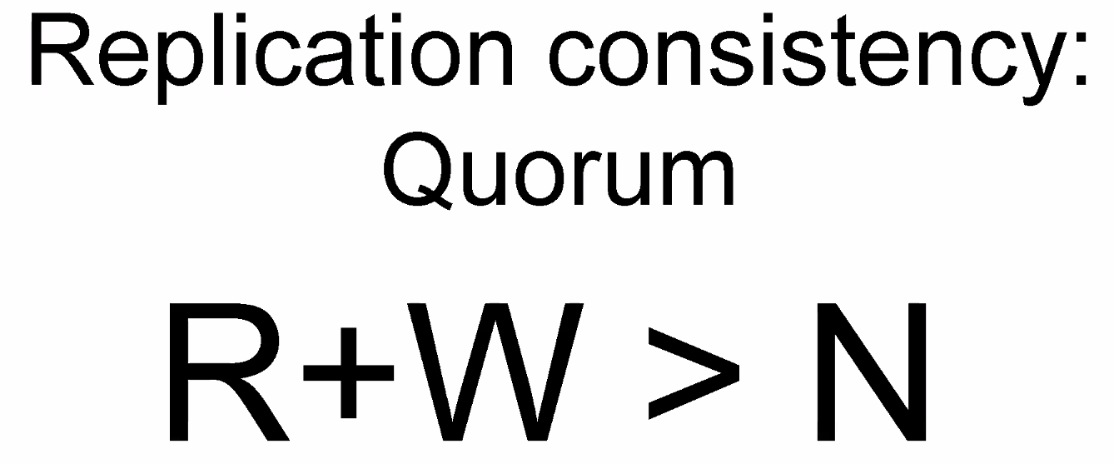
* 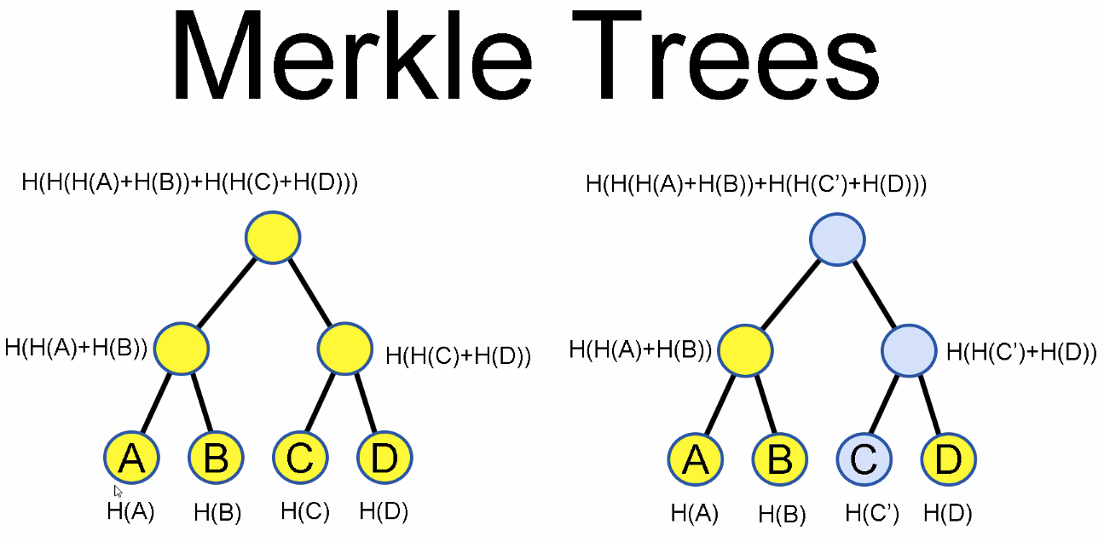
* 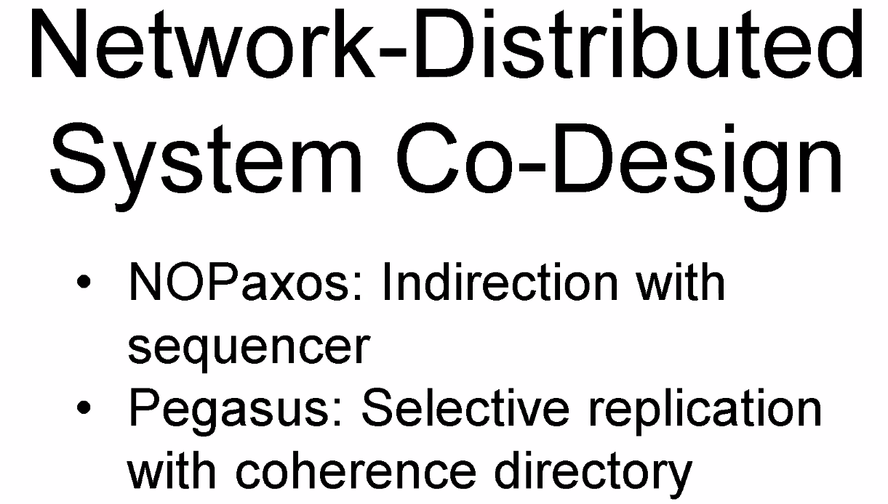

### **Mininet**

* <http://mininet.org/api/annotated.html>

### **TCP Congestion Control Textbook**

* <http://intronetworks.cs.luc.edu/current/html/index.html>